Java2 Lab 9
(JavaFx)
[Experimental Objective]
1. Learn to understand Swing
2. Master the basic method of JAVA graphical interface design by writing and debugging programs

[Javafx composition]
The following image shows the relationship between the Stage, the Scene, the Container, the Layout, and the Controls in JavaFx: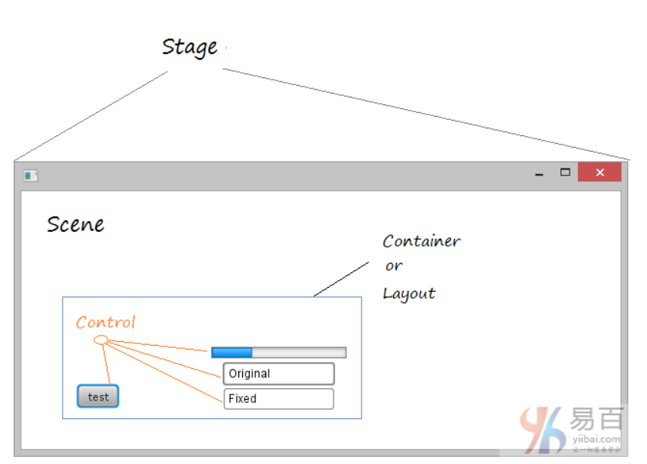
Pane

Javafx some simple class names
1, Scene: create a scene
2, Stage: create a stage
3, Pane: the base class of the panel
4, stackPane: panel, the node is placed in the center of the panel
5, FlowPane: nodes are placed line by line, or column by column
6, GridPane: the node is placed in a cell of a two-dimensional network
7, BorderPane: the node is placed around and central
8, HBox: nodes are placed in a single line
9, VBox: nodes are placed in a single column
10, Color: define the color
11, Font: define the font size, format, thickness, etc.

[Javafx install]
Install e(fx)clipse:
See tutorial:
https://www.yiibai.com/javafx/install-efxclipse-into-eclipse.html

input the text in ‘install new software ‘:
Name: e(fx)clipse
Location: http://download.eclipse.org/efxclipse/updates-released/2.3.0/site

[Exercise]

Exercise 1:
Refer to Exercise 1 of lab8, write the hello world program using JavaFx, and display the window and button contents as hello world. Click the button to output hello world in the console.
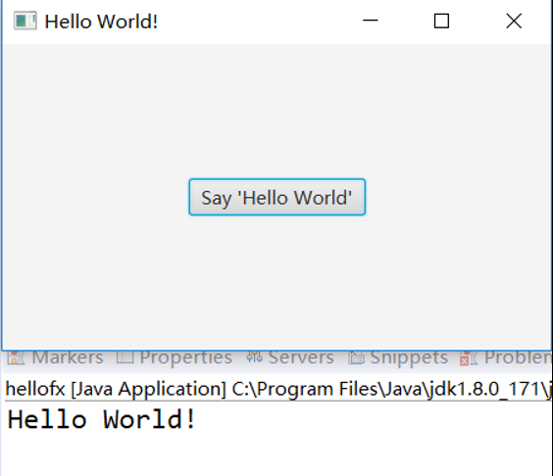
prompt:
Set the button event and assemble the scene, button, stage and other parts in turn.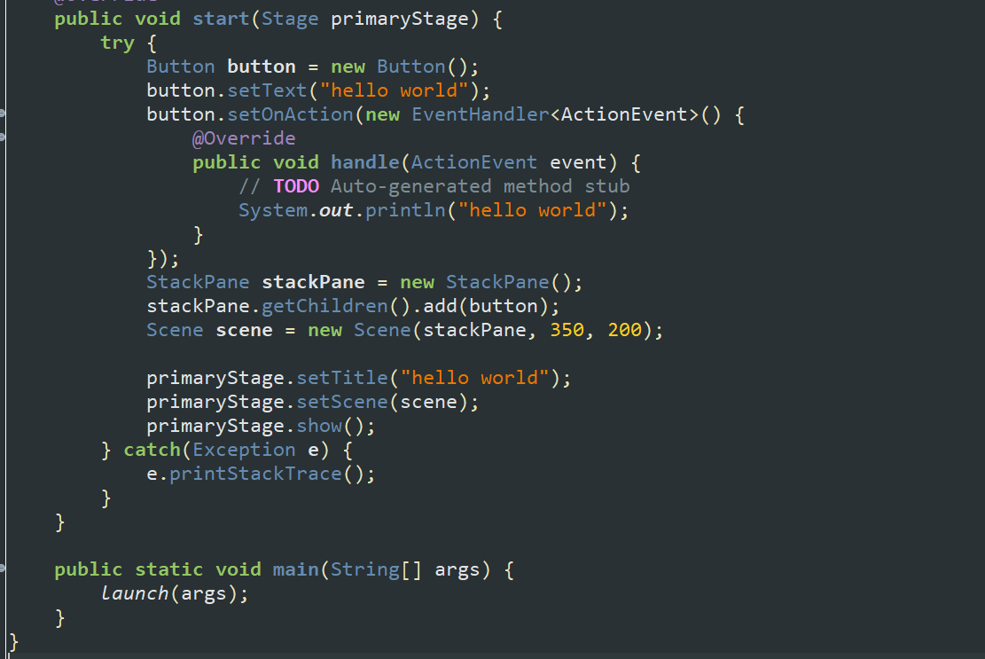
Note: StackPane: It is a card layout similar to the previous CardLayout, that is, the content behind it will be displayed on the previous content.

Exercise 2:
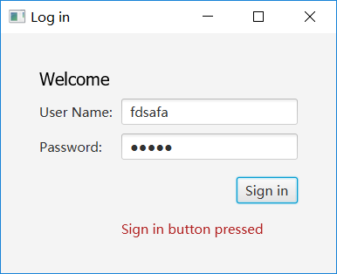

Idea hint:
On the basis of Exercise 1, follow the idea of the last lab8 experiment 2, put the text, label, textfield, password field and other components into the GridPane (because the GridPane can create a two-dimensional row and column grid), then the gridPane After resizing, add it to the scene and set the scene to stage. 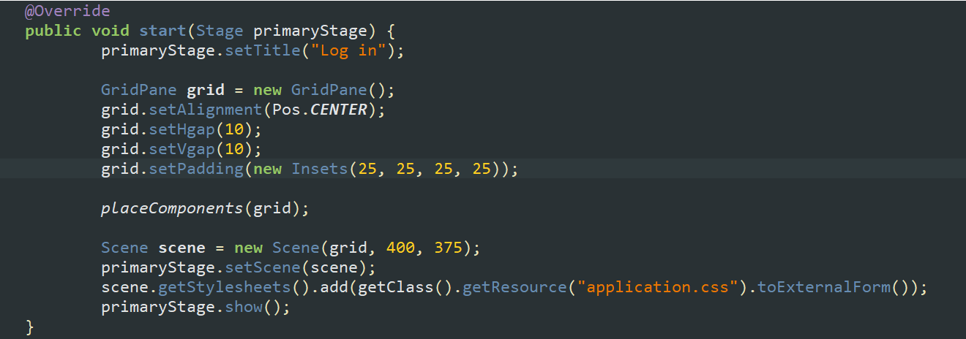
Place other components in turn into the GridPane:
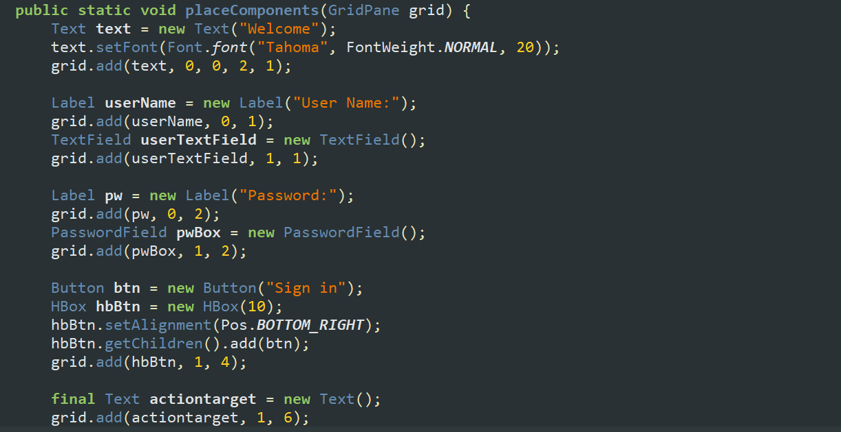
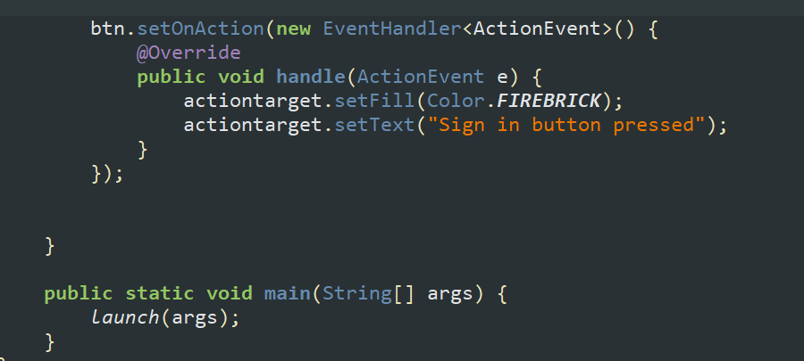

[Optional] Exercise 3:
On the basis of Experiment 2, install JavaFX Scene Builder, implement Experiment 2 in graphical coding, and compare the advantages and disadvantages of graphical coding and coding.
See the tutorial for specific installation steps:

https://www.yiibai.com/javafx/install-javafx-scene-builder-into-eclipse.html
Create a new fxml document in the javaFx project, and right-click on Open with Scene Builder in the fxml file. This will open the graphical editing interface.

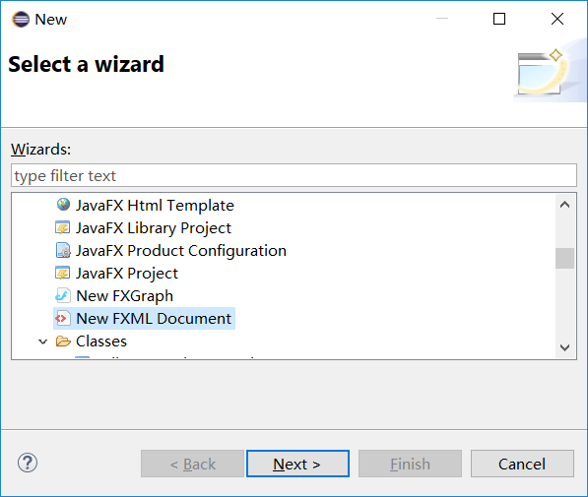

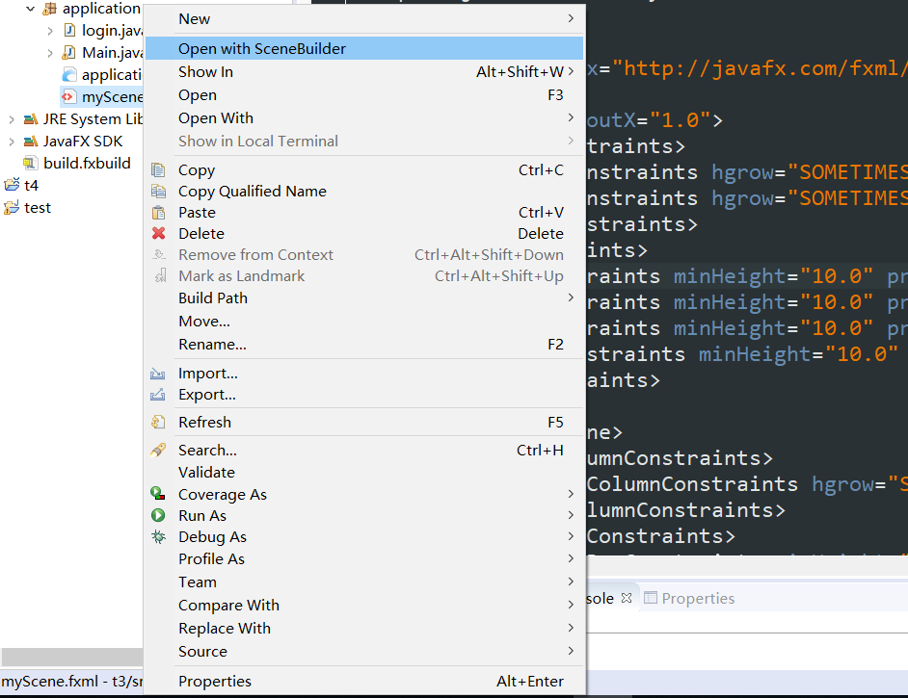
Simply add each component in turn and assemble it.
