Black Jack 21
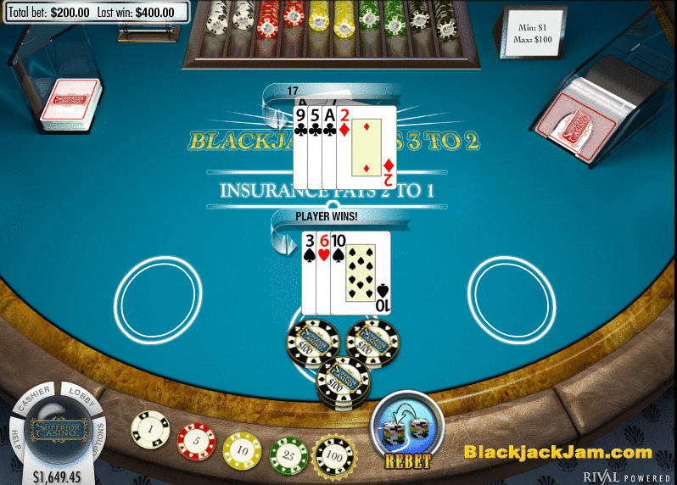
ABSTRACT

Blackjack, commonly known as Twenty-one or Pontoon, is one of the most popular and widely played casino games in the world along with poker, roulette and craps. Much of blackjack's popularity is due to the mix of chance with elements of skill, and the publicity that surrounds card counting(keeping track of which cards have been played since the last shuffle). The goal of our final project was to examine the expected payoff and risk of Blackjack strategy as well as to design a powerful card counting strategies using any of the suitable programming language (we used Java programming).It also gave us a very good idea of socket design, GUI’s development and Implementation of Fault Tolerance. Using socket programming, we implemented Blackjack in java that includes both the Server and the Client side. A perfect design of the project gave us the chance to get the taste of the ideas of some core concepts of socket programming, Client-server interaction, Threads and concurrency handle etc. Besides, the Database System helps us with storing logs on all ongoing transactions. With a multi-client environment, most of the blackjack allows multiple players to compete with the dealer.

Table of contents
1. Introduction | 5
2. Game description  2.1 What if we get Blackjack right away?  2.2 Blackjack terms  2.3 Surrender Blackjack, a variation of the basic game of Blackjack  2.4 Federal Pontoon Payout Odds | 6  8  8  10  10
3. Blackjack Flowchart | 11
4. Fault Tolerance  4.1 Replication  4.2 Replication Manager | 14  15  16
5. Program requirements: | 17
6. How the client and server work?  6.1 Pseudocode | 19  20
7. Diagrams  7.1 Class Diagram  7.2 Sequence diagram  7.3 Use case diagram | 21  21  23  24
8. Class Structure | 24
9. Algorithm & discussion  9.1 BlackJack Server  9.2 Shuffling  9.3 Replication  9.4 Fault Tolerance  9.5 Using Socket | 27  27  28  29  31  32
10. Storing Data | 35
11. Instructions on how to run the program | 37
12. Screenshots | 38
13. Conclusion | 41
14. References | 42

- Introduction

Blackjack is a card comparison game between a player and dealer and played with deck of 52 cards. The players are dealt with an initial two cards in hand with the option of drawing cards to bring the total value to 21 or less without exceeding it, so that the dealer will lose by having a lesser hand than the player or by exceeding 21.

We developed a Blackjack simulation program to run and test various strategies. The program allowed options to see what happens when multiple decks are used, when multiple players are at the table, and when players quit after attaining a certain amount of winnings.

We have used Java platform, Eclipse IDE and MAC operating system to develop the overall project. java.awt toolkit provides us with a very nice graphical environment. In the first, phase we have developed the blackjack table, designed the card, set shuffling algorithm. We then created one server and clients.

Before we proceedwith the design details, we should have a clear idea of how the Blackjackgame actually works. The next section gives us a brief idea of the game.

- Game description
Blackjack is a card comparison game between a player and dealer. The objective for the player is to draw cards that total 21 or come closer to 21 than the dealer. All cards count at face value, except for the King, Queen and Jack which countas 10, and the Ace which counts as either 1 or 11, your choice.

The dealer starts the game. Every player gets two cards, face-up. The dealer gets two cards, but one card is face-up and one facedown—the “hole” card. Only after all players’ hands are played does the dealer look at the hole card and play the dealer’s hand. All cards are dealt from a shoe.

Once you have your two cards in front of you, you can choose to “stand” (draw no more cards), or take a “hit” (draw one or more cards) until you reach 21 or come as close as possible. However, if you go over 21, you “break” and automatically lose. A winning hand pays even money.

Now the dealer turns over the “hole” card and acts on the hand according to the rules of the game. The dealer must draw to 16 and stand when 17 or more is reached. At the end of the game, if your count is the same as the dealer’s, it is a “push” (nobody wins). If the player count is greater than the dealer’s but does not exceed 21, or the dealer’s count exceeds 21, the player wins.

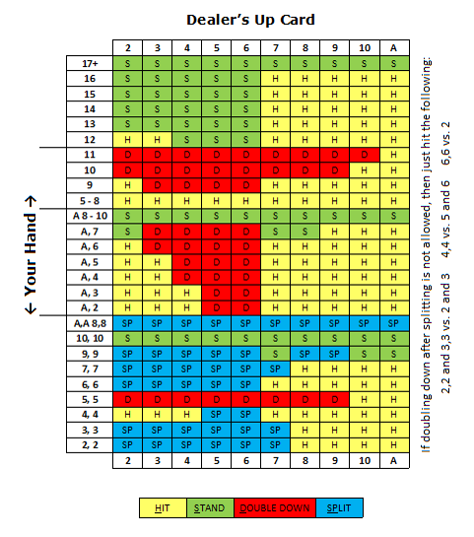

The above is a basic strategy table for the most common 6-to-8 deck, Las Vegas Stripe rules. Specially dealer hits on soft 17, double after split allowed, multiple split aces, one card to split aces and Blackjack pays 3:2.
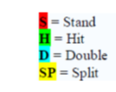
2.1 What if we get Blackjack right away?

In the event your first two cards are an Ace and any ten-value card, the dealer announces your hand as blackjack. You will be paid at this time if the dealer does not have an Ace or ten-valuecard as a face-up card. However, if the dealer’s face-up card is an Ace or a ten-value card, you will not be paid until the dealer’s hole card is turned over. If the dealer’s hand is blackjack, it is a push. A player’s winning blackjack is paid off at odds of 3 to 2.

In the event the player has blackjack (2-card 21) and the dealer draws to 21, the blackjack is the winning hand and will be paid at odds of 3 to 2. In the event the player draws to 21 with more than 2 cards, the dealer’s blackjack is the winning hand.

2.2 Blackjack terms:
Splitting Pairs– If your first two cards are a pair with the same numerical value, you may split them into two hands. You must bet the same amount as your original wager on each hand formed by splitting a pair. If the dealer gets blackjack, only the original wager is collected. You must complete the play onyour first hand before playing your second hand. However, you may double down on each hand. If the split pairs are Aces, you will receive only one card on each. Pairs or cards with the samenumerical value may be split three times (except Aces) for a total of four hands.

Doubling Down– After you get your first two cards, you may make an additional wager up to the original amount except when your first two cards total 21. When doubling down, you draw only one additional card. If the dealer gets blackjack after you’ve doubled down, only the amount of the original wager is collected.

Insurance – If the dealer’s face-up card is an Ace, you may take insurance. To do this you place a bet—no more than one-half your original bet—on the insurance line. If the dealer’s hole card is a 10, Jack, Queen or King, you win your insurance bet odds of 2 to 1. If the dealer’s hole card is any other card, you lose your insurance bet. The dealer collects all losing insurance wagers before continuing the hand.

Even Money– When a player has blackjack and the dealer's face-up card is an Ace, you may choose to be paid even money for the blackjack in lieu of taking insurance.

Handling of Cards– Players are not allowed to touch the cards.

Value of Player's Hand– The player is responsible for the correct count of his or her hand.

Hand Signals– The player is responsible for the proper use of hand signals to indicate hit or stand. Other decisions may be made verbally.

Resplitting of Pairs – A player may split pairs up to three times(total of four hands). Aces may only be split once for a total oftwo hands.
2.3. Surrender Blackjack, a variation of the basic game of Blackjack:

As a player’s point total is announced, after the first two cards have been dealt, he/she may elect to discontinue play of his/ her hand for that round and surrender only one-half of his/her wager. If the first card dealt to the dealer is an Ace, King, Queen, Jack or 10, the dealer will place the wager of the player wishing to surrender on top of the player’s cards. If the dealer’s second card results in a dealer blackjack, the player’s entire wager will be collected by the dealer. However, if the dealer’s second card does not result in a dealer blackjack, then one-half of the layer’swagers will be returned to the player.Various side wagers may be offered on Blackjack.

2.4 Federal Pontoon Payout Odds:
1. Winning wagers made in accordance with Rule. Wagers shall be paid at the odds shown below:
PAYOUT ODDS
Result | Odds
Pontoon | 3 to 2
5 Cards Totaling 21 | 3 to 2
6,7,8 Mixed Suits | 3 to 2
7,7,7 Mixed Suits | 3 to 2
6 Cards Totaling 21 | 2 to 1
6,7,8 Same Suits, except Spades | 2 to 1
7,7,7 Same Suits, except Spades | 2 to 1
7 or More Cards Totaling 21 | 3 to 1
6,7,8 All Spades | 3 to 1
7,7,7 all spades | 3 to 1
All Other Winning Wagers | 1 to 1

2. Super Bonus Payouts will be paid according to Table 2, at the completion of the hand and before the cards are collected.
SUPER BONUS
Super Bonus  7,7,7 same suit and Dealer first card any 7 | $1,000 if bet $2 to $24  $5,000 if bet $25 or greater
- Blackjack Flowchart
There are three basic shapes you need; the diamond, the rectangle and the arrow. The diamond is a decision block. A rectangle is just an operation block. The arrows then simply connect all the blocks together to define how the program will flow.
For Blackjack there are four distinct flowcharts. 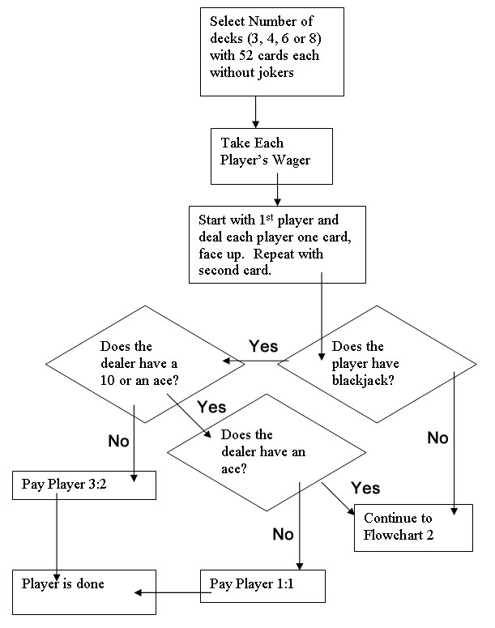
Figure1: Flowchartto covers the initial setup and deal.

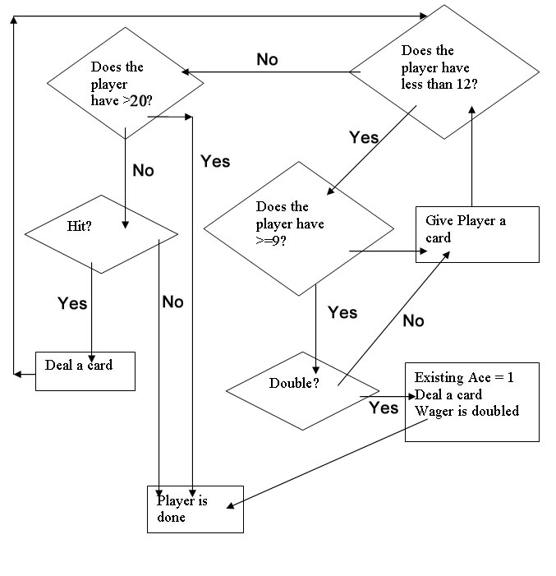
Figure2:Flowchart to covers the logic behind what options a player has.

In the official casino blackjack rules you may have noticed the ability to take out “insurance” on a hand. Note that we don’t deal with the player going over 21 at this point. We will handle that later
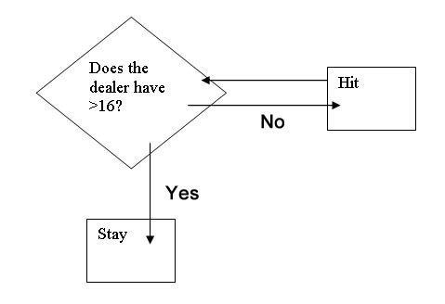
Figure3: Flowchart to see whether A dealer must hit or not.

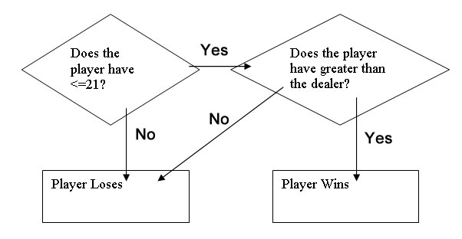
Figure4: Flowchart to check all the players to see if they won or lost.

- Project architecture:
One of the most desirable properties of a distributed computing system is its potential capability of tolerating system component failure. In an idealistic view, if a component of fault-tolerant system fails, another one takes over and resumes processing. This system configuration would ideally be completely invisible from outside the system.Servers can be fault-tolerant through replication and checkpointing technologies in the client server model.
A client is initially connected to a primary server. The primary server normally handles all of the client's transactions. However, a secondary connection is designated to a backup server, whereby if the primary server ever becomes disabled; the client is automatically switched over to the backup server and start working with the last recorded state.
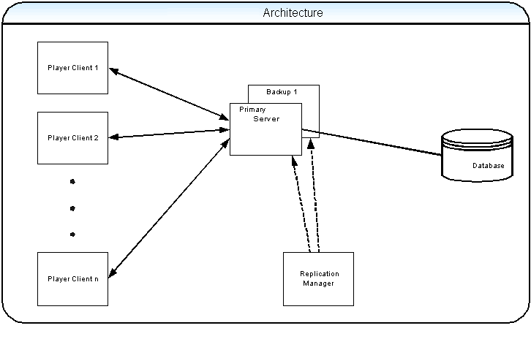
Figure5: System architecture for fault tolerance

Fault tolerance steps work as follows:
A client computer for running an application
Establishing a connection from a client computer to a primary server computer;
Storing connection information for connecting the client to the backup server;
The client periodically polls the primary server to Determining whether the primary server is disabled, wherein if the primary server becomes disabled:
A) Establishing a connection from the client to the backup server;
B) Submitting the card transaction information to the backup server;
C) Completing the card transactions on the backup server;
D) Routing subsequent transactions from the client to the backup server for processing.

4.1 Replication:
For Fault Tolerance following information should be preserved under a single serverfailure:
- The players’ current cards.
- The players' bets.
- The dealers' current cards.
- The dealers' bet.
- The current request to hit or stay from players.
- Information of the players.
This information can be saved in multiple servers through replication. Replication is one of the most widely studied, important and implemented phenomena in adistributed environment. Replication is a strategy in which multiple copies of some data arestored at multiple sites. Some reasons that have made Replication so popular are itsincreased availability, performance and enhanced reliability. Storing andreplicating data at more than one site, implements and supports fault tolerance and hence increase availability. At the same time, as the data is stored at multiple sites, the requestcan find the data close to the site where the request originated, thus increasing theperformance of the system.

But the benefits of replication, of course, do not come withoutoverheads of creating, maintaining and updating the replicas. If the application has read-onlynature, replication can greatly improve the performance. But, if the application needsto process update requests, the benefits of replication can be neutralized to some extent bythe overhead of maintaining consistency among multiple replicas.

4.2 Replication Manager:

- Responsible for server availability notification and recovery
- Server availability notification
  - Server notifies Replication Manager during boot.
  - Replication Manager pings each available server periodically.
- Server recovery
  - Process fault: pinging fails; reboot server by sending script to machine
  - Machine fault (Crash fault): pinging fails; sending script does nothing
- Client-RM communication
  - Client contacts Replication Manager each time it fails over
  - Client quits when Replication Manager returns no server or Replication Manager can’t be reached.

- Program requirements:

Baseline Application Description:It’s an online fault-tolerant, real-time, high-performance gaming application where users play Blackjack and store his/her information in a database

Configuration:
- Operating system - Unix
- Language – Java
- Software - Eclipse

Third-party software:
- mySQL

Baseline Application Features:
- Allows a player to play Blackjack and place bets.
- Allows a new player to create his/her profile.
- Allows players to store/retrieve their information.

Reliability Requirements:
- Preserves on-going game details under a single server failure.
- Preserves on-going game details and waits with a timeout under a client failure. (timeout: 3-5 min)
- Preserves details of on-going transaction under a single server failure.

Real-Time Requirements:
- After each Blackjack game, the user's account information will be updated in database, and it should take no more than 3 seconds to start the next game.
- User retrieves existing profile within 1 second of requesting retrieval.
- Upgraded version of Party Blackjack should allow multiple numbers of players per table with each player able to view other players' action within at most 500 ms after a particular action.

Performance Requirements:
- Server handles up to 10 tables with 1 player per table (for baseline)
- Later, server should handle up to 10 tables with multiple player per table (possibly 6 players per table)
- Database can store profiles up to 500 players.

- How the client and server work?
- Client-RM and Client-Server communication
  - Client contacts Replication Manager each time it runs out of servers to receive a list of available servers.
  - Client connects to all servers in the list and makes a host beans in them, then starts the application with one server
  - During each failover, client connects to the next server in the list.
  - No looping inside list
  - Client quits when Replication Manager returns an empty list of servers or Replication Manager can’t be reached.

6.1 Pseudocode:
The pseudocode for the client and looks as follows:
Client:
while( user does not exit )
check for user input
send commands to the server
receive updates about the game from the server
draw graphics
end
Server:
while( true )
check for client commands
run command
move all entities
send updates about the game to the clients
end

If player does not have blackjack and if it's first time, give 3 choices as below. If 2nd time or more, give only b) or c) choices
a) Start
b) Hit
c) Stay

- Diagrams
7.1 . Class Diagram
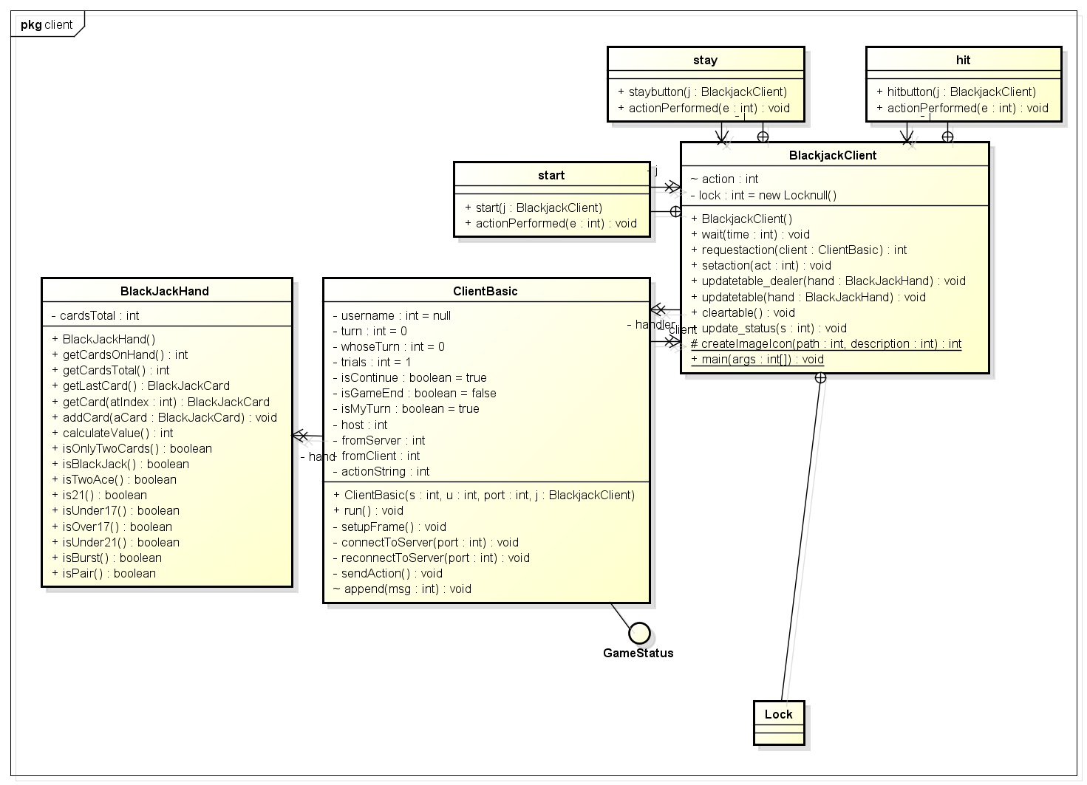
Figure6: Client Class Diagram
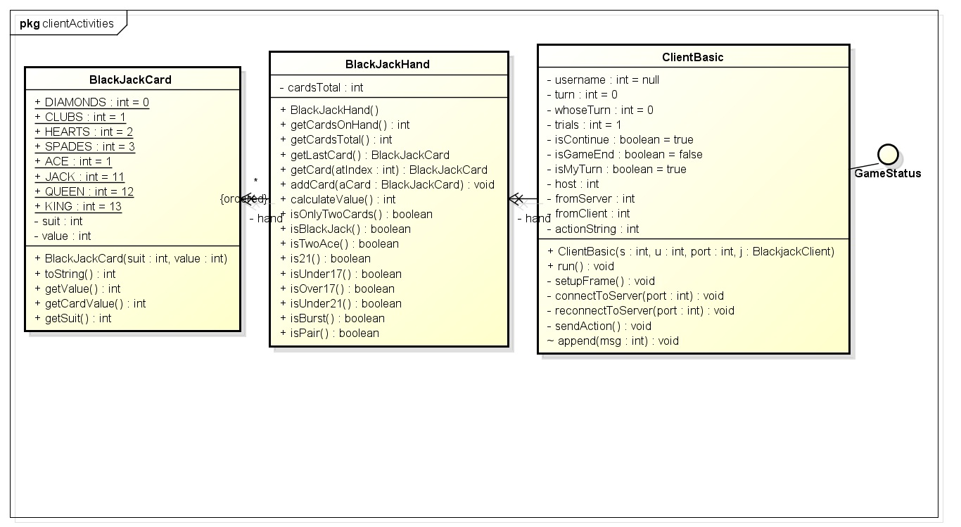
Figure7: Client Activity class diagram
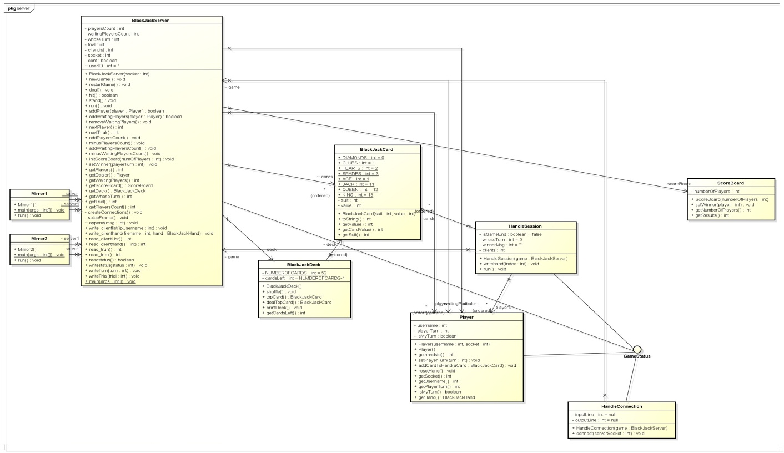
Figure8: Server class diagram
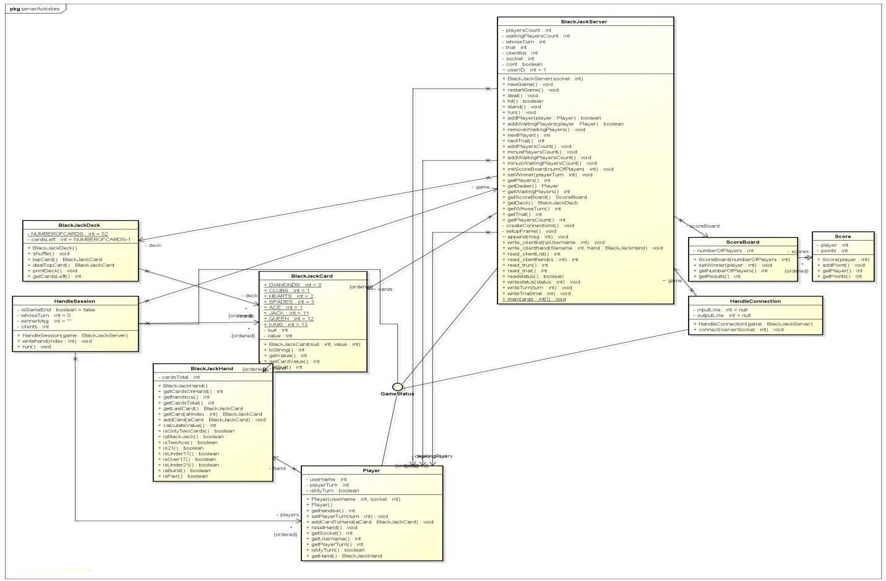
Figure9: Server Activity class diagram
7.2. Sequence diagram:

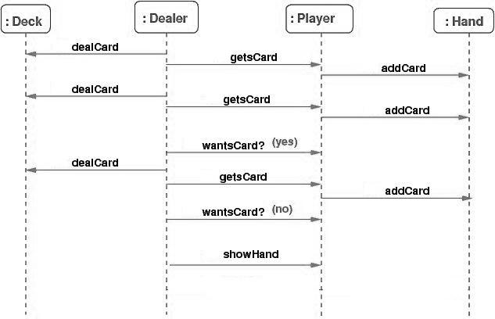
Figure10: Blackjack Sequence diagram

7.3 Use case diagram:

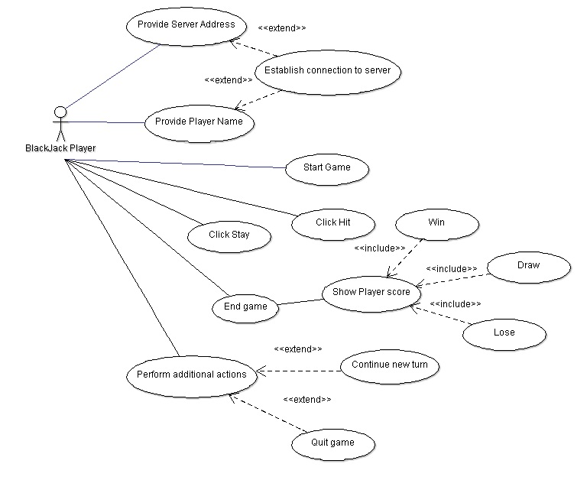
Figure11: Use case diagram of Blackjack

- Class Structure:
client package
BlackjackClient.java
This class holds information regarding the client communication end. It has main method that initiates the clients and sockets

ClientBasic.java
This class is responsible mainly for the GUI. Set of card(2 cards) appear on the screen of every player and unopened cards for dealer

clientActivities package
ClientCard.java
Numerical value is assigned to each suit diamonds, clubs, hearts and spades (1 to 4) and for card number(1 to 13).

ClientHand.java
Initializes BlackJackHand with no card and an empty "hand" vector. Calculates values of the BlackJack with various values for ACE according to condition

Status.java
Initializes BlackJackHand with no card and an empty "hand" vector. Calculates values of the BlackJack with various values for ACE according to condition

server package
BlackJackServer.java
This class consists of main method from where the execution starts for the server section.

ManageConnection.java
This class accepts the players that are trying to connect to the server and add them to the waiting Pool in game

ManageSession.java
This class is responsible for handling the game sessions between client and server. It has socket connection and maintains communication between the players via socket.

Mirror1.java
Replica of server responsible for fault tolerance and maintaining transparency.

Mirror2.java
Replica of server responsible for fault tolerance and maintaining ransparancy.
serverActivities package
BlackJackPlayer.java
It holds the information related to players like username,turns,cards in hand and designation of player.

BlackJackScore.java
It holds the information related to Identification of Player and his/her total points.

BlackJackScoreBoard.java
It is responsible to maintain aggregation of scores. Score holds the information regarding player and respective score.

BlackJackStatus.java
It defines Game parameters like Maximum number of player,Maximum number of trials.

Card.java
Numerical value is assigned to each suit diamonds, clubs, hearts and spades (1 to 4) and for card number(1 to 13).

Deck.java
It initializes the deck by adding in all the cards and, defines all the cards possible in playing cards with aggregation of card class i.e. BlackJackCard

Hand.java
Initializes BlackJackHand with no card and an empty "hand" vector. Calculates values of the BlackJack with various values for ACE according to condition

- Algorithm & discussion:

9.1. BlackJack Server:
BlackJackServer is the main class for rinning server. When a server starts this the main thread run all the time to communicate with the client and other server for making replication. A part of server code is given below,

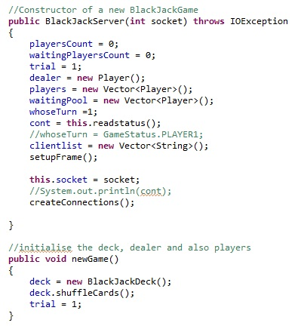

9.2. Shuffling:
Shuffling is a procedure used to randomize a deck of playing cards to provide an element of chance in card games. Shuffling is often followed by a cut, to help ensure that the shuffler has not manipulated the outcome. The shuffle algorithm does the opposite of what sorting, destroying any trace of order that may have been present in a List. That is, this algorithm reorders the List based on input from a source of randomness such that all possible permutations occur with equal likelihood, assuming a fair source of randomness. Here first we have taken all the cards in vector named cardDeck.

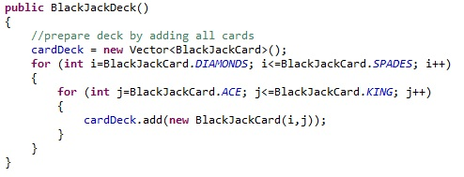
Java collection class give the facility to shuffle the vector. Here the code for shuffling,
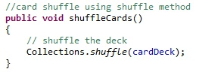
From the shuffled card we are taking the top card from the card deck. The top most card is then one after one to all player as well as dealer.

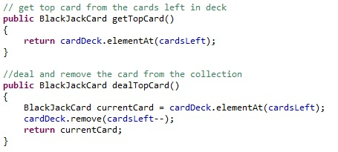

9.3. Replication:
In each game server by handle session save the player’s information, their hands (which cards they have), dealer’s cards, usernames and their IPs, their turn and which trail is in this Game. For each game this information will be update by reset code and servers share this file so For replication when the 1st server fails the second server read the sharing flat files. Also for each user that plays the BalckJack game when he/she login to the server and enters his /her IP in the server it creates one file with the name of the user. The first file is continue.txt the contain yes or no if yes it means that the game is ongoing and if no it means that the game was done at the last trail, The second file is trail file that game is in which trail, the nest step is reading the Iplist file that contains usernames and IP address of users so the server knows which users are playing in his game and then read the turn file to see whose turn is it when the clients connect to the server 2,the server to looks at turn text file and sort it depends on their username and then the game will keeping on. In the replication process in the client side client as a thread creates another thread and puts the parent thread on wait for the transparency

The replication action is performed using the below given method. When an action event occur it stores to action as well as the game status in the replication server.

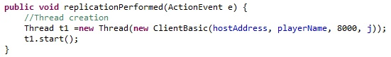

9.4. Fault Tolerance:
The ability of a system to respond gracefully to an unexpected hardware orsoftware failure. There are many levels of fault tolerance, the lowest being the ability to continue operation in the event of a power failure. Many fault-tolerant computer systems mirror all operations -- that is, every operation is performed on two or more duplicate systems, so if one fails the other can take over.
In this project we have used two different machines as server to manage the fault tolerance. We have used two different classes Mirror1 and Mirror2 to perform the operations. Mirror1 is connected with the main server.
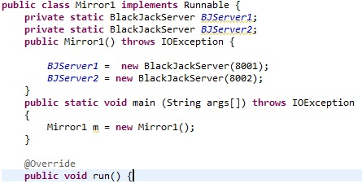
When Mirror1 become fail for any reason then Server ask Mirror2 to take control. Mirror2 then handle all the operations without creating any interruption.
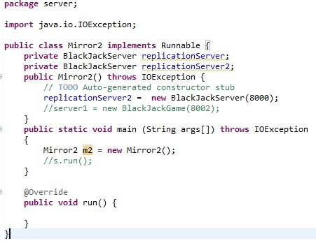

9.5. Using Socket:
Socket class isused for handling TCP connections in Java. Socket can be used as a data source for astream. Network socket is an endpoint of an inter-process communication flow across acomputer network. Most communication between computers is based on the InternetProtocol; therefore most network sockets are Internet sockets. Socket API is an application for programming interface (API), usually provided by the operating system, that allowsapplication programs to control and use network sockets. A socket address is thecombination of an IP address and a port number, much like one end of a telephoneconnection is the combination of a phone number and a particular extension. Based on thisaddress, Internet sockets deliver incoming data packets to the appropriate application process or thread.
This is a typical flow of events for a connection-oriented socket:
- The socket() API creates an endpoint for communications and returns a socket descriptor that represents the endpoint.
- When an application has a socket descriptor, it can bind a unique name to the socket. Servers must bind a name to be accessible from the network.
- The listen() API indicates a willingness to accept client connection requests. When a listen() API is issued for a socket, that socket cannot actively initiate connection requests. The listen() API is issued after a socket is allocated with a socket() API and the bind() API binds a name to the socket. A listen() API must be issued before an accept() API is issued.
- The client application uses a connect() API on a stream socket to establish a connection to the server.
- The server application uses the accept() API to accept a client connection request. The server must issue the bind() and listen() APIs successfully before it can issue an accept() API.
- When a connection is established between stream sockets (between client and server), you can use any of the socket API data transfer APIs. Clients and servers have many data transfer APIs from which to choose, such as send(), recv(), read(), write(), and others.
When a server or client wants to stop operations, it issues a close() API to release any system resources acquired by the socket.
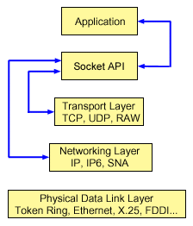
Figure12: Basic Socket Structure

Blackjack uses sockets to communicate between Client-Server and Client-Client. Here is part of code from client to send and receive data to and from server.
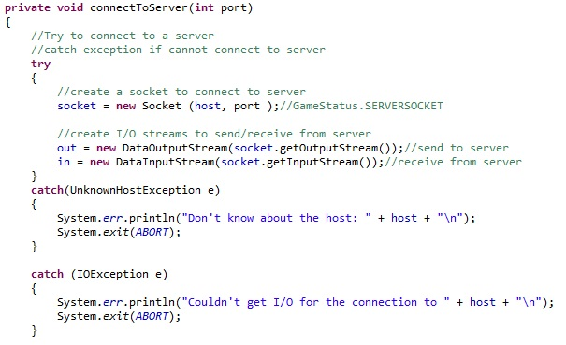

- Storing Data:
A database is an organized collection of data. The data is typically organized to model relevant aspects of reality in a way that supports processes requiring this information. In this project we have used MySQL to store and retrieve data. MAMP is used for managing MySQL. Here the methods from Database Connection class give the facility to collect data which are generated by both server and client and stores all of them in in server side only. When a new game starts it stores the game start time and participating players in userList table. In card table all players hand cards is stored based on the card type and value. For example if the card is spade then it stores card type 0 and if the value is K it stores 13 as card value. A portion of code for storing data into userList is given below,

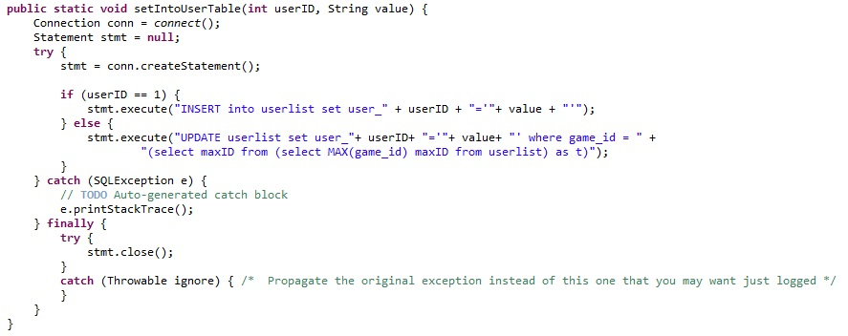

The stored data for userList shows like this,
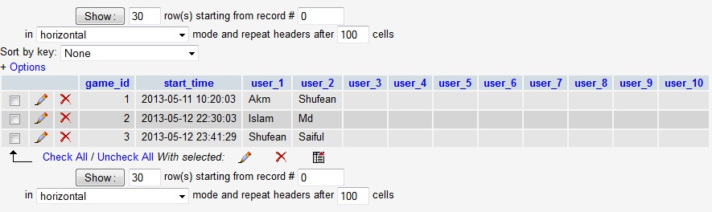
Figure13: Database structure showing userList table
Below given image shows the card table data collected from the user hand.
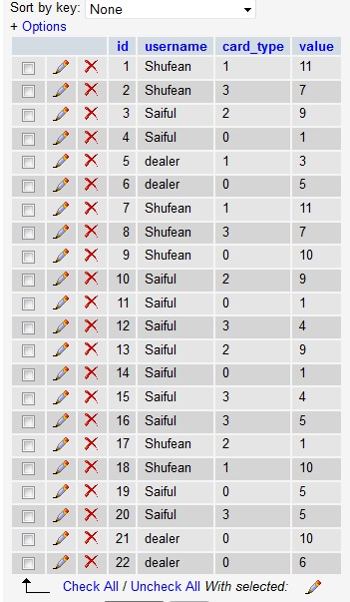
Figure14: Database structure showing card table
- Instructions on how to run the program:

- First use Eclipse IDE and import the project to workspace.
- Then run BlackJackServer.java to manage replications and communicate with clients.
- Then run Mirror1.java as main server.
- Then run Mirror2.java as replication server.
- In client side first run BlackjackClient.java to run the client which provide a graphical user interface to the user.
- Then enter the IP address of the main server.
- Then enter the username name of the player.
- When all the players are ready, click on Start
- Connect the second client in similar manner.
- After all the clients are connected each user will see his /her two cards in the screen.
- At this time all the user can see the dealer card in their game window.
- Hit and Stand button will be activated for only one user at a time.
- Play the game using Hit and Stand button
- Player is notified whether he/she has won or lost the game.
- Now, the 2nd trial gets started automatically.
12. Screenshots:
Inserting server address:
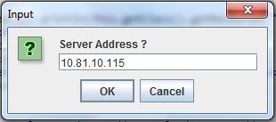
Inserting Player name:
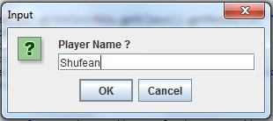
Game Initial Screen:
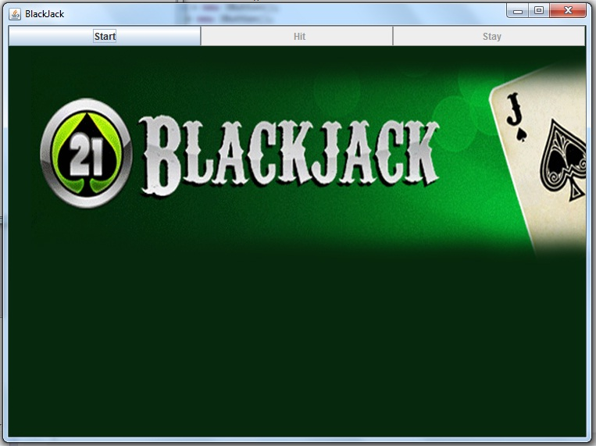
Player Starts a Game:
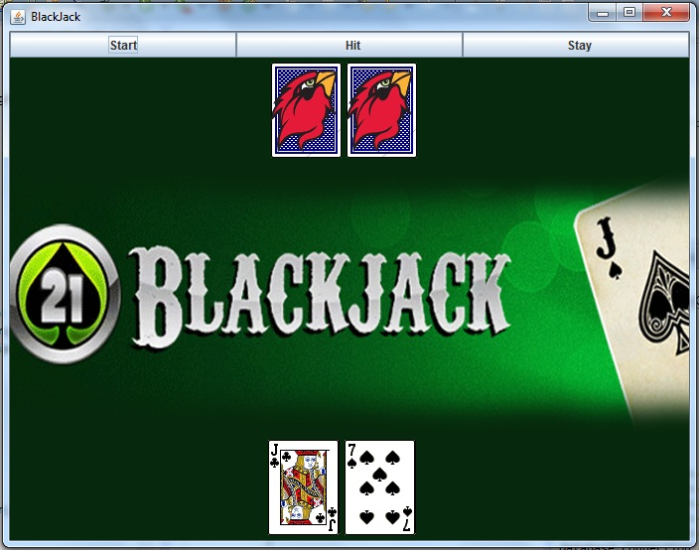

Showing Player Loses:
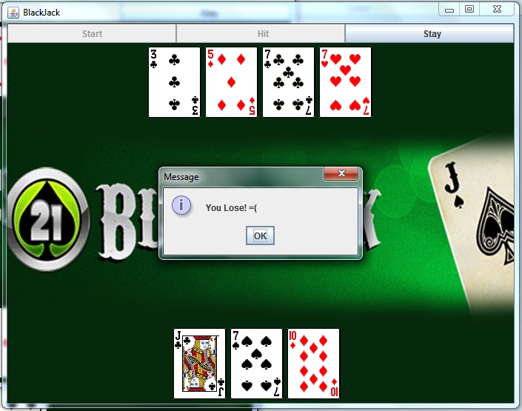
Showing Player Wins:
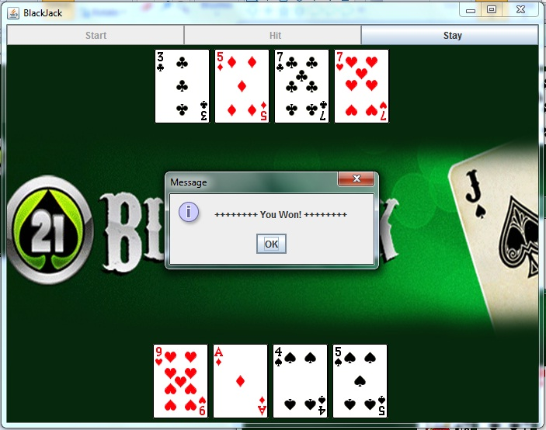
13. Conclusion:
Definition of the distributed system says that it’s the collection of independent computers that appear to its users as a single coherent system. To successfully implement the concept we need to know different architecture of the distributed system, need to know the concept of thread, client, server, code migration etc. This project gives us the primary knowledge of each of those concepts. Under Fault tolerance Client can automatically connect to the Replication server. As soon as any one server fails another one takes over and valuable data are preserved and with restart reloaded from the point of failure. Player profile is also created and their information is stored in MySQL Database System. Still there is lot more scope to make the game dynamic. In future we will implement multiple table servers and run it using thread. Selling bets from the dealer and Provision to let user decide how much amount to bet is another issue that we wish to take care in future. General chat window, where players can talk to each other, can be another idea that we can implement.

We are thankful to Dr. Osborne for providing us such an opportunity to work on such a great and real life project.

14. References:

- http://www.andrewthomas.org.uk/downloads/dissertaion_extract.pdf
- http://www.bsu.edu/libraries/virtualpress/mathexchange/01-01/conrad.pdf
- http://etd.lsu.edu/docs/available/etd-0709103-110308/unrestricted/Dutsch_thesis.pdf
- http://whiteknucklecards.com/blackjack/
- http://www.dkh.minfin.bg/images_content/Blackjack.pdf
- http://code.dawnofthegeeks.com/2009/04/30/blackjack-lesson-2-the-flowchart/
- http://www.casinoblackjack.org/blackjack/strategy/
- http://comscigate.com/JDJ/archives/0301/chen/
- http://www.ece.cmu.edu/~ece841/team5/
- http://www.ece.cmu.edu/~ece749/teams-06/team2/
- http://www.google.com/patents/US5796934
- http://stackoverflow.com/questions/811906/algorithm-for-client-server-games
- http://www.nntp.perl.org/group/perl.beginners/2008/06/msg101304.html

