# Springboot-learning

Git地址 <https://github.com/SpringForAll/SpringBoot-Learning.git>

页面地址 <https://github.com/SpringForAll/SpringBoot-Learning>

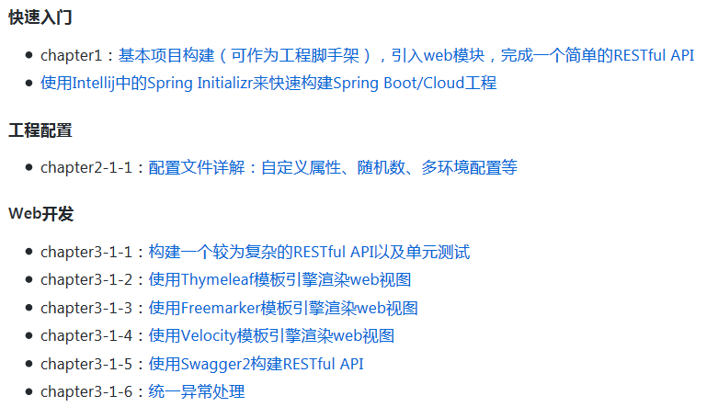

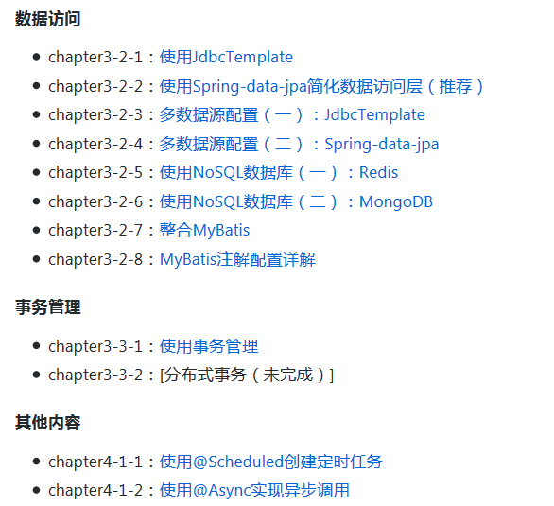

# springboot-examples

Git地址 https://github.com/ityouknow/spring-boot-examples.git

页面地址 https://github.com/ityouknow/spring-boot-examples

