**Abdulrhman Abdullah**

**(Vector Wind Forecast System)**

**MVP**

**10 Dec 2021**

The goal of this project is to forecast next hour wind direction based on last 48 hours’ data.

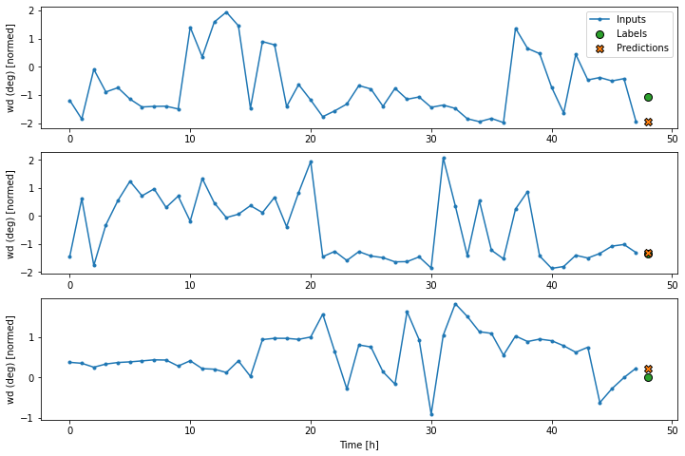

In the above plots of three examples the simple Based Line model is run over the course of 48 hours. This deserves some explanation:

* The blue Inputs line shows the input Wind direction at each time step. The model receives all features.
* The green Labels dots show the target prediction value. These dots are shown at the prediction time, not the input time. That is why the range of labels is shifted 1 step relative to the inputs.
* The orange Predictions crosses are the model's prediction's for each output time step. If the model were predicting perfectly the predictions would land directly on the Labels.

the baseline model returns the current wind direction value as the prediction, predicting "No change". This is a reasonable baseline since wind direction changes slowly.