-- 1. Berapa jumlah total trip valid pada Januari 2026
SELECT
SUM(total_trip) AS total_valid_trips
FROM gold.vw_daily_trip_summary
WHERE DATE_TRUNC('month', pickup_date) = '2026-01-01';
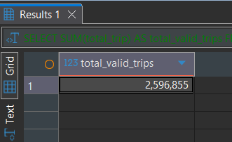

--2. Tanggal apa yang memiliki jumlah trip tertinggi?
SELECT
pickup_date,
total_trip
FROM gold.vw_daily_trip_summary
ORDER BY total_trip DESC
LIMIT 1;
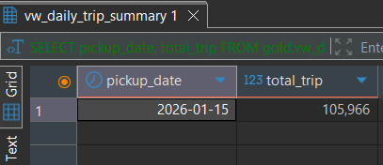

--3. Borough atau zone pickup mana yang memiliki jumlah trip tertinggi?
SELECT
borough,
zone,
total_pickup_trip
FROM gold.vw_zone_performance
ORDER BY total_pickup_trip DESC
LIMIT 1;
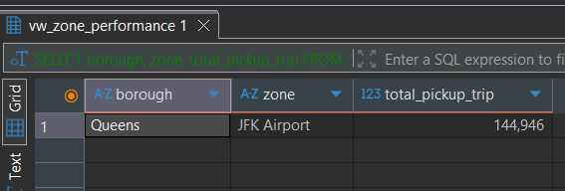
--4. Rute pickup zone ke dropoff zone mana yang paling sering terjadi?
SELECT
pickup_zone,
dropoff_zone,
COUNT(*) as total_trip
FROM gold.vw_trip_enriched
GROUP BY pickup_zone, dropoff_zone
ORDER BY total_trip DESC
LIMIT 5;
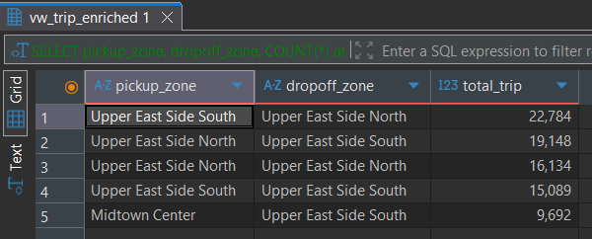

--5. Tampilkan data quality issue terbanyak berdasarkan error_type.
SELECT
error_type,
COUNT(*) as issue_count
FROM silver.data_quality_issues
GROUP BY error_type
ORDER BY issue_count DESC;
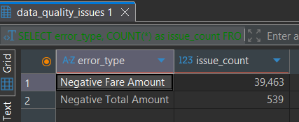
--6. Cari tanggal dengan pola data tidak wajar (trip count sangat rendah/tinggi dibanding rata-rata).
WITH daily_stats AS (
SELECT
AVG(total_trip) as avg_trip,
STDDEV(total_trip) as stddev_trip
FROM gold.vw_daily_trip_summary
)
SELECT
d.pickup_date,
d.total_trip,
ROUND(s.avg_trip, 0) as average_trip
FROM gold.vw_daily_trip_summary d
CROSS JOIN daily_stats s
WHERE d.total_trip > s.avg_trip + (2 * s.stddev_trip)
OR d.total_trip < s.avg_trip - (2 * s.stddev_trip);
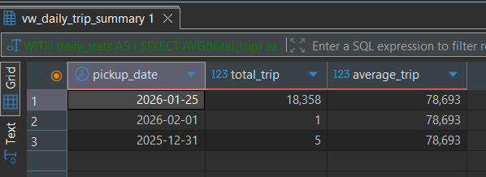
--7. Top 10 pickup zone berdasarkan revenue.
SELECT
zone,
total_revenue
FROM gold.vw_zone_performance
ORDER BY total_revenue DESC
LIMIT 10;
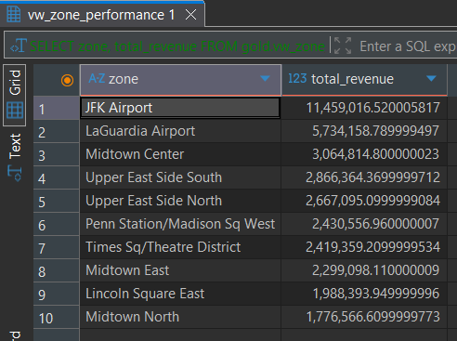
--8. Zone yang memiliki pickup tinggi tetapi average tip rendah.
WITH city_averages AS (
SELECT
AVG(total_pickup_trip) as city_avg_pickup,
AVG(average_tip) as city_avg_tip
FROM gold.vw_zone_performance)
SELECT
z.zone,
z.total_pickup_trip,
ROUND(z.average_tip::NUMERIC, 2) as average_tip
FROM gold.vw_zone_performance z
CROSS JOIN city_averages c
WHERE z.total_pickup_trip > c.city_avg_pickup
AND z.average_tip < c.city_avg_tip
ORDER BY z.total_pickup_trip DESC;
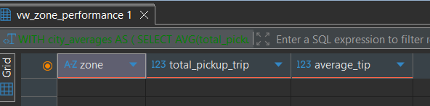
--9. Running total revenue per tanggal.
SELECT
pickup_date,
total_revenue,
SUM(total_revenue) OVER (ORDER BY pickup_date) AS running_total_revenue
FROM gold.vw_daily_trip_summary;
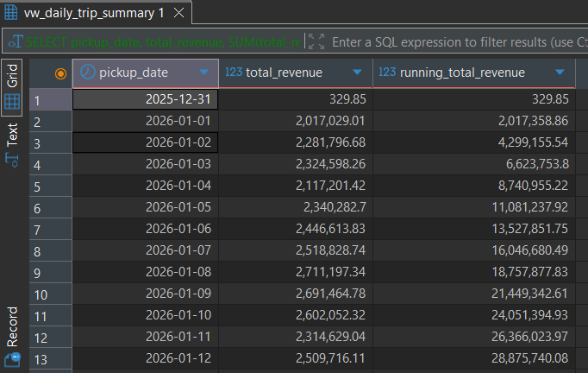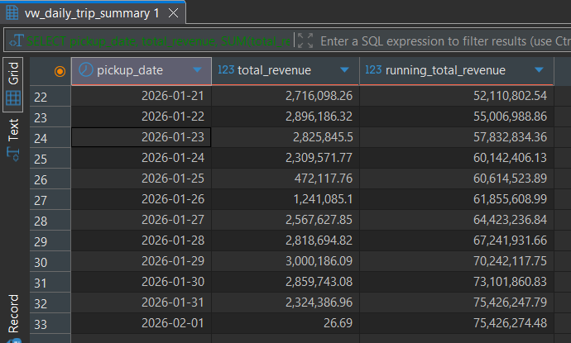

--10. Perbandingan revenue hari ini dengan hari sebelumnya menggunakan LAG.
SELECT
pickup_date,
total_revenue AS revenue_hari_ini,
LAG(total_revenue) OVER (ORDER BY pickup_date) AS revenue_kemarin,
total_revenue - LAG(total_revenue) OVER (ORDER BY pickup_date) AS selisih_revenue
FROM gold.vw_daily_trip_summary;
