Portfolio Management

**Cloud based solution for Service Portfolio Governance**

System Documentation

Document Revision History

|  |  |  |  |  |  |  |
| --- | --- | --- | --- | --- | --- | --- |
| **S.N.** | **Version** | **Date** | **Author** | **Reviewed by** | **Approved by** | **Description of changes** |
| 1 | 0.1 | 09/10/2019 | Adars |  |  | Initial Draft |
|  |  |  |  |  |  |  |

Table of Contents

1. Proposed Solution 4

2. Overview 5

2.1 Screen 1 5

2.2 Screen 2 6

2.3 Screen 3 7

2.4 Screen 4 8

2.5 Screen 5 9

2.6 Screen 6 10

## Proposed Solution

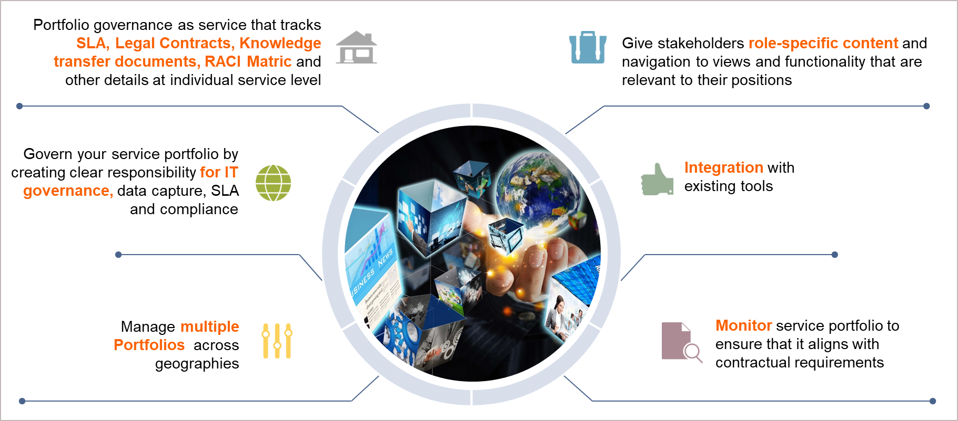

## Overview

### Screen 1

**Title Bar (Header)**: Will change dynamically based on user navigation.

**User Authentication and Access**

User from an OE O1 will have access only to the projects from O1

(This will be handled in second phase)

**Access Levels**

Users with access to multiple OEs

Users with no access restrictions

(This will be handled in second phase)

**OE Details**

OE details will be fetched from DB

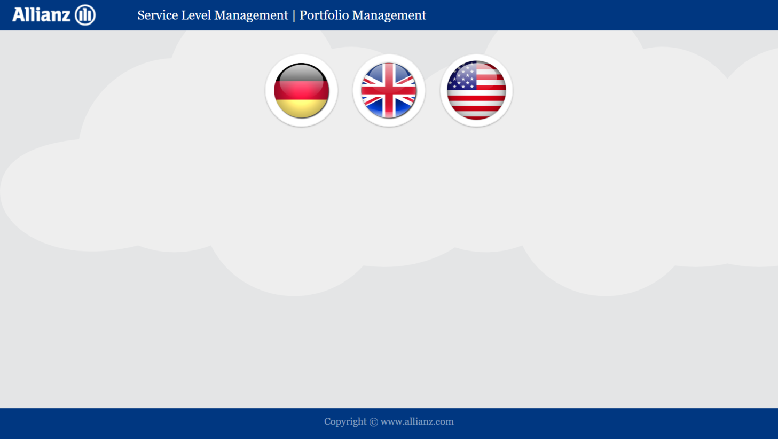

**List of OE**

### Screen 2

**Sub Level 1**

The screen will show the details grouped based on interest

e.g. 1 ABS and non ABS

e.g. 2 ADM and IFS

**Title Bar (Header)**: Will change dynamically based on the OE selected

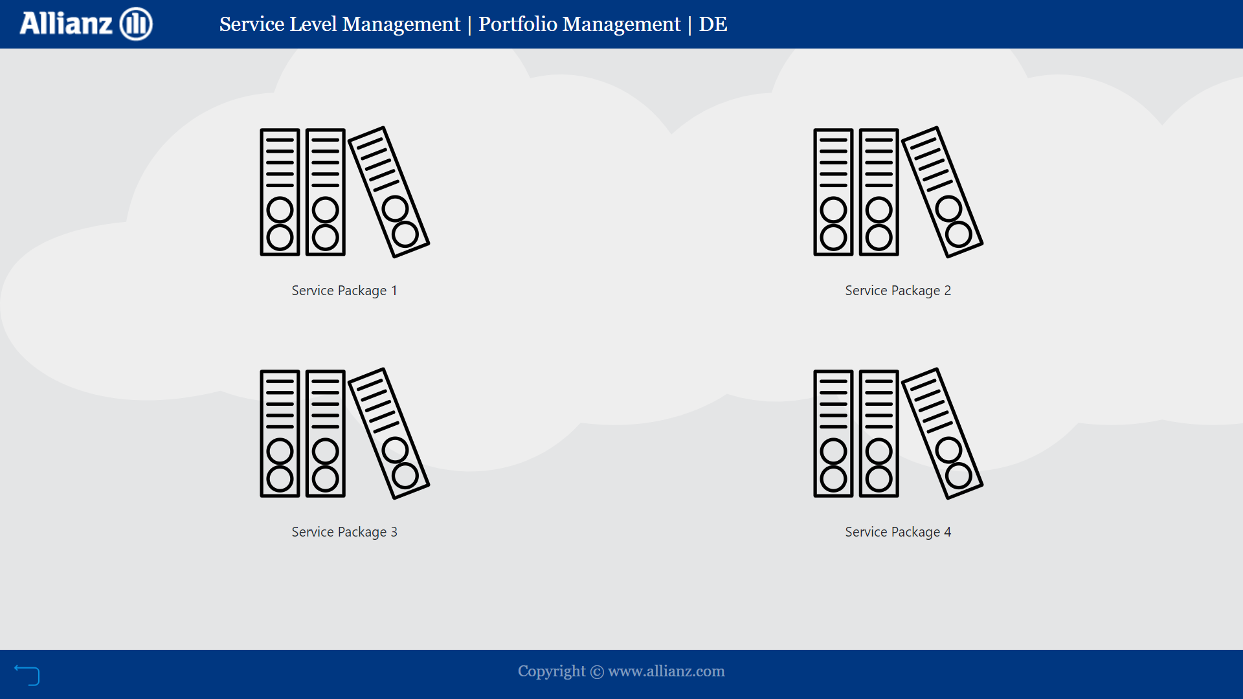

**Sublevel 1**

### Screen 3

**Sublevel 2**

**Sub Level 2**

The screen will show further details based on the selection from previous page

e.g. 1 List of all ABS projects

e.g. 2 List of all ADM projects

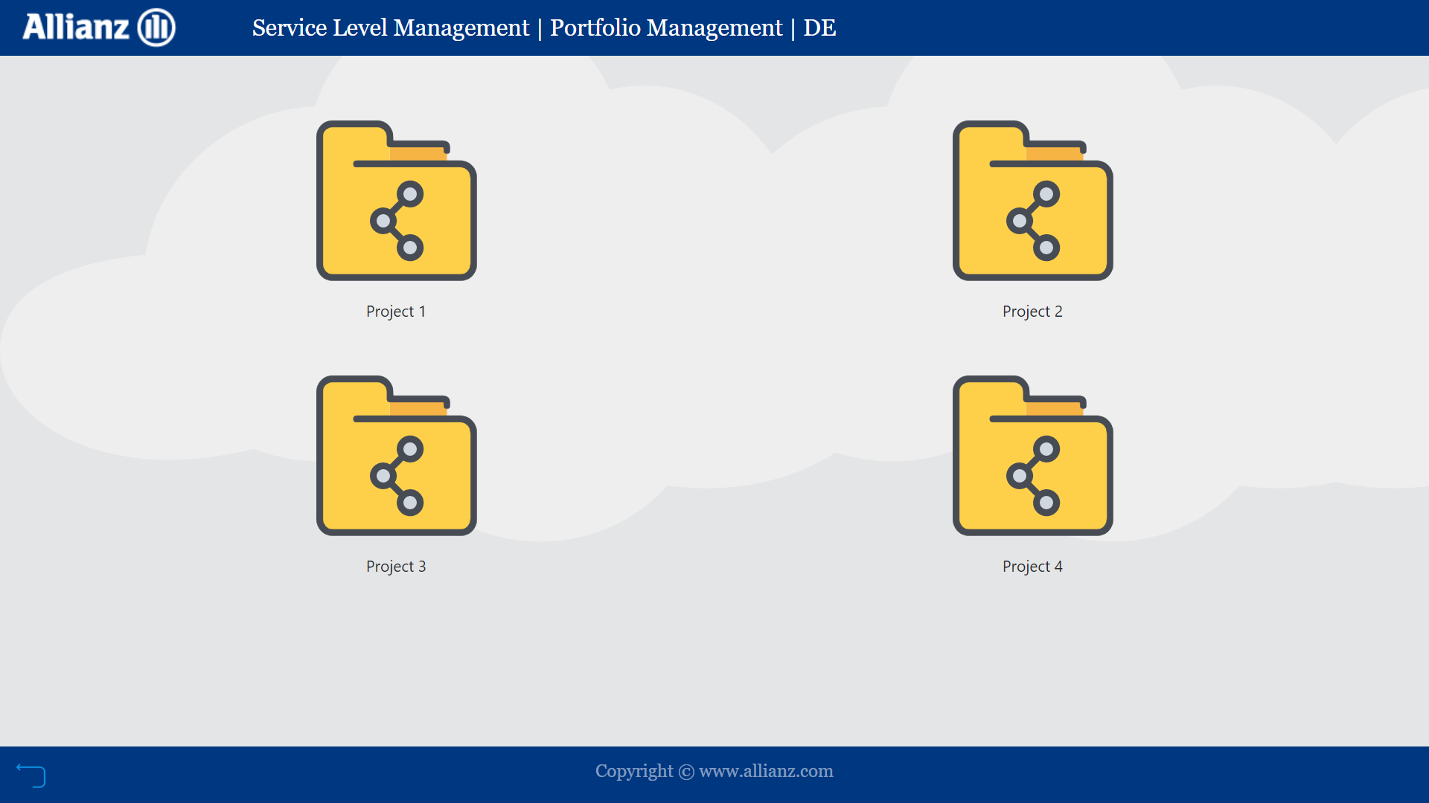

**Title Bar (Header)**: No changes from the last screen

### Screen 4

**Selector**: Link to page containing additional details like contract documents

**Table of details**: Individual team details

**Charts**: Based on the item displayed

**Summary**: Project Status

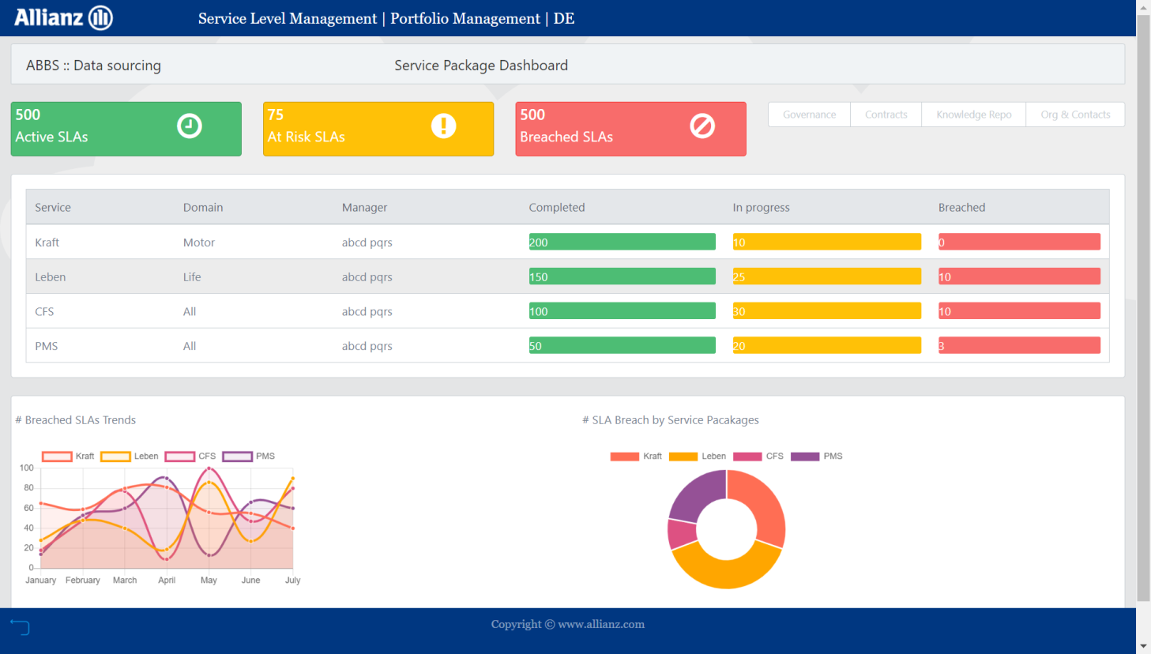

**Project summary**

**Title Bar (Header)**: No changes from the last screen

### Screen 5

**Labels**: Based on the item displayed

**Labels**: Based on the item displayed

**Labels**: Based on the item displayed

**Labels**: Based on the item displayed

**Team data**

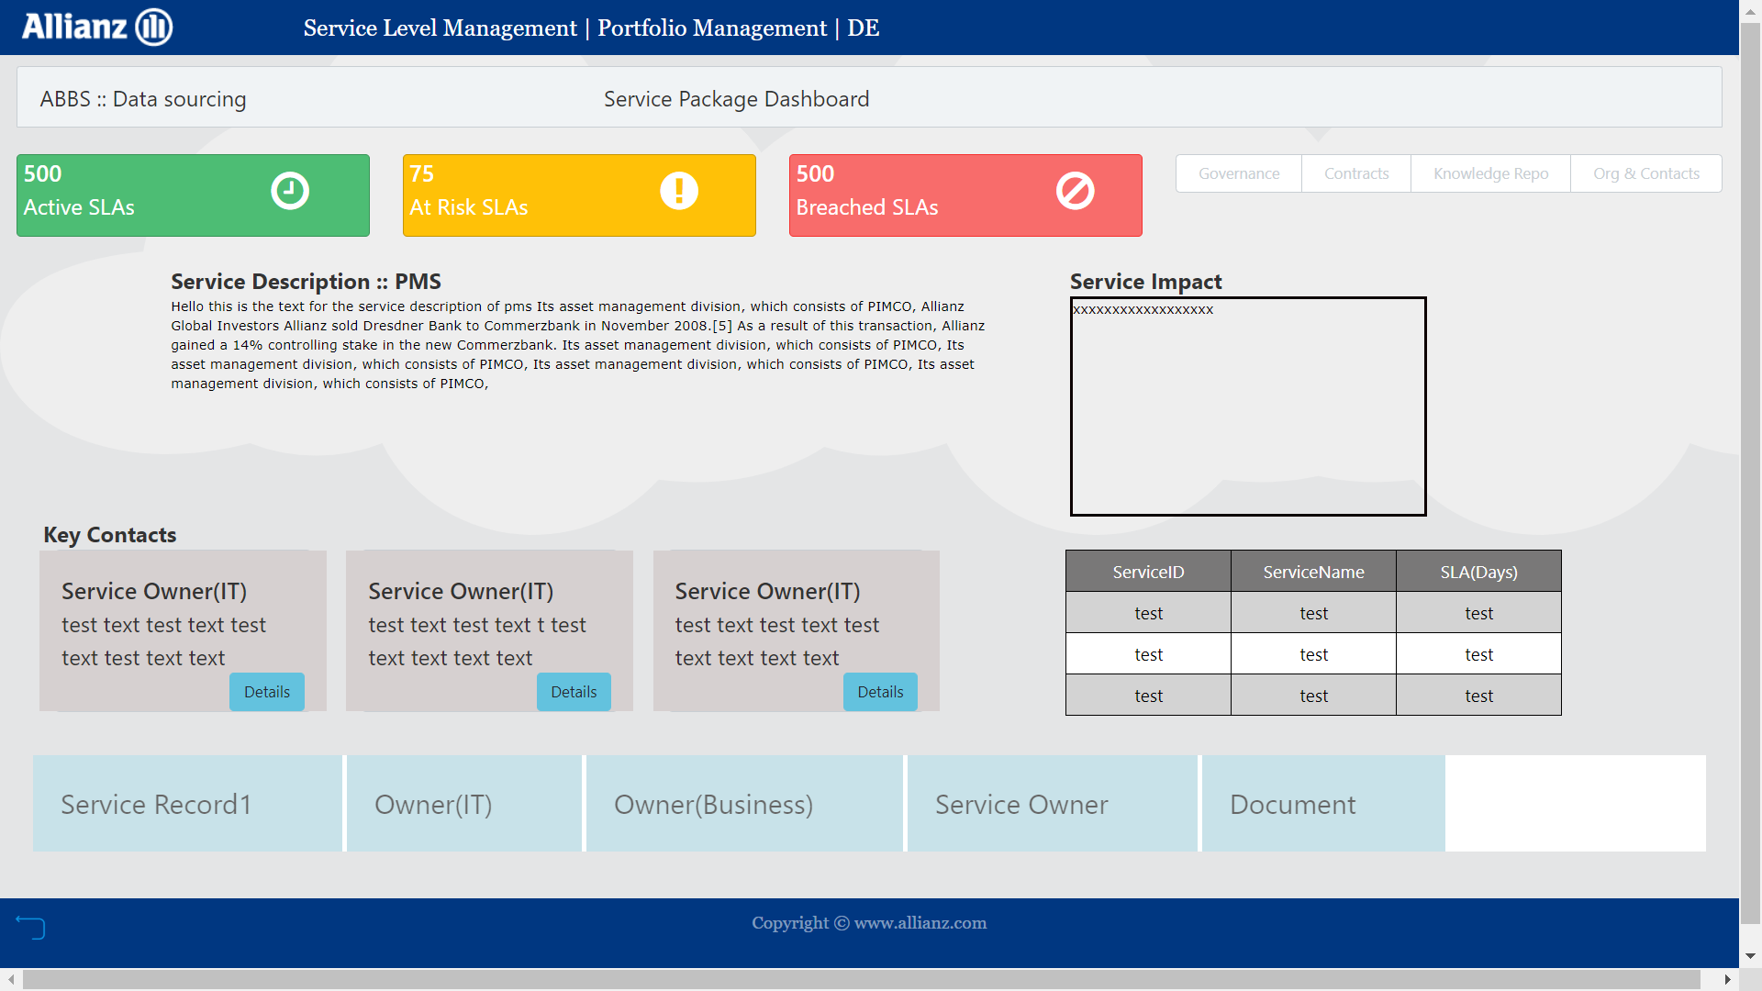

### Screen 6

**Labels**: Based on the item displayed

**Contract documents**

