**Page 01 List of OE**

**Title Bar (Header)**: Will change dynamically based on user navigation.

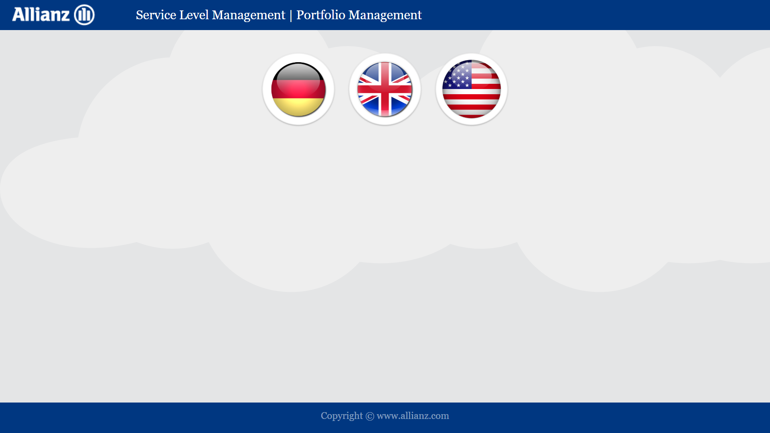

**OE Details**

OE details are static now

**User Authentication and Access**

User from an OE O1 will have access only to the projects from O1

(This will be handled in second phase)

**Access Levels**

Users with access to multiple OEs

Users with no access restrictions

(This will be handled in second phase)

**Page 02 Sublevel**

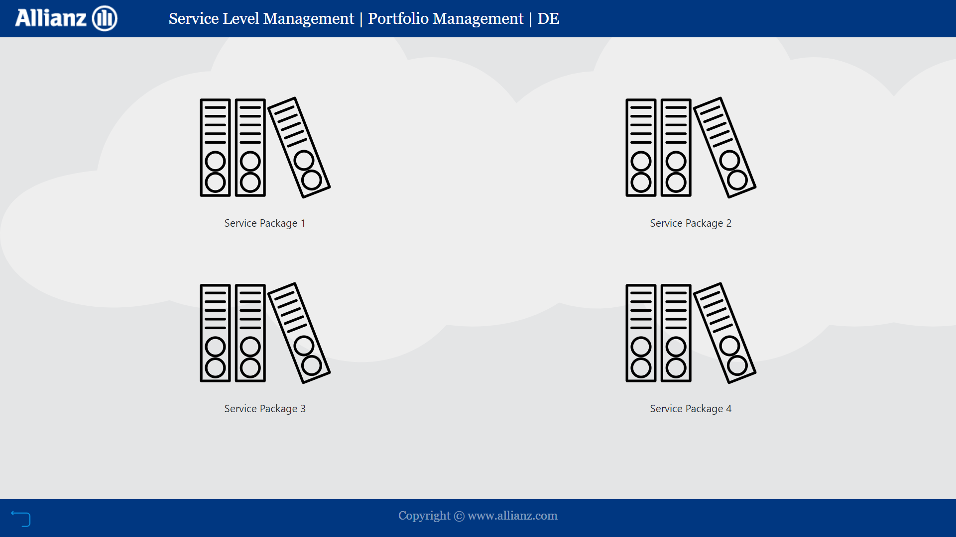

**Sub Levels (multiple layers based on hierarchy)**

The screen will show the details grouped based on interest

For e.g. List of all projects active under the OE selected i.e. ABS projects and non ABS projects

**Title Bar (Header)**: Will change dynamically based on user navigation.

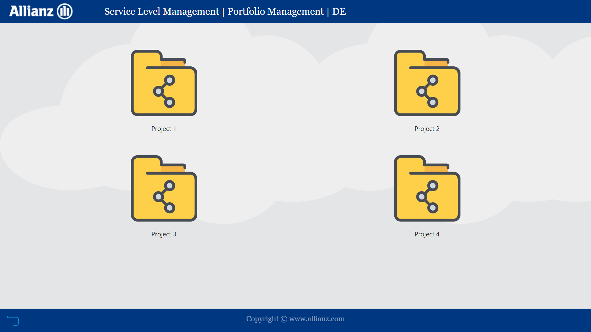

**Page 03**

**Sub Levels (multiple layers based on hierarchy)**

The screen will show the details grouped based on interest

For e.g. List of all projects active under the OE selected i.e. ABS projects and non ABS projects

**Page 04**

**Labels**: Based on the item displayed

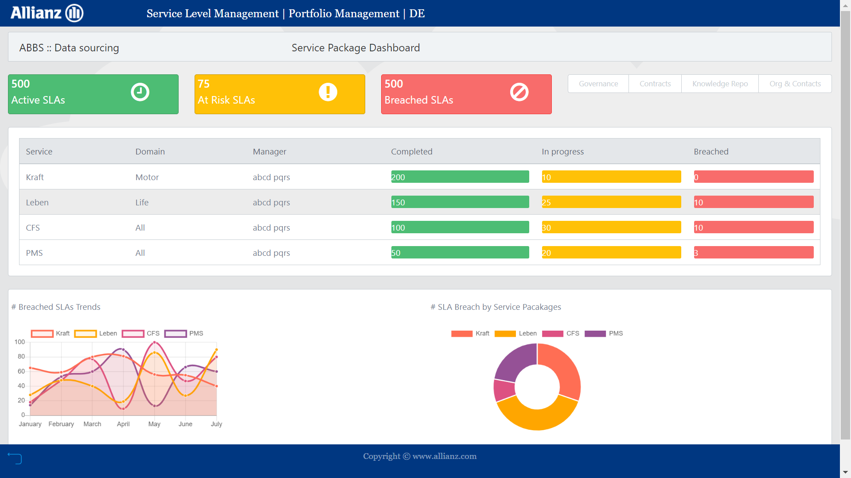

**Charts**: Based on the item displayed

**Summary**: Summary of the Project Status

**Table of details**: Individual team details

**Selector**: Link to page containing additional details like contract documents

**Page 05**

**Labels**: Based on the item displayed

**Labels**: Based on the item displayed

**Labels**: Based on the item displayed

**Labels**: Based on the item displayed

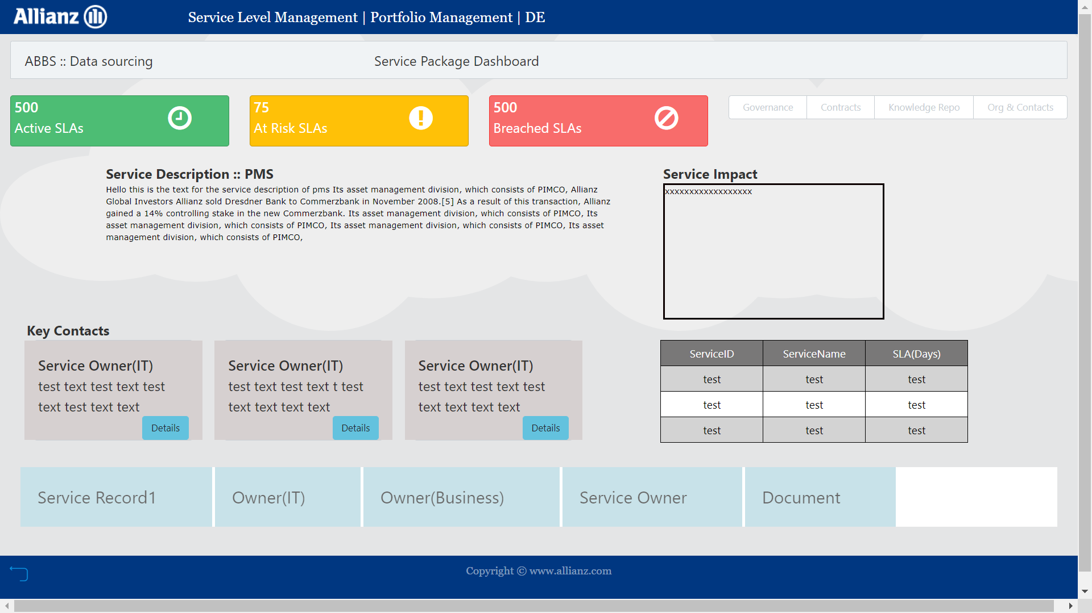

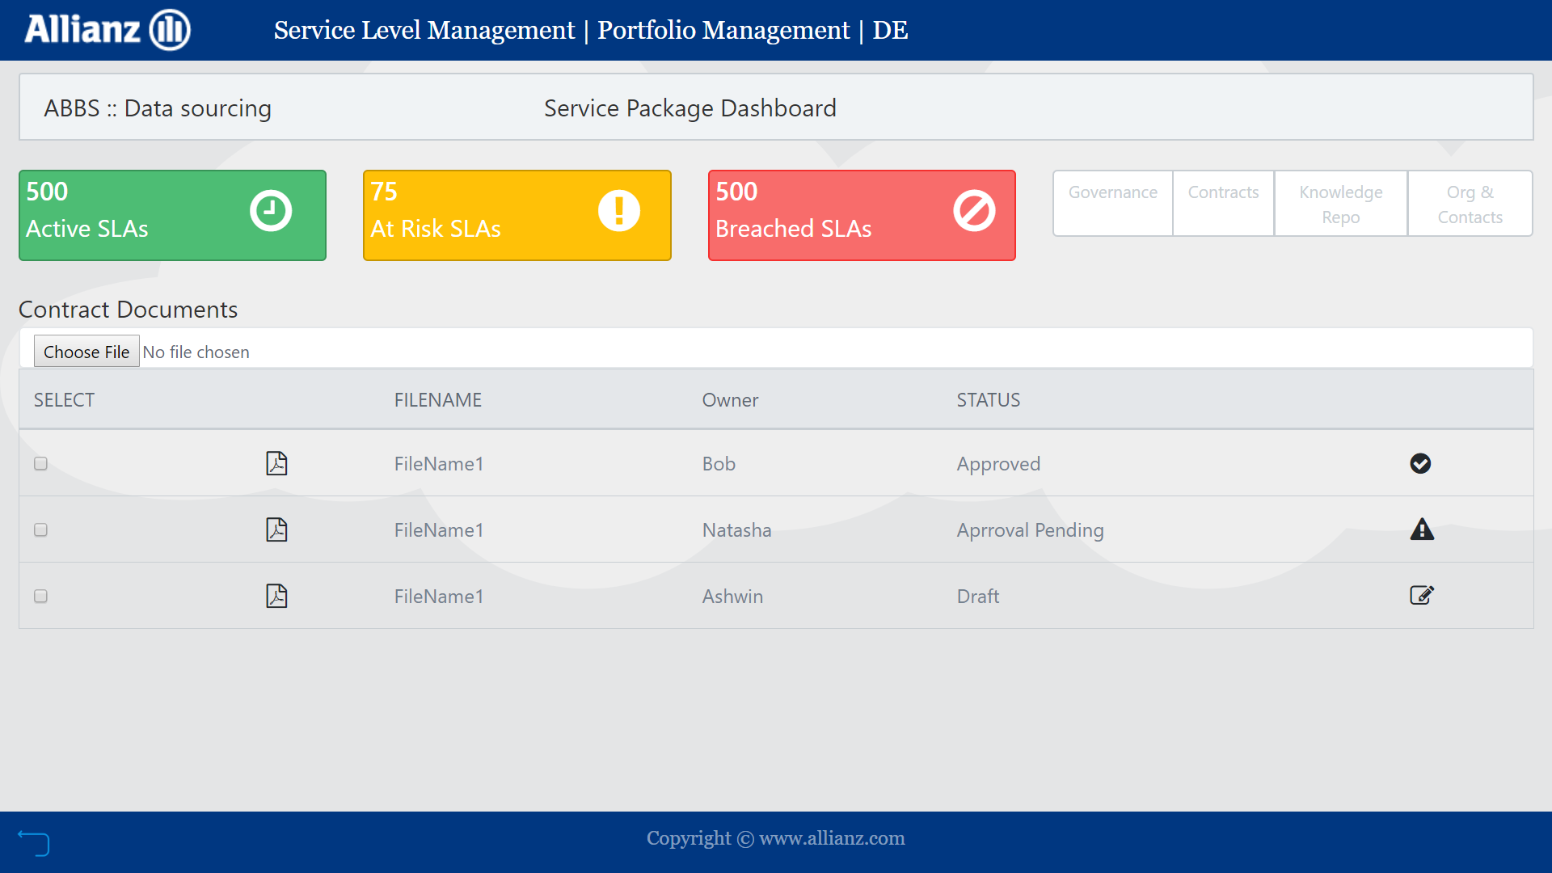

**Page 06 Contract Documents**

**Labels**: Based on the item displayed