Lab 2 Shuhan Xu

2.4.1
K (Kelvin)

2.4.2
E(this unit) = E(regular unit) / k

2.5.1
prediction_dist = np.exp(-mstates / T)
The simulated distribution shows the probabilities of being in one of the four states.
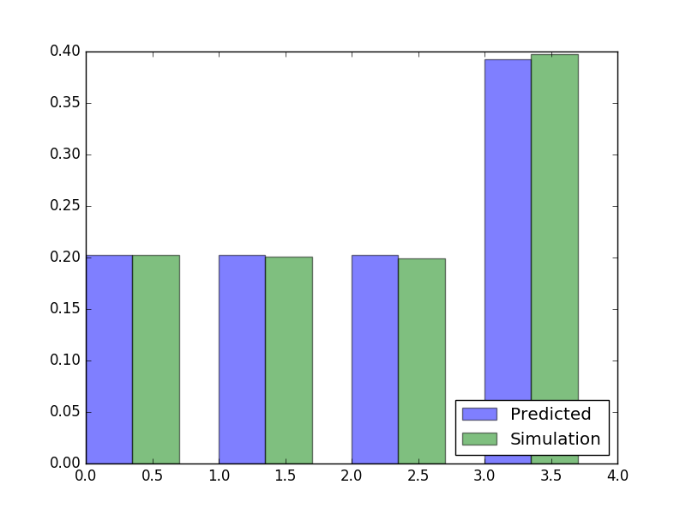
Hence the Boltzman equation is used to convert the energies of the states to probabilities.

2.5.2
This is due to the random nature of sampling. If more steps are used, the simulated distribution will become more similar to the predicted distribution.

2.6.1.
simulation_dist = np.array([sum(simulation_dist[0:3]), simulation_dist[3]])
prediction_dist = np.array([sum(prediction_dist[0:3]), prediction_dist[3]])
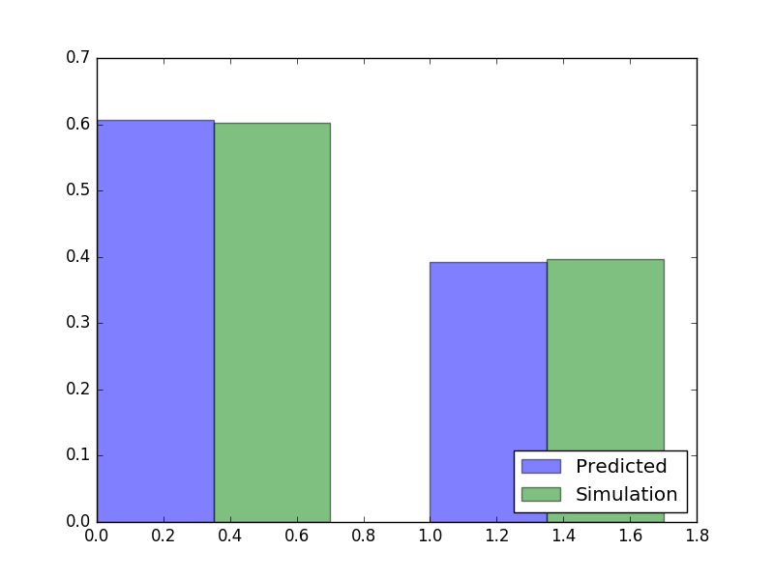

2.6.2
EA = -325
EB = -200
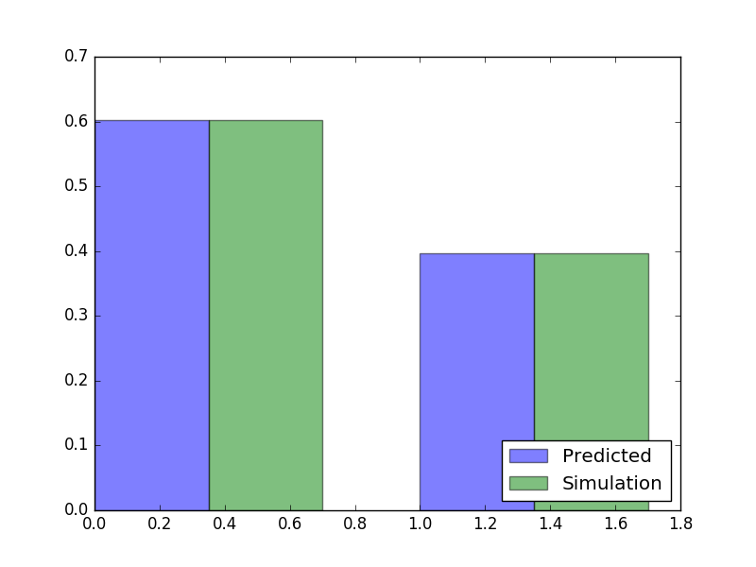

2.6.3.
C= ln3
C is dependent on number of micro states in the macro state.
C represents entropy
Its unit is JK-1

2.6.4.
prediction_dist = np.array([np.exp(-(mstates[0] - T * np.log(3))/T), np.exp(-mstates[3]/T)])

6.5. EA is free energy as it includes the entropy term which is dependent on the numbers of microstates in a macrostate.

6.6. Water has 3 states: solid, liquid and gas. Each state has multiplicity since the atoms can vibrate or move about. Solid state water has less multiplicity than liquid state water since there are less possible configurations of the molecules in solid than liquid water.

