Lab exercise 2 : Entropy – Biophysical Chemistry

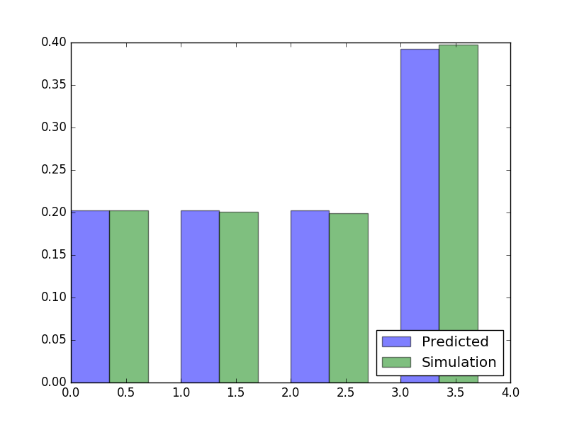

6.1.
simulation_dist = np.array([sum(simulation_dist[0:3]), simulation_dist[3]])
prediction_dist = np.array([sum(prediction_dist[0:3]), prediction_dist[3]])
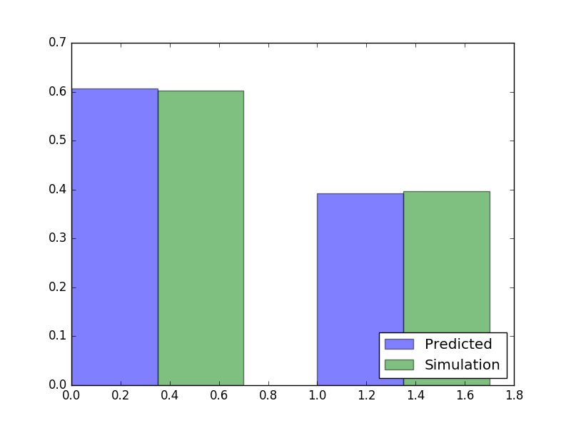

6.2
E_{A} = -325
E_{B} = -200
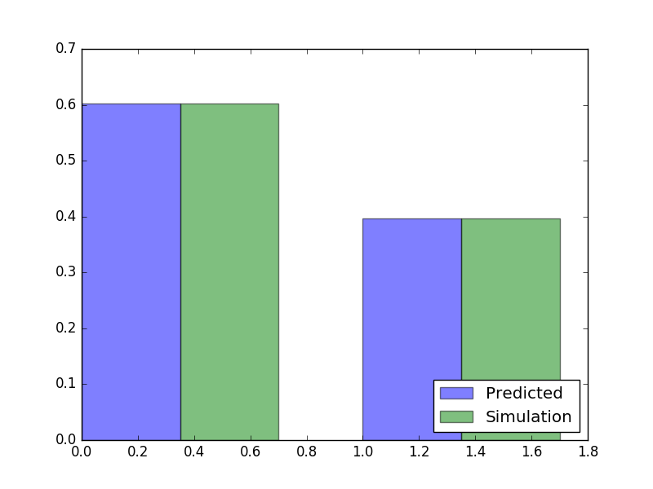

6.3.
C= ln3
C is dependent on number of micro states.
C represents entropy
Its unit is JK⁻¹

6.4.
prediction_dist = np.array([np.exp(-(mstates[0] - T * np.log(3))/T), np.exp(-mstates[3]/T)])

6.5. E_{A} is free energy as it includes the entropy term.

6.6. Water has 3 state solid, liquid and gas. Each state has multiplicity since the atoms can vibrate or move about.

