Lab 3 Shuhan Xu

3.2.1

True, provided that transition between any two states is possible, whether directly or indirectly.

3.2.2

True.

3.2.3

The population of states should not change if it is still possible for one state to transit to another state through other states.

3.2.4

0 1 0 1

1 0 1 0

0 1 0 1

1 0 1 0

3.3.1

10000 steps give a good approximation.

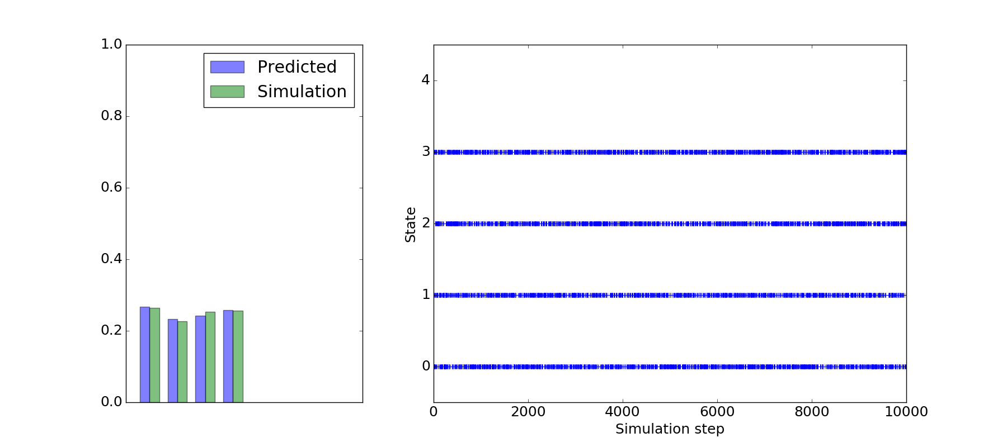

3.3.2

10000 steps give slightly worse approximation than before.

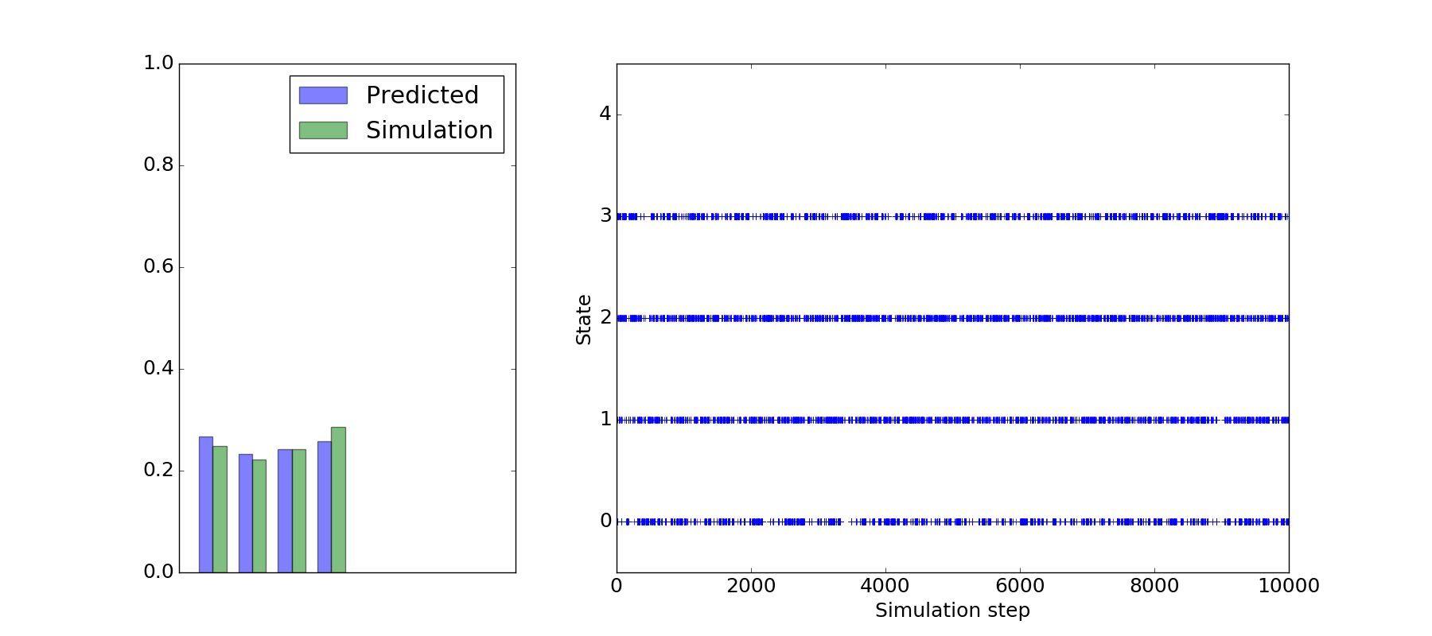

100000 steps are needed instead.

3.4.1

Yes, I can see that the simulation is trapped in state 3, the fourth state.

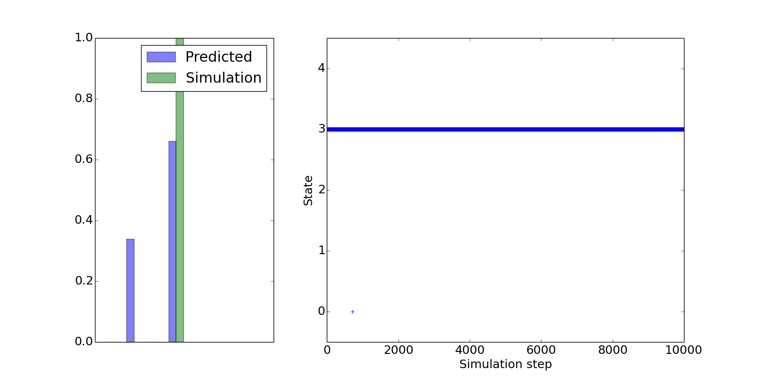

3.4.2

The plot looks different when I change the initial state to state 1, the second state. This shows that more steps are needed to simulate the states accurately.

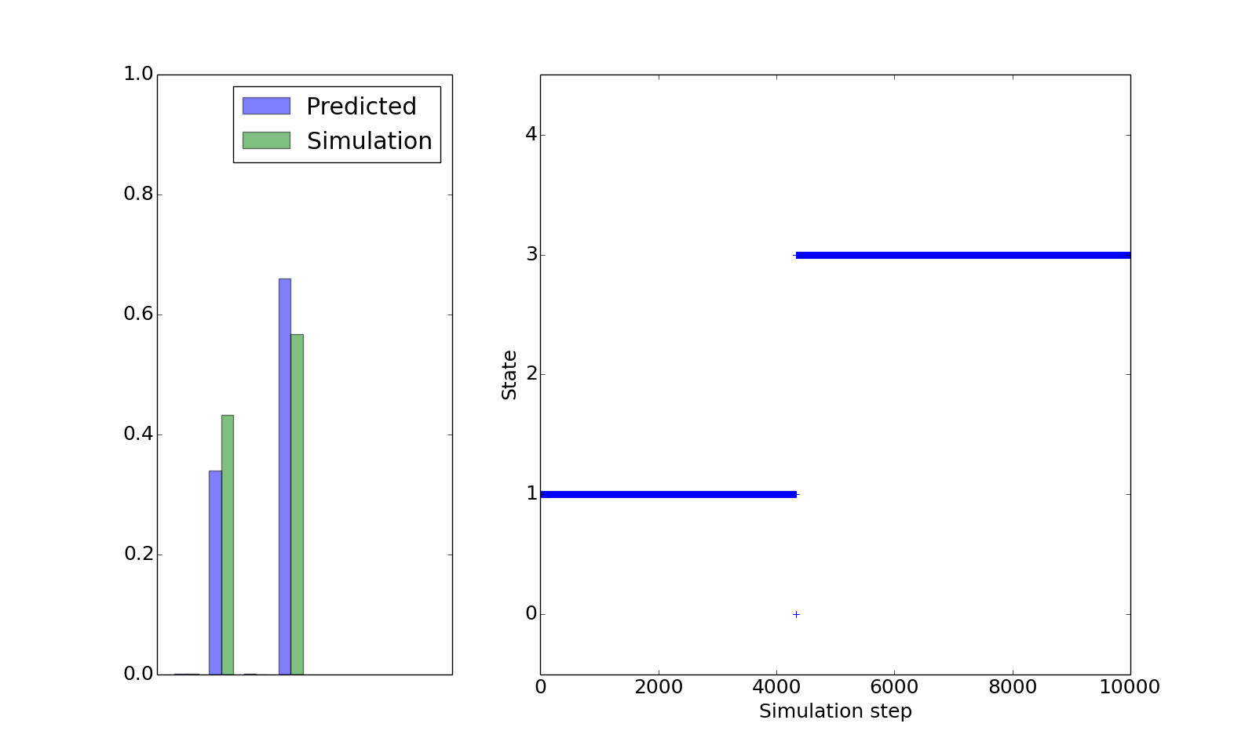

3.5.1

We have to simulate for an infinite amount of time.

3.5.2

A catalyst does not change the population of these states.

3.5.3

A catalyst lowers the energy barrier between the two states so that they can reach equilibrium faster.

3.6.1

The energy of the transition state is much higher compared to other states. Hence, it is more probable for a system to adopt a lower energy state than the transition state.

3.6.2

When enzyme/protein is produced to speed up a chemical or physical process, e.g. insertion of aquaporin allows water to move pass the lipid bilayer more easily.