Lab4 Shuhan Xu

4.2.2.1

The ATP will be completely depleted. This is because the pumped ions will diffuse back down the concentration gradient.

4.2.2.2

We can be fairly sure that an ATP is consumed. However, it is still possible for low-energy ion to diffuse against the gradient but this is rare due to the energetically unfavorable nature of the process

4.2.2.3

The ion will be distributed according to the Boltzamnn distribution with more ions being in the low-energy state as compared to the high-energy state.

4.3.1

change = np.sign(np.random.rand() - 0.5) * stepLength

4.3.2

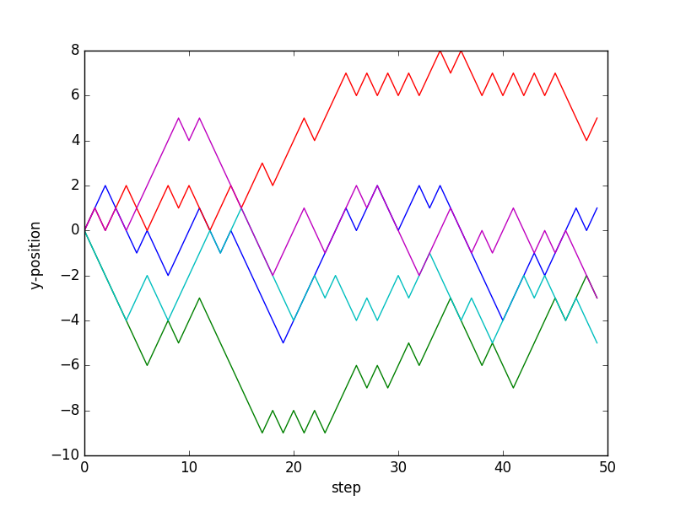

4.3.3

It is not a random walk. Whether the random move is accepted or rejected is based on the energies of current state and the next state.

4.4.1

The average y-position at the end of the walk is approximately 0 for all number of steps.

The absolute y-position at the end of the walk is proportional to the square root of number of steps

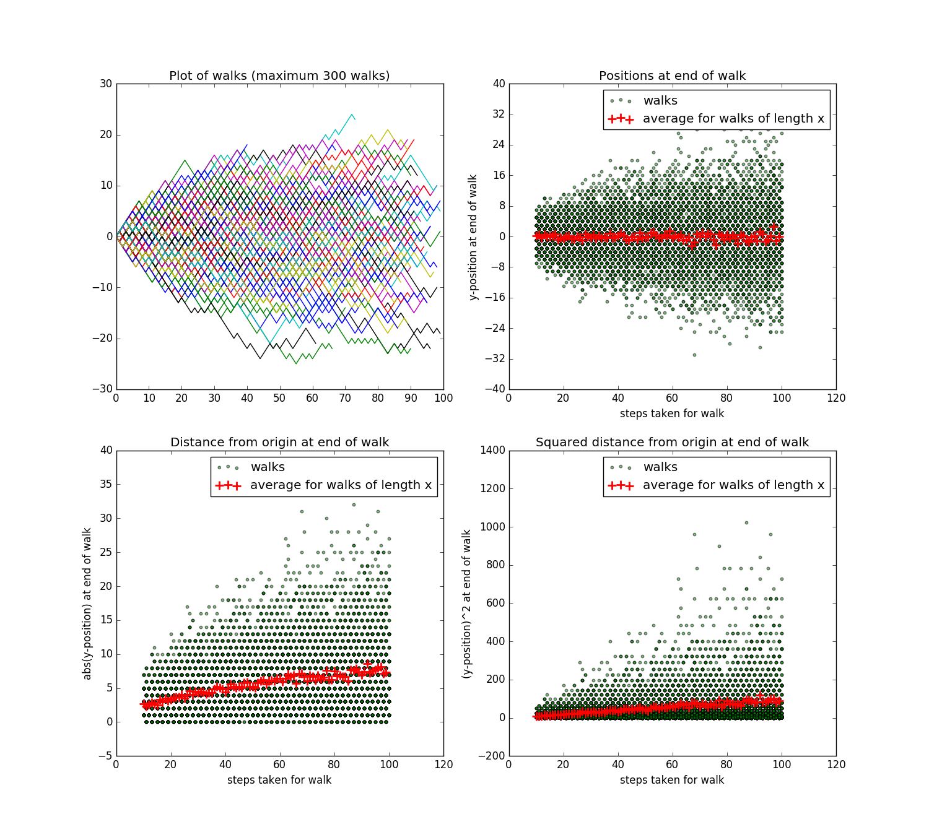The squared y-position at the end of the walk is proportional to the number of steps

4.5.1

This is a linear form.

4.5.2

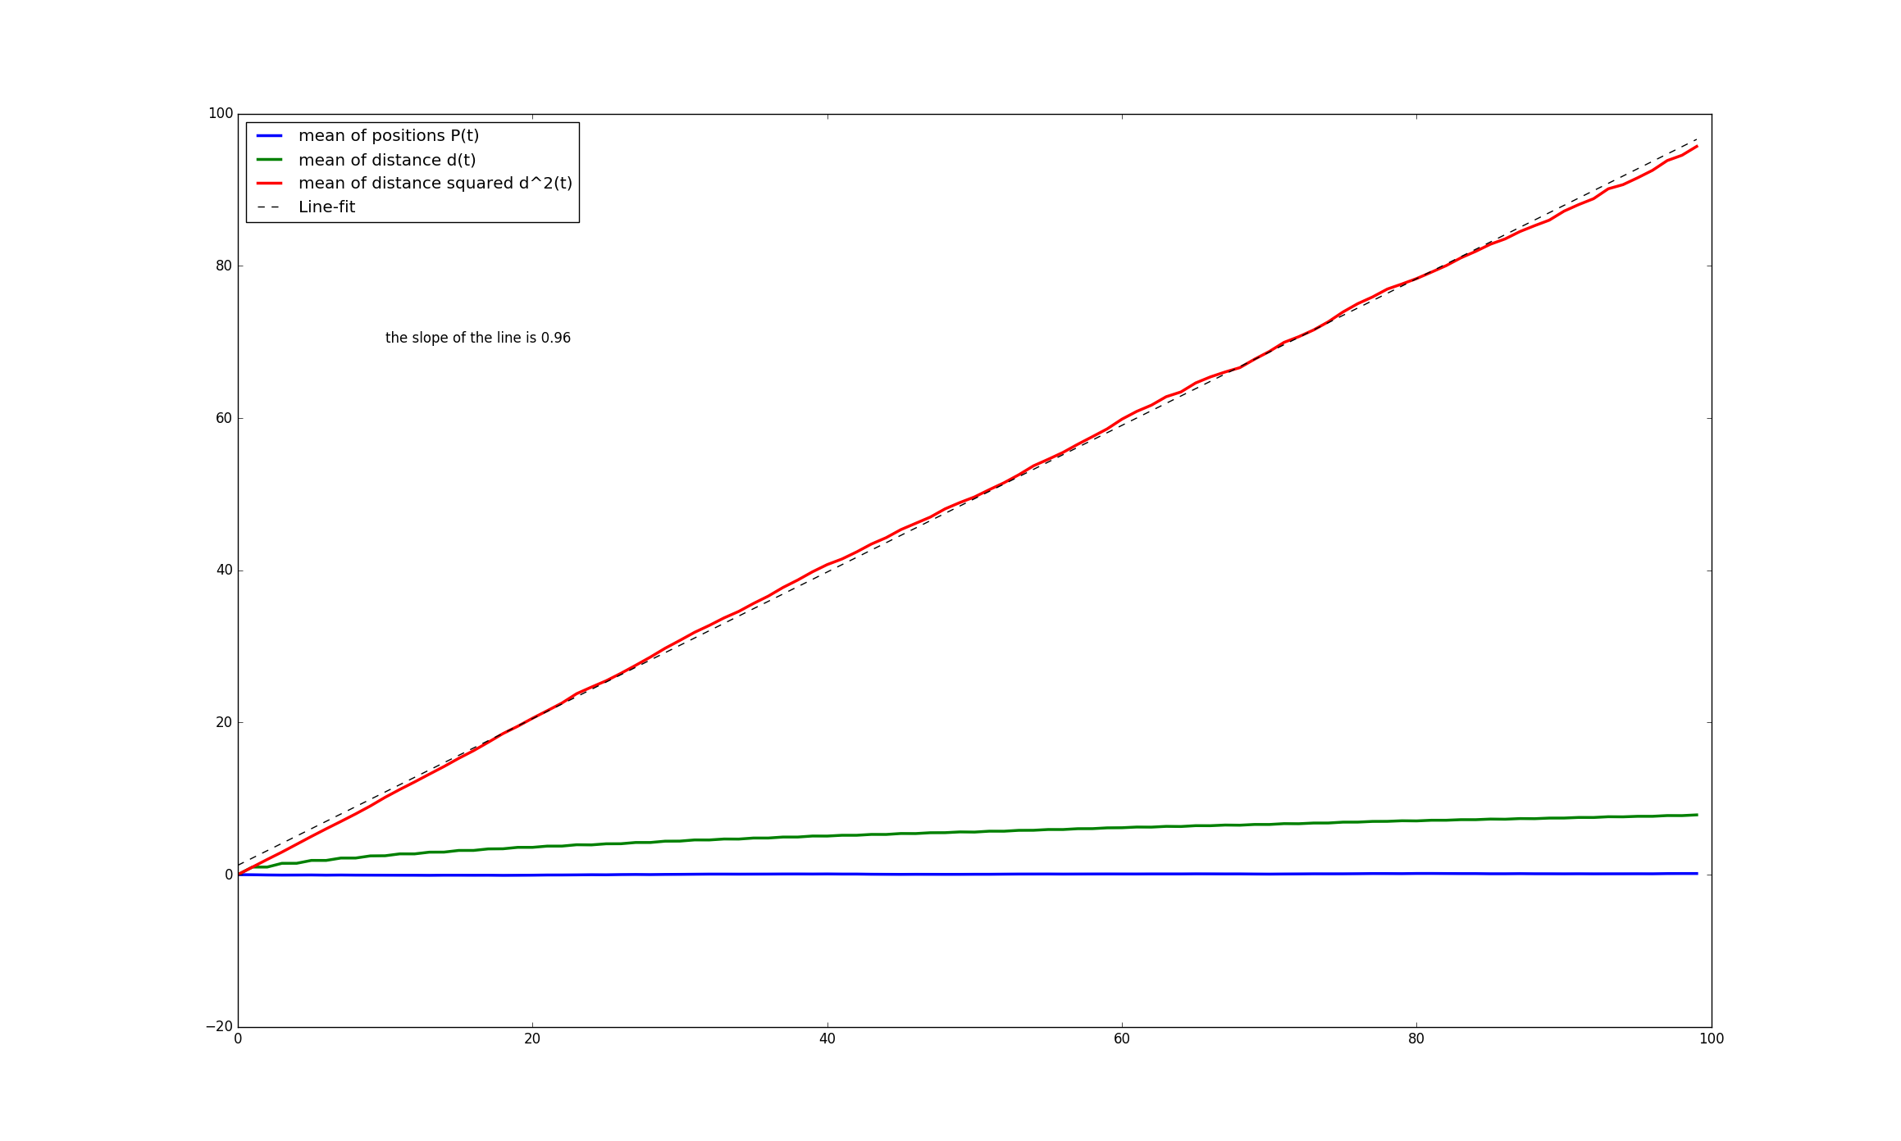

KN is approximately 1.

4.6.1

m2s-1

4.6.2

The water molecules move faster, i.e. diffuse further after a period of time.

4.6.3

Kt is 1 for all combinations of settings.

When step length is 2, Kt is 4.

Kt = L2

Xave2 = L2 * t

4.7.1

def randomWalk(stepLength, steps):

# Make an array to fill with positions

positions = np.zeros(steps)

# Make as many steps as required

for i in np.arange(steps-1):

# Make a random number this observation

change = stepLength * np.sign(np.random.rand()-0.5)

if positions[i] + change > 10:

positions[i+1] = 20 - (positions[i] + change)

elif positions[i] + change < -10:

positions[i+1] = -20 - (positions[i] + change)

else:

positions[i+1] = positions[i] + change

return positions

4.7.2

Kt = 0.2809. This Kt is fit to the model in which there is no confinement and Xave2 increases linearly with t. However, Xave2 only increases linearly when t <= 10 and starts to plateau when t > 10 due to the confinement. Hence this method underestimates Kt.

4.8.1

Diffusion on lipid bilayer.

4.8.2

Diffusion in cytosol.

4.8.3

We can still use the model if we understand the limitation of the model and can justify that the other results are still reasonable given this limitation.