Lab 5 Shuhan Xu

5.2.2.1

1: EA=0

2: EA=1

3: EA=2

4: EA=2

5: EA=0

6: EA=1

7: EA=2

8: EA=1

5.2.2.2

The higher the score, the more packed/folded the model is.

5.3.1.1

At each step, the first and last residues can move to another position around the second and second last residues receptively if the new position is not block by the chain. If a middle residue forms a right-angle bend, it can also flip to the diagonally opposite position provided that position is not blocked by the chain.

5.3.1.2

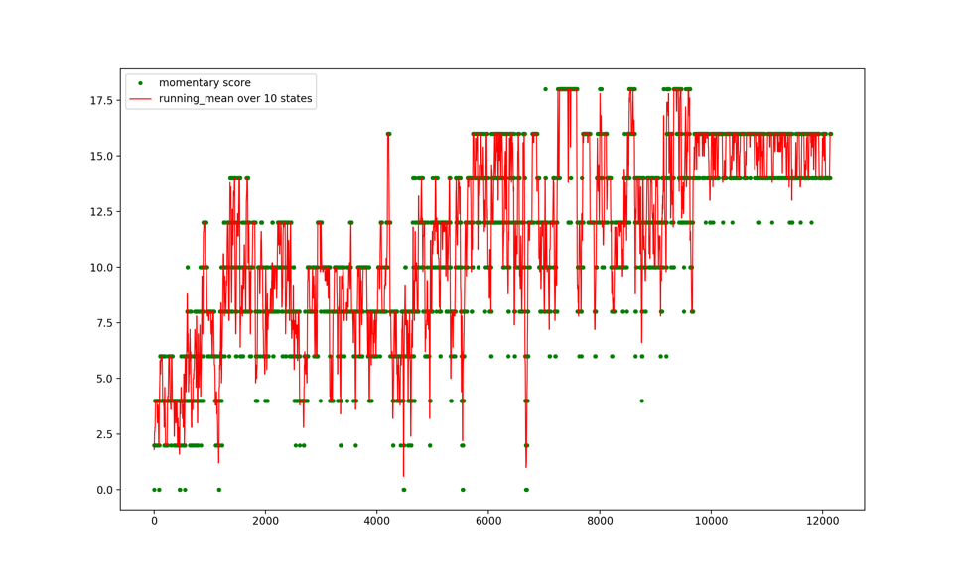

5.3.1.3

A folding sequence can adopt a folded state which can maintain in that state for a long simulation time. A low energy state may not be stable if it stays in that state for only a short time.

5.3.1.4

The best sequence I have is HWWHHWHHHHWWWHHWWHWH. The plot of the simulation is in 5.3.1.2. However, it is still not a folding sequence as it still jumps between a few states after a long stimulation time.

5.3.1.5

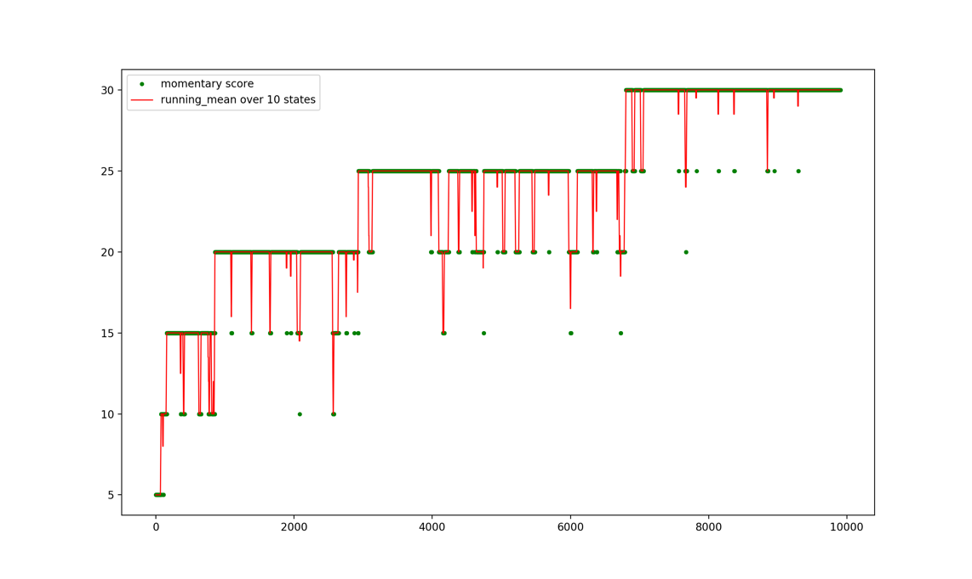

The protein tends to stay longer in a state. However, it takes much longer to find the lowest energy state.

5.3.2.1

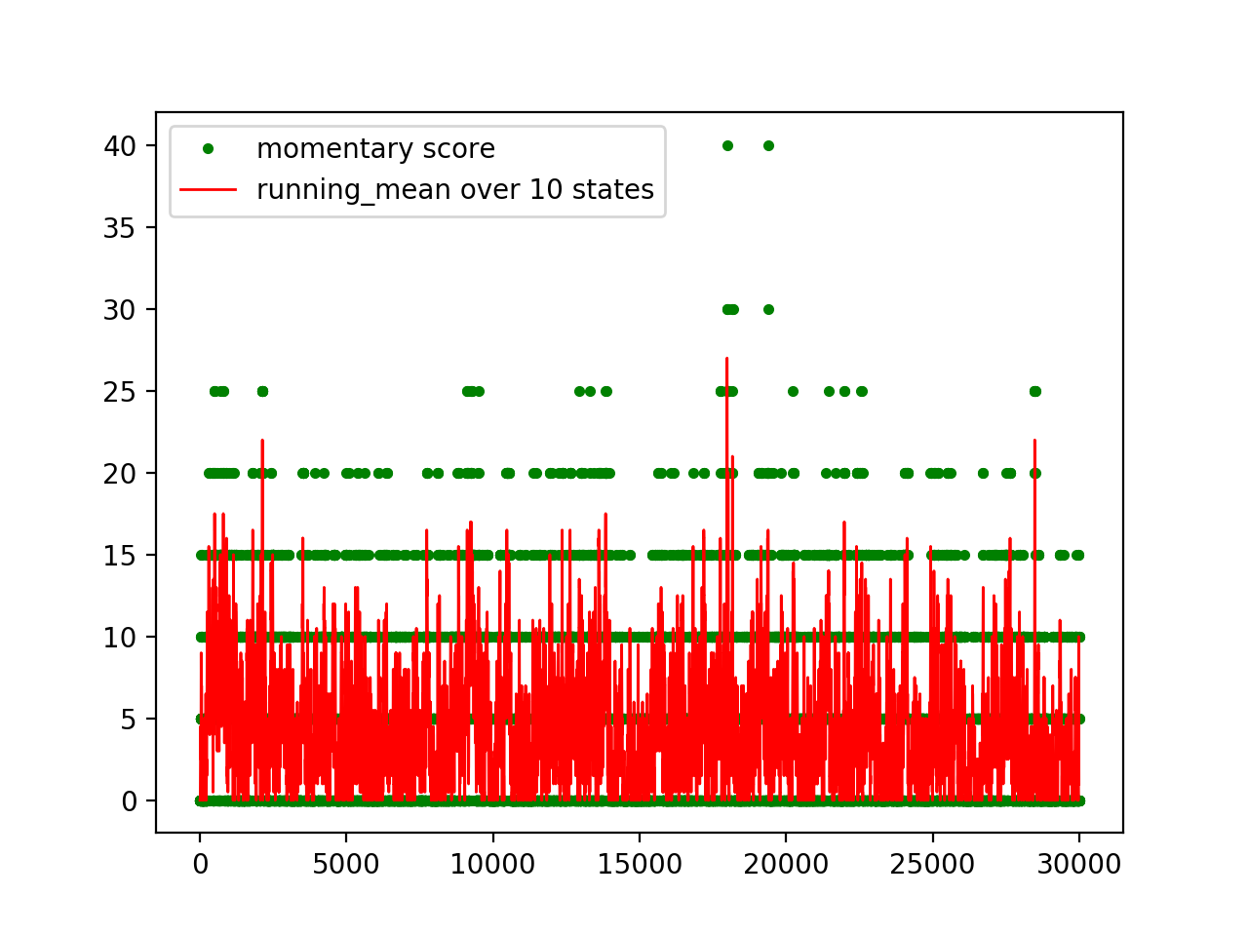

Yes, there is a huge difference. The protein explores more states. However, it tends to stay in high energy states which are more accessible since they have more possible conformations.

5.3.2.2

This corresponds to an increase in temperature. Since it no longer rejects new conformations, all conformations have the same energy. This is also equivalent to a very high temperature.

5.3.2.3

It can no longer simulate the folded state as it does not reject states base on energy and Boltzmann statistics.