Lab 6 Shuhan Xu

6.1.1

This does not allow the scenario in which the protein changes its conformation for the ligand to fit.

6.1.2

I would count the multiplicity of the bound state and the multiplicity of the unbound state. The logarithm of the difference multiplied by the Boltzmann constant will give me the change in entropy of binding.

6.3.1

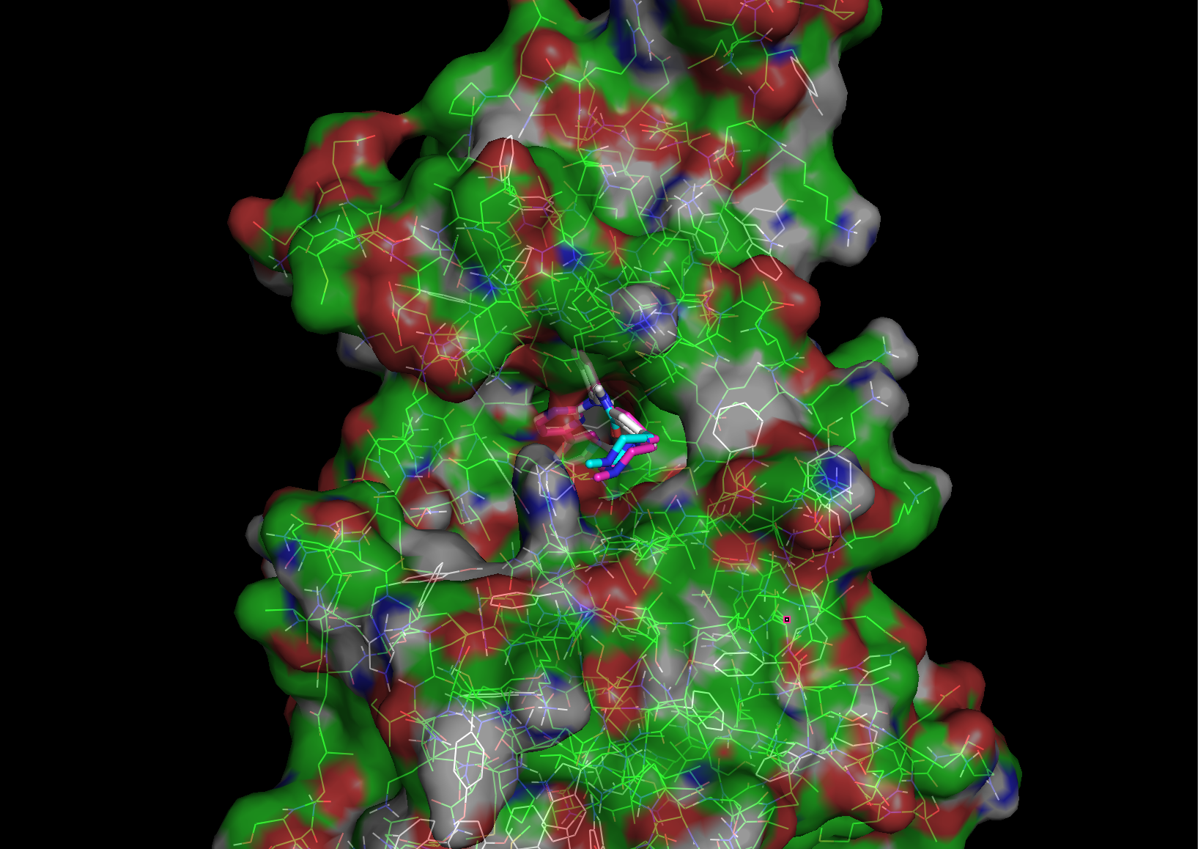

6.3.2

Yes. I can exclude the region which I am sure that the ligand would not bind. For example, I can use only the core and solvent exposed part of trans membrane protein.

6.4.1

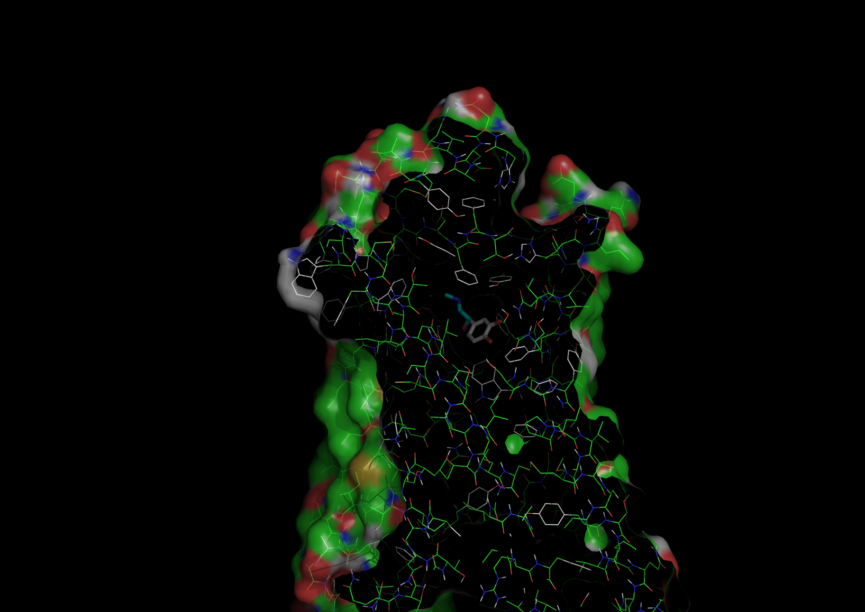

The ligand belongs to receptor A as receptor A has the highest affinity

receptor A

coarse box: -7, -17, -39, 50, 50, 70

fine box: -5, -15, -53, 25, 25, 30

affinity: -7.1 kcal/mol

receptor B

coarse box: -7, -17, -39, 50, 50, 70

fine box: -3, -13, -53, 25, 25, 30

affinity: -6.4 kcal/mol

receptor C

coarse box: -7, -17, -35, 50, 50, 80

fine box: -3, -13, -53, 25, 25, 30

affinity: -5.7 kcal/mol

6.4.2

Lig412 has the highest affinity

Lig045

affinity: -6.1 kcal/mol

Lig412

affinity: -9.3 kcal/mol

Lig973

affinity: -9.2 kcal/mol

6.4.3