Lab 7 Shuhan Xu

7.1.1

It means that the drug will spontaneously bind to the receptor or that it is more favorable for the drug to be bound rather than unbound.

7.1.2

∆Gmemb is positive

7.1.3

It is still possible for the substrate to cross the membrane due to thermal fluctuation but it will be highly unlikely if the ∆Gmemb is too high.

7.2.1.1

True

7.2.1.2

We should measure as often as we can to make the assessment accurate. If we can make 100 measurements, the interval would be 100m.

7.3.1.1

True. The free energy difference does not depends on the path depend.

7.3.1.2

True. Some path may requires more calculation if the barrier is higher, for example, if it involving breaking and forming of more hydrogen bonds.

7.3.1.3

False. The height measurement accuracy depends on the path chosen. For example, if one path changes more variables than the others, that path may introduce more errors in the calculation.

7.4.1.1

In the top right graph, the first bar should be shorter than the second bar since the free energy of the first is higher than that of the second.

7.5.1.1 & 7.5.1.2

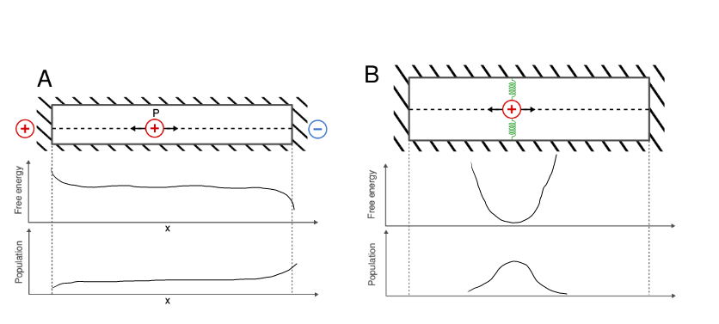

7.5.1.3

potential energy = KX2 / 2

The resulting density expression looks like a Gaussian distribution

7.6.1.1

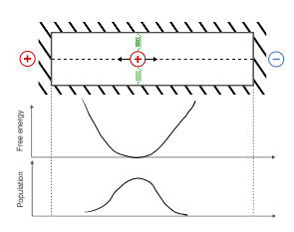

7.6.1.2

If I know the spring constant, I know the energy contribution from the spring. I can substrate this elastic potential energy from the free energy, which will leave us with the energy from the external charge.

7.7.1.1

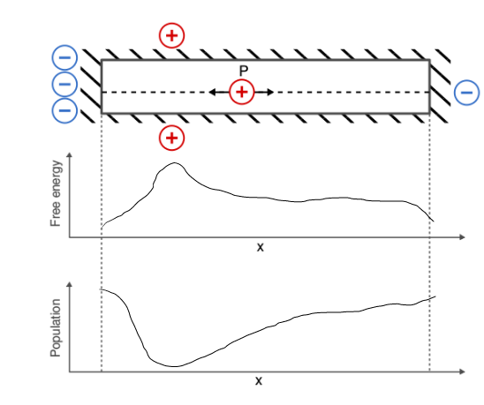

7.7.1.2