Comparative Genomics 2018
Practical 2: Gene Prediction
Group 11
Shuhan Xu, Fuqi Xu, Milda Valiukonyte

Exercise 1

1. tigr-glimmer long-orfs -n -t 1.15 01.fa 01.long-orf-coords

long-orfs: program which finds long non-overlapping ORF from a DNA sequence file
-n: no header information in the output file
-t 1.15: consider only genes with entropy distance score lower than 1.15 in the program
0.1.fa: sequence file
0.1.long-orf-coords: output file containing the coordinates of the long ORF

2. tigr-glimmer extract -t 01.fa 01.long-orf-coords > 01.longorf

extract: program which reads the sequence file, searches for the region defined by the coordinates in the coordinate file, and outputs the region in a fasta file.
-t: exclude the last three characters of the output string
01.fa: sequence file
01.long-orf-coords: coordinates of the long ORF
01.longorf: fasta file of the long ORF

3. tigr-glimmer build-icm -r 01.icm < 01.longorf

build-icm: program which builds an interpolated context model (ICM) from a training set of sequences
-r: use the reverse of the input sequence to build the ICM
01.icm: the output file for the built ICM
01.longorf: fasta file of the long ORF

4. tigr-glimmer glimmer3 -o50 -g110 -t30 01.fa 01.icm 01.glimmer

glimmer3: program which makes gene prediciton
-o50: maximum overlap length of 50 for genes
-g110: minimum gene length of 110
-t30: threshold score of 30 for genes
01.fa: sequence file
01.icm: ICM file
01.glimmer: tag for the two output file 01.glimmer.detail and 01.glimmer.predict

5. One can train using known genes from the genome or genes from an closely related species or strain

6. Glimmer is not suitable for eukaryotic genomes. It does not consider the presence of introns.
7.

09.fa.txt 17.fa.txt
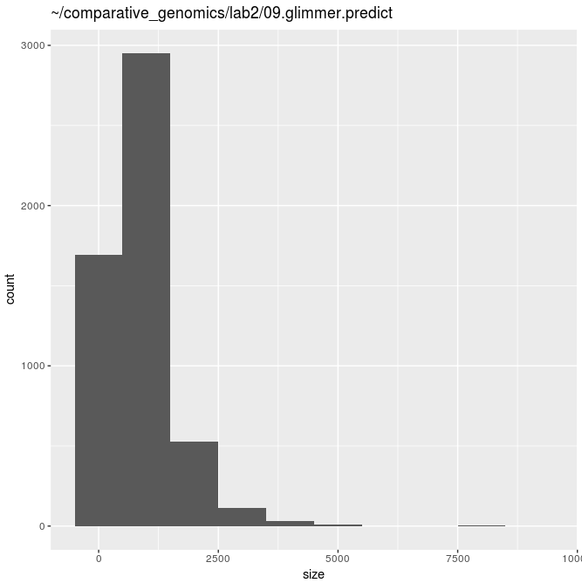
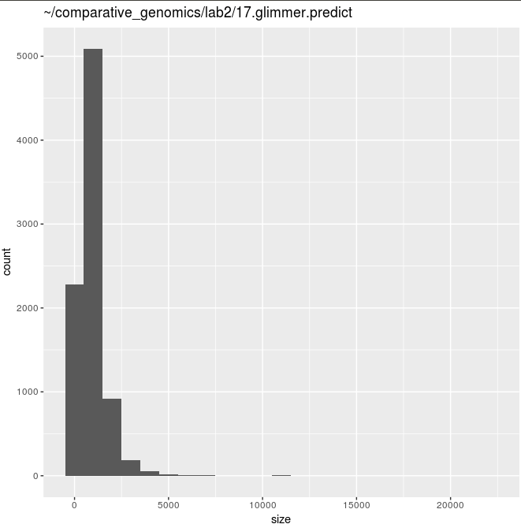

24.fa.txt 49.fa.txt
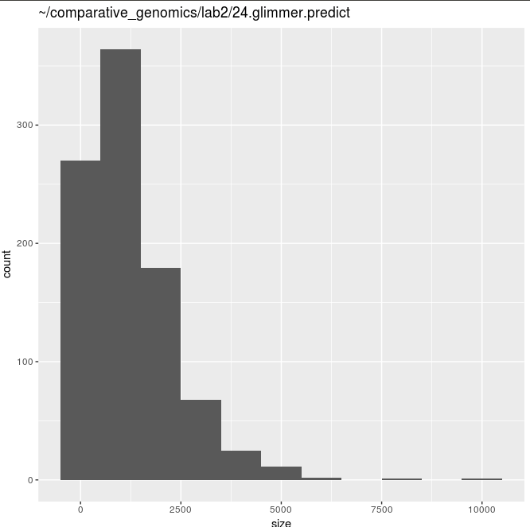
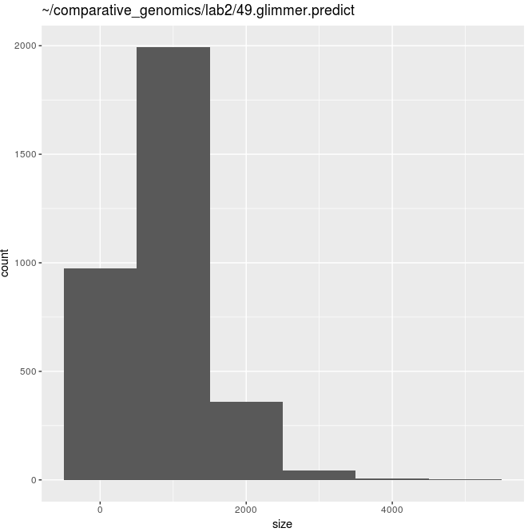

51.fa.txt
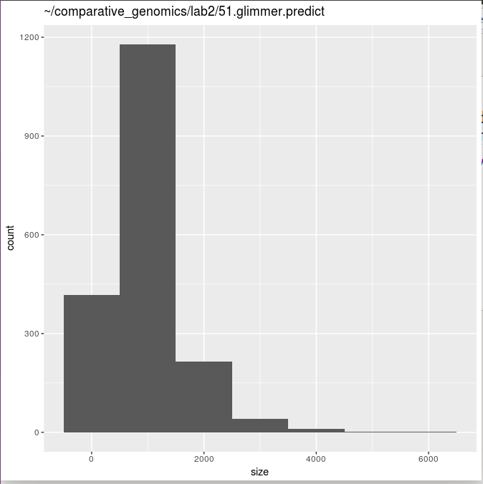

8. 24.fa.txt has much fewer genes compared with the other genomes. For instance, the count for genes of size 1000bp is only 350 for 24.fa.txt as compared to 1000-5000 for other genomes. This is due to the fact that 24.fa.txt is a eukaryote genome and glimmer3 cannot account for introns which disrupt the gene. In general, the shape of the distribution is the same for all genomes with the highest count at 1000.

9.

