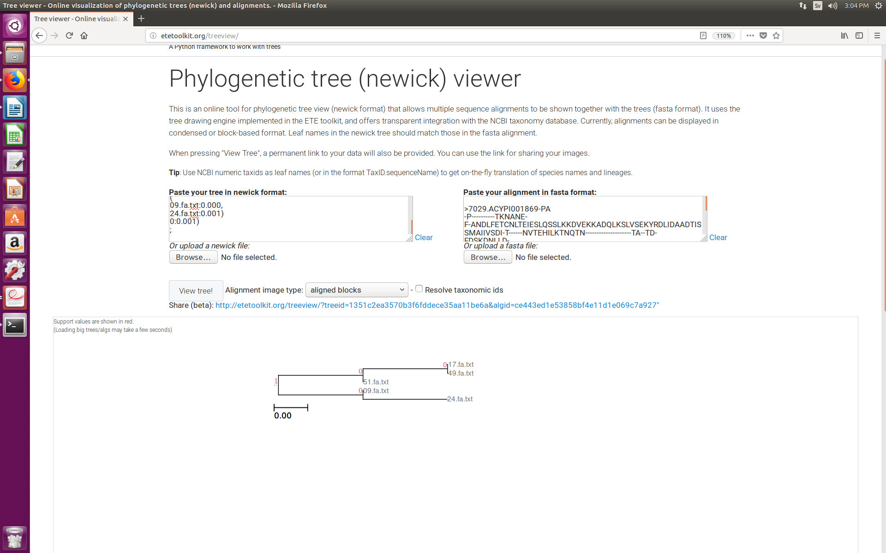GC frequency

nucleotide frequency

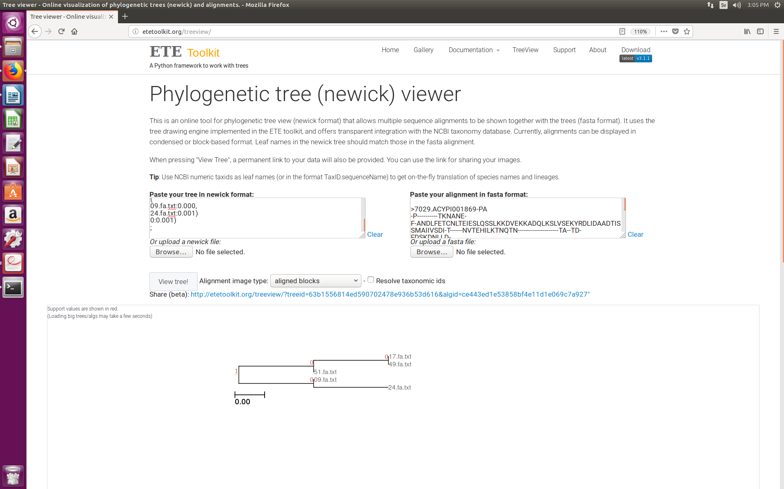

dinucleotide frequency

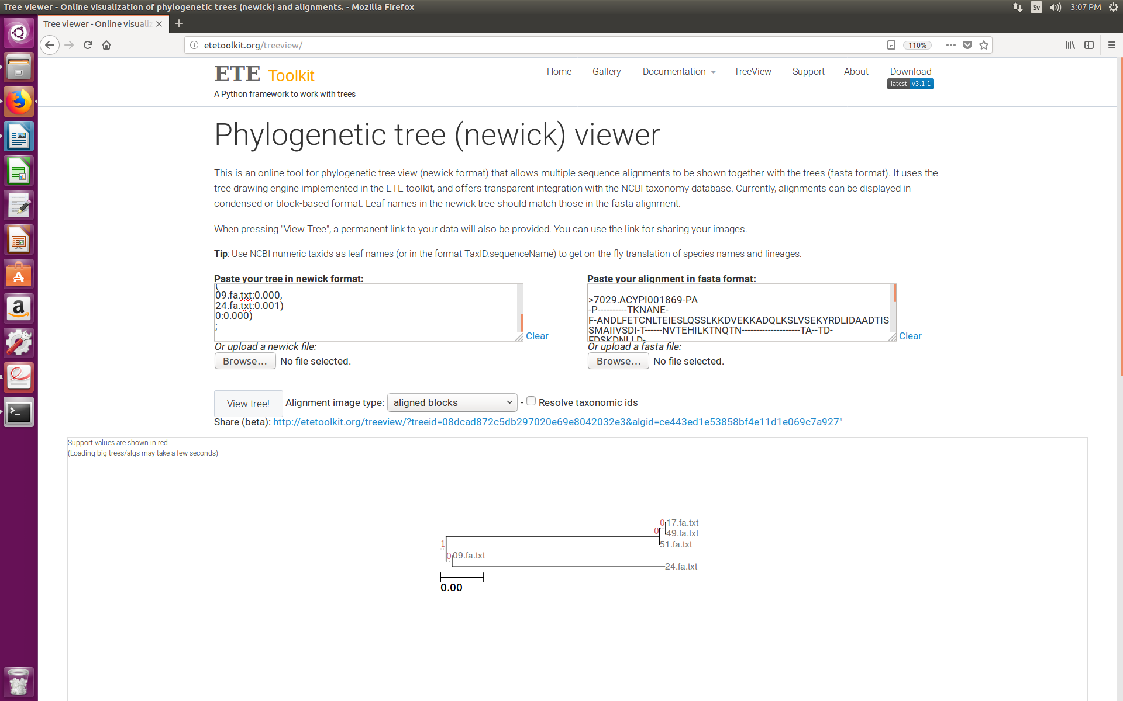

amino acid frequency

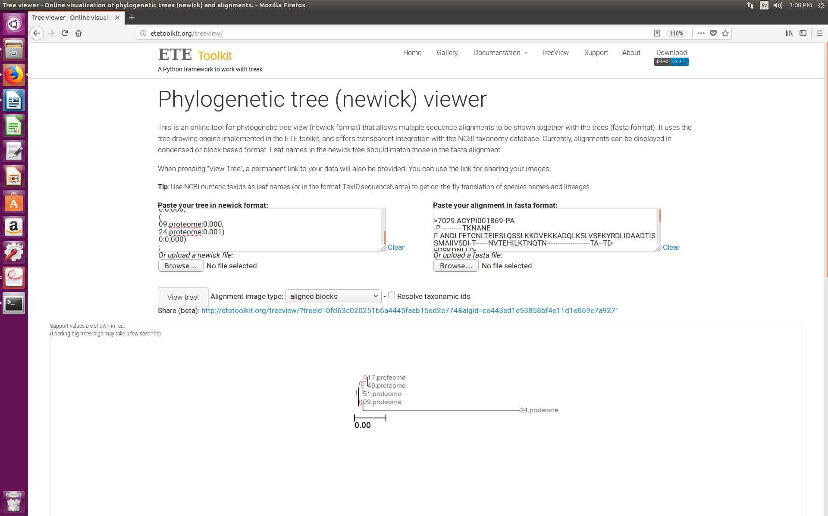

diamino acid frequency

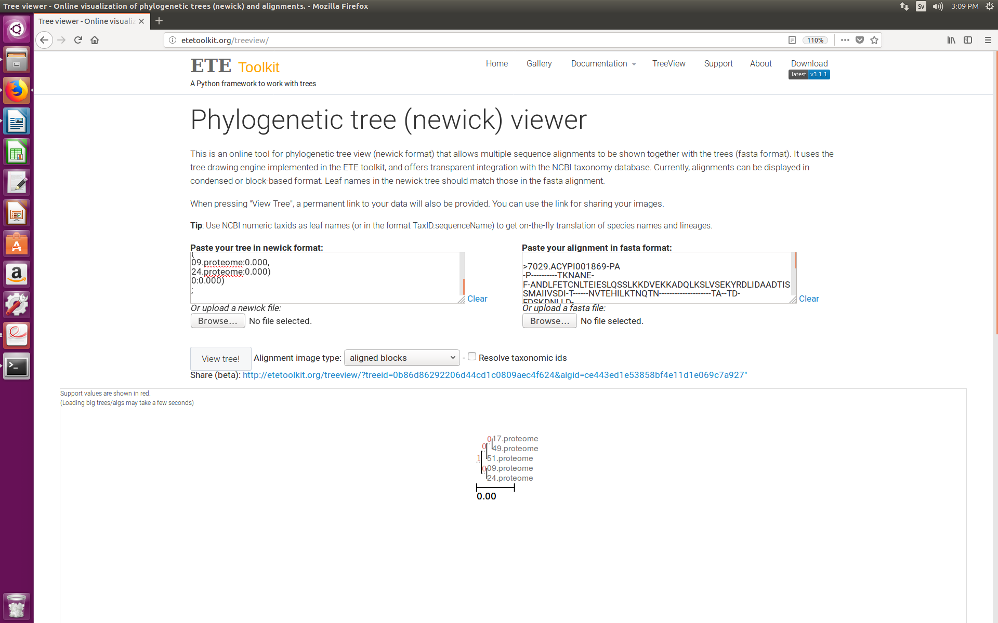

Nucleotide angle

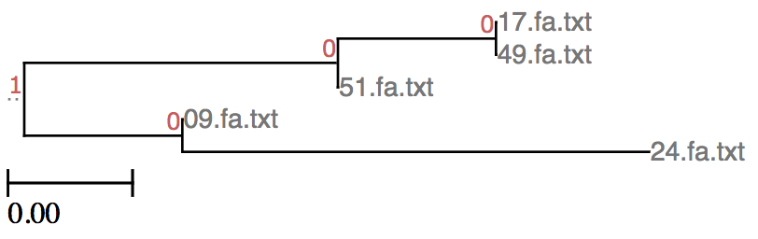

Dinucleotide angle

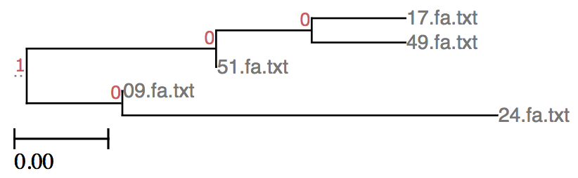

Amino acid angle

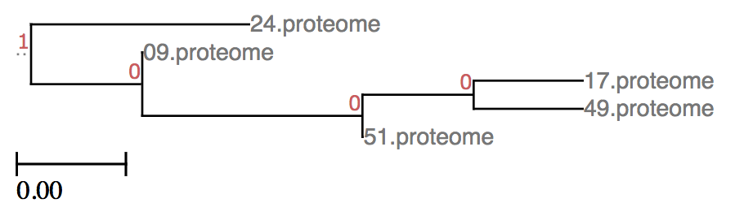

Diamino acid angle

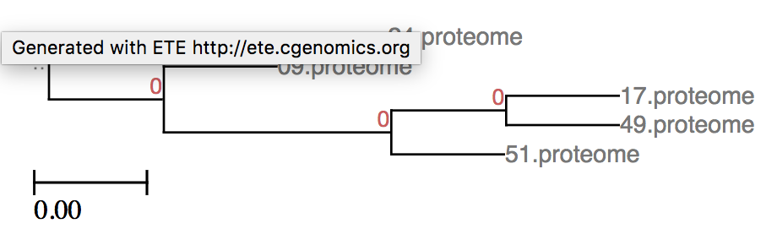

GC normalized

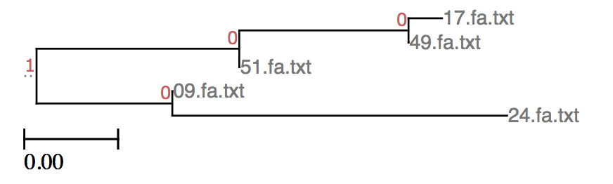

Nucleotide normalized

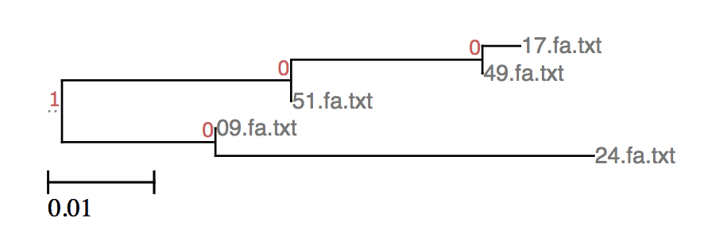

Dinucleotide normalized

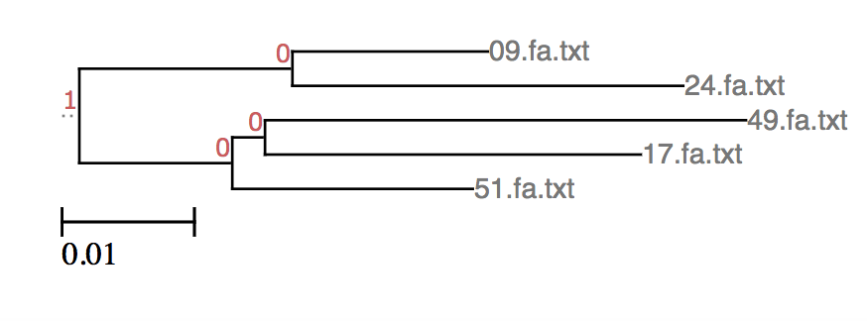

Amino acid normalized

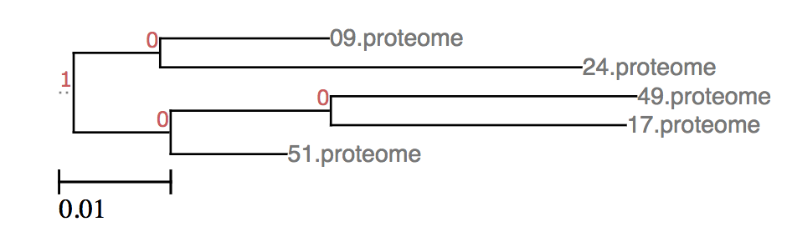

Diamino acid normalized

