Week 4 – Advertise Temperature Readings using Bluetooth Low Energy (BLE)
Introduction
In IoT systems, sensors are the tools to convert real-world analogue values to digital values that can be understandable by the digital devices. However, even with a rapid advancement in microcontrollers, it is still difficult to process large amount of sensor data on the device locally due to the constraint processing power of the microcontrollers. Therefore, one of the solutions is to offload the data from local devices to a more powerful machine, like a laptop. Although using a USB cable is always possible, modern IoT systems prefer wireless communication protocols for scalability. Bluetooth Low Energy (BLE) is one of those wireless communication protocols used by energy-constraint devices.
This lab demonstrates how to send temperature sensor values from your local device (nRF54L15 DK) to your phone or laptop. You will learn:
- How BLE works in general
- To establish a standard BLE advertisement parameters
- To choose an appropriate data format for sensor values in the advertisement packet
- To decode BLE packet on another device
Requirements
The following hardware is required:
- Nordic nRF54L15 DK with your temperature sensor correctly connected
- USB-C cable
- A phone or a laptop with Bluetooth support
Before starting the lab, you must have:
- Installed the correct version of nRF Connect toolchain and SDV.
- Completed the previous sensor reading exercise
- Installed nRF connect app on your phone
Bluetooth Low Energy Advertising
The nRF54L15DK is a peripheral device that advertises its presence and temperature values to a central device. In our lab, the central device can be any device that has a scanning function, such as your phone, a laptop or a tablet. We call this advertise-scan setup the Broadcast Topology as illustrated in Fig. 1.
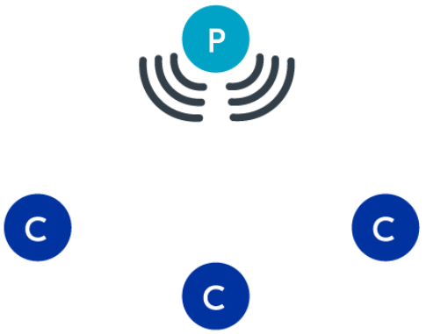
Figure 1 Broadcast topology with one peripheral and several central [1]
When a peripheral device is in an advertising state, it sends out advertising packets periodically at advertising intervals on the advertisement channels.
Advertising intervals: The interval at which an advertising packet is sent. This is in the range of 20 ms to 10.24 s, with a step increase of 0.625 ms.
Advertising channels: The three primary frequency channels (ch. 37, 38 and 39) on the 2.4 GHz band. See BLE Advertisment channels – SemFio Networks for more details.

