实验九：网络

设计Android项目，从<http://www.weather.com.cn/data/cityinfo/101200401.html>上取得某城市的天气信息，并按：

城市：XXX

最低气温：XX℃

最高气温：XX℃

天气状况：XXXXX

的格式显示在TextView中。

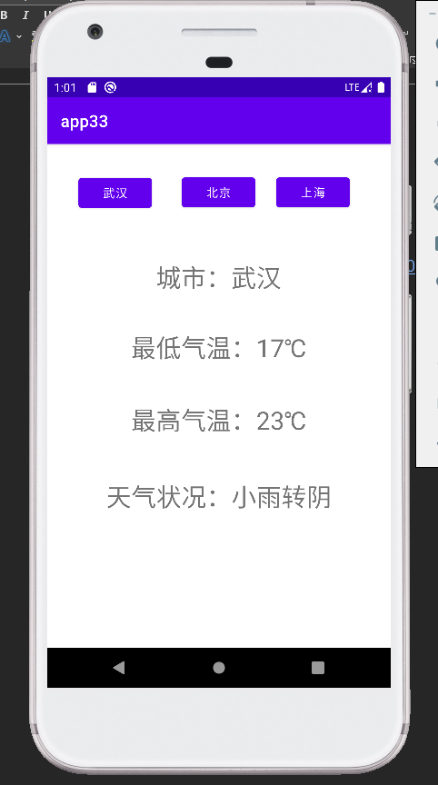

*package* com.shf.app33;  
  
*import* android.view.View;  
*import* android.widget.Button;  
*import* android.widget.TextView;  
*import* androidx.appcompat.app.AppCompatActivity;  
*import* android.os.Bundle;  
*import* org.json.JSONException;  
*import* org.json.JSONObject;  
  
*import* java.io.BufferedReader;  
*import* java.io.InputStreamReader;  
*import* java.net.URL;  
*import* java.net.URLConnection;  
  
*public class* MainActivity *extends* AppCompatActivity {  
 TextView tv_weather, tv_location, tv_temperature_min, tv_temperature_max;  
 Button btn_WH,btn_SH,btn_BJ;  
 String urlStr = "http://www.weather.com.cn/data/cityinfo/";  
 String cityId = "101200401";  
  
 *@Override  
 protected void* onCreate(Bundle savedInstanceState) {  
 *super*.onCreate(savedInstanceState);  
 setContentView(R.layout.activity_main);  
  
 tv_weather=findViewById(R.id.tv_weather);  
 tv_location=findViewById(R.id.tv_location);  
 tv_temperature_min=findViewById(R.id.tv_temperature_min);  
 tv_temperature_max=findViewById(R.id.tv_temperature_max);  
 btn_WH=findViewById(R.id.WH);  
 btn_SH=findViewById(R.id.SH);  
 btn_BJ=findViewById(R.id.BJ);  
  
 btn_WH.performClick();  
 }  
  
 *private void* getWeather(){  
 *new* Thread(*new* Runnable(){  
 *@Override  
 public void* run() {  
 URL url = *null*;  
 *try* {  
 url=*new* URL(urlStr+cityId+".html");  
 URLConnection urlConnection = url.openConnection();  
 InputStreamReader inputStreamReader = *new* InputStreamReader(urlConnection.getInputStream(), "UTF-8");  
 BufferedReader bufferedReader = *new* BufferedReader(inputStreamReader);  
 String line = "";  
 StringBuilder contentBuf = *new* StringBuilder();  
 *while* ((line=bufferedReader.readLine())!=*null*){  
 contentBuf.append(line);  
 }  
 JSONObject jsonObject = *new* JSONObject(contentBuf.toString());  
*// System.out.println(jsonObject);* JSONObject weatherinfo = jsonObject.getJSONObject("weatherinfo");  
*// System.out.println(weatherinfo);* tv_weather.post(*new* Runnable() {  
 *@Override  
 public void* run() {  
 *try* {  
 tv_weather.setText("天气状况："+weatherinfo.getString("weather"));  
 tv_location.setText("城市："+weatherinfo.getString("city"));  
 tv_temperature_min.setText("最低气温："+weatherinfo.getString("temp1"));  
 tv_temperature_max.setText("最高气温："+weatherinfo.getString("temp2"));  
 } *catch* (JSONException e) {  
 *throw new* RuntimeException(e);  
 }  
 }  
 });  
  
  
 } *catch* (Exception e) {  
 *throw new* RuntimeException(e);  
 }  
 }  
 }).start();  
 }  
  
 *public void* show(View view) {  
 *int* id = view.getId();  
 *if* (id==btn_WH.getId()){  
 cityId = "101200101";  
 } *else if* (id==btn_BJ.getId()){  
 cityId = "101010100";  
 } *else if* (id==btn_SH.getId()){  
 cityId = "101020100";  
 }  
 getWeather();  
 }  
}