实验二：组件使用与事件模型

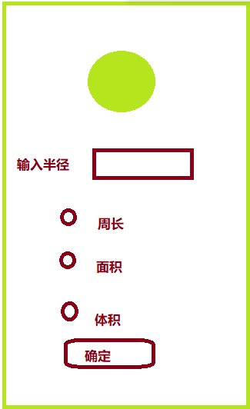

设计如上图界面，输入半径，根据选择分别求圆的周长、面积和球体体积；要求选定某项后，图片对应变化，计算结果用Toast显示在手机屏上。

package com.shf.app7_sy_2;  
  
import android.view.View;  
import android.widget.*;  
import androidx.appcompat.app.AppCompatActivity;  
import android.os.Bundle;  
  
public class MainActivity extends AppCompatActivity implements RadioGroup.OnCheckedChangeListener, View.OnClickListener *{* private ImageView img;  
 private EditText radius;  
 private RadioButton perimeter;  
 private RadioButton area;  
 private RadioButton volume;  
 private Button btn;  
 private RadioGroup rg;  
 private int index = 0;  
  
 @Override  
 protected void onCreate*(*Bundle savedInstanceState*) {* super.onCreate*(*savedInstanceState*)*;  
 setContentView*(*R.layout.*activity_main)*;  
  
 img = findViewById*(*R.id.*img)*;  
 radius = findViewById*(*R.id.*radius)*;  
 perimeter = findViewById*(*R.id.*perimeter)*;  
 area = findViewById*(*R.id.*area)*;  
 volume = findViewById*(*R.id.*volume)*;  
 btn = findViewById*(*R.id.*btn)*;  
 rg = findViewById*(*R.id.*rg)*;  
  
 rg.setOnCheckedChangeListener*(*this*)*;  
 btn.setOnClickListener*(*this*)*;  
 *}* @Override  
 public void onCheckedChanged*(*RadioGroup radioGroup, int i*) {  
// Toast.makeText(getApplicationContext(), i+"", Toast.LENGTH_SHORT).show();* switch (i){  
 case R.id.perimeter:  
 index=0;  
 img.setImageResource(R.drawable.circle1);  
 break;   
 case R.id.area:  
 index=1;  
 img.setImageResource(R.drawable.circle2);  
 break;  
 case R.id.volume:  
 index=2;  
 img.setImageResource(R.drawable.circle3);  
 break;  
 }  
 *}* @Override  
 public void onClick*(*View view*) {* String result = "";  
 double r = Double.*parseDouble(*radius.getText*()*.toString*())*;  
  
 if *(*index==0*){  
// 求周长* result="半径为："+r+"的周长为："+2*Math.*PI*\*r;  
 *}* else if *(*index==1*){  
// 求面积* result="半径为："+r+"的面积为："+Math.*PI*\*Math.*pow(*r,2*)*;  
 *}* else if *(*index==2*){  
// 求体积* result="半径为："+r+"的体积为："+*(*4.0*Math.*PI*\*Math.*pow(*r,3*))*/3;  
 *}* Toast.*makeText(*getApplicationContext*()*, result, Toast.*LENGTH_LONG)*.show*()*;  
 *}  
}*

