1) 程序如下：

public class Fruit

{

public virtual string Name

{

get

{

return ("Fruit");

}

}

}

public class Apple : Fruit

{

public override string Name

{

get

{

return ("Apple");

}

}

}

public class Banana : Fruit

{

public override string Name

{

get

{

return ("Banana");

}

}

}

public class FruitBasket : IEnumerable

{

static int Max = 10;

Fruit[] basket = new Fruit[Max];

int count = 0;

internal Fruit this[int index]

{

get

{

return (basket[index]);

}

set

{

basket[index] = value;

}

}

internal int Count

{

get

{

return (count);

}

}

public void Add(Fruit fruit)

{

if (count >=Max)

{

Console.WriteLine("超出水果篮容量!");

}

basket[count++] = fruit;

}

public IEnumerator GetEnumerator()

{

return (new FruitBasketEnumerator(this));

}

}

public class FruitBasketEnumerator : IEnumerator

{

FruitBasket fruitBasket;

int index;

public void Reset()

{

index = -1;

}

public object Current

{

get

{

return (fruitBasket[index]);

}

}

public bool MoveNext()

{

if (++index >= fruitBasket.Count)

return (false);

else

return (true);

}

internal FruitBasketEnumerator(FruitBasket fruitBasket)

{

this.fruitBasket = fruitBasket;

Reset();

}

}

class Program

{

static void Main(string[] args)

{

FruitBasket fruitBasket = new FruitBasket();

Console.WriteLine("Adding an Apple");

fruitBasket.Add(new Apple());

Console.WriteLine("Adding a Banana");

fruitBasket.Add(new Banana());

Console.WriteLine();

Console.WriteLine("The basket is holding:");

foreach (Fruit fruit in fruitBasket)

{

Console.WriteLine(" 装入水果： " + fruit.Name);

}

Console.Read();

}

}

运行程序，运行结果截图如下：

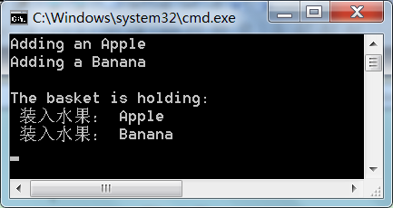

2）当装入水果超过10个时，程序运行会发生什么情况？

static void Main(string[] args)

{

FruitBasket fruitBasket = new FruitBasket();

Console.WriteLine("Adding an Apple");

fruitBasket.Add(new Apple());

Console.WriteLine("Adding a Banana");

fruitBasket.Add(new Banana());

**for (int i = 0; i < 10; i++)**

**{**

**Console.WriteLine("Adding a Apple");**

**fruitBasket.Add(new Apple());**

**}**

Console.WriteLine();

Console.WriteLine("The basket is holding:");

foreach (Fruit fruit in fruitBasket)

{

Console.WriteLine(" 装入水果： " + fruit.Name);

}

Console.Read();

}

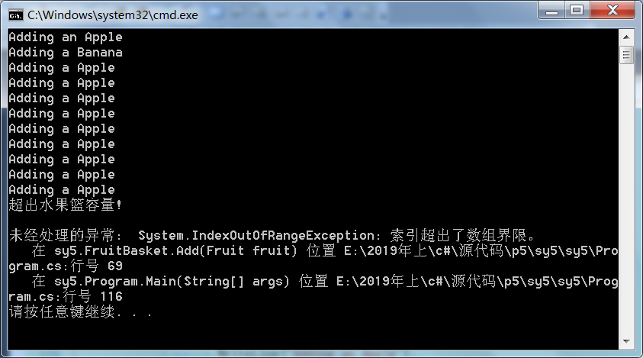

如何解决？

public void Add(Fruit fruit)

{

if (count >=Max)

{

Console.WriteLine("超出水果篮容量!");

**return;**

}

basket[count++] = fruit;

}

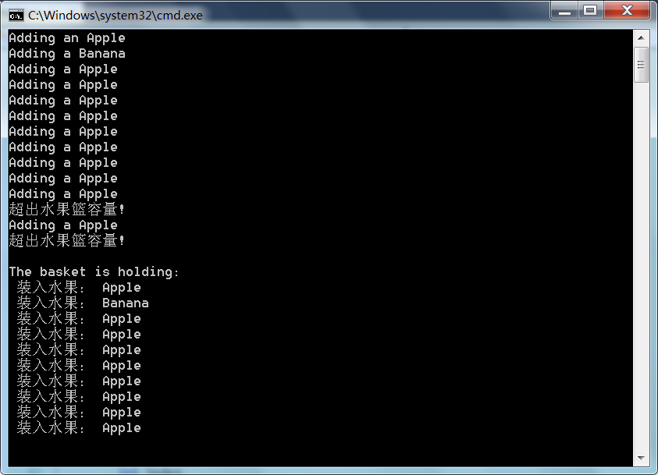

(3)如果在水果篮中再装入橘子（Orange），如何修改程序？

namespace sy5

{

public class Fruit

{

……

}

……

**public class Orange : Fruit**

**{**

**public override string Name**

**{**

**get**

**{**

**return ("Orange");**

**}**

**}**

**}**

……

class Program

{

static void Main(string[] args)

{

……

Console.WriteLine("Adding a Banana");

fruitBasket.Add(new Banana());

**Console.WriteLine("Adding an Orange");**

**fruitBasket.Add(new Orange());**

……

}

}

}

