实验5 JavaScript操作DOM对象
实验类型：验证性 要求：必做 学时：2
一、实验目的
1. 掌握DOM的用法。
2. 掌握window,history,document等常用BOM对象的用法。
3. 掌握用getElementById()、getElementsByName()、getElementsByTagName()方法访问DOM元素。
二、实验要求
1、制作关闭按钮，删除按钮。
2、使用HBuilder作为网页文本编辑器。
3、制作页面的前进、后退等。
三、实验内容
1. 访问当当购物车页面节点
<!DOCTYPE html>
<html>
<head lang="en">
<meta charset="UTF-8">
<title>访问当当购物车页面节点</title>
<link type="text/css" rel="stylesheet" href="css/cartStyle.css" />
</head>
<body>
<div class="content">
<div class="logo">
<img src="images/dd_logo.jpg"><span onclick="close_plan();">关闭</span>
</div>
<div class="cartList" id="cartList">
<ul>
<li>¥<input type="text" name="price" value="21.90"></li>
<li><input type="button" name="minus" value="-" onclick="minus(0);"><input type="text" name="amount" value="1"><input type="button" name="plus" value="+" onclick="plus(0);"></li>
<li id="price0">¥21.90</li>
<li><p onclick="collection();">移入收藏</p><p onclick="del();">删除</p></li>
</ul>
<ul>
<li>¥<input type="text" name="price" value="24.00"></li>
<li><input type="button" name="minus" value="-" onclick="minus(1);"><input type="text" name="amount" value="1"><input type="button" name="plus" value="+" onclick="plus(1);"></li>
<li id="price1">¥24.00</li>
<li><p onclick="collection();">移入收藏</p><p onclick="del();">删除</p></li>
</ul>
<ol>
<li id="totalPrice">&nbsp;</li>
<li><span onclick="accounts();">结 算</span></li>
</ol>
</div>
<div></div>
</div>
<script type="text/javascript" src="js/shopping.js"></script>
<script type="text/javascript">
function accounts(){
let num1 = document.getElementById("cartList").firstElementChild.firstElementChild.nextSibling.nextSibling.firstChild.nextSibling.value;
let num2 = document.getElementById("cartList").firstElementChild.nextElementSibling.firstElementChild.nextSibling.nextSibling.firstChild.nextSibling.value;
let total = document.getElementById("cartList").lastElementChild.firstElementChild.innerHTML;
console.log(num1)
console.log(num2)
console.log(total)
var str="您本次购买的商品信息如下：<br/>白岩松：白说："+num1+"<br/>岛上书店："+num2+"<br/>商品共计："+total;
document.getElementById("cartList").nextElementSibling.innerHTML=str;
}
</script>
</body>
</html>
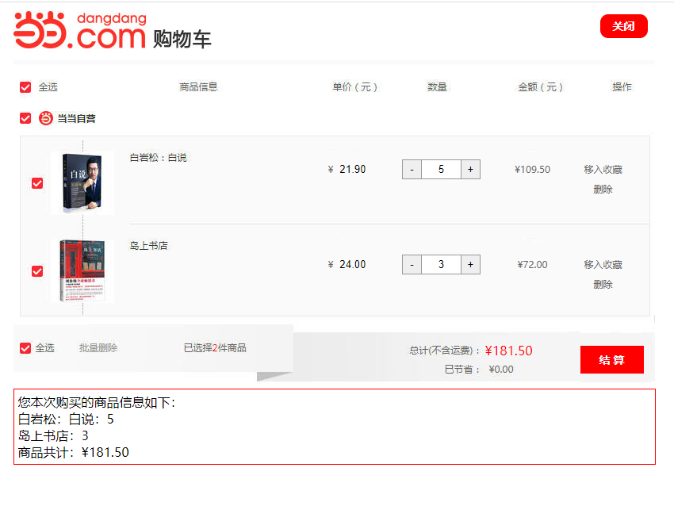
⒉操作当当购物车页面
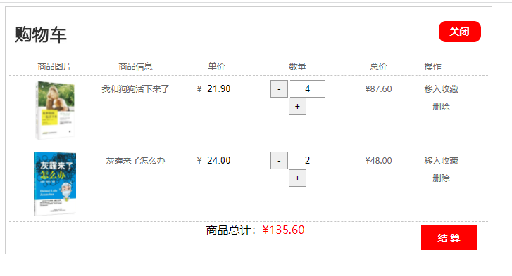
<!DOCTYPE html>
<html>
<head lang="en">
<meta charset="UTF-8">
<title>操作当当购物车页面</title>
<link type="text/css" rel="stylesheet" href="css/cartStyle.css" />
</head>
<body>
<div class="content">
<div class="logo">
<img src="images/dd_logo.jpg"><span onclick="close_plan();">关闭</span>
</div>
<div class="cartList" id="cartList">
<ul>
<li>商品图片</li>
<li>商品信息</li>
<li>单价</li>
<li>数量</li>
<li>总价</li>
<li>操作</li>
</ul>
<ul>
<li><img src="images/dog.jpg"></li>
<li>我和狗狗活下来了</li>
<li>¥<input type="text" name="price" value="21.90"></li>
<li>
<input type="button" name="minus" value="-" onclick="minus(0);">
<input type="text" name="amount" value="1" onchange="setAmount(0,this)">
<input type="button" name="plus" value="+" onclick="plus(0);">
</li>
<li id="price0">¥21.90</li>
<li>
<p onclick="collection();">移入收藏</p>
<p onclick="del(this);">删除</p>
</li>
</ul>
<ul>
<li><img src="images/mai.jpg"></li>
<li>灰霾来了怎么办</li>
<li>¥<input type="text" name="price" value="24.00"></li>
<li>
<input type="button" name="minus" value="-" onclick="minus(1);">
<input type="text" name="amount" value="1" onchange="setAmount(1,this)">
<input type="button" name="plus" value="+" onclick="plus(1);">
</li>
<li id="price1">¥24.00</li>
<li>
<p onclick="collection();">移入收藏</p>
<p onclick="del(this);">删除</p>
</li>
</ul>
<ol>
<li id="totalPrice">商品总计：<span></span></li>
<li><span onclick="accounts()">结 算</span></li>
</ol>
</div>
</div>
<script>
function close_plan() {
window.close();
}
function collection() {
if (confirm("移入收藏后，将不再购物车显示，是否继续操作?")) alert("移入收藏成功！！！")
}
function del(t) {
// console.log(t)
t.parentNode.parentNode.parentNode.removeChild(t.parentNode.parentNode)
totalPrice()
}
function minus(num) {
let price = document.getElementsByName("price")[num].value;
let amount = document.getElementsByName("amount")[num].value;
if (amount<=1) alert("不能再减了")
else {
amount--;
document.getElementsByName("amount")[num].value=amount;
document.getElementById("price"+num).innerHTML="¥"+(price*amount).toFixed(2)
}
totalPrice()
}
function plus(num) {
// console.log(num)
let price = document.getElementsByName("price")[num].value;
let amount = document.getElementsByName("amount")[num].value
amount++;
document.getElementsByName("amount")[num].value=amount;
document.getElementById("price"+num).innerHTML="¥"+(price*amount).toFixed(2)
totalPrice()
}
function setAmount(num,_this) {
// console.log(_this.value)
document.getElementsByName("amount")[num].value=_this.value
countPrice(num)
}
function countPrice(num) {
let price = document.getElementsByName("price")[num].value;
let amount = document.getElementsByName("amount")[num].value
document.getElementsByName("amount")[num].value=amount;
document.getElementById("price"+num).innerHTML="¥"+(price*amount).toFixed(2)
totalPrice()
}
function totalPrice() {
let price = document.getElementsByName("price")
let amount = document.getElementsByName("amount")
let sum = 0;
for (let i = 0; i < price.length; i++) {
sum += price[i].value * amount[i].value
}
document.getElementById("totalPrice").childNodes[1].innerHTML="¥"+sum.toFixed(2);
}
totalPrice()
function accounts() {
let str="您本次购买的商品信息如下：\n商品名称：\n"
let price = document.getElementsByName("price")
// console.log(price[0].parentNode.parentNode.childNodes[3].innerHTML)
for (let i=0;i<price.length; i++) {
str += price[i].parentNode.parentNode.childNodes[3].innerHTML + "\n"
}
str += "商品数量："
// console.log(price[0].parentNode.parentNode.childNodes[7].childNodes[3].value)
let c=0;
for (let i=0;i<price.length; i++) {
c+=parseInt(price[i].parentNode.parentNode.childNodes[7].childNodes[3].value)
}
str += c + "件；\n"
str+="商品总计："
let amount = document.getElementsByName("amount")
let sum = 0;
for (let i = 0; i < price.length; i++) {
sum += price[i].value * amount[i].value
}
str += sum+"元；运费：0元；\n请确认以上信息是否有误！！！"
confirm(str)? alert("提交成功"):console.log("");
}
</script>
</body>
</html>

3. 制作论坛发贴
<!DOCTYPE html>
<html>
<head lang="en">
<meta charset="UTF-8">
<title>课工场论坛列表</title>
<link href="css/bbs.css" rel="stylesheet">
</head>
<body>
<div class="bbs">
<header><span onclick="post()">我要发帖</span></header>
<section>
<ul id="postList"></ul>
</section>
<div class="post" id="post">
<input class="title" placeholder="请输入标题（1-50个字符）" id="title">
所属版块：<select id="sec"><option>请选择版块</option><option>电子书籍</option><option>新课来了</option><option>新手报到</option><option>职业规划</option></select>
<textarea class="content" id="content"></textarea>
<input class="btn" value="发布" onclick="postSuccess()">
</div>
</div>
<script>
function post() {
document.getElementById("post").style.display = "block";
}
function postSuccess() {
let newLi = document.createElement("li");
let random = parseInt(Math.random()*4)+1;
let touDiv = document.createElement("div");
let touImg = document.createElement("img");
touImg.setAttribute("src","images/tou0"+random+".jpg")
touDiv.appendChild(touImg);
let titleH1 = document.createElement("h1");
let title = document.getElementById("title").value;
titleH1.innerHTML=title
let newP = document.createElement("p");
let newSpan = document.createElement("span");
let sec = document.getElementById("sec").value;
newSpan.innerHTML="板块”："+sec
let date = new Date();
let currentDate = date.getFullYear()+"-"+(date.getMonth()+1)+"-"+date.getDate()+" "+date.getHours()+":"+date.getMinutes()+":"+date.getSeconds();
let timeSpan = document.createElement("span");
timeSpan.innerHTML="发表时间："+currentDate
newP.appendChild(newSpan)
newP.appendChild(timeSpan)
newLi.appendChild(touDiv)
newLi.appendChild(titleH1)
newLi.appendChild(newP)
let postList = document.getElementById("postList");
console.log(postList)
postList.insertBefore(newLi,postList.firstChild)
document.getElementById("title").value=""
document.getElementById("content").value=""
document.getElementById("post").style.display = "none"
}
</script>
</body>
</html>

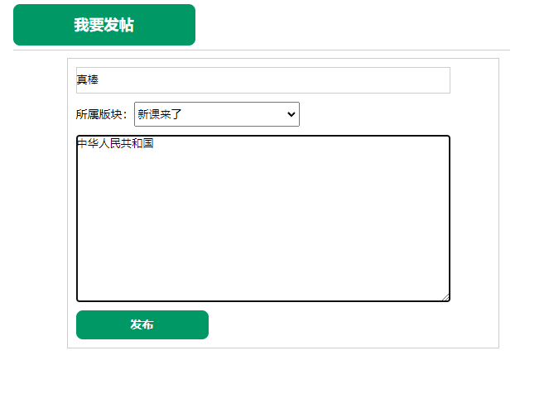
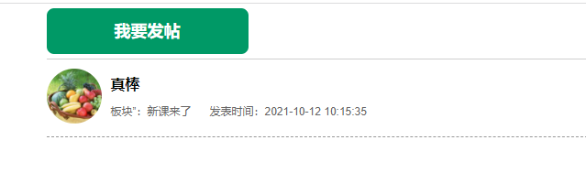
4.制作带关闭按钮的广告
<!DOCTYPE html>
<html>
<head lang="en">
<meta charset="UTF-8">
<title>带关闭按钮的滚动广告</title>
<style type="text/css">
#main{ text-align:center;}
#float{
position:absolute;
left:30px;
top:60px;
z-index:1;
}
#close{
position:absolute;
top:60px;
left:134px;
z-index:2;
cursor:hand;
}
</style>
</head>
<body>
<div id="close" onClick="adv_close()"><img src="images/close.jpg"></div>
<div id="float"><img src="images/advpic.jpg"></div>
<div id="main"><img src="images/contentpic.jpg"></div>
<script>
function adv_close(){
document.getElementById("close").style.display="none";
document.getElementById("float").style.display="none";
}
var closeTop;
var closeLeft;
var floatTop;
var floatLeft;
var closeObject;
var floatObject;
function place(){
closeObject=document.getElementById("close");
floatObject=document.getElementById("float");
if(closeObject.currentStyle){//IE浏览器
closeTop=parseInt(closeObject.currentStyle.top);
closeLeft=parseInt(closeObject.currentStyle.left);
floatTop=parseInt(floatObject.currentStyle.top);
floatLeft=parseInt(floatObject.currentStyle.left);
}
else{//fireFox浏览器
closeTop=parseInt(document.defaultView.getComputedStyle(closeObject,null).top);
closeLeft=parseInt(document.defaultView.getComputedStyle(closeObject,null).left);
floatTop=parseInt(document.defaultView.getComputedStyle(floatObject,null).top);
floatLeft=parseInt(document.defaultView.getComputedStyle(floatObject,null).left);
}
}
function roll(){
var closeScrollTop=parseInt(document.documentElement.scrollTop||document.body.scrollTop);
var closeScrolllLeft=parseInt(document.documentElement.scrollLeft||document.body.scrollLeft);
var floatScrollTop=parseInt(document.documentElement.scrollTop||document.body.scrollTop);
var floatScrolllLeft=parseInt(document.documentElement.scrollLeft||document.body.scrollLeft);
closeObject.style.top=closeTop+closeScrollTop+"px";
closeObject.style.left=closeLeft+closeScrolllLeft+"px";
floatObject.style.top=floatTop+floatScrollTop+"px";
floatObject.style.left=floatLeft+floatScrolllLeft+"px";
}
window.onload=place;
window.onscroll=roll;
</script>
</body>
</html>


五、实验小结
通过本次实验我学会了DOM的基本语法，掌握window、history、document等常用BOM对象的用法 ，掌握用getElementById()、getElementsByName()、getElementsByTagName()方法访问DOM元素。

