# 实验五 JavaBean的应用

## 实验目的与要求

1. 理解并掌握JavaBean的主要应用技术以及JSP+JDBC+JavaBean模式（即Model1模式）的Web应用开发技术。
2. 参考教材的有关内容与示例，按要求编写并调试相应的程序。

## 实验内容

参见教材P335～337实验5的实验内容之1～5。

## 实验代码

DbBean.java

package com.shf.mvc.beans;  
  
import java.sql.*;  
import java.util.ArrayList;  
import java.util.Arrays;  
import java.util.List;  
  
public class DbBean *{* public static Connection *con*;  
  
 static *{* try *{  
 con* = *getConnection()*;  
 *}* catch *(*ClassNotFoundException e*) {* e.printStackTrace*()*;  
 *}* catch *(*SQLException e*) {* e.printStackTrace*()*;  
 *}  
 }* public static Connection getConnection*()* throws ClassNotFoundException, SQLException *{* Class.*forName(*"com.mysql.jdbc.Driver"*)*;  
 *con* = DriverManager.*getConnection(*"jdbc:mysql://localhost:3306/test1", "root", "root"*)*;  
 return *con*;  
 *}* public static void closeConnection*()* throws SQLException *{  
 con*.close*()*;  
 *}* public static void addUser*(*List*<*String*>* pars*)* throws SQLException *{* PreparedStatement preparedStatement = *con*.prepareStatement*(*"insert into score values (?,?,?,?,?,?,?)"*)*;  
  
 preparedStatement.setString*(*1, pars.get*(*0*))*;  
 preparedStatement.setString*(*2, pars.get*(*1*))*;  
 preparedStatement.setString*(*3, pars.get*(*2*))*;  
 preparedStatement.setString*(*4, pars.get*(*3*))*;  
 preparedStatement.setString*(*5, pars.get*(*4*))*;  
 preparedStatement.setString*(*6, pars.get*(*5*))*;  
 preparedStatement.setString*(*7, pars.get*(*6*))*;  
 preparedStatement.executeUpdate*()*;  
  
 preparedStatement.close*()*;  
 *}* public static void alterUser*(*List*<*String*>* pars*)* throws SQLException *{* PreparedStatement preparedStatement = *con*.prepareStatement*(*"update score set xm=?,bh=?,sx=?,yy=?,yw=?,zf=? where xh=?"*)*;  
  
 preparedStatement.setString*(*1, pars.get*(*0*))*;  
 preparedStatement.setString*(*2, pars.get*(*1*))*;  
 preparedStatement.setString*(*3, pars.get*(*2*))*;  
 preparedStatement.setString*(*4, pars.get*(*3*))*;  
 preparedStatement.setString*(*5, pars.get*(*4*))*;  
 preparedStatement.setString*(*6, pars.get*(*5*))*;  
 preparedStatement.setString*(*7, pars.get*(*6*))*;  
 System.*out*.println*(*preparedStatement*)*;  
  
 preparedStatement.executeUpdate*()*;  
  
 preparedStatement.close*()*;  
 *}* public static void deleteUser*(*String xh*)* throws SQLException *{* PreparedStatement preparedStatement = *con*.prepareStatement*(*"delete from score where xh=?"*)*;  
 preparedStatement.setString*(*1, xh*)*;  
 preparedStatement.executeUpdate*()*;  
  
 preparedStatement.close*()*;  
 *}* public static List*<*String*>* showUserInfo*(*List*<*String*>* pars*)* throws SQLException *{* PreparedStatement preparedStatement = *con*.prepareStatement*(*"select * from score where xh=?"*)*;  
 preparedStatement.setString*(*1, pars.get*(*0*))*;  
 ResultSet resultSet = preparedStatement.executeQuery*()*;  
 resultSet.next*()*;  
 String bh = resultSet.getString*(*"bh"*)*;  
 String xh = resultSet.getString*(*"xh"*)*;  
 String xm = resultSet.getString*(*"xm"*)*;  
 String yw = resultSet.getString*(*"yw"*)*;  
 String sx = resultSet.getString*(*"sx"*)*;  
 String yy = resultSet.getString*(*"yy"*)*;  
 String zf = resultSet.getString*(*"zf"*)*;  
 preparedStatement.close*()*;  
 return Arrays.*asList(*bh, xh, xm, yw, sx, yy, zf*)*;  
 *}* public static Integer countUser*(*String bh*)* throws SQLException *{* PreparedStatement countSql = *con*.prepareStatement*(*"select count(*) cou from score where bh=?"*)*;  
 countSql.setString*(*1, bh*)*;  
 ResultSet countN = countSql.executeQuery*()*;  
 countN.next*()*;  
 Integer cou = Integer.*parseInt(*countN.getString*(*"cou"*))*;  
 System.*out*.println*(*"cou="+cou*)*;  
 countSql.close*()*;  
 return cou;  
 *}* public static List*<*List*<*String*>>* showUserInfoPages*(*List*<*String*>* pars*)* throws SQLException *{* PreparedStatement preparedStatement = *con*.prepareStatement*(*"select * from score where bh=? limit ?,? "*)*;  
 preparedStatement.setString*(*1, *(*String*)* pars.get*(*0*))*;  
 preparedStatement.setInt*(*2, Integer.*parseInt(*pars.get*(*1*)))*;  
 preparedStatement.setInt*(*3, Integer.*parseInt(*pars.get*(*2*)))*;  
 ResultSet resultSet = preparedStatement.executeQuery*()*;  
 List*<*List*<*String*>>* list = new ArrayList*<>()*;  
 while *(*resultSet.next*()) {* String xh = resultSet.getString*(*"xh"*)*;  
 String xm = resultSet.getString*(*"xm"*)*;  
 String bh = resultSet.getString*(*"bh"*)*;  
 String zf = resultSet.getString*(*"zf"*)*;  
 list.add*(*Arrays.*asList(*xh,xm,bh,zf*))*;  
 *}* preparedStatement.close*()*;  
 return list;  
 *}  
}*

addUser.jsp

*<%--  
 Created by IntelliJ IDEA.  
 User: SHF  
 Date: 2021/10/18  
 Time: 10:25  
 To change this template use File | Settings | File Templates.  
--%>  
<%@* page contentType="text/html;charset=UTF-8" language="java" *%>  
<*html*>  
<*head*>  
 <*title*>*addUser*</*title*>  
</*head*>  
<*body*>  
<*form action="/demo5/jdbcAddUser.jsp" method="post" style="margin: auto;width: 500px;text-align: center"*>  
<*h2*>*学生成绩增加*</*h2*>* 班级：  
 *<*select name="bh" id=""*>  
 <*option value="200201011"*>*200201011*</*option*>  
 <*option value="200201012"*>*200201012*</*option*>  
 </*select*> <*br*>* 学号： *<*input type="text" name="xh"*> <*br*>* 姓名： *<*input type="text" name="xm"*> <*br*>* 语文： *<*input type="text" name="yw"*> <*br*>* 数学： *<*input type="text" name="sx"*> <*br*>* 英语： *<*input type="text" name="yy"*> <*br*>  
 <*input type="submit" value="提交"*>  
 <*input type="reset" value="重置"*>  
</*form*>  
</*body*>  
</*html*>*

jdbcAddUser.jsp

*<%@* page import="java.sql.Connection" *%>  
<%@* page import="java.sql.DriverManager" *%>  
<%@* page import="java.sql.Statement" *%>  
<%@* page import="java.sql.PreparedStatement" *%>  
<%@* page import="java.util.Arrays" *%>  
<%@* page import="static com.shf.mvc.beans.DbBean.addUser" *%><%--  
 Created by IntelliJ IDEA.  
 User: SHF  
 Date: 2021/10/19  
 Time: 8:29  
 To change this template use File | Settings | File Templates.  
--%>  
<%@* page contentType="text/html;charset=UTF-8" language="java" *%>  
<*html*>  
<*head*>  
 <*title*>*Title*</*title*>  
</*head*>  
<*body*>*<%  
 request.setCharacterEncoding*(*"UTF-8"*)*;  
 String bh = request.getParameter*(*"bh"*)*;  
 String xh = request.getParameter*(*"xh"*)*;  
 String xm = request.getParameter*(*"xm"*)*;  
 String yw = request.getParameter*(*"yw"*)*;  
 String sx = request.getParameter*(*"sx"*)*;  
 String yy = request.getParameter*(*"yy"*)*;  
 String zf = String.*valueOf(*Double.*parseDouble(*yw*)*+Double.*parseDouble(*sx*)*+Double.*parseDouble(*yy*))*;  
  
 *addUser(*Arrays.*asList(*xh,xm,bh,sx,yy,yw,zf*))*;  
  
 response.sendRedirect*(*"/demo5/selectClass.jsp"*)*;  
%>  
*</*body*>  
</*html*>*

selectClass.jsp

*<%--  
 Created by IntelliJ IDEA.  
 User: SHF  
 Date: 2021/10/19  
 Time: 9:17  
 To change this template use File | Settings | File Templates.  
--%>  
<%@* page contentType="text/html;charset=UTF-8" language="java" *%>  
<*html*>  
<*head*>  
 <*title*>*Title*</*title*>  
</*head*>  
<*body*>  
<*form action="/demo5/showScore.jsp"*>  
 <*h2*>*部门：  
 *<*select name="bh" id=""*>  
 <*option value="200201011"*>*200201011*</*option*>  
 <*option value="200201012"*>*200201012*</*option*>  
 </*select*> <*br*>  
 </*h2*>  
 <*input type="submit" value="提交"*>  
</*form*>  
</*body*>  
</*html*>*

showScore.jsp

*<%@* page import="java.sql.*" *%>  
<%@* page import="static com.shf.mvc.beans.DbBean.con" *%>  
<%@* page import="static com.shf.mvc.beans.DbBean.countUser" *%>  
<%@* page import="java.util.Arrays" *%>  
<%@* page import="static com.shf.mvc.beans.DbBean.*" *%>  
<%@* page import="java.util.List" *%><%--  
 Created by IntelliJ IDEA.  
 User: SHF  
 Date: 2021/10/19  
 Time: 9:18  
 To change this template use File | Settings | File Templates.  
--%>  
<%@* page contentType="text/html;charset=UTF-8" language="java" *%>*<%  
 String bh = request.getParameter*(*"bh"*)*;  
 int getPage = request.getParameter*(*"page"*)*!=null?Integer.*parseInt(*request.getParameter*(*"page"*))*:0;  
 System.*out*.println*(*bh*)*;  
 System.*out*.println*(*getPage*)*;  
  
 Integer count = *countUser(*bh*)*;  
  
 int pageSize=2;  
 int currentPage=1;  
 int pageNumber=count%pageSize==0?count/pageSize:count/pageSize+1;  
 if *(*getPage == 0*)* currentPage=1;  
 else if *(*getPage<=1*)* currentPage=1;  
 else if *(*getPage>=pageNumber*)* currentPage=pageNumber;  
 else currentPage=getPage;  
  
 int sql=*(*currentPage-1*)*\*pageSize;  
 System.*out*.println*(*sql*)*;  
 List*<*List*<*String*>>* lists = *showUserInfoPages(*Arrays.*asList(*bh, String.*valueOf(*sql*)*, String.*valueOf(*pageSize*)))*;  
%>  
*<*html*>  
<*head*>  
 <*title*>*Title*</*title*>  
</*head*>  
<*body*>  
 <*table border="1"*>  
 <*h2*>*学生成绩*</*h2*>  
 <*tr*>  
 <*td*>*学号*</*td*>  
 <*td*>*姓名*</*td*>  
 <*td*>*班级*</*td*>  
 <*td*>*总分*</*td*>  
 <*td*>*详情*</*td*>  
 <*td*>*修改*</*td*>  
 <*td*>*删除*</*td*>  
 </*tr*>* <%  
 for *(*List*<*String*>* list : lists*) {* %>  
 *<*tr*>  
 <*td*><*em*>*<%=list.get*(*0*)*%>*</*em*></*td*>  
 <*td*><*em*>*<%=list.get*(*1*)*%>*</*em*></*td*>  
 <*td*><*em*>*<%=list.get*(*2*)*%>*</*em*></*td*>  
 <*td*><*em*>*<%=list.get*(*3*)*%>*</*em*></*td*>  
 <*td*><*em*><*a href="/demo5/showScoreInfo.jsp?xh=<%=list.get*(*0*)*%>"*>*详情*</*a*></*em*></*td*>  
 <*td*><*em*><*a href="/demo5/jdbcAlter.jsp?xh=<%=list.get*(*0*)*%>"*>*修改*</*a*></*em*></*td*>  
 <*td*><*em*><*a href="/demo5/jdbcDelete.jsp?xh=<%=list.get*(*0*)*%>"*>*删除*</*a*></*em*></*td*>  
 </*tr*>* <%*}*%>  
 *<*p*>  
 <*span*>*第 <%=currentPage%> 页， 共 <%=pageNumber%> 页*</*span*>  
 <*a href="/demo5/showScore.jsp?bh=<%=bh%>"*>*首页*</*a*>* <% if*(*currentPage!=1*){*%>  
 *<*a href="/demo5/showScore.jsp?bh=<%=bh%>&page=<%=currentPage-1%>"*>*上一页*</*a*>* <%*}*%>  
 <% if*(*currentPage!=pageNumber*){*%>  
 *<*a href="/demo5/showScore.jsp?bh=<%=bh%>&page=<%=currentPage+1%>"*>*下一页*</*a*>* <%*}*%>  
 *<*input type="text" placeholder="跳转到第 N 页" id="N"*>  
 <*a href="javascript:;" onclick="*toShowScore(*<%=bh%>*)*"*>*跳转*</*a*>  
 </*p*>  
 </*table*>  
 <*script*>* function *toShowScore(*bh*) {* var N = document.getElementById*(*'N'*)*.value;  
 window.location.href="/demo5/showScore.jsp?bh="+bh+"&page="+N  
 *}  
 </*script*>  
</*body*>  
</*html*>*

showScoreInfo.jsp

*<%@* page import="java.sql.Connection" *%>  
<%@* page import="java.sql.PreparedStatement" *%>  
<%@* page import="java.sql.DriverManager" *%>  
<%@* page import="java.sql.ResultSet" *%>  
<%@* page import="static com.shf.mvc.beans.DbBean.con" *%>  
<%@* page import="static com.shf.mvc.beans.DbBean.showUserInfo" *%>  
<%@* page import="java.util.Arrays" *%>  
<%@* page import="java.util.List" *%><%--  
 Created by IntelliJ IDEA.  
 User: SHF  
 Date: 2021/10/19  
 Time: 9:40  
 To change this template use File | Settings | File Templates.  
--%>  
<%@* page contentType="text/html;charset=UTF-8" language="java" *%>*<%  
 String xh = request.getParameter*(*"xh"*)*;  
 System.*out*.println*(*xh*)*;  
  
 List*<*String*>* pars = *showUserInfo(*Arrays.*asList(*xh*))*;  
%>  
*<*html*>  
<*head*>  
 <*title*>*Title*</*title*>  
</*head*>  
<*body*>  
<*form*>  
 <*h1*>*详情*</*h1*>* 班级: *<*input type="text" name="bh" disabled value="<%=pars.get*(*0*)*%>"*> <*br*>* 学号: *<*input type="text" name="xh" disabled value="<%=pars.get*(*1*)*%>"*> <*br*>* 姓名: *<*input type="text" name="xm" disabled value="<%=pars.get*(*2*)*%>"*> <*br*>* 语文: *<*input type="text" name="yw" disabled value="<%=pars.get*(*3*)*%>"*> <*br*>* 数学: *<*input type="text" name="sx" disabled value="<%=pars.get*(*4*)*%>"*> <*br*>* 英语: *<*input type="text" name="yy" disabled value="<%=pars.get*(*5*)*%>"*> <*br*>* 总分: *<*input type="text" name="zf" disabled value="<%=pars.get*(*6*)*%>"*> <*br*>  
 <*a href="/demo5/selectClass.jsp"*>*返回选择班级页面*</*a*>  
</*form*>  
</*body*>  
</*html*>*

jdbcDelete.jsp

*<%@* page import="java.sql.Connection" *%>  
<%@* page import="java.sql.DriverManager" *%>  
<%@* page import="java.sql.PreparedStatement" *%>  
<%@* page import="java.sql.ResultSet" *%>  
<%@* page import="static com.shf.mvc.beans.DbBean.con" *%>  
<%@* page import="static com.shf.mvc.beans.DbBean.deleteUser" *%>  
<%@* page import="java.util.Arrays" *%><%--  
 Created by IntelliJ IDEA.  
 User: SHF  
 Date: 2021/10/19  
 Time: 11:01  
 To change this template use File | Settings | File Templates.  
--%>  
<%@* page contentType="text/html;charset=UTF-8" language="java" *%>*<%  
 String xh = request.getParameter*(*"xh"*)*;  
 System.*out*.println*(*xh*)*;  
  
 *deleteUser(*xh*)*;  
  
 response.sendRedirect*(*"/demo5/selectClass.jsp"*)*;  
%>  
*<*html*>  
<*head*>  
 <*title*>*Title*</*title*>  
</*head*>  
<*body*>  
  
</*body*>  
</*html*>*

jdbcAlter.jsp

*<%@* taglib prefix="form" uri="http://www.springframework.org/tags/form" *%>  
<%@* page import="java.sql.Connection" *%>  
<%@* page import="java.sql.PreparedStatement" *%>  
<%@* page import="java.sql.DriverManager" *%>  
<%@* page import="java.sql.ResultSet" *%>  
<%@* page import="static com.shf.mvc.beans.DbBean.con" *%>  
<%@* page import="static com.shf.mvc.beans.DbBean.showUserInfo" *%>  
<%@* page import="java.util.Arrays" *%>  
<%@* page import="java.util.List" *%><%--  
 Created by IntelliJ IDEA.  
 User: SHF  
 Date: 2021/10/19  
 Time: 11:02  
 To change this template use File | Settings | File Templates.  
--%>  
<%@* page contentType="text/html;charset=UTF-8" language="java" *%>*<%  
 String xh = request.getParameter*(*"xh"*)*;  
 System.*out*.println*(*xh*)*;  
  
 List*<*String*>* pars = *showUserInfo(*Arrays.*asList(*xh*))*;  
%>  
*<*html*>  
<*head*>  
 <*title*>*Title*</*title*>  
</*head*>  
<*body*>  
<*form action="/demo5/jdbcAlterController.jsp"*>  
 <*h2*>*学生成绩*</*h2*>* 班级: *<*input type="text" name="bh" value="<%=pars.get*(*0*)*%>"*> <*br*>* 学号: *<*input type="text" name="xh" value="<%=pars.get*(*1*)*%>" readonly*> <*br*>* 姓名: *<*input type="text" name="xm" value="<%=pars.get*(*2*)*%>"*> <*br*>* 语文: *<*input type="text" name="yw" value="<%=pars.get*(*3*)*%>"*> <*br*>* 数学: *<*input type="text" name="sx" value="<%=pars.get*(*4*)*%>"*> <*br*>* 英语: *<*input type="text" name="yy" value="<%=pars.get*(*5*)*%>"*> <*br*>* 总分: *<*input type="text" name="zf" value="<%=pars.get*(*6*)*%>" readonly*> <*br*>  
 <*input type="submit" value="提交"*>  
</*form*>  
</*body*>  
</*html*>*

jdbcAlterController.jsp

*<%@* page import="java.sql.PreparedStatement" *%>  
<%@* page import="java.sql.DriverManager" *%>  
<%@* page import="java.sql.Connection" *%>  
<%@* page import="static com.shf.mvc.beans.DbBean.con" *%>  
<%@* page import="static com.shf.mvc.beans.DbBean.alterUser" *%>  
<%@* page import="java.util.Arrays" *%>  
<%@* page import="java.sql.SQLException" *%><%--  
 Created by IntelliJ IDEA.  
 User: SHF  
 Date: 2021/10/19  
 Time: 11:19  
 To change this template use File | Settings | File Templates.  
--%>  
<%@* page contentType="text/html;charset=UTF-8" language="java" *%>*<%  
 request.setCharacterEncoding*(*"UTF-8"*)*;  
 String bh = request.getParameter*(*"bh"*)*;  
 String xh = request.getParameter*(*"xh"*)*;  
 String xm = request.getParameter*(*"xm"*)*;  
 String yw = request.getParameter*(*"yw"*)*;  
 String sx = request.getParameter*(*"sx"*)*;  
 String yy = request.getParameter*(*"yy"*)*;  
 String zf = String.*valueOf(*Double.*parseDouble(*yw*)*+Double.*parseDouble(*sx*)*+Double.*parseDouble(*yy*))*;  
  
 *alterUser(*Arrays.*asList(*xm,bh,sx,yy,yw,zf,xh*))*;  
  
 response.sendRedirect*(*"/demo5/selectClass.jsp"*)*;  
%>  
*<*html*>  
<*head*>  
 <*title*>*Title*</*title*>  
</*head*>  
<*body*>  
  
</*body*>  
</*html*>*

## 实验截图

添加学生

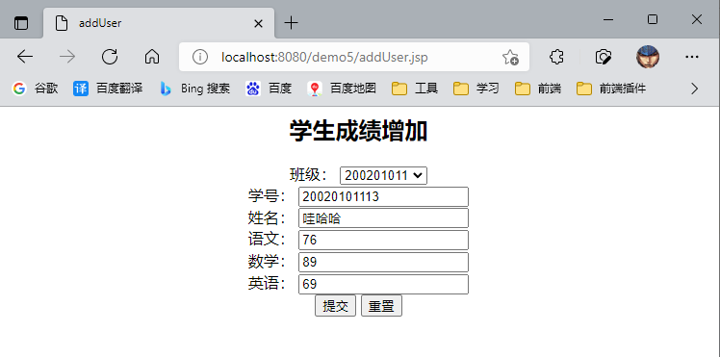

根据班级查询学生

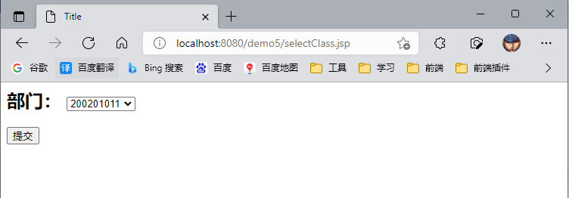

展示学生成绩 分页展示 每页两条，可跳转

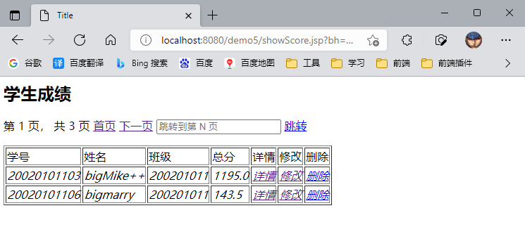

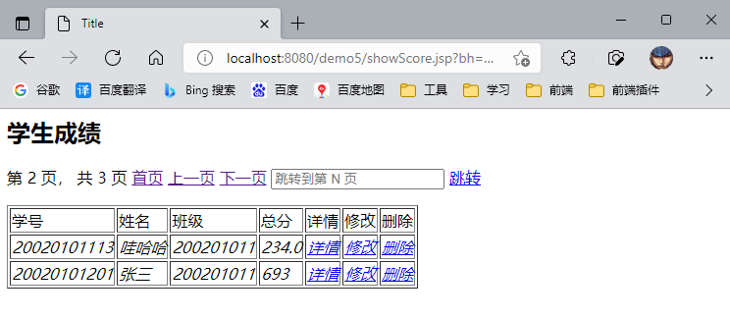

学生成绩详情

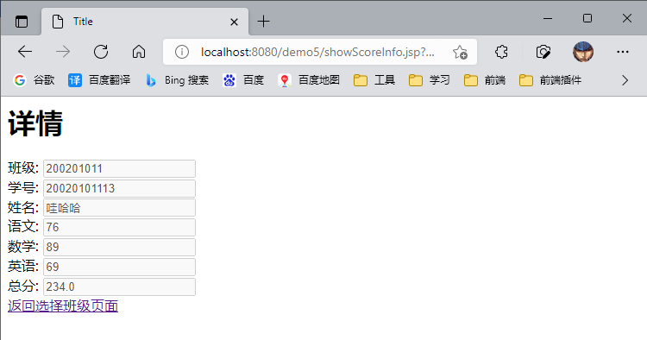

修改学生成绩

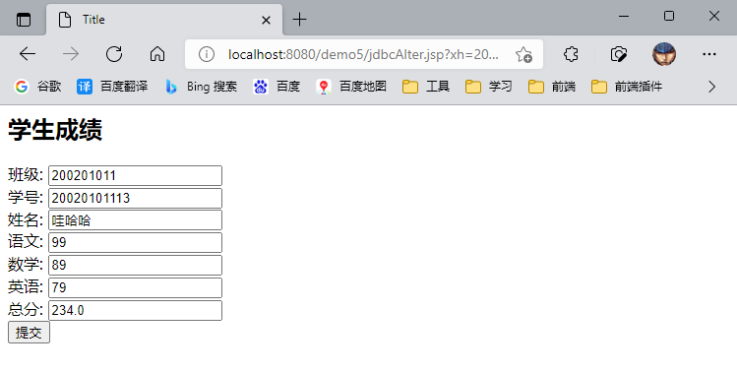

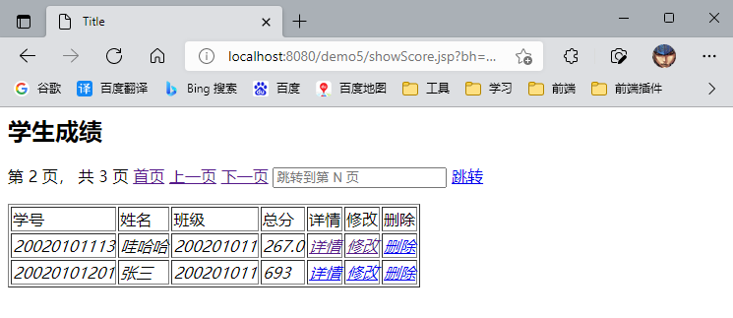

删除学生成绩

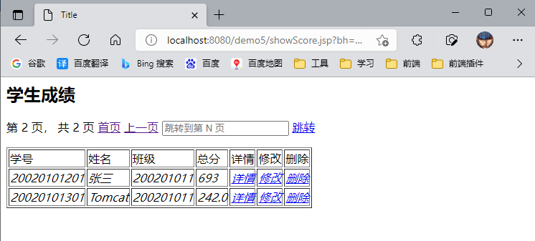

## 实验小结

通过本次实验我学会了通过JSP+JDBC结合javaBean来操作数据库，对JDBC的操作进行封装，在JSP页面直接调用。JavaBean中有连接数据库、关闭数据库连接、添加数据、修改数据、查询数据、删除数据的方法提供给JSP页面调用，让程序更容易阅读，让代码更加清晰。