# 实验九 JSP实用组件的应用

## 实验目的与要求

1. 掌握jspSmartUpload组件与jExcelAPI组件的基本应用技术。
2. 参考教材的有关内容与示例，按要求编写并调试相应的程序。

## 实验内容

参见教材P341～342实验9的实验内容之1～2。

## 实验代码

Web.xml

*<*servlet*>  
 <*servlet-name*>*UploadServlet*</*servlet-name*>  
 <*servlet-class*>*com.shf.mvc.servlet.UploadServlet*</*servlet-class*>  
</*servlet*>  
<*servlet-mapping*>  
 <*servlet-name*>*UploadServlet*</*servlet-name*>  
 <*url-pattern*>*/UploadServlet*</*url-pattern*>  
</*servlet-mapping*>  
<*servlet*>  
 <*servlet-name*>*exportExcelServlet*</*servlet-name*>  
 <*servlet-class*>*com.shf.mvc.servlet.exportExcelServlet*</*servlet-class*>  
</*servlet*>  
<*servlet-mapping*>  
 <*servlet-name*>*exportExcelServlet*</*servlet-name*>  
 <*url-pattern*>*/exportExcelServlet*</*url-pattern*>  
</*servlet-mapping*>*

UploadServlet.java

package com.shf.mvc.servlet;  
  
import org.apache.commons.fileupload.FileItem;  
import org.apache.commons.fileupload.disk.DiskFileItemFactory;  
import org.apache.commons.fileupload.servlet.ServletFileUpload;  
  
import javax.servlet.ServletException;  
import javax.servlet.http.HttpServlet;  
import javax.servlet.http.HttpServletRequest;  
import javax.servlet.http.HttpServletResponse;  
import java.io.File;  
import java.io.IOException;  
import java.io.PrintWriter;  
import java.util.List;  
  
public class UploadServlet extends HttpServlet *{* private static final long *serialVersionUID* = 1L;  
  
 *// 上传文件存储目录* private static final String *UPLOAD_DIRECTORY* = "upload";  
  
 *// 上传配置* private static final int *MEMORY_THRESHOLD* = 1024 * 1024 * 3; *// 3MB* private static final int *MAX_FILE_SIZE* = 1024 * 1024 * 40; *// 40MB* private static final int *MAX_REQUEST_SIZE* = 1024 * 1024 * 50; *// 50MB  
  
 /**  
 * 上传数据及保存文件  
 */* @Override  
 protected void doPost*(*HttpServletRequest request,HttpServletResponse response*)* throws ServletException, IOException *{  
 // 检测是否为多媒体上传* if *(*!ServletFileUpload.*isMultipartContent(*request*)) {  
 // 如果不是则停止* PrintWriter writer = response.getWriter*()*;  
 writer.println*(*"Error: 表单必须包含 enctype=multipart/form-data"*)*;  
 writer.flush*()*;  
 return;  
 *}  
  
 // 配置上传参数* DiskFileItemFactory factory = new DiskFileItemFactory*()*;  
 *// 设置内存临界值 - 超过后将产生临时文件并存储于临时目录中* factory.setSizeThreshold*(MEMORY_THRESHOLD)*;  
 *// 设置临时存储目录* factory.setRepository*(*new File*(*System.*getProperty(*"java.io.tmpdir"*)))*;  
  
 ServletFileUpload upload = new ServletFileUpload*(*factory*)*;  
  
 *// 设置最大文件上传值* upload.setFileSizeMax*(MAX_FILE_SIZE)*;  
  
 *// 设置最大请求值 (包含文件和表单数据)* upload.setSizeMax*(MAX_REQUEST_SIZE)*;  
  
 *// 中文处理* upload.setHeaderEncoding*(*"UTF-8"*)*;  
  
 *// 构造临时路径来存储上传的文件  
 // 这个路径相对当前应用的目录* String uploadPath = request.getServletContext*()*.getRealPath*(*"./"*)* + File.*separator* + *UPLOAD_DIRECTORY*;  
  
  
 *// 如果目录不存在则创建* File uploadDir = new File*(*uploadPath*)*;  
 if *(*!uploadDir.exists*()) {* uploadDir.mkdir*()*;  
 *}* try *{  
 // 解析请求的内容提取文件数据* @SuppressWarnings*(*"unchecked"*)* List*<*FileItem*>* formItems = upload.parseRequest*(*request*)*;  
  
 if *(*formItems != null && formItems.size*()* > 0*) {  
 // 迭代表单数据* for *(*FileItem item : formItems*) {  
 // 处理不在表单中的字段* if *(*!item.isFormField*()) {* String fileName = new File*(*item.getName*())*.getName*()*;  
 String filePath = uploadPath + File.*separator* + fileName;  
 File storeFile = new File*(*filePath*)*;  
 *// 在控制台输出文件的上传路径* System.*out*.println*(*filePath*)*;  
 *// 保存文件到硬盘* item.write*(*storeFile*)*;  
 request.setAttribute*(*"message", "文件上传成功! 文件名称："+fileName*)*;  
 request.setAttribute*(*"filename", fileName*)*;  
 *}  
 }  
 }  
 }* catch *(*Exception ex*) {* request.setAttribute*(*"message", "错误信息: " + ex.getMessage*())*;  
 *}  
 // 跳转到 message.jsp* request.getServletContext*()*.getRequestDispatcher*(*"/demo9/message.jsp"*)*.forward*(*request, response*)*;  
 *}  
}*

upload.jsp

*<%--  
 Created by IntelliJ IDEA.  
 User: SHF  
 Date: 2021/11/9  
 Time: 16:41  
 To change this template use File | Settings | File Templates.  
--%>  
<%@* page language="java" contentType="text/html; charset=UTF-8"  
 pageEncoding="UTF-8"*%>  
<!DOCTYPE* html PUBLIC "-//W3C//DTD HTML 4.01 Transitional//EN"  
"http://www.w3.org/TR/html4/loose.dtd"*>  
<*html*>  
<*head*>  
 <*meta http-equiv="Content-Type" content="text/html; charset=UTF-8"*>  
 <*title*>*文件上传*</*title*>  
</*head*>  
<*body*>  
<*h1*>*文件上传*</*h1*>  
<*form method="post" action="/UploadServlet" enctype="multipart/form-data"*>* 选择一个文件:  
 *<*input type="file" name="uploadFile" */>  
 <*br*/><*br*/>  
 <*input type="submit" value="上传" */>  
</*form*>  
</*body*>  
</*html*>*

message.jsp

*<%--  
 Created by IntelliJ IDEA.  
 User: SHF  
 Date: 2021/11/9  
 Time: 16:51  
 To change this template use File | Settings | File Templates.  
--%>  
<%@* page language="java" contentType="text/html; charset=UTF-8"  
 pageEncoding="UTF-8"*%>  
<!DOCTYPE* html PUBLIC "-//W3C//DTD HTML 4.01 Transitional//EN"  
"http://www.w3.org/TR/html4/loose.dtd"*>  
<*html*>  
<*head*>  
 <*meta http-equiv="Content-Type" content="text/html; charset=UTF-8"*>  
 <*title*>*文件上传结果*</*title*>  
</*head*>  
<*body*>  
<*center*>  
 <*h2*>*${message}*</*h2*>  
 <*a href="/exportExcelServlet?filename=${filename}"*>*显示JSP页面*</*a*>  
</*center*>  
</*body*>  
</*html*>*

*<%--  
 Created by IntelliJ IDEA.  
 User: SHF  
 Date: 2021/11/16  
 Time: 10:50  
 To change this template use File | Settings | File Templates.  
--%>  
<%@* taglib prefix="c" uri="http://java.sun.com/jsp/jstl/core" *%>  
<%@* page contentType="text/html;charset=UTF-8" language="java" *%>  
<*html*>  
<*head*>  
 <*title*>*Title*</*title*>  
</*head*>  
<*body*>  
<*table border="1" width="200" cellpadding="0" cellspacing="0"*>  
 <*c:forEach items="${list}" varStatus="i" var="item" *>  
 <*tr align="center" class="foreach_tr1"*>  
 <*c:forEach items="${item}" varStatus="i" var="itemTd" *>  
 <*td*>  
 <*h2*>*${itemTd}*</*h2*>  
 </*td*>  
 </*c:forEach*>  
 </*tr*>  
 </*c:forEach*>  
</*table*>  
</*body*>  
</*html*>*

exportExcelServlet.java

package com.shf.mvc.servlet;  
  
import jxl.Cell;  
import jxl.Sheet;  
import jxl.Workbook;  
import jxl.read.biff.BiffException;  
  
import javax.servlet.ServletException;  
import javax.servlet.http.HttpServlet;  
import javax.servlet.http.HttpServletRequest;  
import javax.servlet.http.HttpServletResponse;  
import java.io.FileInputStream;  
import java.io.IOException;  
import java.io.InputStream;  
import java.util.ArrayList;  
import java.util.List;  
  
public class exportExcelServlet extends HttpServlet *{* @Override  
 protected void doGet*(*HttpServletRequest req, HttpServletResponse resp*)* throws ServletException, IOException *{* doPost*(*req,resp*)*;  
 *}* @Override  
 protected void doPost*(*HttpServletRequest req, HttpServletResponse response*)* throws ServletException, IOException *{  
// 刚刚上传的文件路径* String filename = req.getParameter*(*"filename"*)*;  
  
 *//创建一个list 用来存储读取的内容* List list = new ArrayList*()*;  
 Workbook rwb = null;  
 Cell cell = null;  
  
 *//创建输入流* InputStream stream = new FileInputStream*(*"D:\\DEMO\\JavaWeb3\\Work1\\target\\Work1-1.0-SNAPSHOT\\upload\\"+filename*)*;  
  
 *//获取Excel文件对象* try *{* rwb = Workbook.*getWorkbook(*stream*)*;  
 *}* catch *(*BiffException e*) {* e.printStackTrace*()*;  
 *}  
  
 //获取文件的指定工作表 默认的第一个* Sheet sheet = rwb.getSheet*(*0*)*;  
  
 *//行数(表头的目录不需要，从1开始)* for*(*int i=0; i<sheet.getRows*()*; i++*){  
  
 //创建一个数组 用来存储每一列的值* String*[]* str = new String*[*sheet.getColumns*()]*;  
  
 *//列数* for*(*int j=0; j<sheet.getColumns*()*; j++*){  
  
 //获取第i行，第j列的值* cell = sheet.getCell*(*j,i*)*;  
 str*[*j*]* = cell.getContents*()*;  
  
 *}  
 //把刚获取的列存入list* list.add*(*str*)*;  
 *}  
// for(int i=0;i<list.size();i++){  
// String[] str = (String[])list.get(i);  
// for(int j=0;j<str.length;j++){  
// System.out.println(str[j]);  
// }  
// }* req.setAttribute*(*"list",list*)*;  
 req.getRequestDispatcher*(*"/demo9/excel.jsp"*)*.forward*(*req,response*)*;  
 *}  
}*

## 实验截图

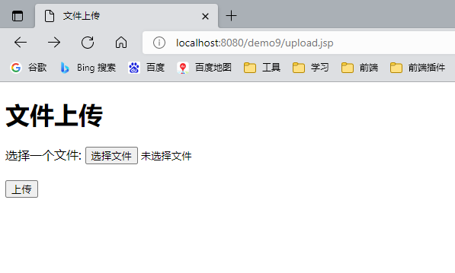

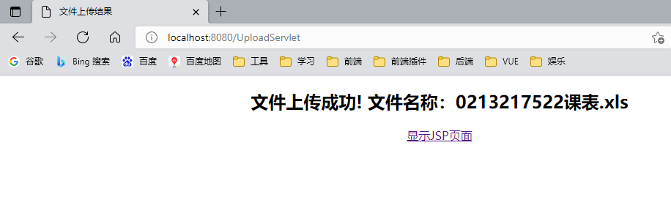

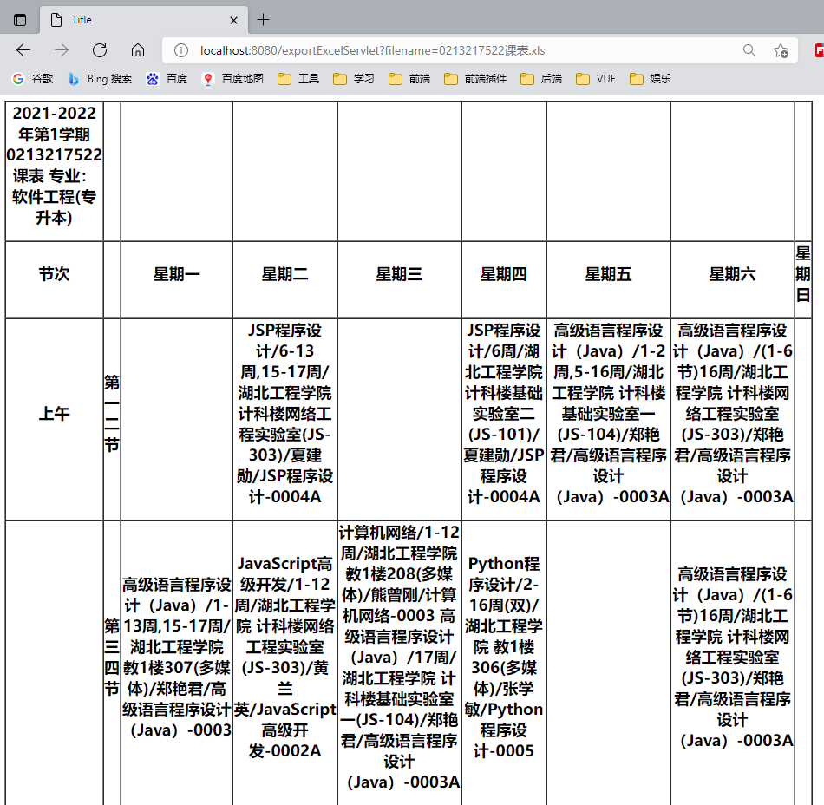

## 实验小结

通过本次实验我学会使用commons-fileupload插件上传文件到服务器，使用jexcelapi将上传xls文件读取并存储到LIST二维数组中，使用jstl JSP标准标签库进行循环遍历展示数据