# 实验二 JSP的基本应用

## 实验目的与要求

1. 理解并掌握JSP的基本应用技术。
2. 参考教材的有关内容与示例，按要求编写并调试相应的程序。

## 实验内容

参见教材P330～331实验2的实验内容之1～5。

## 实验代码

JSPController.java

package com.shf.mvc.controller;  
  
import org.springframework.stereotype.Controller;  
import org.springframework.ui.Model;  
import org.springframework.web.bind.annotation.RequestMapping;  
  
@Controller  
public class JSPController *{* @RequestMapping*(*"/hi"*)* public String Hi*(){* return "Hi";  
 *}* @RequestMapping*(*"/counter"*)* public String Counter*(*Model model*){* return "Counter";  
 *}* @RequestMapping*(*"/sum"*)* public String Sum*(*Model model*){* return "Sum";  
 *}* @RequestMapping*(*"/table"*)* public String Table*(*Model model*){* return "Table";  
 *}* @RequestMapping*(*"/counterInclude"*)* public String CounterInclude *(*Model model*){* return " CounterInclude";  
 *}* @RequestMapping*(*"/counterForward"*)* public String CounterForward *(*Model model*){* return " CounterForward ";  
 *}  
}*

Counter.jsp

*<%@* page contentType="text/html;charset=UTF-8" language="java" *%>  
<*html*>  
<*head*>  
 <*title*>*Title*</*title*>  
</*head*>  
<*body*>*<%  
 int n = 0;  
 String counter = *(*String*)* application.getAttribute*(*"counter"*)*;  
 if *(*counter != null*)* n = Integer.*parseInt(*counter*)*;  
 if *(*session.isNew*())* ++n;  
 counter = String.*valueOf(*n*)*;  
 application.setAttribute*(*"counter", counter*)*;  
%>  
*<*h1*>*您是第  
 <%= counter %>  
 个访问本站的用户。*</*h1*>  
</*body*>  
</*html*>*

Sum.jsp

*<%@* page contentType="text/html;charset=UTF-8" language="java" *%>  
<*html*>  
<*head*>  
 <*title*>*Sum*</*title*>  
</*head*>  
<*body*>*<%  
 int sum = 0;  
 for *(*int i = 1; i < 100; i++*) {* if *(*i%3==0*)* sum+=i;  
 *}*%>  
*<*h1*>*1-100内可以被3整除的整数和为：<%=sum%>*</*h1*>  
</*body*>  
</*html*>*

Table.jsp

*<%@* page contentType="text/html;charset=UTF-8" language="java" *%>  
<*html*>  
<*head*>  
 <*title*>*Table*</*title*>  
</*head*>  
<*body*>  
<*table border="1"*>  
 <*tr*>  
 <*td*>*N*</*td*>  
 <*td*>*2*N*</*td*>  
 <*td*>*N*N*</*td*>  
 </*tr*>* <%  
 int h=10;  
 for*(*int i=1;i<=h;i++*){* %>  
 *<*tr*>  
 <*td*>*<%=i%>*</*td*>  
 <*td*>*<%=i*2%>*</*td*>  
 <*td*>*<%=i*i%>*</*td*>  
 </*tr*>* <%*}*%>  
*</*table*>  
</*body*>  
</*html*>*

counterInclude.jsp

*<%@* page contentType="text/html;charset=UTF-8" language="java" *%>  
<*html*>  
<*head*>  
 <*title*>*Title*</*title*>  
</*head*>  
<*body*>  
 <*jsp:include page="sum100.jsp"*>  
 <*jsp:param name="sum" value="100"*/>  
 </*jsp:include*>  
</*body*>  
</*html*>*

counterForward.jsp

*<%@* page contentType="text/html;charset=UTF-8" language="java" *%>  
<*html*>  
<*head*>  
 <*title*>*Title*</*title*>  
</*head*>  
<*body*>  
 <*jsp:forward page="sum100.jsp"*>  
 <*jsp:param name="sum" value="100"*/>  
 </*jsp:forward*>  
</*body*>  
</*html*>*

sum100.jsp

*<%@* page contentType="text/html;charset=UTF-8" language="java" *%>  
<*html*>  
<*head*>  
 <*title*>*Title*</*title*>  
</*head*>  
<*body*>*<%  
 int count = Integer.*parseInt(*request.getParameter*(*"sum"*))*;  
 int sum = 0;  
 for *(*int i = 1; i < count; i++*) {* sum+=i;  
 *}*%>  
*<*h1*>*1-<%=count%>的整数和为：<%=sum%>*</*h1*>  
</*body*>  
</*html*>*

## 实验截图

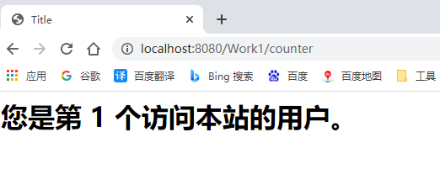

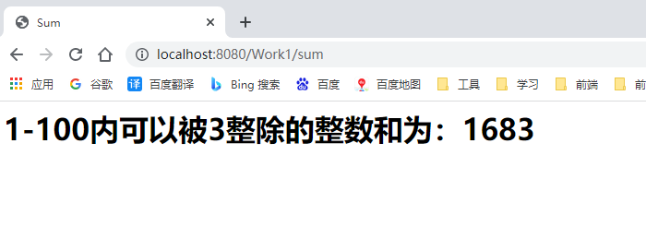

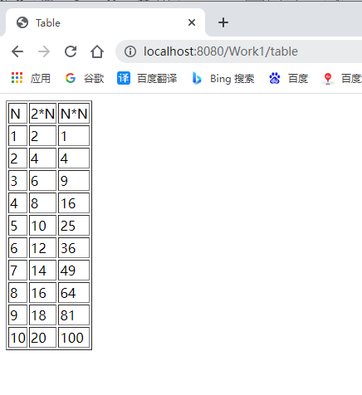

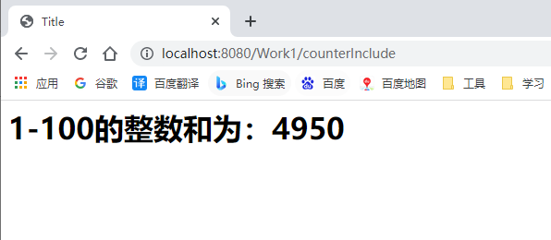

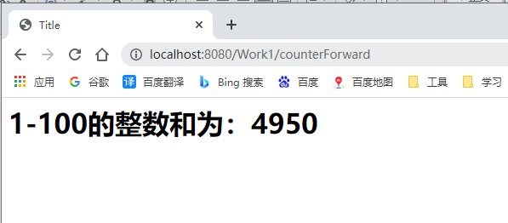

## 实验小结

通过本次实验我学会使用jsp的指令标记、jsp的动作标记以及jsp的注释方式。能够使用param动作标记为其他标记提供附加信息，使用include标记动态加载一个文件，forward标记跳转到指定页面，plugin标记加载插件。使用<%!%>进行变量声明，使用<%=%>显示表达式的值,使用<%%>插入Java程序段。