# 实验四 JDBC的应用

## 实验目的与要求

1. 理解并掌握JDBC的主要应用技术以及JSP+JDBC模式的Web应用开发技术。
2. 参考教材的有关内容与示例，按要求编写并调试相应的程序。

## 实验内容

参见教材P334～335实验4的实验内容之1～７。

## 实验代码

Test1数据库 Score表

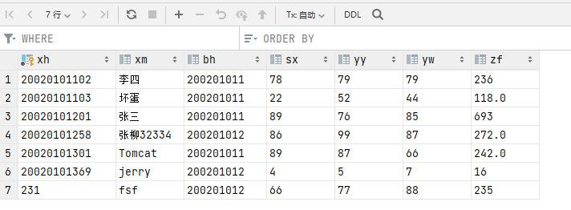

addUser.jsp 添加学生成绩

*<%--  
 Created by IntelliJ IDEA.  
 User: SHF  
 Date: 2021/10/18  
 Time: 10:25  
 To change this template use File | Settings | File Templates.  
--%>  
<%@* page contentType="text/html;charset=UTF-8" language="java" *%>  
<*html*>  
<*head*>  
 <*title*>*addUser*</*title*>  
</*head*>  
<*body*>  
<*form action="/jdbcAddUser.jsp" method="post" style="margin: auto;width: 500px;text-align: center"*>  
<*h2*>*学生成绩增加*</*h2*>* 班级：  
 *<*select name="bh" id=""*>  
 <*option value="200201011"*>*200201011*</*option*>  
 <*option value="200201012"*>*200201012*</*option*>  
 </*select*> <*br*>* 学号： *<*input type="text" name="xh"*> <*br*>* 姓名： *<*input type="text" name="xm"*> <*br*>* 语文： *<*input type="text" name="yw"*> <*br*>* 数学： *<*input type="text" name="sx"*> <*br*>* 英语： *<*input type="text" name="yy"*> <*br*>  
 <*input type="submit" value="提交"*>  
 <*input type="reset" value="重置"*>  
</*form*>  
</*body*>  
</*html*>*

jdbcAddUser.jsp 添加学生成绩并写入数据库

*<%@* page import="java.sql.Connection" *%>  
<%@* page import="java.sql.DriverManager" *%>  
<%@* page import="java.sql.Statement" *%>  
<%@* page import="java.sql.PreparedStatement" *%><%--  
 Created by IntelliJ IDEA.  
 User: SHF  
 Date: 2021/10/19  
 Time: 8:29  
 To change this template use File | Settings | File Templates.  
--%>  
<%@* page contentType="text/html;charset=UTF-8" language="java" *%>  
<*html*>  
<*head*>  
 <*title*>*Title*</*title*>  
</*head*>  
<*body*>*<%  
 request.setCharacterEncoding*(*"UTF-8"*)*;  
 String bh = request.getParameter*(*"bh"*)*;  
 String xh = request.getParameter*(*"xh"*)*;  
 String xm = request.getParameter*(*"xm"*)*;  
 String yw = request.getParameter*(*"yw"*)*;  
 String sx = request.getParameter*(*"sx"*)*;  
 String yy = request.getParameter*(*"yy"*)*;  
 String zf = String.*valueOf(*Double.*parseDouble(*yw*)*+Double.*parseDouble(*sx*)*+Double.*parseDouble(*yy*))*;  
  
 Class.*forName(*"com.mysql.jdbc.Driver"*)*;  
 Connection con = DriverManager.*getConnection(*"jdbc:mysql://localhost:3306/test1", "root", "root"*)*;  
  
 PreparedStatement preparedStatement = con.prepareStatement*(*"insert into score values (?,?,?,?,?,?,?)"*)*;  
  
 preparedStatement.setString*(*1, xh*)*;  
 preparedStatement.setString*(*2, xm*)*;  
 preparedStatement.setString*(*3, bh*)*;  
 preparedStatement.setString*(*4, sx*)*;  
 preparedStatement.setString*(*5, yy*)*;  
 preparedStatement.setString*(*6, yw*)*;  
 preparedStatement.setString*(*7, zf*)*;  
 preparedStatement.executeUpdate*()*;  
  
 *//8、释放资源* preparedStatement.close*()*;  
 con.close*()*;  
  
 response.sendRedirect*(*"/selectClass.jsp"*)*;  
%>  
*</*body*>  
</*html*>*

selectClass.jsp 选择班级跳转到成绩查询页面

*<%--  
 Created by IntelliJ IDEA.  
 User: SHF  
 Date: 2021/10/19  
 Time: 9:17  
 To change this template use File | Settings | File Templates.  
--%>  
<%@* page contentType="text/html;charset=UTF-8" language="java" *%>  
<*html*>  
<*head*>  
 <*title*>*Title*</*title*>  
</*head*>  
<*body*>  
<*form action="/showScore.jsp"*>  
 <*h2*>*部门：  
 *<*select name="bh" id=""*>  
 <*option value="200201011"*>*200201011*</*option*>  
 <*option value="200201012"*>*200201012*</*option*>  
 </*select*> <*br*>  
 </*h2*>  
 <*input type="submit" value="提交"*>  
</*form*>  
</*body*>  
</*html*>*

showScore.jsp 学生成绩查询页面 包含分页

*<%@* page import="java.sql.*" *%><%--  
 Created by IntelliJ IDEA.  
 User: SHF  
 Date: 2021/10/19  
 Time: 9:18  
 To change this template use File | Settings | File Templates.  
--%>  
<%@* page contentType="text/html;charset=UTF-8" language="java" *%>*<%  
 String bh = request.getParameter*(*"bh"*)*;  
 int getPage = request.getParameter*(*"page"*)*!=null?Integer.*parseInt(*request.getParameter*(*"page"*))*:0;  
 System.*out*.println*(*bh*)*;  
 System.*out*.println*(*getPage*)*;  
  
 Class.*forName(*"com.mysql.jdbc.Driver"*)*;  
 Connection con = DriverManager.*getConnection(*"jdbc:mysql://localhost:3306/test1", "root", "root"*)*;  
 PreparedStatement countSql = con.prepareStatement*(*"select count(*) cou from score where bh=?"*)*;  
 countSql.setString*(*1,bh*)*;  
 ResultSet countN = countSql.executeQuery*()*;  
 countN.next*()*;  
 String cou = countN.getString*(*"cou"*)*;  
 int count= Integer.*parseInt(*cou*)*;  
  
 int pageSize=2;  
 int indexPage=1;  
 int currentPage=1;  
 int pageNumber=count%pageSize==0?count/pageSize:count/pageSize+1;  
 if *(*getPage == 0*)* currentPage=1;  
 else if *(*getPage<=1*)* currentPage=1;  
 else if *(*getPage>=pageNumber*)* currentPage=pageNumber;  
 else currentPage=getPage;  
  
 int sql=*(*currentPage-1*)*\*pageSize;  
 System.*out*.println*(*sql*)*;  
  
 PreparedStatement preparedStatement = con.prepareStatement*(*"select * from score where bh=? limit ?,? "*)*;  
 preparedStatement.setString*(*1,bh*)*;  
 preparedStatement.setInt*(*2, sql*)*;  
 preparedStatement.setInt*(*3, pageSize*)*;  
 ResultSet resultSet = preparedStatement.executeQuery*()*;  
%>  
*<*html*>  
<*head*>  
 <*title*>*Title*</*title*>  
</*head*>  
<*body*>  
 <*table border="1"*>  
 <*h2*>*学生成绩*</*h2*>  
 <*tr*>  
 <*td*>*学号*</*td*>  
 <*td*>*姓名*</*td*>  
 <*td*>*班级*</*td*>  
 <*td*>*总分*</*td*>  
 <*td*>*详情*</*td*>  
 <*td*>*修改*</*td*>  
 <*td*>*删除*</*td*>  
 </*tr*>* <%while *(*resultSet.next*()){*%>  
 *<*tr*>  
 <*td*><*em*>*<%=resultSet.getString*(*"xh"*)*%>*</*em*></*td*>  
 <*td*><*em*>*<%=resultSet.getString*(*"xm"*)*%>*</*em*></*td*>  
 <*td*><*em*>*<%=resultSet.getString*(*"bh"*)*%>*</*em*></*td*>  
 <*td*><*em*>*<%=resultSet.getString*(*"zf"*)*%>*</*em*></*td*>  
 <*td*><*em*><*a href="/showScoreInfo.jsp?xh=<%=resultSet.getString*(*"xh"*)*%>"*>*详情*</*a*></*em*></*td*>  
 <*td*><*em*><*a href="/jdbcAlter.jsp?xh=<%=resultSet.getString*(*"xh"*)*%>"*>*修改*</*a*></*em*></*td*>  
 <*td*><*em*><*a href="/jdbcDelete.jsp?xh=<%=resultSet.getString*(*"xh"*)*%>"*>*删除*</*a*></*em*></*td*>  
 </*tr*>* <%*}*%>  
 *<*p*>  
 <*span*>*第 <%=currentPage%> 页， 共 <%=pageNumber%> 页*</*span*>  
 <*a href="/showScore.jsp?bh=<%=bh%>"*>*首页*</*a*>* <% if*(*currentPage!=1*){*%>  
 *<*a href="/showScore.jsp?bh=<%=bh%>&page=<%=currentPage-1%>"*>*上一页*</*a*>* <%*}*%>  
 <% if*(*currentPage!=pageNumber*){*%>  
 *<*a href="/showScore.jsp?bh=<%=bh%>&page=<%=currentPage+1%>"*>*下一页*</*a*>* <%*}*%>  
 *<*input type="text" placeholder="跳转到第 N 页" id="N"*>  
 <*a href="javascript:;" onclick="*toShowScore(*<%=bh%>*)*"*>*跳转*</*a*>  
 </*p*>* <%  
 countSql.close*()*;  
 preparedStatement.close*()*;  
 con.close*()*;  
 %>  
 *</*table*>  
 <*script*>* function *toShowScore(*bh*) {* var N = document.getElementById*(*'N'*)*.value;  
 window.location.href="/showScore.jsp?bh="+bh+"&page="+N  
 *}  
  
 </*script*>  
</*body*>  
</*html*>*

showScoreInfo.jsp 显示学生成绩详情

*<%@* page import="java.sql.Connection" *%>  
<%@* page import="java.sql.PreparedStatement" *%>  
<%@* page import="java.sql.DriverManager" *%>  
<%@* page import="java.sql.ResultSet" *%><%--  
 Created by IntelliJ IDEA.  
 User: SHF  
 Date: 2021/10/19  
 Time: 9:40  
 To change this template use File | Settings | File Templates.  
--%>  
<%@* page contentType="text/html;charset=UTF-8" language="java" *%>*<%  
 String xh = request.getParameter*(*"xh"*)*;  
 System.*out*.println*(*xh*)*;  
 Class.*forName(*"com.mysql.jdbc.Driver"*)*;  
 Connection con = DriverManager.*getConnection(*"jdbc:mysql://localhost:3306/test1", "root", "root"*)*;  
 PreparedStatement preparedStatement = con.prepareStatement*(*"select * from score where xh=?"*)*;  
 preparedStatement.setString*(*1,xh*)*;  
 ResultSet resultSet = preparedStatement.executeQuery*()*;  
%>  
*<*html*>  
<*head*>  
 <*title*>*Title*</*title*>  
</*head*>  
<*body*>  
<*form*>  
 <*h1*>*详情*</*h1*>* <%while *(*resultSet.next*()){*%>  
 班级: *<*input type="text" name="bh" disabled value="<%=resultSet.getString*(*"bh"*)*%>"*> <*br*>* 学号: *<*input type="text" name="xh" disabled value="<%=resultSet.getString*(*"xh"*)*%>"*> <*br*>* 姓名: *<*input type="text" name="xm" disabled value="<%=resultSet.getString*(*"xm"*)*%>"*> <*br*>* 语文: *<*input type="text" name="yw" disabled value="<%=resultSet.getString*(*"yw"*)*%>"*> <*br*>* 数学: *<*input type="text" name="sx" disabled value="<%=resultSet.getString*(*"sx"*)*%>"*> <*br*>* 英语: *<*input type="text" name="yy" disabled value="<%=resultSet.getString*(*"yy"*)*%>"*> <*br*>* 总分: *<*input type="text" name="zf" disabled value="<%=resultSet.getString*(*"zf"*)*%>"*> <*br*>* <%*}*%>  
 *<*a href="/selectClass.jsp"*>*返回选择班级页面*</*a*>  
</*form*>  
</*body*>  
</*html*>*

jdbcAlter.jsp 学生成绩修改页面展示

*<%@* taglib prefix="form" uri="http://www.springframework.org/tags/form" *%>  
<%@* page import="java.sql.Connection" *%>  
<%@* page import="java.sql.PreparedStatement" *%>  
<%@* page import="java.sql.DriverManager" *%>  
<%@* page import="java.sql.ResultSet" *%><%--  
 Created by IntelliJ IDEA.  
 User: SHF  
 Date: 2021/10/19  
 Time: 11:02  
 To change this template use File | Settings | File Templates.  
--%>  
<%@* page contentType="text/html;charset=UTF-8" language="java" *%>*<%  
 String xh = request.getParameter*(*"xh"*)*;  
 System.*out*.println*(*xh*)*;  
 Class.*forName(*"com.mysql.jdbc.Driver"*)*;  
 Connection con = DriverManager.*getConnection(*"jdbc:mysql://localhost:3306/test1", "root", "root"*)*;  
 PreparedStatement preparedStatement = con.prepareStatement*(*"select * from score where xh=?"*)*;  
 preparedStatement.setString*(*1,xh*)*;  
 ResultSet resultSet = preparedStatement.executeQuery*()*;  
 resultSet.next*()*;  
%>  
*<*html*>  
<*head*>  
 <*title*>*Title*</*title*>  
</*head*>  
<*body*>  
<*form action="jdbcAlterController.jsp"*>  
 <*h2*>*学生成绩*</*h2*>* 班级: *<*input type="text" name="bh" value="<%=resultSet.getString*(*"bh"*)*%>"*> <*br*>* 学号: *<*input type="text" name="xh" value="<%=resultSet.getString*(*"xh"*)*%>" readonly*> <*br*>* 姓名: *<*input type="text" name="xm" value="<%=resultSet.getString*(*"xm"*)*%>"*> <*br*>* 语文: *<*input type="text" name="yw" value="<%=resultSet.getString*(*"yw"*)*%>"*> <*br*>* 数学: *<*input type="text" name="sx" value="<%=resultSet.getString*(*"sx"*)*%>"*> <*br*>* 英语: *<*input type="text" name="yy" value="<%=resultSet.getString*(*"yy"*)*%>"*> <*br*>* 总分: *<*input type="text" name="zf" value="<%=resultSet.getString*(*"zf"*)*%>" readonly*> <*br*>  
 <*input type="submit" value="提交"*>  
</*form*>  
</*body*>  
</*html*>*

jdbcAlterController.jsp 修改成绩并存入数据库

*<%@* page import="java.sql.PreparedStatement" *%>  
<%@* page import="java.sql.DriverManager" *%>  
<%@* page import="java.sql.Connection" *%><%--  
 Created by IntelliJ IDEA.  
 User: SHF  
 Date: 2021/10/19  
 Time: 11:19  
 To change this template use File | Settings | File Templates.  
--%>  
<%@* page contentType="text/html;charset=UTF-8" language="java" *%>*<%  
 request.setCharacterEncoding*(*"UTF-8"*)*;  
 String bh = request.getParameter*(*"bh"*)*;  
 String xh = request.getParameter*(*"xh"*)*;  
 String xm = request.getParameter*(*"xm"*)*;  
 String yw = request.getParameter*(*"yw"*)*;  
 String sx = request.getParameter*(*"sx"*)*;  
 String yy = request.getParameter*(*"yy"*)*;  
 String zf = String.*valueOf(*Double.*parseDouble(*yw*)*+Double.*parseDouble(*sx*)*+Double.*parseDouble(*yy*))*;  
  
 Class.*forName(*"com.mysql.jdbc.Driver"*)*;  
 Connection con = DriverManager.*getConnection(*"jdbc:mysql://localhost:3306/test1", "root", "root"*)*;  
  
 PreparedStatement preparedStatement = con.prepareStatement*(*"update score set xm=?,bh=?,sx=?,yy=?,yw=?,zf=? where xh=?"*)*;  
  
 preparedStatement.setString*(*1, xm*)*;  
 preparedStatement.setString*(*2, bh*)*;  
 preparedStatement.setString*(*3, sx*)*;  
 preparedStatement.setString*(*4, yy*)*;  
 preparedStatement.setString*(*5, yw*)*;  
 preparedStatement.setString*(*6, zf*)*;  
 preparedStatement.setString*(*7, xh*)*;  
 System.*out*.println*(*preparedStatement*)*;  
  
 preparedStatement.executeUpdate*()*;  
  
 *//8、释放资源* preparedStatement.close*()*;  
 con.close*()*;  
  
 response.sendRedirect*(*"/selectClass.jsp"*)*;  
%>  
*<*html*>  
<*head*>  
 <*title*>*Title*</*title*>  
</*head*>  
<*body*>  
  
</*body*>  
</*html*>*

jdbcDelete.jsp 删除学生成绩并存入数据库

*<%@* page import="java.sql.Connection" *%>  
<%@* page import="java.sql.DriverManager" *%>  
<%@* page import="java.sql.PreparedStatement" *%>  
<%@* page import="java.sql.ResultSet" *%><%--  
 Created by IntelliJ IDEA.  
 User: SHF  
 Date: 2021/10/19  
 Time: 11:01  
 To change this template use File | Settings | File Templates.  
--%>  
<%@* page contentType="text/html;charset=UTF-8" language="java" *%>*<%  
 String xh = request.getParameter*(*"xh"*)*;  
 System.*out*.println*(*xh*)*;  
  
 Class.*forName(*"com.mysql.jdbc.Driver"*)*;  
 Connection con = DriverManager.*getConnection(*"jdbc:mysql://localhost:3306/test1", "root", "root"*)*;  
 PreparedStatement preparedStatement = con.prepareStatement*(*"delete from score where xh=?"*)*;  
 preparedStatement.setString*(*1,xh*)*;  
 preparedStatement.executeUpdate*()*;  
  
 preparedStatement.close*()*;  
 con.close*()*;  
  
 response.sendRedirect*(*"/selectClass.jsp"*)*;  
%>  
*<*html*>  
<*head*>  
 <*title*>*Title*</*title*>  
</*head*>  
<*body*>  
  
</*body*>  
</*html*>*

## 实验截图

添加学生

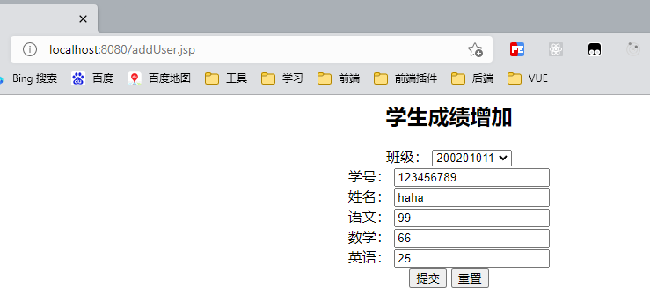

班级选择

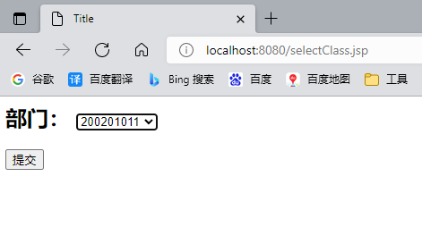

查看班级学生成绩

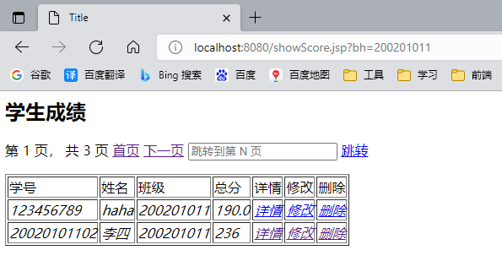

查看学生成绩详情

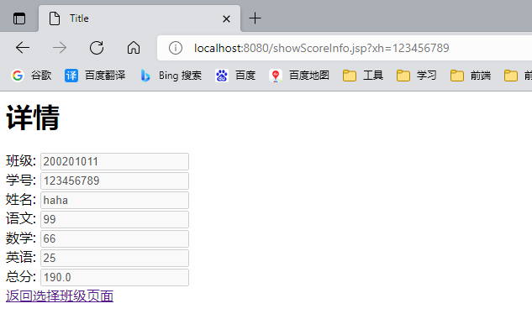

修改学生成绩

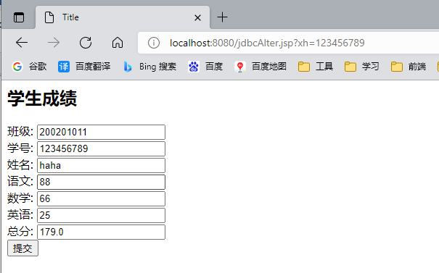

删除学生成绩

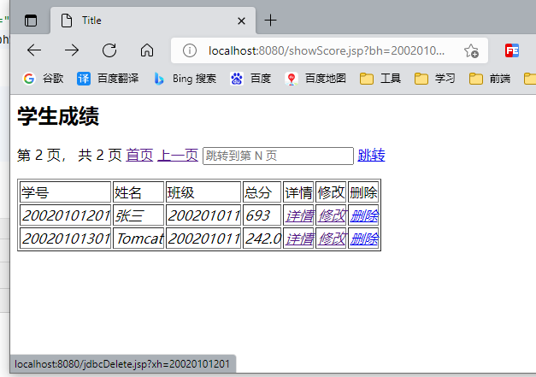

学生成绩分页

第一页 隐藏上一页

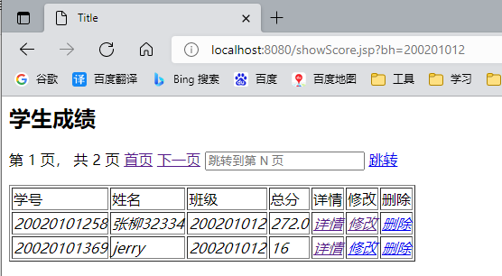

第二页 是最后一页 隐藏下一页

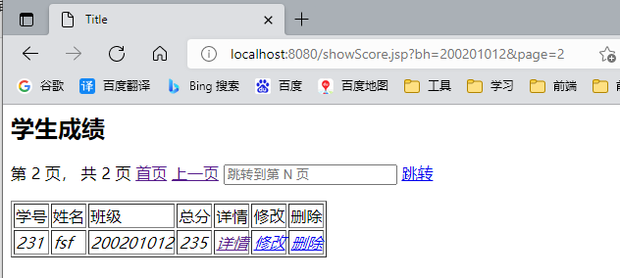

跳转到第一页

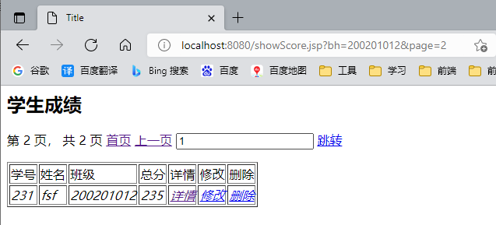

## 实验小结

通过本次实验我学会使用JSP+JDBC+Tomcat+MySQL制作一个学生成绩管理系统，能够实现基本的增删改查，能够使用分页技术每页显示2为同学的成绩，能够动态展示分页条，使用request域获取请求参数，并使用Mysql提供的jar包连接数据库并使用prepareStatement预编译JDBC，来避免Sql注入。