实验1：熟悉Java运行环境

**实验目的：**

掌握JDK的安装与配置；掌握eclips环境的安装与配置；掌握Java程序的编辑、调试与运行。

**实验题目：**

编写一个Java应用程序，显示自己的学号、姓名、兴趣爱好等字符串。

**代码：**

**Hello.java**

package com.shf.test;  
  
public class Hello {  
 public static void main(String[] args) {  
 Person person = new Person();  
 person.setId("0213217522");  
 person.setAge(21);  
 person.setName("舒洪凡");  
 person.setGender("男");  
 person.setHobby(new String[]{"计算机","羽毛球","运动"});  
 System.*out*.println(person);  
 }  
}

**Person.java**

package com.shf.test;  
  
import java.util.Arrays;  
  
public class Person {  
 private String id;  
 private int age;  
 private String name;  
 private String gender;  
 private String[] hobby;  
  
 public Person() {  
 }  
  
 public Person(String id, int age, String name, String gender, String[] hobby) {  
 this.id = id;  
 this.age = age;  
 this.name = name;  
 this.gender = gender;  
 this.hobby = hobby;  
 }  
  
 public String getId() {  
 return id;  
 }  
  
 public void setId(String id) {  
 this.id = id;  
 }  
  
 public int getAge() {  
 return age;  
 }  
  
 public void setAge(int age) {  
 this.age = age;  
 }  
  
 public String getName() {  
 return name;  
 }  
  
 public void setName(String name) {  
 this.name = name;  
 }  
  
 public String getGender() {  
 return gender;  
 }  
  
 public void setGender(String gender) {  
 this.gender = gender;  
 }  
  
 public String[] getHobby() {  
 return hobby;  
 }  
  
 public void setHobby(String[] hobby) {  
 this.hobby = hobby;  
 }  
  
 @Override  
 public String toString() {  
 return "Person{" +  
 "学号id=" + id +  
 ", 年龄age=" + age +  
 ", 姓名name='" + name + '\'' +  
 ", 性别gender='" + gender + '\'' +  
 ", 兴趣爱好hobby=" + Arrays.*toString*(hobby) +  
 '}';  
 }  
}

**实验截图：**

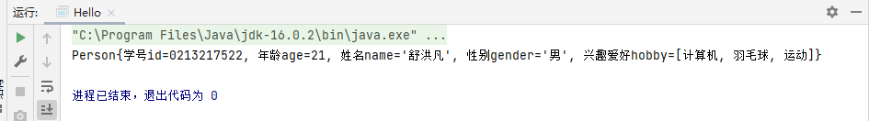

**实验小结：**

**通过本次实验**

1. **掌握JDK的安装与配置；掌握集成化环境的安装与配置；**
2. **掌握Java程序在集成化开发环境的编辑、调试与运行。**
3. **掌握Java的基础语法、掌握Java对象和类的概念的定义和使用，能够使用Java基本的数据类型和方法。**