**实验四 类与对象**

## 实验目的

1. 掌握类的定义与对象的创建。
2. 理解构造方法和this关键字的用法。
3. 掌握对象对于属性及方法的引用。

## 实验内容

定义一个Student类，其中有成员变量，学号，姓名，性别，是否为班干部，以及语文数学英语的分数，求成绩的方法。

定义一个主类，主方法中通过学生类创造对象，通过键盘输入对象属性值，然后输出学生的属性值，调用方法输出该学生的总成绩与平均成绩。

## 实验代码

Student.java

package com.shf.demo4;  
  
import java.math.BigDecimal;  
import java.math.RoundingMode;  
  
public class Student *{* private String studentId; *// 学号* private String name; *// 姓名* private boolean gender; *// 性别* private boolean isClassLeader; *// 是否班干部* private double chineseScore;  
 private double mathScore;  
 private double englishScore;  
  
 public Student*() {  
 }* public Student*(*String studentId, String name, boolean gender, boolean isClassLeader, double chineseScore, double mathScore, double englishScore*) {* this.studentId = studentId;  
 this.name = name;  
 this.gender = gender;  
 this.isClassLeader = isClassLeader;  
 this.chineseScore = chineseScore;  
 this.mathScore = mathScore;  
 this.englishScore = englishScore;  
 *}* public String getStudentId*() {* return studentId;  
 *}* public void setStudentId*(*String studentId*) {* this.studentId = studentId;  
 *}* public String getName*() {* return name;  
 *}* public void setName*(*String name*) {* this.name = name;  
 *}* public boolean isGender*() {* return gender;  
 *}* public void setGender*(*boolean gender*) {* this.gender = gender;  
 *}* public boolean isClassLeader*() {* return isClassLeader;  
 *}* public void setClassLeader*(*boolean classLeader*) {* isClassLeader = classLeader;  
 *}* public double getChineseScore*() {* return chineseScore;  
 *}* public void setChineseScore*(*double chineseScore*) {* this.chineseScore = chineseScore;  
 *}* public double getMathScore*() {* return mathScore;  
 *}* public void setMathScore*(*double mathScore*) {* this.mathScore = mathScore;  
 *}* public double getEnglishScore*() {* return englishScore;  
 *}* public void setEnglishScore*(*double englishScore*) {* this.englishScore = englishScore;  
 *}* public double getSum*(){* return chineseScore + mathScore + englishScore;  
 *}* public double getAvg*(){* return new BigDecimal*(*getSum*()* / 3*)*.setScale*(*2, RoundingMode.*UP)*.doubleValue*()*;  
 *}* @Override  
 public String toString*() {* return "Student{" +  
 "studentId='" + studentId + '\'' +  
 ", name='" + name + '\'' +  
 ", gender=" + gender +  
 ", isClassLeader=" + isClassLeader +  
 ", chineseScore=" + chineseScore +  
 ", mathScore=" + mathScore +  
 ", englishScore=" + englishScore +  
 '}';  
 *}  
}*

StudentDemo.java

package com.shf.demo4;  
  
import java.util.Scanner;  
  
public class StudentDemo *{* public static void main*(*String*[]* args*) {* Student student = new Student*()*;  
 Scanner scanner = new Scanner*(*System.*in)*;  
  
 System.*out*.print*(*"请输入学生学号："*)*;  
 String studentId = scanner.nextLine*()*;  
 student.setStudentId*(*studentId*)*;  
  
 System.*out*.print*(*"请输入学生姓名："*)*;  
 String name = scanner.nextLine*()*;  
 student.setName*(*name*)*;  
  
 System.*out*.print*(*"请输入学生性别：（1---男，0----女）"*)*;  
 boolean gender ;  
 if *(*scanner.nextInt*()* == 1*)* gender=true;  
 else gender=false;  
 student.setGender*(*gender*)*;  
  
 System.*out*.print*(*"请输入学生是否为班干部：（1---是，0----否）"*)*;  
 boolean isClassLeader ;  
 if *(*scanner.nextInt*()* == 1*)* isClassLeader=true;  
 else isClassLeader=false;  
 student.setClassLeader*(*isClassLeader*)*;  
  
 System.*out*.print*(*"请输入学生语文成绩："*)*;  
 double chineseScore = scanner.nextDouble*()*;  
 student.setChineseScore*(*chineseScore*)*;  
  
 System.*out*.print*(*"请输入学生数学成绩："*)*;  
 double mathScore = scanner.nextDouble*()*;  
 student.setMathScore*(*mathScore*)*;  
  
 System.*out*.print*(*"请输入学生英语成绩："*)*;  
 double englishScore = scanner.nextDouble*()*;  
 student.setEnglishScore*(*englishScore*)*;  
  
 System.*out*.println*(*"======================================"*)*;  
 System.*out*.println*(*student*)*;  
 System.*out*.println*(*"学生的总成绩为："+student.getSum*())*;  
 System.*out*.println*(*"学生的平均成绩为："+student.getAvg*())*;  
 *}  
}*

## 实验运行截图

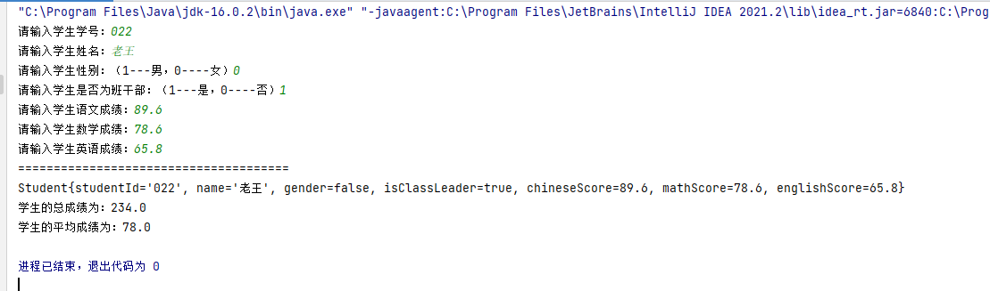

## 实验小结

通过本次实验我掌握了类的定义和创建类的实例，并且学会给对象赋初值的2种方法，第一种是使用类的有参数构造器，第二种使用类提供的getter和setter方法来读取或者设置对象总的成员变量。