实验八： Java组件与事件处理

## 实验目的

1、掌握使用布局管理器对组件进行管理.；

2、掌握Java Swing 组件的使用方法。

3、理解 Java 的事件处理机制，掌握为不同组件编写事件处理程序的方法；

## 实验内容

编写一个应用程序，设计四个按钮，分别命名为“加”.“减”.“乘”.“除”，有三个文本框。单击相应按钮，将两个文本框中的数字做运算，在第三个文本框中显示结果。

## 实验代码

package com.shf.demo9;  
  
import java.awt.Color;  
import java.awt.FlowLayout;  
import java.awt.event.ActionEvent;  
import java.awt.event.ActionListener;  
import javax.swing.JButton;  
import javax.swing.JFrame;  
import javax.swing.JLabel;  
import javax.swing.JTextField;  
  
  
class TestSum*{* public static void main*(*String*[]* args*) {* Sum sum = new Sum*()*;  
 System.*out*.println*(*sum*)*;  
 *}  
}*public class Sum extends JFrame implements ActionListener *{* JButton plus;  
 JButton subtract;  
 JButton multiply;  
 JButton divide;  
 JTextField TextFieldOne;  
 JTextField TextFieldTwo;  
 JTextField TextFieldThree;  
 JLabel label;  
  
 public Sum*() {* init*()*;  
 setVisible*(*true*)*;  
 setResizable*(*true*)*;  
 validate*()*;  
 setDefaultCloseOperation*(*JFrame.*DISPOSE_ON_CLOSE)*;  
 *}* public void init*() {* setLayout*(*new FlowLayout*())*;  
 setSize*(*500, 320*)*;  
 setTitle*(*"加减乘除计算器"*)*;  
 plus = new JButton*(*"加Plus"*)*;  
 subtract = new JButton*(*"减Subtract"*)*;  
 multiply = new JButton*(*"乘Multiple"*)*;  
 divide = new JButton*(*"除Divide"*)*;  
  
 TextFieldOne = new JTextField*(*"请输入第一个数字",10*)*;  
 TextFieldOne.setHorizontalAlignment*(*JTextField.*CENTER)*;  
  
 TextFieldTwo = new JTextField*(*"请输入第二个数字",10*)*;  
 TextFieldTwo.setHorizontalAlignment*(*JTextField.*CENTER)*;  
  
 TextFieldThree = new JTextField*(*"计算结果(点击下方任一按钮)",20*)*;  
 TextFieldThree.setHorizontalAlignment*(*JTextField.*CENTER)*;  
  
 label = new JLabel*(*" ", JLabel.*CENTER)*;  
 label.setBackground*(*Color.*green)*;  
  
 add*(*TextFieldOne*)*;  
 add*(*label*)*;  
 add*(*TextFieldTwo*)*;  
 add*(*TextFieldThree*)*;  
 add*(*plus*)*;  
 add*(*subtract*)*;  
 add*(*multiply*)*;  
 add*(*divide*)*;  
 setBackground*(*Color.*gray)*;

*// 添加动作事件监听*  
 plus.addActionListener*(*this*)*;  
 subtract.addActionListener*(*this*)*;  
 multiply.addActionListener*(*this*)*;  
 divide.addActionListener*(*this*)*;  
 *}* @Override  
 public void actionPerformed*(*ActionEvent e*) {* double n;  
 if *(*e.getSource*()* == plus*) {* double n1, n2;  
 try *{* n1 = Double.*parseDouble(*TextFieldOne.getText*())*;  
 n2 = Double.*parseDouble(*TextFieldTwo.getText*())*;  
 n = n1 + n2;  
 TextFieldThree.setText*(*String.*valueOf(*n*))*;  
 label.setText*(*"+"*)*;  
 *}* catch *(*NumberFormatException ee*) {* TextFieldThree.setText*(*"请输入数字字符"*)*;  
 *}  
 }* else if *(*e.getSource*()* == subtract*) {* double n1, n2;  
 try *{* n1 = Double.*parseDouble(*TextFieldOne.getText*())*;  
 n2 = Double.*parseDouble(*TextFieldTwo.getText*())*;  
 n = n1 - n2;  
 TextFieldThree.setText*(*String.*valueOf(*n*))*;  
 label.setText*(*"-"*)*;  
 *}* catch *(*NumberFormatException ee*) {* TextFieldThree.setText*(*"请输入数字字符"*)*;  
 *}  
 }* else if *(*e.getSource*()* == multiply*) {* double n1, n2;  
 try *{* n1 = Double.*parseDouble(*TextFieldOne.getText*())*;  
 n2 = Double.*parseDouble(*TextFieldTwo.getText*())*;  
 n = n1 * n2;  
 TextFieldThree.setText*(*String.*valueOf(*n*))*;  
 label.setText*(*"*"*)*;  
 *}* catch *(*NumberFormatException ee*) {* TextFieldThree.setText*(*"请输入数字字符"*)*;  
 *}  
 }* else if *(*e.getSource*()* == divide*) {* double n1, n2;  
 try *{* n1 = Double.*parseDouble(*TextFieldOne.getText*())*;  
 n2 = Double.*parseDouble(*TextFieldTwo.getText*())*;  
 n = n1 / n2;  
 TextFieldThree.setText*(*String.*valueOf(*n*))*;  
 label.setText*(*"/"*)*;  
 *}* catch *(*NumberFormatException ee*) {* TextFieldThree.setText*(*"请输入数字字符"*)*;  
 *}  
 }* validate*()*;  
 *}  
}*

## 实验截图

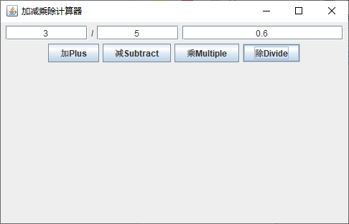

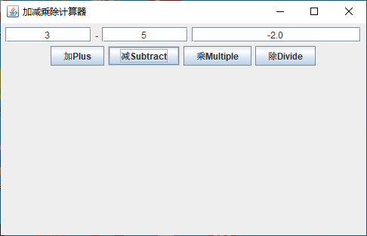

## 实验小结

通过本次实验我学会Swing类库的基本使用，使用流式布局管理器FlowLayout按照从上到下、从左到右进行放置定位，使用JTextField单行文本框组件输入数据和展示数据，使用JLable标签组件显示加减乘除的标志。实现ActionListener事件监听接口，使用addActionKListener()添加监听，使用removeActionKListener()删除监听。使用actionPerformed(ActionEvent e)实现接口中的方法，响应动作事件。