# MFC实验一

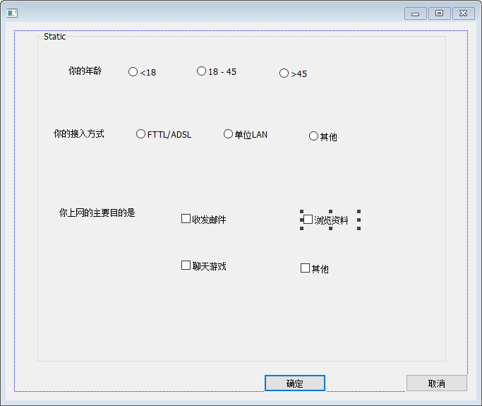

void C调查问卷Dlg::OnBnClickedOk()

{

CString str, strCtr1;

str = "你的年龄";

UINT nID = GetCheckedRadioButton(aage2, age3);

GetDlgItemText(nID, strCtr1);

str = str + strCtr1;

str = str + (CString)"\n你使用的接入方式:\n ";

nID = GetCheckedRadioButton(type1, type3);

GetDlgItemText(nID, strCtr1);//获得指定控键的标题文本

str = str + strCtr1;

str = str + (CString)" \n你上网主要是：\n";

UINT nCheckIDs[4] = { goal1,goal2,goal3,goal4 };

CButton* pBtn;

for (int i = 0; i < 4; i++)

{

pBtn = (CButton*)GetDlgItem(nCheckIDs[i]);

if (pBtn->GetCheck()) {

pBtn->GetWindowText(strCtr1);//GetWindowText函数作用和GetDlgItemText函数作用相同，也是获取窗口的文本内容,注意用法不同，前者用的比较广

str = str + strCtr1;

str = str + (CString)" ";

}

}

MessageBox(str, _T("调查问卷"), MB_ICONQUESTION | MB_ABORTRETRYIGNORE);

// **TODO: 在此添加控件通知处理程序代码**

CDialogEx::OnOK();

}

