1

var array = [String]()

for element in 0..<10 {

    array.append("element\(element)")

}

for element in array{

    print(element)

}

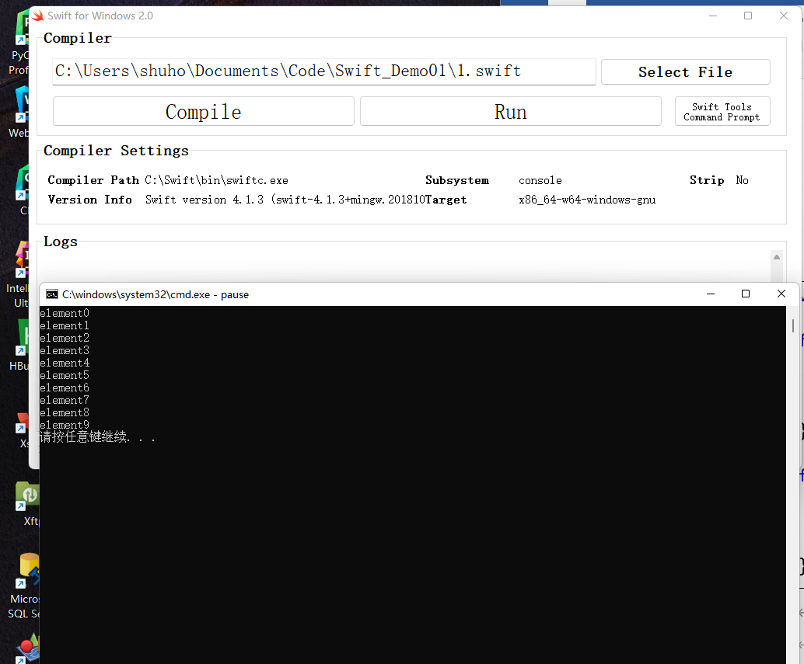

2

var set = Set<Int>()

repeat {

    var element = Int(arc4random_uniform(50))

    set.insert(element)

} while set.count < 10

print(set.sort())

3

var dict = Dictionary<String,String>()

dict["1"] = "Lucy"

dict["2"] = "John"

dict["3"] = "Smith"

dict["4"] = "Aimee"

dict["5"] = "Amanda"

for (k,v) in dict{

    print("\(k)---\(v)")

}

