# 实验九 Spring MVC 框架入门

## 实验目的

1. 了解Spring MVC的工作流程；
2. 掌握Spirng MVC入门程序的编写。
3. 掌握Spring MVC常用注解的使用。
4. 掌握Spring MVC的参数传递

## 实验内容

1. 搭建Spring MVC环境。
2. 在input.jsp页面提交用户姓名、密码，点击提交按钮，页面跳转到success.jsp页面，并在该页面输出提交的数据值。

## 实验代码：

Web.xml

*<?*xml version="1.0" encoding="UTF-8"*?>*<web-app xmlns="http://xmlns.jcp.org/xml/ns/javaee"  
 xmlns:xsi="http://www.w3.org/2001/XMLSchema-instance"  
 xsi:schemaLocation="http://xmlns.jcp.org/xml/ns/javaee http://xmlns.jcp.org/xml/ns/javaee/web-app_4_0.xsd"  
 version="4.0">  
 <servlet>  
 <servlet-name>DispatcherServlet</servlet-name>  
 <servlet-class>org.springframework.web.servlet.DispatcherServlet</servlet-class>  
 <init-param>  
 <param-name>contextConfigLocation</param-name>  
 <param-value>classpath:spring-mvc.xml</param-value>  
 </init-param>  
 <load-on-startup>1</load-on-startup>  
 </servlet>  
 <servlet-mapping>  
 <servlet-name>DispatcherServlet</servlet-name>  
 <url-pattern>/</url-pattern>  
 </servlet-mapping>  
</web-app>

Spring-mvc.xml

*<?*xml version="1.0" encoding="UTF-8"*?>*<beans xmlns="http://www.springframework.org/schema/beans"  
 xmlns:xsi="http://www.w3.org/2001/XMLSchema-instance"  
 xmlns:context="http://www.springframework.org/schema/context"  
 xmlns:jdbc="http://www.springframework.org/schema/jdbc"  
 xmlns:jee="http://www.springframework.org/schema/jee"  
 xmlns:tx="http://www.springframework.org/schema/tx"  
 xmlns:aop="http://www.springframework.org/schema/aop"  
 xmlns:mvc="http://www.springframework.org/schema/mvc"  
 xmlns:util="http://www.springframework.org/schema/util"  
 xsi:schemaLocation="  
 http://www.springframework.org/schema/beans http://www.springframework.org/schema/beans/spring-beans-3.2.xsd  
 http://www.springframework.org/schema/context http://www.springframework.org/schema/context/spring-context-3.2.xsd  
 http://www.springframework.org/schema/jdbc http://www.springframework.org/schema/jdbc/spring-jdbc-3.2.xsd  
 http://www.springframework.org/schema/jee http://www.springframework.org/schema/jee/spring-jee-3.2.xsd  
 http://www.springframework.org/schema/tx http://www.springframework.org/schema/tx/spring-tx-3.2.xsd  
 http://www.springframework.org/schema/aop http://www.springframework.org/schema/aop/spring-aop-3.2.xsd  
 http://www.springframework.org/schema/mvc http://www.springframework.org/schema/mvc/spring-mvc-3.2.xsd  
 http://www.springframework.org/schema/util http://www.springframework.org/schema/util/spring-util-3.2.xsd">  
 <context:component-scan base-package="com.shf.controller"/>  
 <bean class="org.springframework.web.servlet.view.InternalResourceViewResolver">  
 <property name="prefix" value="/WEB-INF/jsp/"/>  
 <property name="suffix" value=".jsp"/>  
 </bean>  
</beans>

Index.jsp

*<%--  
 Created by IntelliJ IDEA.  
 User: shuho  
 Date: 2022/5/16  
 Time: 11:00  
 To change this template use File | Settings | File Templates.  
--%>*<%@ page contentType="text/html;charset=UTF-8" language="java" %>  
<html>  
<head>  
 <title>Title</title>  
</head>  
<body>  
<h1>登录成功</h1>  
<h2>用户名: ${requestScope.username }</h2>  
<h2>密码: ${requestScope.password }</h2>  
</body>  
</html>

Login.jsp

*<%--  
 Created by IntelliJ IDEA.  
 User: shuho  
 Date: 2022/5/16  
 Time: 11:00  
 To change this template use File | Settings | File Templates.  
--%>*<%@ page contentType="text/html;charset=UTF-8" language="java" %>  
<html>  
<head>  
 <title>Title</title>  
</head>  
<body>  
 <form action="/login" method="post">  
 <h1>登录</h1>  
 用户名：<input type="text" name="username"> <br>  
 密码：<input type="password" name="password"> <br>  
 <input type="submit" value="提交">  
 </form>  
</body>  
</html>

LoginController.java

package com.shf.controller;  
  
import com.shf.pojo.User;  
import org.springframework.stereotype.Controller;  
import org.springframework.ui.Model;  
import org.springframework.web.bind.annotation.RequestBody;  
import org.springframework.web.bind.annotation.RequestMapping;  
import org.springframework.web.bind.annotation.ResponseBody;  
  
import javax.servlet.http.HttpServletResponse;  
  
@Controller  
public class LoginController {  
 @RequestMapping("/")  
 public String login(){  
 return "login";  
 }  
  
 @RequestMapping("/login")  
 public String index(Model model , User user){  
 System.*out*.println(user);  
 model.addAttribute("username",user.getUsername());  
 model.addAttribute("password",user.getPassword());  
 return "index";  
 }  
}

## 运行截图

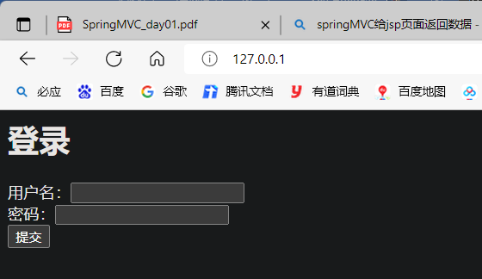

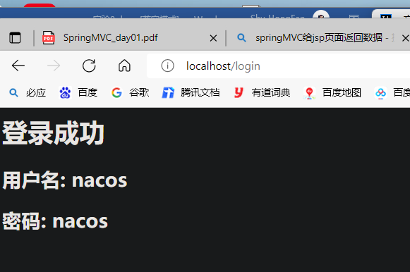

## 实验小结

通过本次实验我学会使用springMVC创建一个基本的项目，能够掌握springMVC中的常用注解的使用，能够使用springMVC进行参数传递。