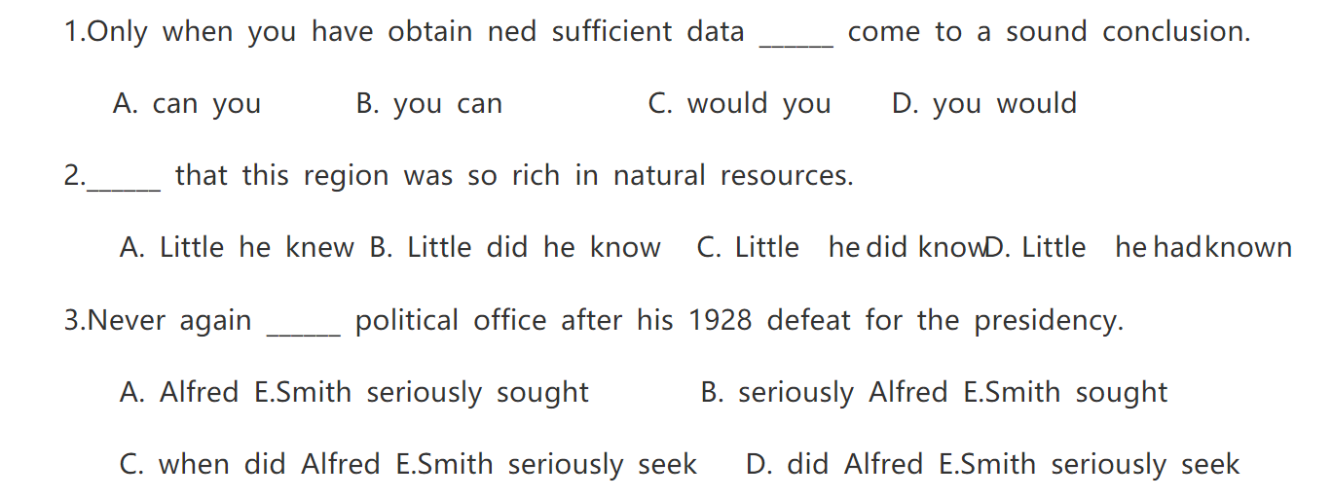

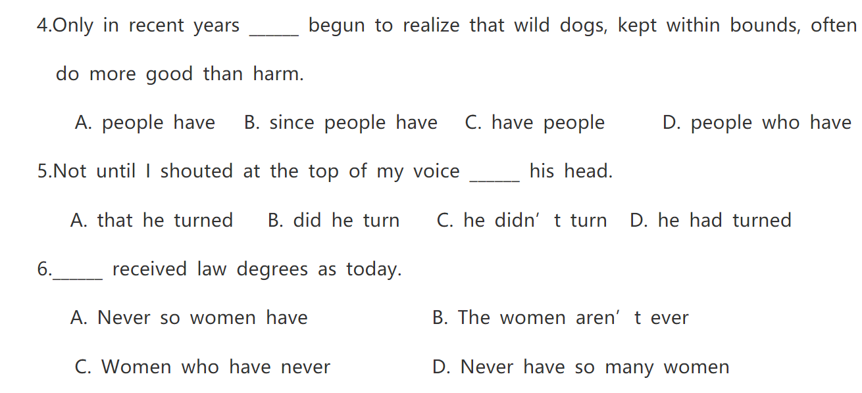

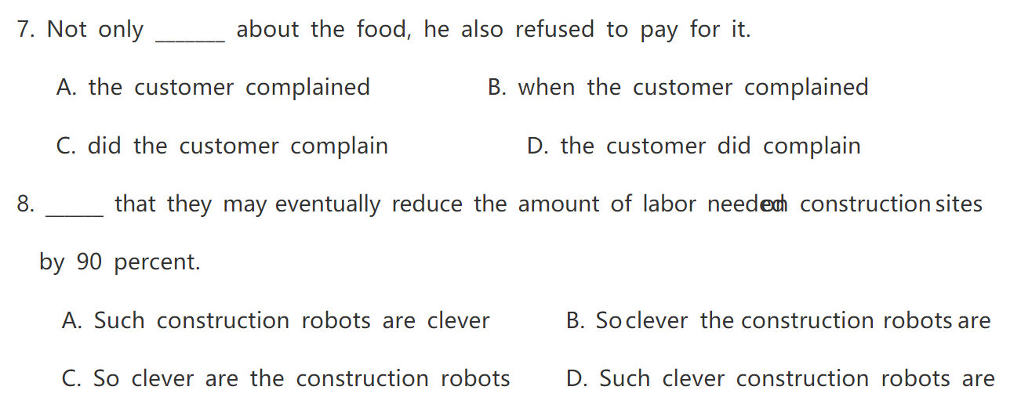



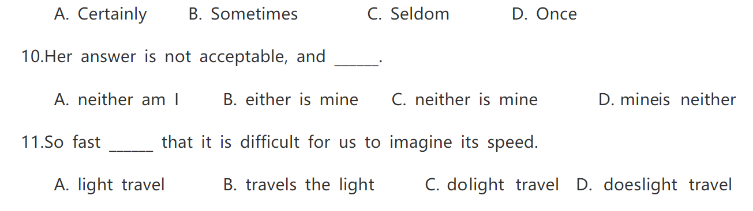

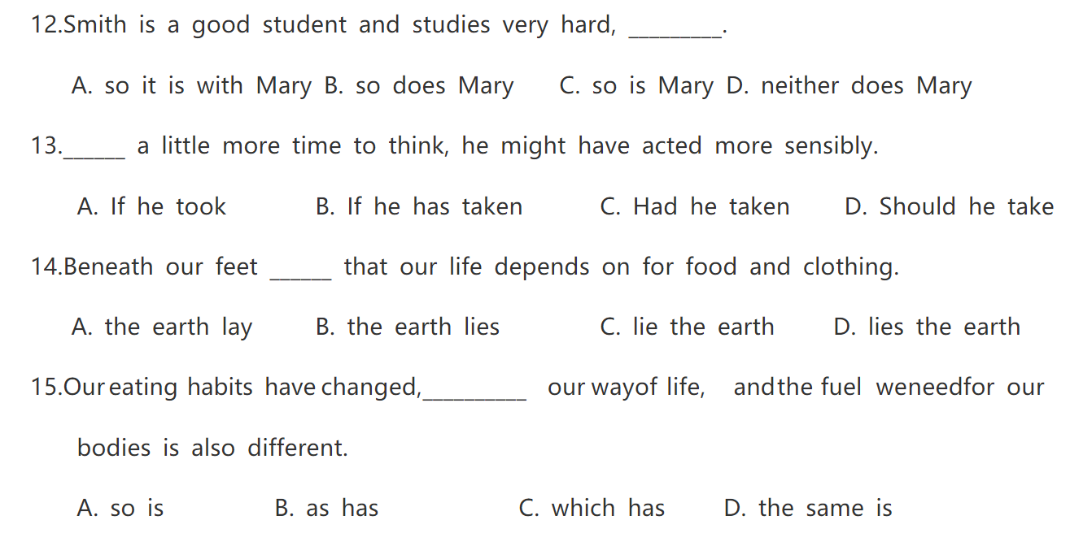

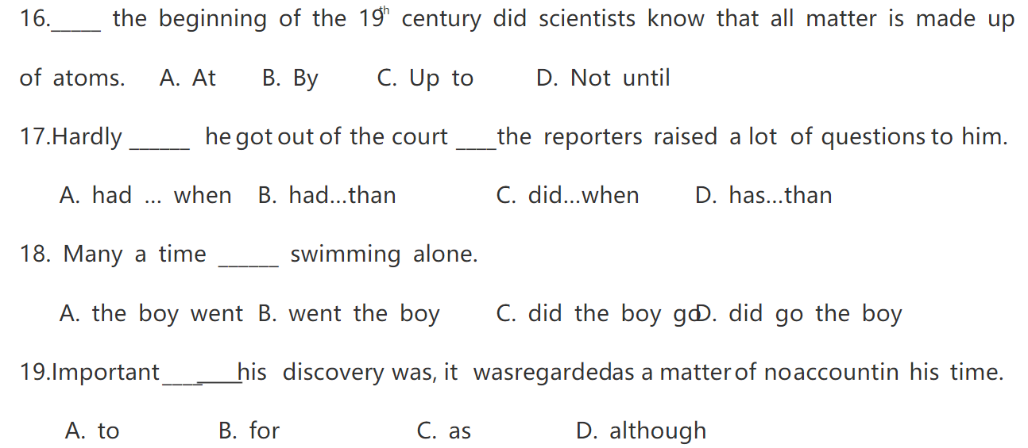

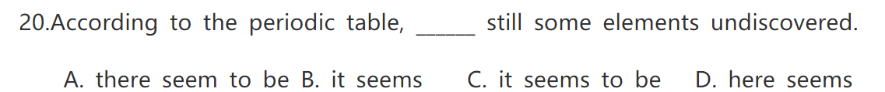

**强调句练习题**

1．________ you picked up the watch?

A. Where it was that      B. Where was it that      C. Where was it there      D. It was where that

2．It's his brother ________ never been to Australia. You'd better take him with you.

A. that is                             B. who is                             C. that have                             D. who has

3．It is the ability to do the job    matters not where you come from or what you are.

A. which                                  B. that                                  C. what                                  D. where

4．Was it last summer __________ you and your friends went to Moscow?

A. when                                   B. how                                   C. which                                   D. that

5．It is very interesting ___________ snowmen in winter.

A. making                            B. building                            C. to make                            D. to build

6．—Taian is a really comfortable city to live in.

—________, and it's world ­famous for Mount Tai.

A. So it is                            B. So is it                            C. So it does                            D. So does it

7．I found _______ convenient to shop on line at home.

A. it's                                     B. that                                     C. it                                     D. that was

8．It was in the Bird's Nest______many wonderful events were held in the year of 2008.

A. Where                                B. Which                                C. that                                D. in which

9．I just wonder   that makes him so excited.

A. why it does                       B. what he does                       C. how it is                       D. what it is

10．It was with his iron-fist approach            crimes in the southern state _______the 70-year-old man built a political name.

A. to fighting, where        B. of fighting, that         C. of fighting, where        D. to fighting, that

11．It was with great joy _______ he received the news ____ his lost son would soon return home.

A. because; that                         B. that; that                 C. because; which                        D. that; \

12．—Where did you come across our Chinese teacher?

—It was in the supermarket ___________ I purchased mooncakes.

A. that                                  B. where                                  C. which                                  D. when

13．The journey to America was very important to him because it was that journey     changed his attitudes towards English study.

A. of which                          B. to which                          C. that                          D. through which

14．— It was ___________ who helped us out of danger.

— What brave and helpful children! We should learn from them.

A. they                                   B. them                                   C. their                                   D. theirs

15．It wasn't until Monday night ______ we were told that Unit 5 would be excluded（排除）.

A. since                                  B. when                                  C. that                                  D. before

16．It was as a result of his carelessness _______ a serious fire broke out during the night.

A. when                                  B. that                                  C. before                                  D. since

17．Do you have any idea        computer plays so important a part in our daily life?

A. how is it that                B. what is it that                C. how it is that                D. what it is that

18．It was only __________he reached school ___________he realized that it was Sunday.

A. when; did                       B. when; that                       C. that; when                       D. that; which

19．—Have you seen the film Under the Hawthorn Tree?

—Of course, I have. It was in our village         it was made.

A. that                                  B. where                                  C. when                                  D. which

20．It was        back home after the experiment.

A. not until midnight did he go                           B. until midnight that he didn't go

C. not until midnight that he went                      D. until midnight when he didn't go

21．I wonder ________ that brought the Olympics back to life.

A. who it was                      B. who was it                      C. it was who                      D. was it who

22．It was the hard work and determination of the generation        had changed the opinion of people towards Chinese.

A. why                                   B. that                                   C. when                                   D. which

23．It was the typhoon    was called Tiange    hit Zhuhai and Macao.

A. which; that                      B. what; which                      C. that; who                      D. that; which

24．It was the training ____________ he had as a teenager _________ made him such a good engineer.

A. that; that                        B. what; that                        C. that; who                        D. that; which

25．I don't know            everyone in my class thinks I am funny.

A. why it is that              B. why is it which              C. who is it which              D. who it is which

26．It ______ not until she came back ______ Jane realized that she had lost her ID card.

A. is, that                             B. was, who                             C. was, that                             D. is, who

27．It was the high scores       Yang Liwei got on the psychological tests       finally won him the status of China's first astronaut.

A. that; that                        B. that; what                        C. what; that                        D. that; which

28．— Do you know _________ made him successful in his career?

— Yes. His hard work and strong will, of course.

A. what it was that           B. what was it that           C. it was what that           D. was it what that

29．It is Russia ________ will hold the 2018 World Cup.

A. that                                  B. which                                  C. where                                  D. when

30．You are waiting at a wrong place. It is at the entrance        your mother will meet you.

A. where                                   B. that                                   C. which                                   D. how