词汇题

1. The general ordered that the thief _________.
2. be punished B. would punish

C. would be punished D. should punish

1. The belief that the children of working mothers usually suffer is _________ by most scientists.
2. rejected B. refused C. resisted D. reduced
3. What he told us about the affair simply doesn’t make any _________.
4. sense B. meaning C. idea D. significance
5. There was nothing we could do __________ wait at that moment.
6. but B. rather than C. in spite of D. besides
7. we could see the stars ________ well from the top pf the mountain.
8. clearly B. generally C. fairly D. closely
9. ___________ we are living in the big date era, we are able to collect and analyze as much patient information as possible.
10. Even if B. As if C. As soon as D. Now that
11. ___________ all the animals I’ve ever had, these two dogs are the most sensitive to the spoken word.
12. From B. Of表示所属关系(...的) C. For D. With
13. __________ the great differences between them, they felt in love with each other at first sight.
14. In spite B. Although C. Despite D. Despite of
15. The music advisor taught her how to _________ a song to find its mood and meaning.
16. compose B. preserve C. include D. analyze
17. George is so _________ in debt that he is afraid to show up in the pub in case he meets his six creditors.
18. involved B. concentrated C. devoted D. concerned
19. All of us think it difficult to ________ the difference between the two things.
20. talk B. speak C. lecture D. tell
21. A new situation is likely to ________ when the school leaving age is raised to 16.
22. rise B. arise C. happen D. raise
23. Be quite. It is rude to ________ people when they are speaking.
24. interfere B. introduce C. interrupt D. prevent
25. Rapid reading means reading something fast just to _________ the general idea.
26. Master B. seize C. grasp D. imagine
27. Finding it difficult to _______ to the climate in the city, he decided to move to the North.
28. adopt B. adapt C. fit D. suit
29. They built strong walls round the town as a _________ against the enemy.
30. depend B. defend C. defeat D. defense
31. The students were not _______ to leave the classroom without an adequate reason.
32. permitted B. remitted C. admitted D. emitted
33. I don’t think it is easy to _______ your weight if keep on eating that way.
34. decrease B. reduce C decline D. shorten
35. The guide is ________ a line of tourists through the narrow passage with the help of his torch.
36. concluding B. containing C. conducting D. conquering
37. It ________ the village where we spent our holidays last summer.
38. reminds me of B. reminds me to C. remembers me of D. remembers me to
39. It’s too expensive for me. I can’t ________ it.
40. spend B. cost C. pay D. afford
41. I didn’t know what to do but then an idea suddenly _________ to me.
42. happened B. entered C. occurred D. hit
43. He said that he did not want to _________ any further responsibilities.
44. take on B. bring on C. get on D carry out
45. Send the children to bed. I can’t ____________ their noise any longer.
46. put off B. put up C. stand up D. put up with
47. Will you please _________ my parcel at the post-office as you pass?
48. Pick out B. pick up C. take out D. take up
49. In making such models, skills as well as thorough knowledge of plant structure are_________.
50. called on B. called up C. caller for D. called in
51. The little boy ________ his hiding place when he coughed.
52. gave away B. gave up C. got away D. got in
53. None of us expected the chairman to _______ at the party. We thought he was still in hospital.
54. turn in B. turn up C. turn over D. turn down
55. when he heard the bad news, he _________ completely.
56. broke away B. broke up C. broke down D. broke out
57. If I had time, I would _______ golf as hobby.
58. take in B. take on C. take up D. take over
59. We have cooperated well with them many years for the shared________.
60. honor B. reward C. benefit D. prize
61. I took the medicine, but it did not have any ______ on me.
62. effect B. relation C. touch D. affect
63. He said that he’d like to take______ of this opportunity to cooperate with you.
64. benefit B. advantage C. profit D. occasion
65. The new nurse does not have much _______ in taking care of patients.
66. experience B. regret C. desire D. talent
67. Will you be taking my previous experience into _______ when you fix my salary?
68. possession B. scale C. mind D. account
69. I suggest that you put the dangerous things out of the children’s_________.
70. control B. reach C. order D. sight
71. They have always been on good ________ with their next-door neighbors.
72. terms B. friendship C. relations D. connection
73. Grandma told me the story in a very sad ______ and we were all moved.
74. tune B. tongue C. tone D. ton
75. The telegram was based on information from a _______ source.
76. recent B. reliable C. rare D. private
77. You are making me ______ with your stories of how hard the examination is.
78. normal B. negative C. nervous D. neutral
79. Leaning a foreign language is a question of learning new skills, or a question of

______ new knowledge.

A) obtaining  B) gaining  C) achieving  D) acquiring

1. The examination I took yesterday wasn’t very difficult, but it was ________ long.
2. much rather B. so much C. too much D. much too
3. It may rain, but I shall go out ________; I don’t mind the rain.
4. anywhere B. anyhow C. however D. nevertheless
5. _______ of them knew about the plan because it was a secret.
6. Some B. Any C. No one D. None
7. I know nothing about him ______ he is a teacher.
8. besides B. in addition C. except for D. except that
9. The heavy snow could not keep us _______ going out to work.
10. from B. on C. upon D. up
11. I suppose I can count ______ you for help in this matter.
12. of B. on C. at D. to
13. Most people come to realize that it is about time the government ______ further measures to control the population.
14. must take B. is taking C. takes D. took

阅读填空

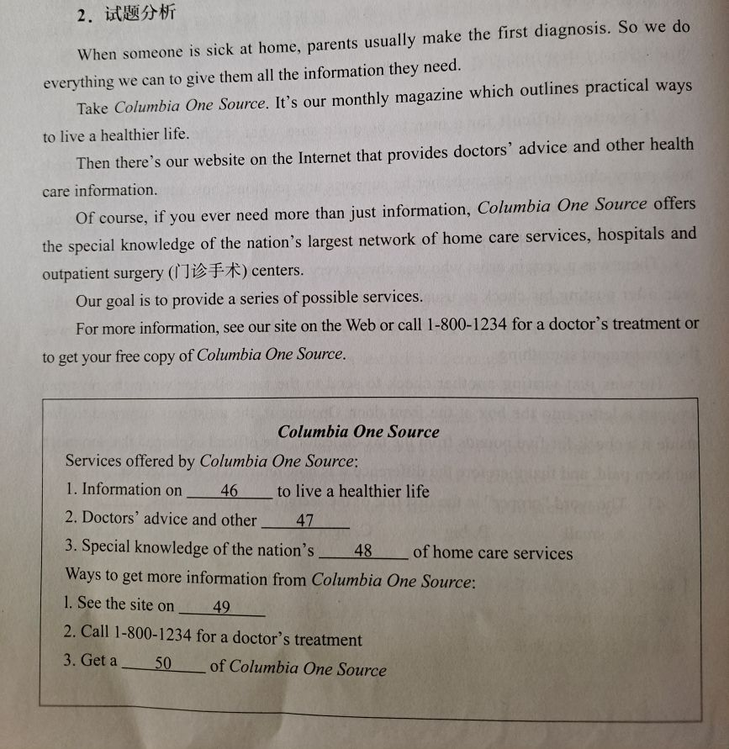

46 practical way

47 health care information

48 largest network

49 the web

50 free copy

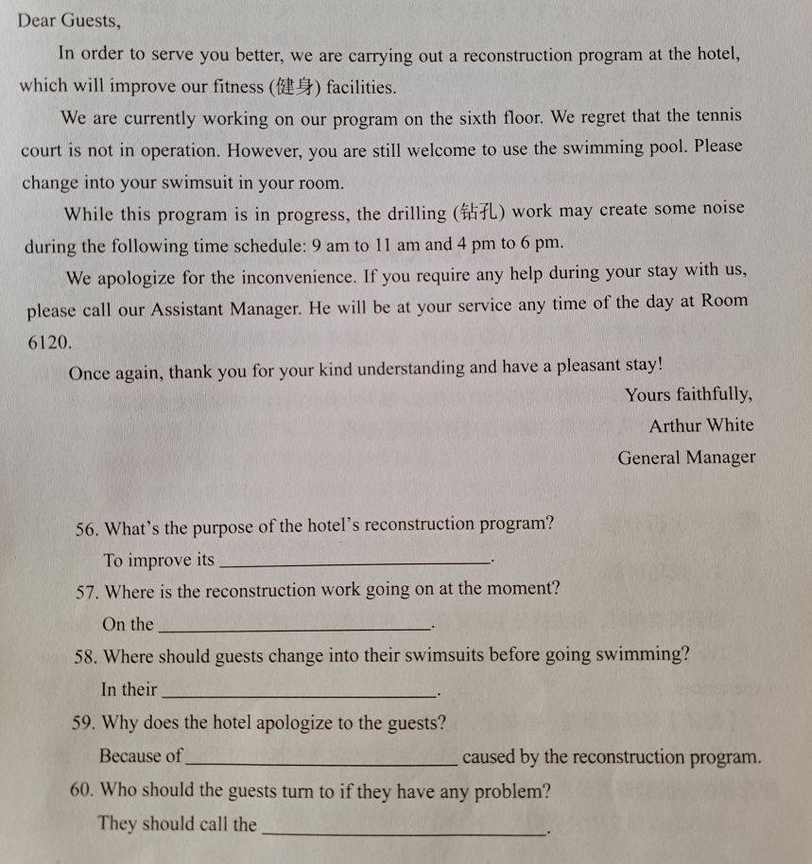

56 fitness facilities

57 sixth floor

58 room

59 the inconvenience

60 assistant manager