# Docker ForMysql

## DockerMysql单机

mkdir /usr/local/mysql

cd /usr/local/mysql

touch mysql.conf

mysql.cnf文件是我们自定义的配置文件，后面会挂载到磁盘中

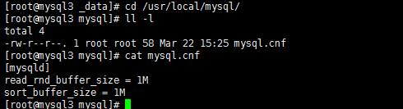

docker volume mysql_data 创建一个mysql_data磁盘卷，磁盘卷放置于docker下面

docker volume ls列出刚刚创建的磁盘卷

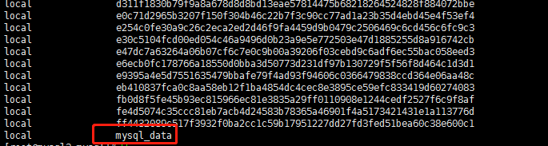

查看磁盘卷放置的目录

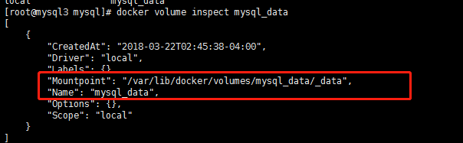

启动docker容器

docker run --name mysqlSingle --env MYSQL_ROOT_PASSWORD=123 -p3308:3306 -v /usr/local/mysql/mysql.cnf:/etc/mysql/conf.d/my.cnf -v mysql_data:/usr/mysql/lib -d mysql:5.7

启动docker容器

-v 是挂载外部磁盘卷

刚刚创建的mysql,.cnf挂载到/etc/mysql/conf.d/my.cnf

mysql_data 接收数据的文件mysql_data

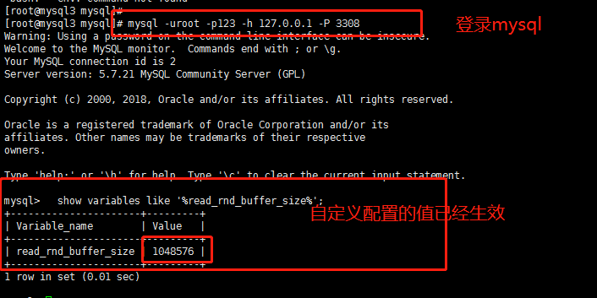

查看mysql的数据文件



所有msql数据

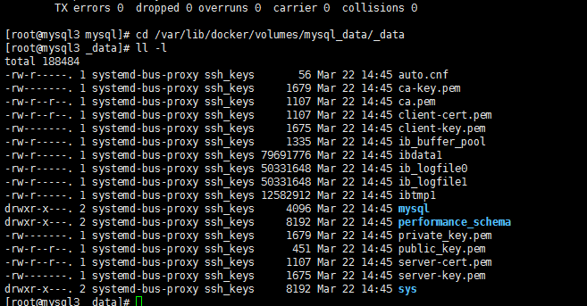

Docker网络属于桥接模式

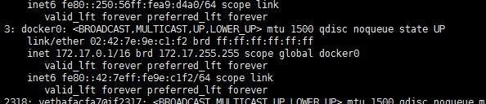

## DockerMysql主从

### Master

|  |
| --- |
| read_rnd_buffer_size = 1M  sort_buffer_size = 1M  # replicatio  server-id = 3308 //服务ID 确保两台机器必须不同  log-bin = mysql-bin  log-error = /var/log/mysql/error.log  log_slave_updates = 1  binlog_format = row  sync_binlog = 1  gtid_mode = on  enforce_gtid_consistency = on  master_info_repository = table  relay_log_info_repository = table  port=3308 |

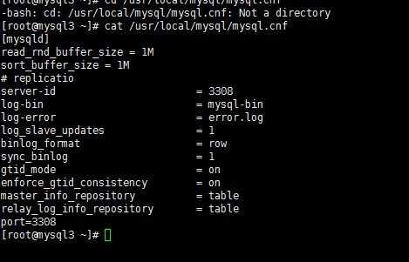

启动mysql

Docker volume create mysql_log

docker run --name mysqlSingleMgr --env MYSQL_ROOT_PASSWORD=123 -p3308:3308 -v /usr/local/mysql/mysqlMgr.cnf:/etc/mysql/conf.d/my.cnf -v mysql_data:/usr/mysql/lib -v mysql_log:/var/log/mysql -d mysql:5.7

GRANT REPLICATION SLAVE ON *.* TO 'mysql03'@'%' IDENTIFIED BY 'mysql03';//创建用户，赋予REPLICATION 权限

INSTALL PLUGIN rpl_semi_sync_master SONAME 'semisync_master.so';//安装集群心态检测包

SET GLOBAL rpl_semi_sync_master_enabled = 1;//设置集群心跳检测包可用

### Slave

编辑mysql.cnf

|  |
| --- |
| read_rnd_buffer_size = 1M  sort_buffer_size = 1M  # replication  server-id = 3309  relay-log = relay-bin  log-error = /var/log/mysql/error.log  log_slave_updates = 1  binlog_format = row  sync_binlog = 1  gtid_mode = on  enforce_gtid_consistency = on  master_info_repository = table  relay_log_info_repository = table  port=3308 |

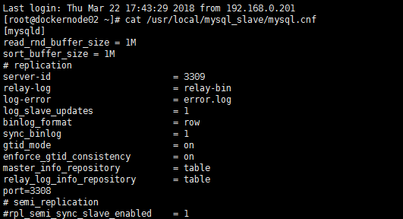

启动mysql

docker run --name mysqlSingle --env MYSQL_ROOT_PASSWORD=123 -p3308:3308 -v /usr/local/mysql_slave/mysql.cnf:/etc/mysql/conf.d/my.cnf -v mysql_data:/usr/mysql/lib -d mysql:5.7

INSTALL PLUGIN rpl_semi_sync_slave SONAME 'semisync_slave.so';

SET GLOBAL rpl_semi_sync_slave_enabled = 1;

Change master to   
master_host='192.168.0.115',master_port=3308,master_user='mysql03',master_password='mysql03'

start slave;

show slave status\G;

查看

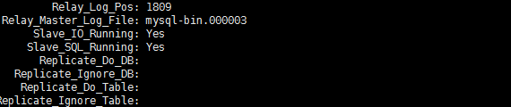

## Docker Mysql Mgr

### Master:

Vi /usr/local/mysql/mysqlMgrHost.cnf

|  |
| --- |
| [mysqld]  read_rnd_buffer_size = 1M  sort_buffer_size = 1M  log-error=/var/log/mysql/mysql_error.log  # replicatio  server-id = 3308  log-bin = mysql-bin  #log-error = error.log  log_slave_updates = 1  binlog_format = row  sync_binlog = 1  gtid_mode = on  enforce_gtid_consistency = on  master_info_repository = table  relay_log_info_repository = table  port=3308  log_slave_updates = ON  binlog_checksum = NONE  binlog_format = ROW  transaction_isolation = READ-COMMITTED  gtid_mode = ON  enforce_gtid_consistency = ON  # GR 配置项 其中loose前缀表示若Group Replication plugin未加载 mysql server仍继续启动  transaction_write_set_extraction = XXHASH64  loose-group-replication-ip-whitelist="192.168.0.0/24"  loose-group_replication_single_primary_mode=true  loose-group_replication_enforce_update_everywhere_checks=false  loose-group_replication_group_name = "aaaaaaaa-aaaa-aaaa-aaaa-aaaaaaaaaaaa" # 组名，此处可拿select uuid();生成  loose-group_replication_start_on_boot = off # 在mysqld启动时不自动启动组复制  loose-group_replication_local_address = "192.168.0.115:24901"  loose-group_replication_group_seeds = "192.168.0.115:24901,192.168.0.117:24902"  loose-group_replication_bootstrap_group = off |

Docker volume create mysql_data

Docker volume create mysql_log

mysql_data目录

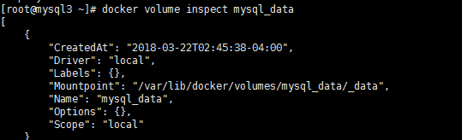

#### 启动docker

docker run --name mysqlMaster --hostname=mysql3 --network=host --env MYSQL_ROOT_PASSWORD=123 -p3308:3308 -v /usr/local/mysql/mysqlMgrHost.cnf:/etc/mysql/conf.d/my.cnf -v mysql_data:/usr/mysql/lib -v mysql_log:/var/log/mysql -d mysql:5.7

#### 进入mysql



#### Mysql配置

|  |
| --- |
| SET SQL_LOG_BIN=0;  CREATE USER mysql03@'%';  GRANT REPLICATION SLAVE ON *.* TO mysql03@'%' IDENTIFIED BY 'mysql03';  FLUSH PRIVILEGES;  SET SQL_LOG_BIN=1;  CHANGE MASTER TO MASTER_USER='mysql03', MASTER_PASSWORD='mysql03' FOR CHANNEL 'group_replication_recovery';  INSTALL PLUGIN group_replication SONAME 'group_replication.so';  SELECT * FROM information_schema.plugins WHERE PLUGIN_NAME LIKE '%group%';  SET GLOBAL group_replication_bootstrap_group=ON;  START GROUP_REPLICATION;  SET GLOBAL group_replication_bootstrap_group=OFF;  set global group_replication_allow_local_disjoint_gtids_join=1;  SELECT * FROM performance_schema.replication_group_members; |

执行select出现如图

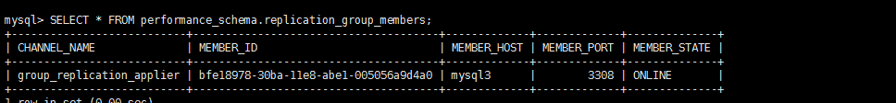

### Slave:

Vi /usr/local/mysql/mysqlMgrHost.cnf

|  |
| --- |
| [mysqld]  read_rnd_buffer_size = 1M  sort_buffer_size = 1M  log-error=/var/log/mysql/mysql_error.log  # replicatio  server-id = 3310  log-bin = mysql-bin  #log-error = error.log  log_slave_updates = 1  binlog_format = row  sync_binlog = 1  gtid_mode = on  enforce_gtid_consistency = on  master_info_repository = table  relay_log_info_repository = table  port=3308  log_slave_updates = ON  binlog_checksum = NONE  binlog_format = ROW  transaction_isolation = READ-COMMITTED  gtid_mode = ON  enforce_gtid_consistency = ON  # GR 配置项 其中loose前缀表示若Group Replication plugin未加载 mysql server仍继续启动  transaction_write_set_extraction = XXHASH64  loose-group-replication-ip-whitelist="192.168.0.0/24"  loose-group_replication_single_primary_mode=true  loose-group_replication_enforce_update_everywhere_checks=false  loose-group_replication_group_name = "aaaaaaaa-aaaa-aaaa-aaaa-aaaaaaaaaaaa" # 组名，此处可拿select uuid();生成  loose-group_replication_start_on_boot = off # 在mysqld启动时不自动启动组复制  loose-group_replication_local_address = "192.168.0.117:24902"  loose-group_replication_group_seeds = "192.168.0.117:24902,192.168.0.115:24901"  loose-group_replication_bootstrap_group = off |

#### 启动docker

docker run --name mysql --hostname=mysql4 --network=host --env MYSQL_ROOT_PASSWORD=123 -p3308:3308 -v /usr/local/mysql/mysqlMgrHost.cnf:/etc/mysql/conf.d/my.cnf -v mysql_data:/usr/mysql/lib -v mysql_log:/var/log/mysql -d mysql:5.7

#### 进入docker

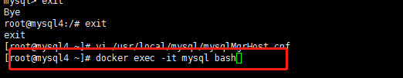

#### 进入mysql

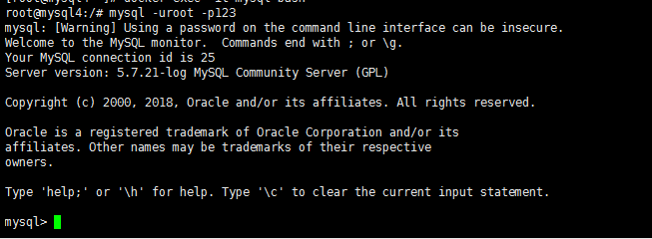

#### Mysql配置

|  |
| --- |
| SET SQL_LOG_BIN=0;  CREATE USER mysql03@'%';  GRANT REPLICATION SLAVE ON *.* TO mysql03@'%' IDENTIFIED BY 'mysql03';  FLUSH PRIVILEGES;  SET SQL_LOG_BIN=1;  CHANGE MASTER TO MASTER_USER='mysql03', MASTER_PASSWORD='mysql03' FOR CHANNEL 'group_replication_recovery';  INSTALL PLUGIN group_replication SONAME 'group_replication.so';]  set global group_replication_allow_local_disjoint_gtids_join=1;  START GROUP_REPLICATION; |

最后需要出现如图

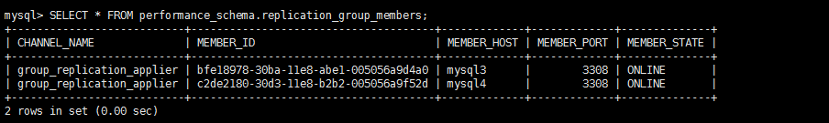

证明配置成功

可以查看日志如图中标红所示

