## Introduction

There is a dataset about data analyst jobs. This data would help me because I want to be a data analyst. I want to know some information about this kind of job. I never know about this job and my job experience also dont't contain analyst. So I hope to learn about these jobs by simple analysis. Now I would explore the following 3 questions:

1.Find the best jobs by salary and company rating.

2. Explore skills required in job descriptions.

3.Predict salary based on company size.

## Find the best jobs by salary and company rating

After cleaning the dataset, I grouped the average salaries and company rating for each job title.

The best jobs by salary and company rating, the following jobs satisfy the two demand (average salary >= 110000 and rating > 4.5 ):

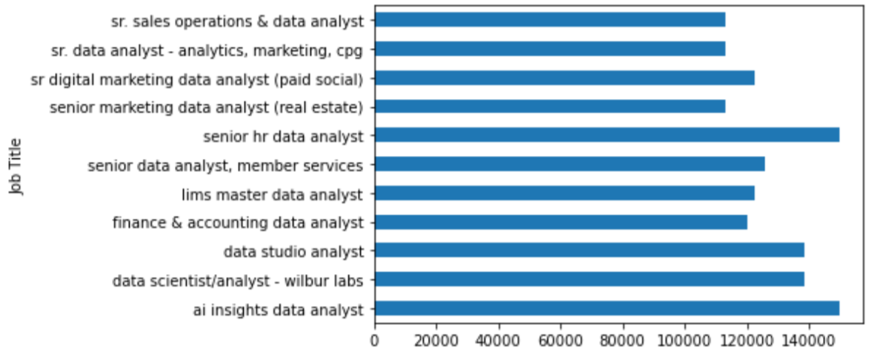 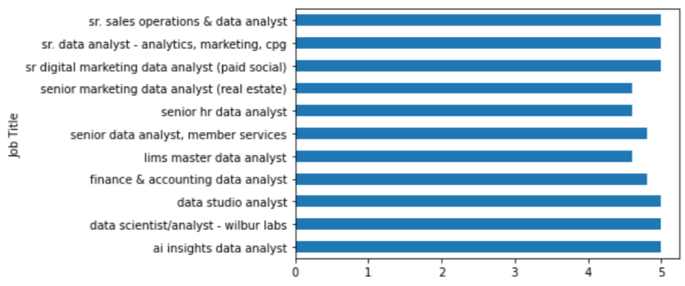

From the charts, senior level about data science, marketing, hr would be a great job.

## Explore skills required in job descriptions

Firstly, I got some common skills from 20 job descriptions. And then I create a function to statistic whether these skills that I got exists. Finally, by analyzing counts I got the required skills.

BI, SQL, Excel, communication skills, Python/R, Tableau, Access, Modeling, Statistical software, Office software, programming. These are the most mentioned skills.

So if I want to be a data analyst, I should master skills about data visualization, the Query language, excellent communication skills, simple programming and modeling.

## Predict salary based on company size

I thought that the bigger size the company is, the higher salary the employee earns. But I put train data into Linear regression model, the result is so worse. And the correlation between salary and company size is very small, almost 0. So I don’t know how to predict salary. Now I have no idea. And I am eager to be guided by someone.