TCT-Shell User Guide
Version 0.5

Copyright© 2013 Samsung Corporation. All rights reserved.
Copyright© 2013 Intel Corporation. All rights reserved.
*Other names and brands may be claimed as the property of others
Contents
1 Introduction 3
2 Overview 3
3 Terminology 3
4 Prerequisites 4
5 Installing TCT-shell 4
6 TCT-shell Options 5
6.1 Mandatory options 5
6.2 Optional options 6
7 Typical Usage 7
7.1 Generating a Test Plan 7
7.2 Running Tests 7
8 View Report 9

Change history
Change history
Version | Date | Author | Change log
0.1 | 04/08 /2013 | Dandan Liu, Jing Zhang | Initial version
0.2 | 06/05/2013 | Dandan Liu | Modify the format of the document
0.3 | 06/13/2013 | Dandan Liu | Remove “Capability” relative parameter and section
0.4 | 06/21/2013 | Dandan Liu | Update the grammar error
0.5 | 06/24/2013 | Dandan Liu | Update according to technical review

Introduction
This document provides comprehensive information about TCT-shell, with an overview, installation instructions, command option descriptions, and typical usage.

Overview
TCT-shell is a lightweight console tool and serves as a major component of the Tizen Compliance Test (TCT) tool set. By providing an alternative way to execute the TCT tools with Testkit-lite, TCT-shell allows users to:
- Run test packages
- Run test plans
- Generate test reports
- Rerun failed tests
- Show test resources, such as plans, test results, and connected devices

Terminology
Test package: An .rpm file that contains test cases.
Test plan: An .xml file that contains a series of test suites.
Test report: A human-readable HTML file that shows the test results.
Test result: An .xml file that contains the result information of a test execution.

Prerequisites
Make sure these items are in place before starting:
- One of these Linux distribution versions is installed:
- Ubuntu 12.04 (32-bits)
- Ubuntu 12.04 (64-bits)
- Ubuntu 12.10 (32-bits)
- Ubuntu 12.10 (64-bits)
- Software TCT-shell depends on is installed Python and python-support (0.90.0 or later).
- Tizen capable devices with the latest the Tizen implementation (for example, M0 and Lunchbox) are available.
- The sdb software is correctly installed.

Installing TCT-shell
To install TCT-shell:
Note: Make sure the installation environment is ready before starting. For detailed instructions, refer to the "Installing the TCT Tools" section in the Web TCT Tools User Guide.
- Switch to the TCT directory, where the TCT package is decompressed, by executing this command:
$cd <TCT_Directory>
- Install TCT-shell by using one of these methods, as appropriate:
- Install TCT-shell independently, using the .deb package:
$sudodpkg -i tct-shell_<Version>.deb
- Install the entire TCT tool set:
$sudo ./install.sh

TCT-shell Options

Mandatory options
Mandatory options
Option | Description
-p, --testplan | Specify testplan.xml as the test plan.
-t, --test | Specify testing suites. If more than one suite is provided, list them all and separate them with whitespace.
-r, --rerun-fail | Rerun all failed test cases, according to the specified XML.

Optional options
Optional options
Option | Description
-o resultfile, --output=resultfile | Specify the output file for the resulting XML output. If more than one test xml file is provided, results will be merged into this output file.
--enable-memory-collection | Allow memory to be released when free memory is less than 100 MB.
-v, --version | Show version information.
--skip-iu | Do not install and uninstall suite packages during a test. Install and uninstall them manually.
-a, --all-suites | Show all available test-suites in the local repository. Its location is defined in the configuration file named CONFIG, and its path is:/opt/tct/shell/CONFIG.
-c, --capability | Specify the capability file.
--non-active | Disable the ability to set the result of core manual cases from the console.
--deviceid | Set sdb device serial information.
--plan-list | List all existing plans in the plan folder. The plan folder is defined in the configuration file named CONFIG, and its path is:/opt/tct/shell/.
--result-list | List all history results in the result folder. The result folder is defined in the configuration file named CONFIG, and its path is:/opt/tct/shell/ CONFIG.
--device-list | List all connected devices.
--all | All test cases will be executed.
--manual | Only manual test cases will be executed.
--id | Specify the ID of a test case to run.
-h, --help | Show this help message and exit.

Typical Usage

Generating a Test Plan
Test plans
Suites to include | Command
Include all suites in the local repository | $ tct-plan-generator -o <somewhere>/testplan.xml
Include all suites in the special repository | $ tct-plan-generator -o <somewhere>/testplan.xml -r <somewhere>/repository_folder
Include the suites in the special repository where the name matches a specific regular expression | $ tct-plan-generator -o <somewhere>/testplan.xml -r <somewhere>/repository_folder --match '<regex>'
Include the suites in the special repository where the name matches a specific regular expression, and exclude any file where the name matches another regular expression | $ tct-plan-generator -o <somewhere>/testplan.xml -r <somewhere>/repository_folder --match ‘<regex>’ --unmatch ‘<unmatch_regex>’  For example, to exclude the Testkit-stub package:  $ tct-plan-generator -o <somewhere>/testplan.xml -r <somewhere>/repository_folder --match ‘*.rpm’ --unmatch ‘stub’

Running Tests
Running tests
Function | Command
Show the help information | $ tct-shell --help
Show the plan list | $ tct-shell --plan-list  Test plans are placed in the ‘/opt/tct/shell/plan’ folder, by default. Edit the ‘/opt/tct/shell/CONFIG’ file to change it, if necessary:  TCT_PLAN_FOLDER = <path-to-plans>
Show the package list | $ tct-shell --all-suites  The default package repository is in the /home/package folder. Edit ‘/opt/tct/shell/CONFIG’ file to change it, if necessary:  TEST_SUITE_DIR = <path-to-suites>
Show the test result list | $ tct-shell --result-list  Each test result is generated as a separate folder in the /opt/tct/shell/result folder.
Show the device list: | $ tct-shell --device-list
Run a test plan | $ tct-shell --testplan ‘<somewhere>/testplan.xml’
Run some test packages | $ tct-shell --test ‘package1 package2 … packageN’
Run a test case by its ID: | $ tct-shell --test ‘package’ --id <case-id>
Rerun all failed test cases | $ tct-shell --rerun-fail ‘<somewhere>/test-result.xml’
Install and uninstall suite packages manually | Do not install and uninstall suite packages during a test (they need to be installed and uninstalled manually):  $ tct-shell --testplan ‘<somewhere>/testplan.xml’ --skip-iu
Specify a capability file for a test | $ tct-shell --testplan ‘<somewhere>/testplan.xml’ --capability ‘<somewhere>/capability.xml’
Run a test package on a specific device: | $ tct-shell --testplan ‘<somewhere>/testplan.xml’ --deviceid<device-id>
Run all test cases, including automatic and manual cases | $ tct-shell --testplan ‘<somewhere>/testplan.xml’ --all
Run manual test cases | $ tct-shell --testplan ‘<somewhere>/testplan.xml’ --manual
Specify the output file for test results | $ tct-shell --testplan ‘<somewhere>/testplan.xml’ -o <somewhere>/test-result.xml
Skip core manual cases during the test | $ tct-shell --testplan ‘<somewhere>/testplan.xml’ --non-active

View Report
A test’s result is placed in /opt/tct/shell/result, in a new folder, with the test’s date-time string as the name. To view the results, navigate to the test’s result folder and open the summary.xml file with the web browser. This is a sample file:
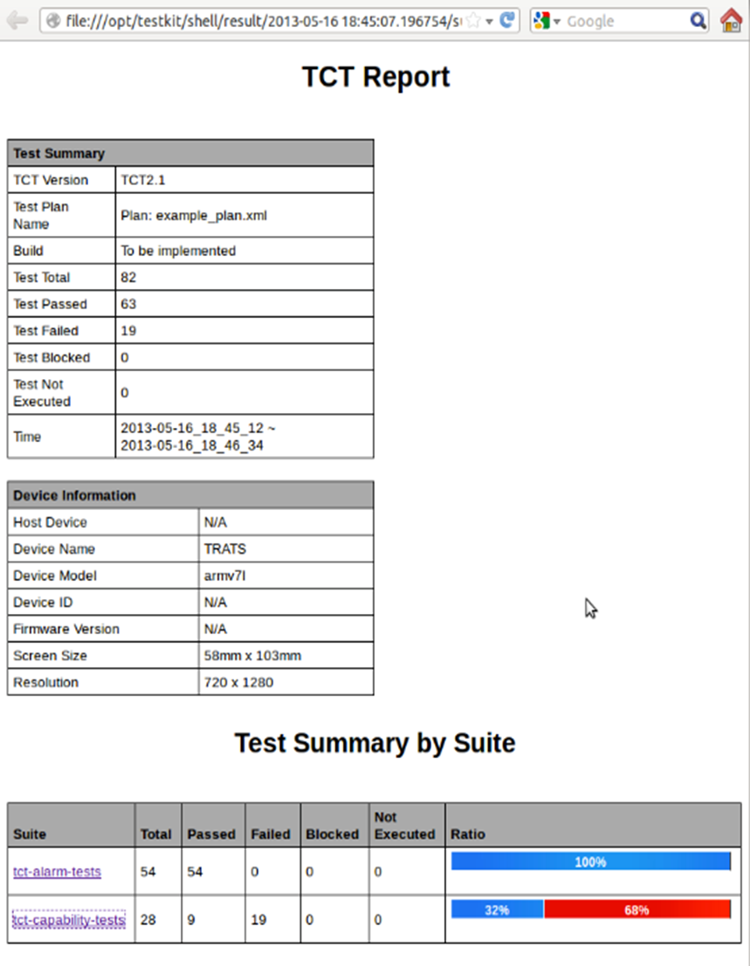
Click on the suite name in the Test Summary by Suite table to see details.
This is an example of the test suite’s details:
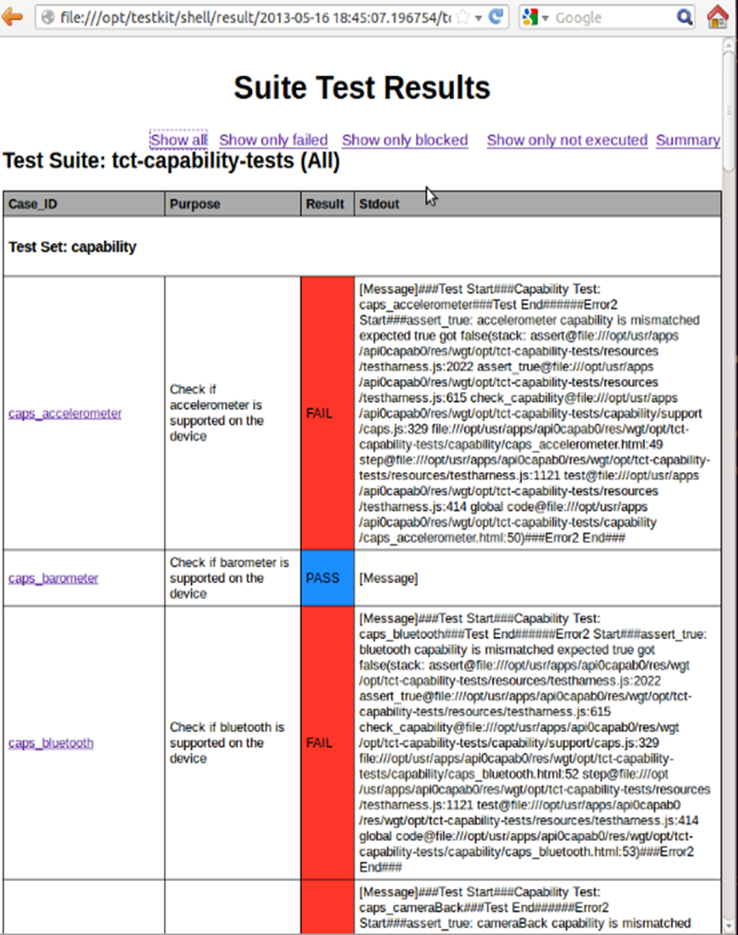

Click on the corresponding link, at the top of the page, to filter the failed, blocked, or not executed test cases.
This is an example of the filtered information:
