• Natural Nearest Neighbor 1

I. Algorithm 1

II. Source Code 1

III. Data 1

• EXPERIMENT 2

I. EXPERIMENTAL OBJECTIVE 2

II. EXPERIMENT PRINCIPLE 2

III. EXPERIMENTAL PROCEDURE 2

APPENDIX 4

## Natural Nearest Neighbor

### Algorithm

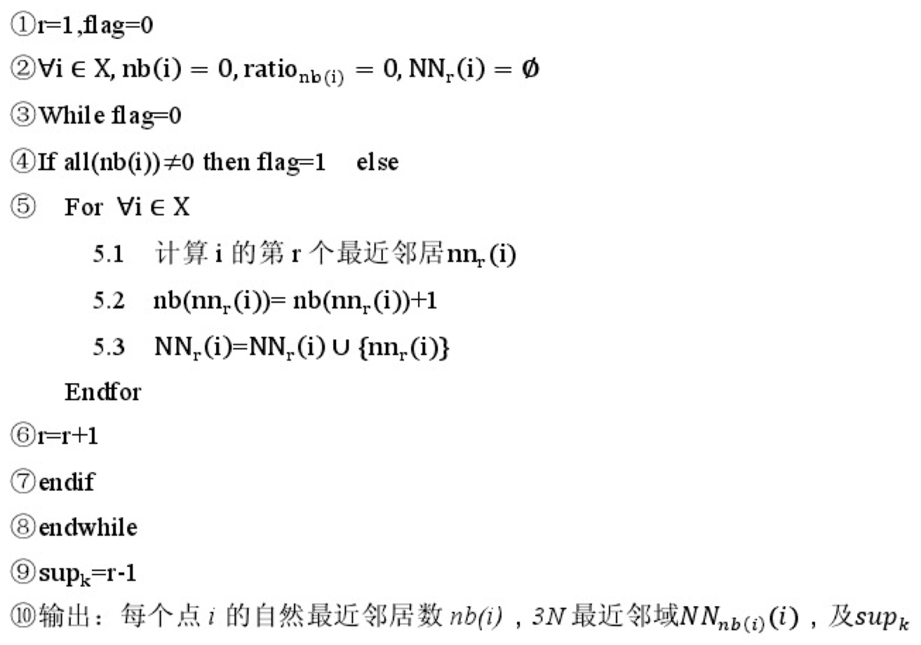

~~表示点y的第r 最近邻~~表示元素 $i$ 的第r 个最近邻居， $nb\left(i\right)$ 表示元素 $i$ 在其它点的r邻域中出现的次数， $\sup_{k}$ 为数据集的平均邻居点数。

### Source Code**[1]**

### Data[2]

|  |  |  |  |  |  |  |  |  |  |
| --- | --- | --- | --- | --- | --- | --- | --- | --- | --- |
| Hubs与错误率的实验分析 | | | | | | | | | |
| 实验目的 | 检测具有 $高K_occurrences$ 的点是否拥有与之相高的错误率 | | | | | | | | |
| 实验数据 | **Name** | $$Src$$ | | **n** | | **d** | $$Cls$$ | | $$Dist$$ |
| **Two Moons** |  | | 14977 | | 2 | 2 | | $$l_{2}$$ |
| **Abalone** | UCI | | 4177 | | 8 | 29 | | $$l_{2}$$ |
| **Ionosphere** | UCI | | 351 | | 34 | 2 | | $$l_{2}$$ |
| 实验方法 | * 利用自然最近邻算法求出 $K_occurrences$* 根据原始的类标签，计算每个点作为其它点最近邻的错误率 * 检测拥有 $高K_occurrences$ 的点是否拥有与之相高的错误率 | | | | | | | | |
| 实验结果 | **Name** | $$K$$ | **Hubs** | | **SNK** | $$Corr$$ | | **Rate** | |
| **Two Moons** | **10** | **0** | | **-0.2** | **False** | | **0** | |
| **Abalone** | **19** | **2%** | |  | **False** | | **0** | |
| **Ionosphere** | **14** | **12%** | | **1.54** | **True** | | **65.9%** | |
| 实验结论 | 只有在高维度的数据集中， 拥有 $高K_occurrences$ 的点才能拥有与之相高的错误率 | | | | | | | | |

## IMPROVEMENT EXPERIMENT

### EXPERIMENTAL OBJECTIVE

To verify the accuracy of spectral clustering similarity matrices with hubs in high-dimension.

### EXPERIMENT PRINCIPLE

* The main objectives of (distance-based) clustering algorithms are to minimize intra-cluster distance and maximize inter-cluster distance. The skewness of k-occurrences in high-dimensional data influences both objectives.
* Intra-cluster distance may be increased due to points with low k-occurrences. Nevertheless, the skewness of $N_{k}$ suggests that in high-dimensional data outliers are also expected due to inherent properties of vector space.
* Inter-cluster distance may be reduced due to points with high k-occurrences, that is, hubs. Like outliers, hubs do not cluster well, but for a different reason: they have low inter-cluster distance, because they are close to many points, thus also to points from other clusters.

### EXPERIMENTAL PROCEDURE

* **STEP1**

Select as hubs those points $x$ with $h(x, k) > 2$, that is, $N_{k}(x)$ more than two standard deviations higher than the mean. Let $n_{h}$ be the number of hubs selected.

|  |  |  |  |
| --- | --- | --- | --- |
| **Ionosphere Data Set** | | | |
| Data Set Characteristics: | Multivariate | Number of Instances: | 351 |
| Attribute Characteristics: | Integer, Real | Number of Attributes: | 34 |

* [3]作为其它结点最近邻的次数

$h(x, k) > 2$

|  |  |  |  |  |  |  |  |  |  |  |  |  |  |  |  |  |  |  |  |  |  |  |  |
| --- | --- | --- | --- | --- | --- | --- | --- | --- | --- | --- | --- | --- | --- | --- | --- | --- | --- | --- | --- | --- | --- | --- | --- |
| hub | 71 | 68 | 65 | 61 | 59 | 57 | 55 | 50 | 47 | 45 | 42 | 41 | 40 | 39 | 37 | 36 | 35 | 34 | 33 | 32 | 31 | 30 | 29 |
| index | 1 | 1 | 2 | 3 | 2 | 1 | 1 | 1 | 1 | 1 | 1 | 1 | 1 | 1 | 2 | 2 | 3 | 1 | 2 | 5 | 3 | 2 | 1 |

* **STEP2**

Each hub $x_{i}(i=1,2…n_{h})$ has been considered as several points’ $y$ nearest neighbor.

Begin with calculating $error(y)$ of training instances that consider hub as their nearest neighbor for each dimension. These calculations are performed according to Eq. (1);

$error\left(y\right)=\left|x_{i}-y\right|$ (1)

The average and standard deviation of the error is $μ_{err}$ and $σ_{err}$ respectively.

* **STEP3:**

Calculate the normalized error and the weights of these instances according to Eqs. (2) and (3) as follows:

$$err\left(y\right)=\frac{error\left(y\right)-μ_{err} }{σ_{err}} (2)$$

$$w\left(y\right)=e^{-err\left(y\right)} (3)$$

* **STEP4**

According to Eq. (4) the corrected hub $x_{i}$ is the average of those instances that have $x_{i}$ as their nearest neighbor.

$$x_{i}=\frac{1}{\sum{w\left(y\right)}}\sum_{i=1}^{|y|}{{w\left(y\right)y}_{i}} (4)$$

* **STEP5**

Use the weights recalculate their similarities according to Eq. (5).

$$similarity\left(y_{i}\right)=w\left(y_{i}\right)dist\left(y_{i}\right) (5)$$

### EXPERIMENTAL CONCLUSION

逆近邻错分的次数对比

* 原始数据

|  |  |  |  |  |  |  |  |  |  |  |  |  |  |  |  |  |
| --- | --- | --- | --- | --- | --- | --- | --- | --- | --- | --- | --- | --- | --- | --- | --- | --- |
| 错分次数 | 20 | 17 | 15 | 14 | 13 | 12 | 11 | 9 | 7 | 6 | 5 | 4 | 3 | 2 | 1 | 0 |
| 结点数 | 2 | 1 | 3 | 2 | 2 | 3 | 1 | 1 | 1 | 5 | 1 | 9 | 14 | 44 | 85 | 177 |

* 修改后的数据

|  |  |  |  |  |  |  |  |  |  |  |  |  |
| --- | --- | --- | --- | --- | --- | --- | --- | --- | --- | --- | --- | --- |
| 错分次数 | 16 | 14 | 12 | 10 | 7 | 6 | 5 | 4 | 3 | 2 | 1 | 0 |
| 结点数 | 1 | 2 | 2 | 6 | 2 | 1 | 8 | 3 | 11 | 33 | 83 | 199 |

## APPENDIX

1. Source Code

   NearestNeighbor

   |  |
   | --- |
   | function NN( dataSet,dataSetName )    fprintf('Nearest Neighbor Begin...\n');    [N, dim]=size(dataSet);    %Compute Rejoint Matrix  tic;  dist = squareform(pdist(dataSet));  toc    %  [sdist,index]=sort(dist,2);      %???????  r=1;  flag=0;  nb=zeros(1,N); %??????  NNN=zeros(N,N); %????????  count=0; %???????????????????  count1=0; %???????????????  count2=0; %??????????????    %????????  while flag==0  for i=1:N  k=index(i,r+1);  nb(k)=nb(k)+1;  NNN(k,nb(k))=i;  end  r=r+1;  count2=0;  for i=1:N  if nb(i)==0  count2=count2+1;  end  end  %??nb(i)=0?????????????  if count1==count2  count=count+1;  else  count=1;  end  if count2==0 || (r>2 && count>=2) %????????  flag=1;  end  count1=count2;  end    %?????????????  SUPk=r-1; %??K??????????????  K=SUPk;  %disp(K);  fprintf('K=%d\n',K);  savePath=strcat('Result/',dataSetName,'/');  if ~exist(savePath,'dir')  mkdir(savePath);  end    k_ocurrence=nb;  save(strcat(savePath,'k_ocurrence.mat'),'k_ocurrence');  save(strcat(savePath,'K.mat'),'K');  [k_ocurrenceSort,k_ocurrenceIndexSort]=sort(k_ocurrence,'descend');  save(strcat(savePath,'k_ocurrenceSort.mat'),'k_ocurrenceSort');  save(strcat(savePath,'k_ocurrenceIndexSort.mat'),'k_ocurrenceIndexSort');  save(strcat(savePath,'NNN.mat'),'NNN');        % AdjointMatrixGraph(NN,0);  fprintf('Nearest Neighbor End...\n');  disp('----------------');  Error( dataSet,dataSetName,K,k_ocurrenceSort, k_ocurrenceIndexSort,NNN);    end |

   Error

   |  |
   | --- |
   | function Error( dataSet,dataSetName )  fprintf('Error Begin...\n');  struct=load(strcat('Result/',dataSetName,'/NNN.mat'));  names=fieldnames(struct);  NNN=struct.(names{1});  [N, dim]=size(NNN);  err=zeros(1,N);  err_avg=zeros(1,N);  %Load Labeled DataSet  struct=load(strcat('DataSet/',dataSetName,'/',dataSetName,'_labeled.mat'));  names=fieldnames(struct);  dataLabel=struct.(names{1});    % Compute Avg Error Rate  for i=1:N  label=dataLabel(i,1);  for j=1:N  if(NNN(i,j)==0)  break;  end  label2=dataLabel(NNN(i,j),1);  if(label~=label2)  err(i)=err(i)+1;  end  end  if(j~=1)  err_avg(i)=err(i)/(j-1);  end  end    savePath=strcat('result/',dataSetName,'/');  if ~exist(savePath,'dir')  mkdir(savePath);  end  save(strcat(savePath,'err.mat'),'err');  save(strcat(savePath,'err_avg.mat'),'err_avg');  [errSort,errorIndexSort]=sort(err,2,'descend');  save(strcat(savePath,'errorIndexSort.mat'),'errorIndexSort');  save(strcat(savePath,'errSort.mat'),'errSort');  [err_avgSort,errorIndex_avgSort]=sort(err_avg,2,'descend');  save(strcat(savePath,'errorIndex_avgSort.mat'),'errorIndex_avgSort');  save(strcat(savePath,'err_avgSort.mat'),'err_avgSort');      fprintf('Error End...\n');  end |

  
2. Data

   [AbaloneDemo](D:\\迅雷下载\\AbaloneDemo.xlsx)

   AbaloneDemoNL
3. 33 64 26 29 85 75 53 43 26 49 29 37 21 19 24 7 83 28 58 42 56 82 38 25 47 35 40 13 25 10 18 73 75 90 83 30 56 24 34 54 31 36 91 92 92 81 26 28 88 28 67 51 25 22 48 28 38 25 90 22 38 13 16 47 17 31 37 57 21 88 9 38 63 33 46 40 15 38 26 43 41 84 44 78 21 46 33 10 22 39 15 5 28 57 78 78 2 27 29 22 85 15 18 2 29 22 28 27 20