**Kent Police and Kent County Council Community Safety Team**

***“Is there an Anti-Social behaviour (ASB) problem in Kent and, if so, what would you recommend to Kent Community Safety Partners to prevent ASB?”***

**Submitted by: Subhan Shujah Ali  
Date: 16/06/2025  
Position: Analyst (North Division) – Interview Task  
Submitted to: Kent Police & Kent Community Safety Team**

Executive summary

Anti-social behaviour (ASB) is defined under the Antisocial Behaviour Act 2003 and Police Reform and Social Responsibility Act 2011 as: “Behaviour by a person which causes, or is likely to cause, harassment, alarm or distress to persons not of the same household.” ASB includes a wide spectrum of behaviours – from vandalism and noise to street drinking or youth congregation causing public unease.

Understanding the domain is essential for analysts. Without it, there's a risk of misinterpreting data, drawing incorrect conclusions, and making misguided recommendations. At the start of this project, I assumed ASB was mainly youth-related or minor nuisances. But research showed it spans a wide range of behaviours and affects all age groups – often going unreported. Clarifying these nuances was vital to producing realistic, well-targeted recommendations.

To identify whether ASB is a “problem” in Kent, we must clarify what constitutes a “problem”: is it high volume, rapid increase, comparison to national levels? This report explores these dimensions to assess the extent and nature of the ASB issue in Kent.

Data overview

This report uses publicly available data from Police.UK, paired with population estimates from the Office of National Statistics (ONS), to conduct an area-based and time-series analysis.

Data was collected from the Police.UK open data, taking monthly crime CSVs from May 2022 to April 2025, filtered for ASB. A total of 35 months of data was consolidated, cleaned, and analysed in Python. ASB counts were aggregated by month, as well as by district when analysing Kent districts. Population figures from mid-2023 ONS estimates were used to calculate figures adjusted for population rates.

Analysis and Key findings

Monthly reported ASB incidents (Figure A, below) from May 2022 to April 2025 reveals a consistent seasonal pattern, with peaks during the summer (particularly July – August) and troughs in the winter. For example, reported incidents exceeded 3,000 in both August 2022 and August 2023, while falling to nearly half that in December and January.

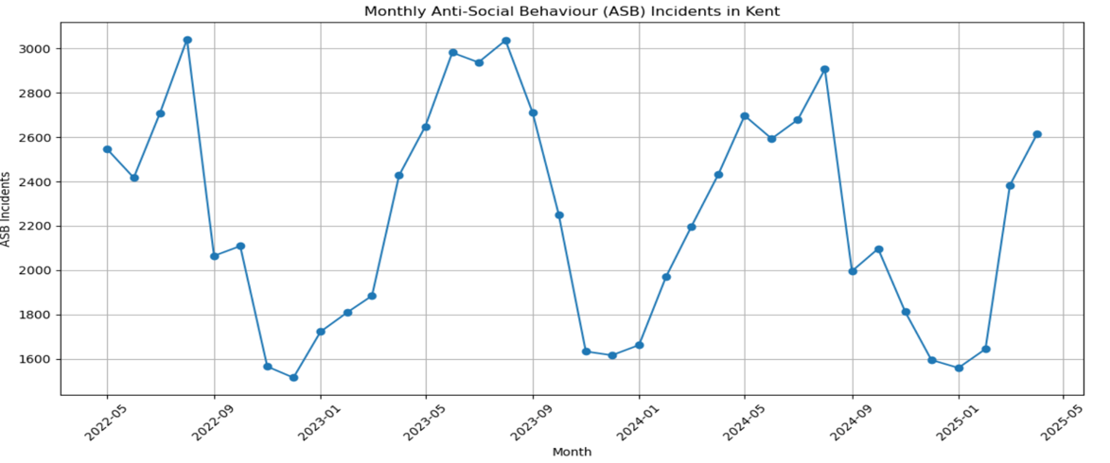

Figure 1: Monthly ASB incidents in Kent

Over the full 36-month period, there is little evidence of a sustained rise in ASB across Kent. Although monthly figures fluctuate, a year-on-year decline from 2023 to 2024 is visible. Each year follows a similar monthly pattern, with comparable peaks and troughs – typically rising in summer and falling in winter –suggesting a repeating seasonal rhythm. However, ASB appears to have plateaued at a moderately high level, particularly in the summer months. This points to a persistent issue. Such stagnation is concerning, signalling that current strategies may lack the strength to deliver long-term progress. These conditions call for focused, seasonal responses.

A notable spike in March 2025, increasing further in April, disrupts the downward trend in 2024, suggesting that any perceived reduction in ASB may not be sustainable. The uptick underscores the volatility of ASB patterns and the risk of premature assumptions about long-term decline. Policymaking must therefore remain responsive and adaptive to these fluctuations.

Importantly, this stability doesn’t negate the presence of a problem, rather reframes it. The lack of progress in reducing ASB means it remains a persistent concern, particularly during seasonal spikes. Therefore, effective policy should aim at long-term reduction and preventative strategies.

In terms of geographic distribution, raw incident counts place Medway, Swale, and Maidstone among the highest for ASB volume. However, when adjusted for population, the highest ASB rates per 1,000 residents are found in Gravesham, Thanet, Swale, Medway, in that descending order. Medway notably stands out as a hotspot in both absolute and relative terms, with over 50 incidents per 1,000 residents.

Highlighting geographic variations is crucial. When high-rate ASB districts are surrounded by lower-rate areas, the resulting inequality can strain local services and complicate county-wide responses. Targeted geographic policies are therefore essential.

Figure 2: Kent’s monthly share total UK ASB incidents compared to Kent’s population share (~2.78%).

Figure 2 shows that in most months (21 out of 35), Kent’s share in total UK ASB incidents exceeded its population share, indicating a consistent pattern of overrepresentation relative to the rest of the UK.

To assess whether ASB is disproportionately high in Kent compared to the rest of the UK, two forms of hypothesis testing were conducted. A one-sample t-test was applied to the monthly ASB share of Kent from May 2022 to April 2025. This tested whether Kent’s average monthly contribution to national ASB (approximately 2.88%) was significantly higher than its share of the UK population (2.78%). The test returned statistically significant results (p < 0.05), indicating that Kent consistently accounted for a larger share of ASB than would be expected by its population size.

Additionally, one-proportion z-tests were performed using the total number of ASB incidents recorded in Kent versus the UK for 2023, 2024, and the two years combined. In all three cases, the results were statistically significant, further confirming that Kent’s ASB rate exceeds what would be expected if it aligned with national averages. Taken together, both the yearly trends and cumulative figures suggest that Kent is performing worse than the rest of the UK in terms of reported ASB.

In conclusion, the evidence clearly demonstrates that ASB remains a problem in Kent. The data reveals a stagnation at a moderately high level, with no sustained progress in reducing incidents over time. Seasonal spikes in summer, along with recent resurgences in early 2025, further highlight its ongoing volatility. Additionally, Kent performs worse than the national average, with hypothesis testing confirming that its share of ASB is consistently higher than expected based on its population size. On top of this, the geographic disparities – where certain districts face far higher ASB rates than others, reinforcing the need for focused, localised intervention. While ASB may not be escalating into crisis, these patterns show that it is entrenched, unevenly distributed, and unaddressed in key areas, justifying continued attention and targeted policy action.

Recommendations

Efforts to reduce anti-social behaviour (ASB) in Kent should be targeted geographically and temporally. First, interventions must focus on local hotspots, particularly Gravesham, Thanet, Swale, and Medway, where ASB rates exceed 50 incidents per 1,000 residents. These areas experience a disproportionately high burden and should be prioritised in any future allocation of police resources, community outreach, or preventative funding.

There is also a clear need for seasonal targeting. ASB consistently peaks during the summer months (July–August), suggesting that prevention efforts should be scaled up during this period. Temporary initiatives – such as expanded youth services, public outreach campaigns, or visible patrols – could be strategically concentrated during these seasonal spikes to maximise impact and reduce pressure on emergency response systems.

A promising strategy for long-term prevention is expanding access to structured programmes like boxing clubs. From personal experience and wider evidence (Hills and Walker, 2016), boxing offers all people a constructive outlet and an alternative to anti-social activities. At Redbridge ABC, I’ve seen how the sport provides discipline, positive role models, and a sense of belonging.

This approach is supported by the INTACT initiative run by Dyfed-Powys Police (HMICFRS, 2024), which combines early intervention and diversionary activities to ASB. The programme includes boxing among its youth engagement methods, and as of June 2023, over 600 individuals had participated in targeted interventions. Notably, 72% had no further police contact three months later, and the force estimates a public service saving of around £9,000 per individual. Such results show the effectiveness of these interventions and justify greater investment in local partnerships between community groups, district councils, and police services to expand similar offerings in Kent.

Limitations

The findings in this report are based on open police data, which brings important constraints that affect how confidently we can interpret the results. Firstly, the dataset only captures incidents of ASB that are reported to the police. Many incidents – particularly those perceived as low-level or handled informally – are likely to go unreported. Moreover, this dataset does not include ASB reports made to local councils, meaning the true extent of ASB is likely underrepresented.

The dataset also lacks critical detail for policy design. There is no information on suspect demographics, repeat offenders, motivations, or case outcomes. This limits our ability to understand root causes or challenge assumptions, such as the idea that ASB is primarily youth-driven. Without this context, we cannot reliably infer who is responsible or whether interventions are working. Crucially, the data reflects reported incidents – not verified crimes, convictions, or resolved outcomes.

Despite quality assurance processes like formatting checks and manual review, Police.UK data still has known limitations. These include location inaccuracies and inconsistent recording practices across forces. The data is also time-sensitive and rarely updated once published, meaning later reclassifications, such as ASB into a criminal charge, wouldn’t be accounted for.

During this project, a dilemma arose when comparing Police.UK data with figures published by Kent Online (Smith, 2025), which cited much lower ASB totals reported by Kent Police (over 10,000 cases less). This discrepancy highlighted that differing definitions, validation, or aggregation methods can lead to conflicting figures – even when both sources draw from official channels. This underscores the importance of understanding data provenance and being transparent about limitations when interpreting statistics from multiple sources.

Finally, data completeness can vary month to month. Upload issues, backlogs, or system upgrades occasionally delay or prevent full reporting by police forces. While none of these issues invalidate the core analysis, they do require a cautious approach, particularly when making comparisons over time or between regions.

Bibliography

Ali, S. (self) (2025). Kent_ASB.ipynb. GitHub Repository. Retrieved, from <https://github.com/shuja-ali298/kent_police/blob/main/Kent_ASB.ipynb>

Hills, S., & Walker, M. (2016). The Role of Boxing in Development: A Social Marketing Perspective. Retrieved from <https://www.englandboxing.org/wp-content/uploads/2023/10/The_Role_of_Boxing_in_Development.pdf>

HMICFRS. (2024). The policing response to antisocial behaviour: PEEL spotlight report. Published 10 October 2024. Retrieved from <https://hmicfrs.justiceinspectorates.gov.uk/publication-html/policing-response-to-antisocial-behaviour/>

Lancashire Police and Crime Commissioner. (2023). Boxing project makes impact in Hyndburn with Commissioner's Funding. Retrieved from <https://www.lancashire-pcc.gov.uk/boxing-project-makes-impact-in-hyndburn-with-commissioners-funding/>

Police.UK. Street-level crime. Retrieved from <https://data.police.uk/data>

Office for National Statistics (2024). Estimates of the population for the UK, England, Wales, Scotland, and Northern Ireland. Retrieved from <https://www.ons.gov.uk>

Smith, A. (2025). The number of reports of anti-social behaviour in each Kent borough over the last two years. Kent Online. <https://www.kentonline.co.uk/kent/news/the-drop-in-anti-social-behaviour-reports-across-kent-320323/>

Staffordshire Police, Fire and Crime Commissioner. (2015). PCC funding helps tackle ASB through boxing. Retrieved from <https://staffordshire-pfcc.gov.uk/rugeley-boxing-club/>

Staffordshire Police, Fire and Crime Commissioner. (2017). Anti-social behaviour knocked out by young boxers. Retrieved from <https://staffordshire-pfcc.gov.uk/anti-social-behaviour-knocked-out-by-young-boxers/>