**Spice Projects Note:**

1. When Creating the Project ensure to choose asp.net core and Individual Authentication.
2. Go to startup.cs and edit the connection string with short name such as asp-Spice of data base that you want to create, highlighted below (dark)

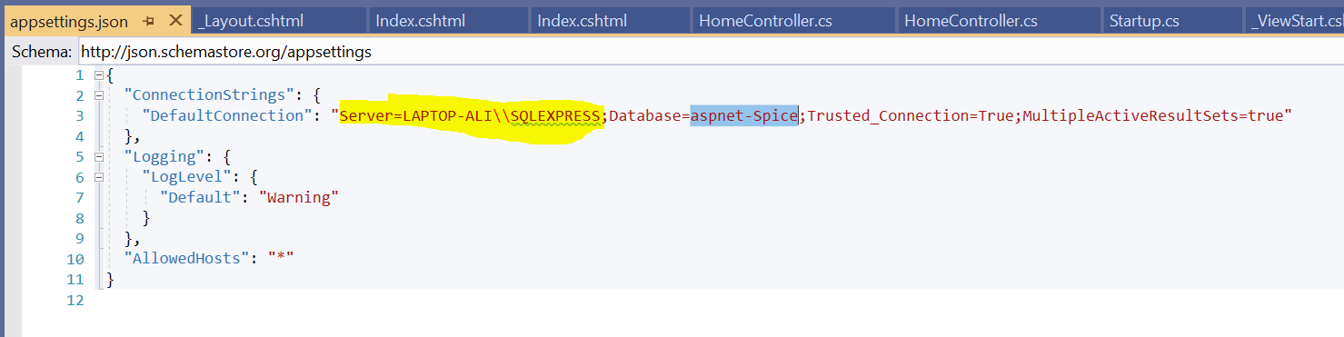

1. Open NuGet Console and type update-database, it will create database in server, If it cannot something is wrong, I have not installed any Entitiy frame work for it to work. Make sure to change the sql server name in connection, highlighted above in yellow.

The above is necessary otherwise you may experience Entitiy framework errors. These packages are installed by default. See below and it works an it works with additional packages.

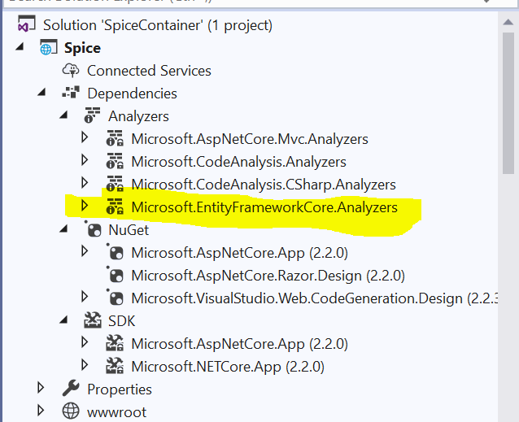

Creating Separate Areas for both Admin and Customer.

1. Right click and create two areas for each one (Customer and Admin)

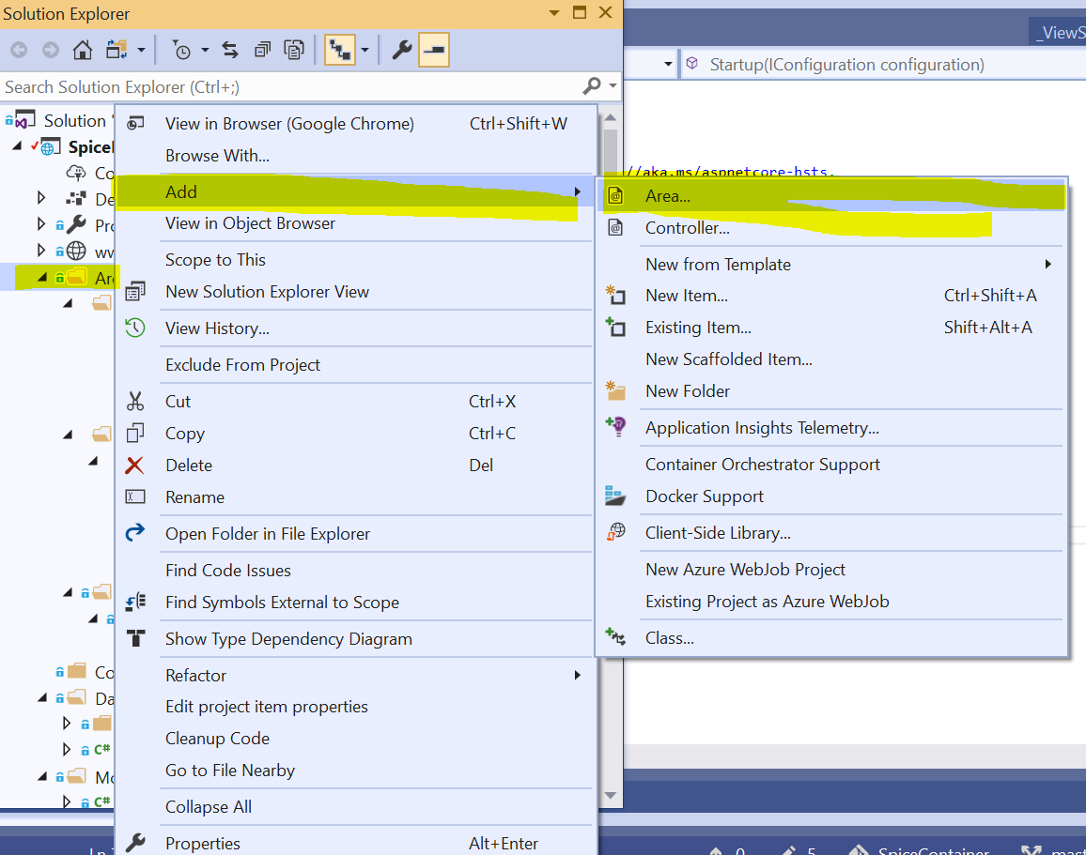

1. You can actually can make one home, make the customer, in the startup file , in the starteup file replace it with original as the following:

routes.MapRoute(

name: "areas",

template: "{area=Customer}/{controller=Home}/{action=Index}/{id?}");

1. 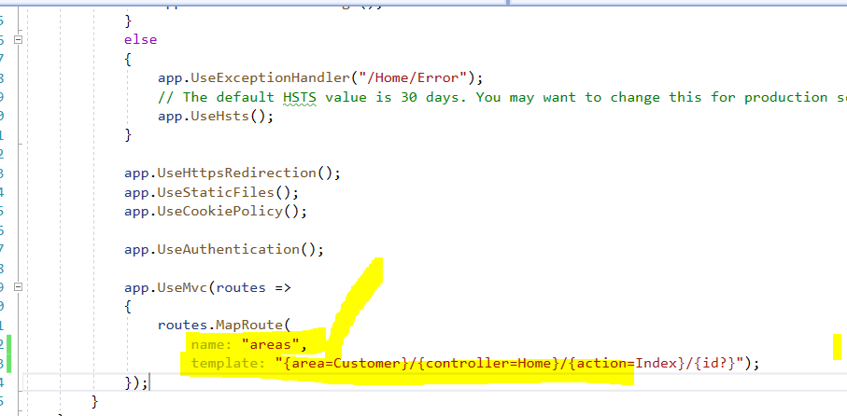
2. Now you need to have the views and separate controller in both customer and admin. Example for customer is shown below: You may not need to copy the ViewStart.cshtml as it work without this as well.

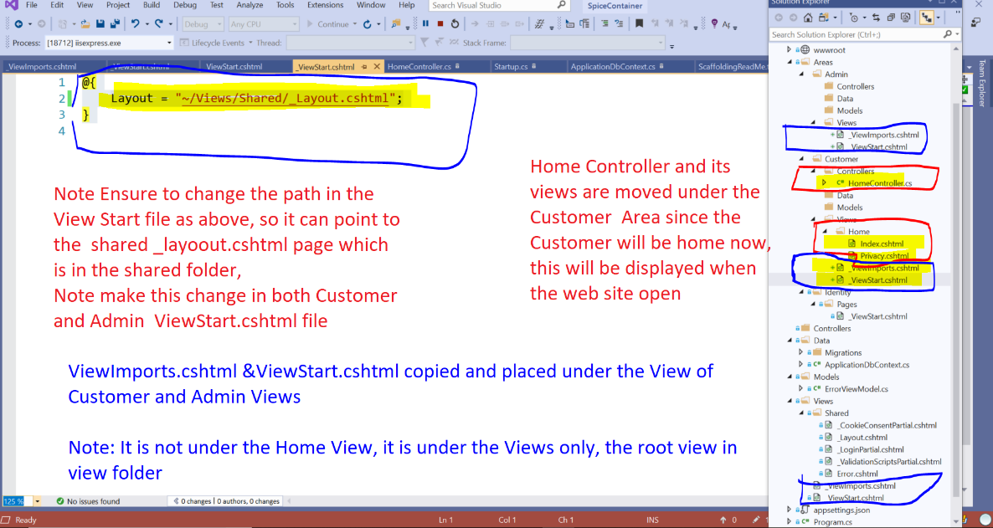

1. Now we need to tell the Home Controller which we moved to Customer about the Area. Hence do it as below: Add [Area(“Customer”)]
2. 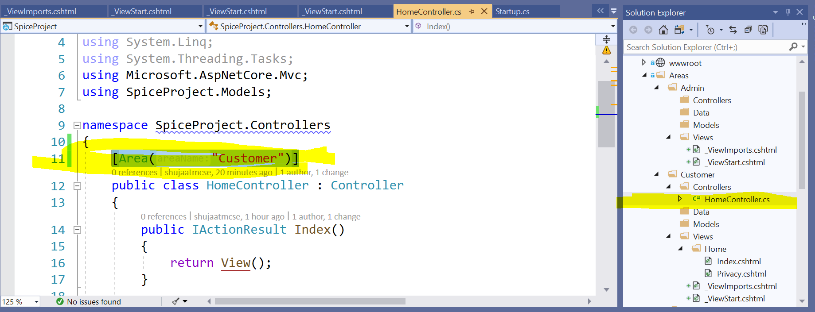
3. Below is a screen shot that shown the admin controller as well.

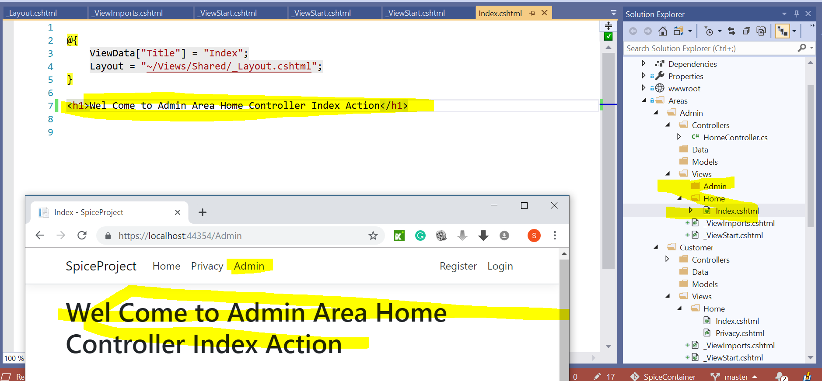

The complete code is on github with commits [**Customer&AdminAreaWithReadMeFile**](https://github.com/shujaatmcse/SpiceProject/commit/58e5c0de4b6745a8979f8e822eb71c2a5231481b)