# Validation Tool

Contents

Validation Tool 1

Introduction 1

Connection components 1

Request components 1

Event response components 1

File upload components 1

Frame viewer 1

File download components 1

## Introduction

Validation Tool is a WebSocket client intended to verify the iConnect-WS TSI and iConnect-WS UPP functionality using the JSON messages.

## Connection components

Connection components are used to specify the WebSocket host, endpoint and to connect to a specified endpoint.

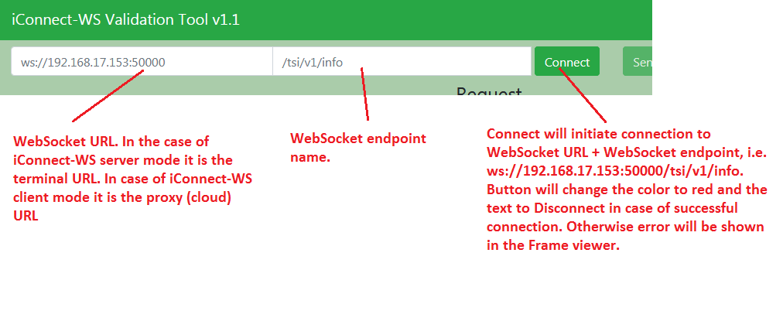

## Request components

Request components are used to prepare the JSON message (request) to be send to connected WebSocket endpoint.

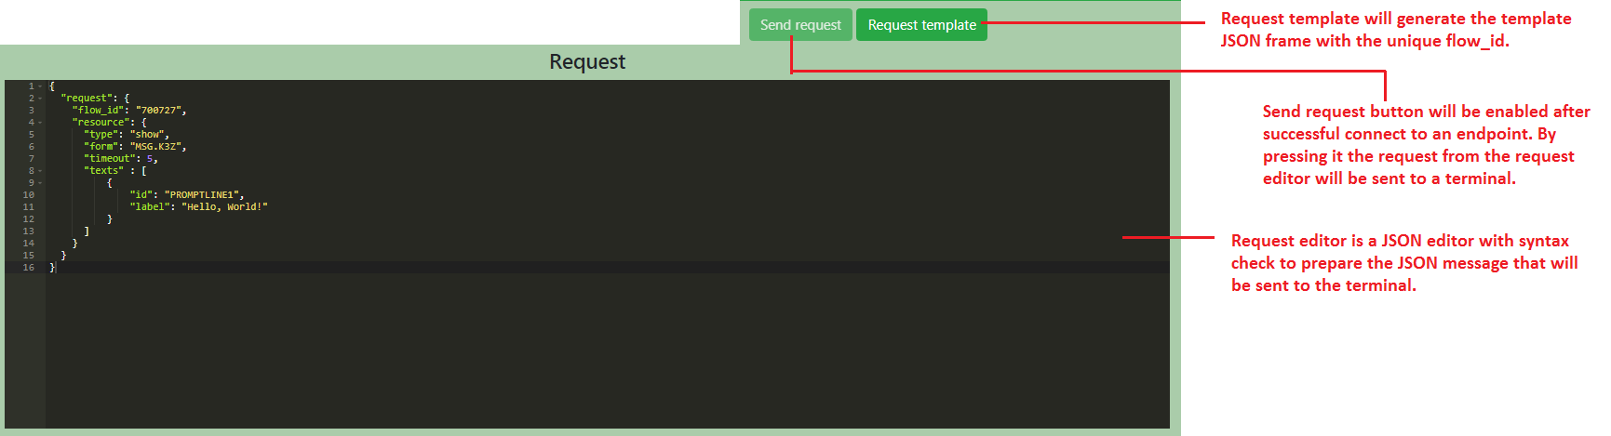

## Event response components

Event response components are used to prepare the JSON message (event ACK) to be send to connected WebSocket endpoint automatically or manually.

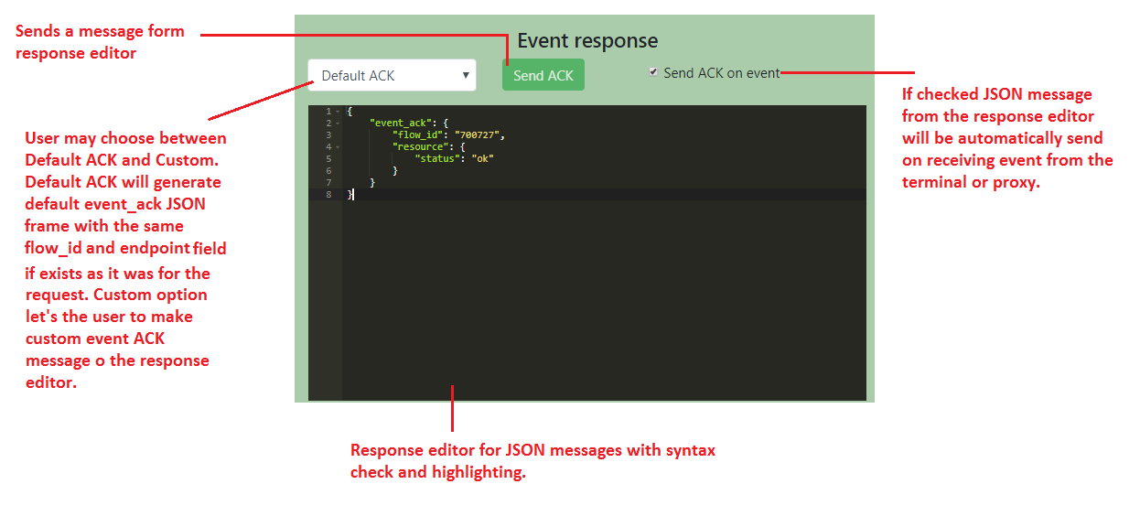

## File upload components

Validation tool provides a possibility to upload the file from the PC to a terminal. This feature is tested with Google Chrome Version 67.0.3396.99 with enabled ***--allow-file-access-from-files*** option. This option should be set after chrome.exe in the shortcut i.e. "C:\Program Files (x86)\Google\Chrome\Application\chrome.exe" --allow-file-access-from-files. File upload will not work on Chrome w/o ***--allow-file-access-from-files*** option.

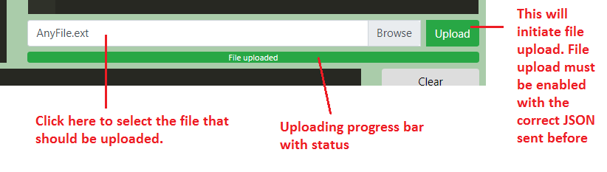

## Frame viewer

Frame viewer is used to show the JSON frame flow from/to the connected endpoint as well as to show the Validation Tool errors.

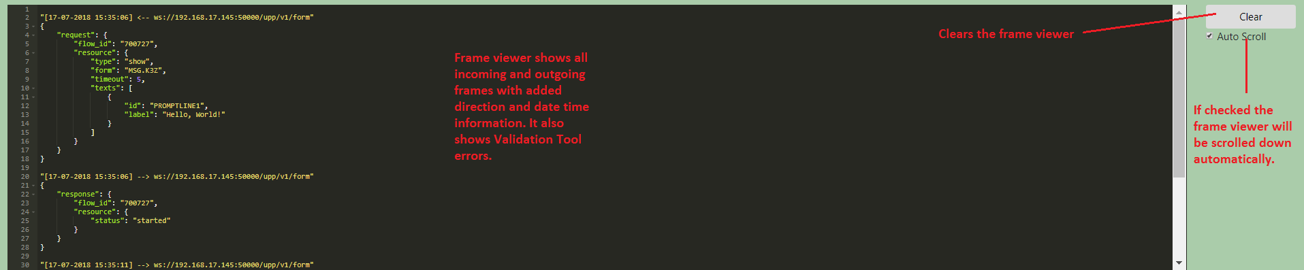

## File download components

The binary data received from the terminal/proxy will be saved in the file in the browsers default download folder. File name can be specified in Binary Data Settings window which will appear automatically.

