Networking 786
OSI Model:
TCP/IP:

OSI to TCP/IP Mapping:
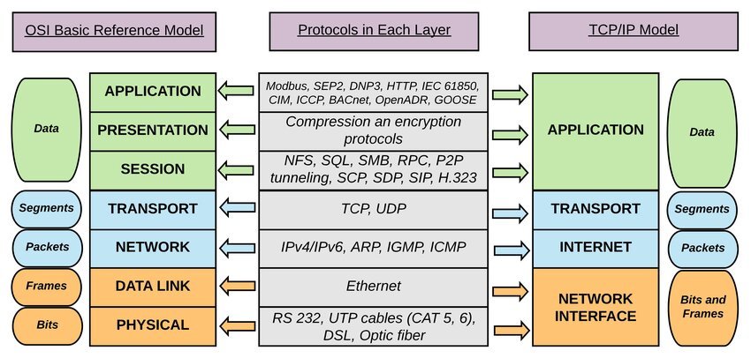
TCP IP Protocol Suite:
