**36) Merge multiple files based on a common field or column.**

**=>Example1:create 2 files with contents**

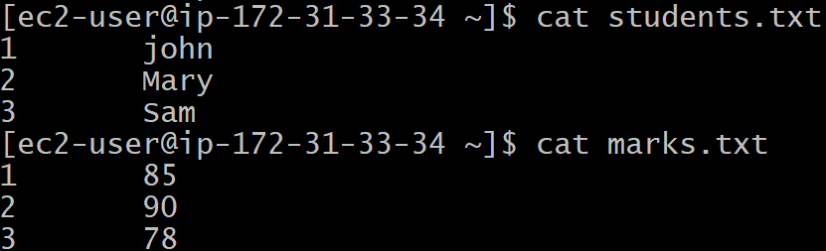

**Here the ID column is common in both the files.**

**Using join :**

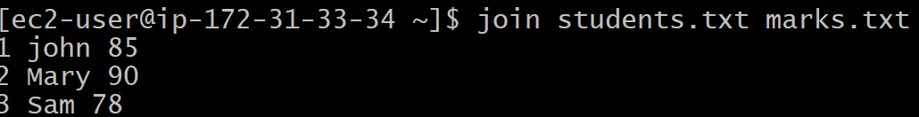

**Example2: file with Column Header:**

**Create 2 files with header:**

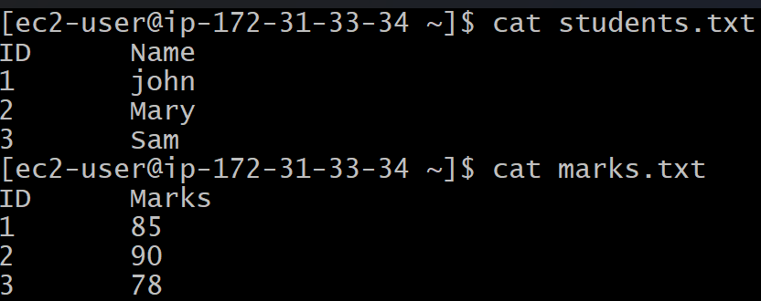

**Step 1: Remove headers and sort**

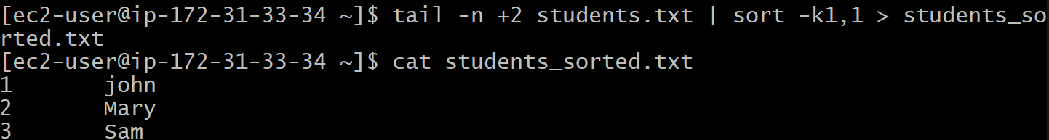

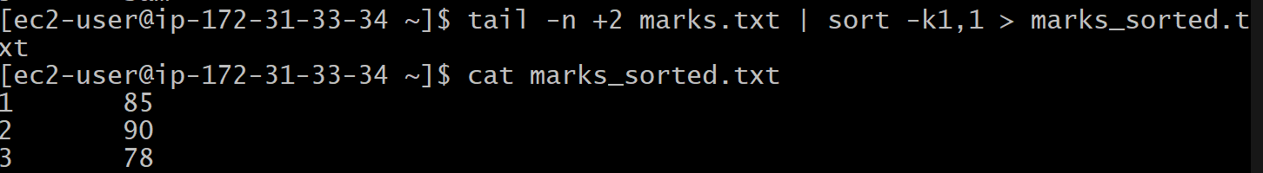

**Step 2: Use join**

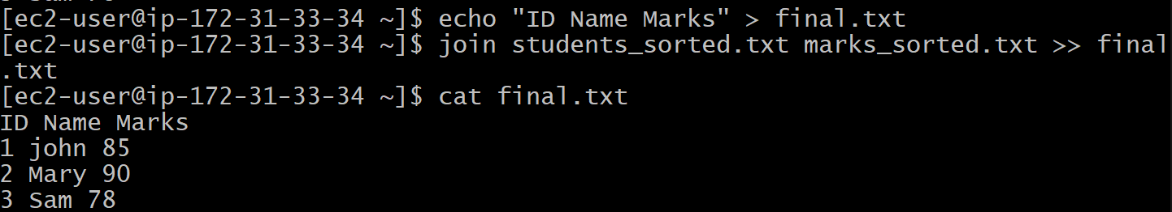

**37) Substitute text in a file using search and replace.**

**Syntax: sed -I ‘s/search/replace/g’ file**

**Taking example in the following file:**

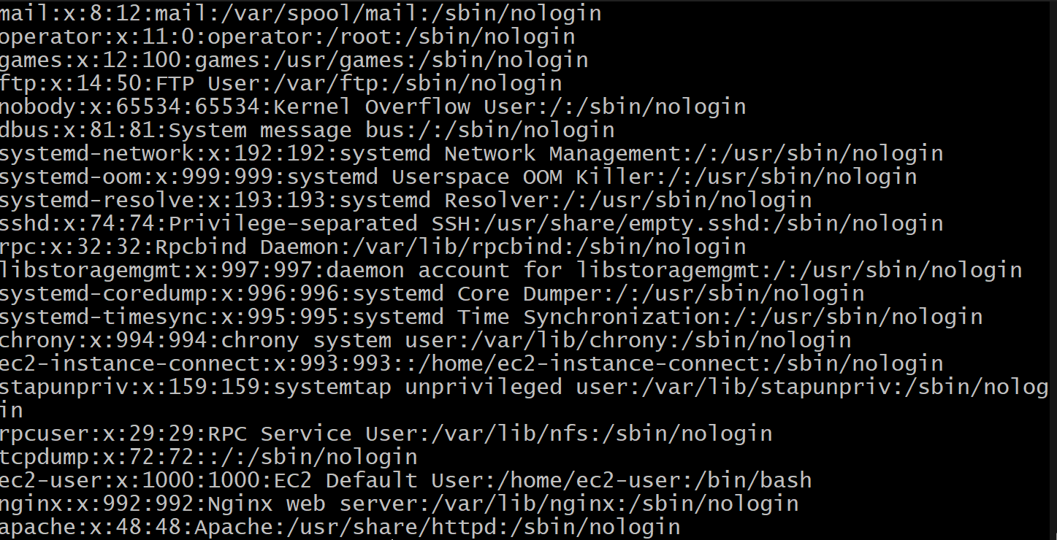

**Here I want to search for nologin and replace with yeslogin**



**Then output would be:**

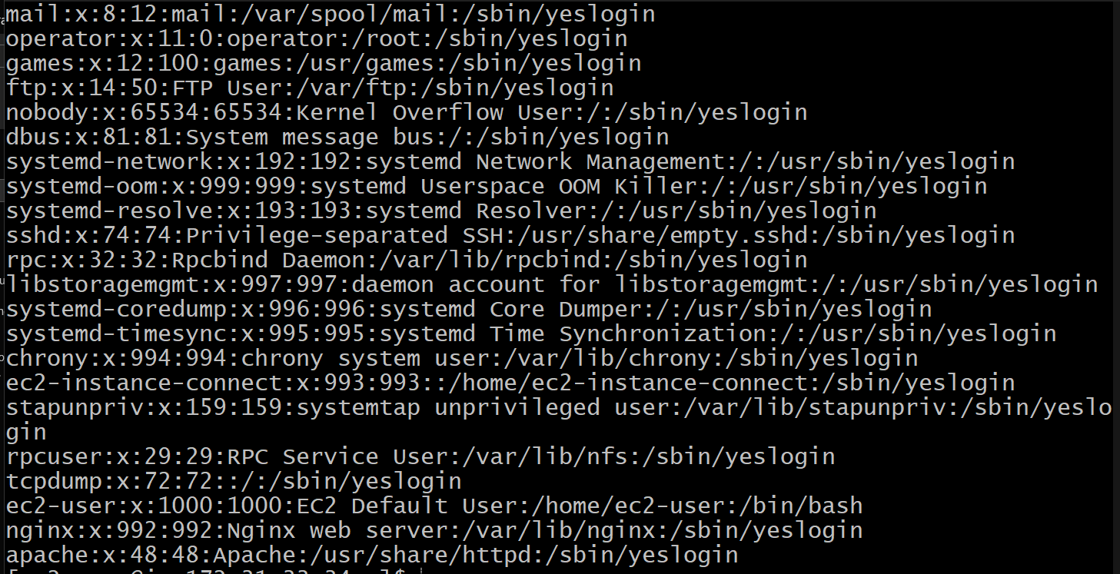

**38) Delete specific lines based on a pattern or line number.**

1. **Delete by line number (using sed)**

**sed -i '5d' file.txt**

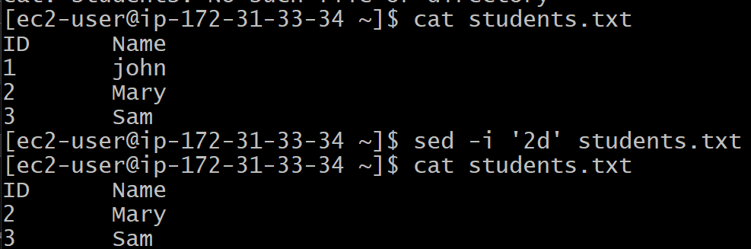

1. **Delete by pattern (using sed)**

**sed -i '/foo/d' file.txt**

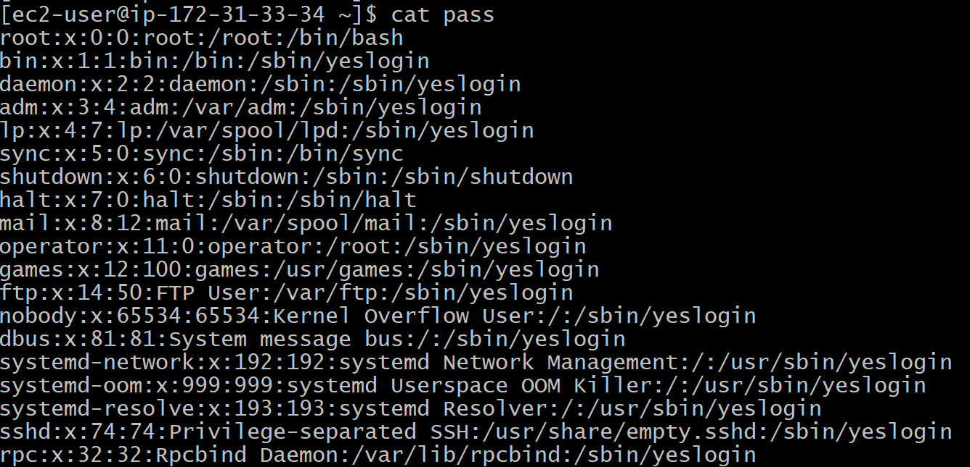

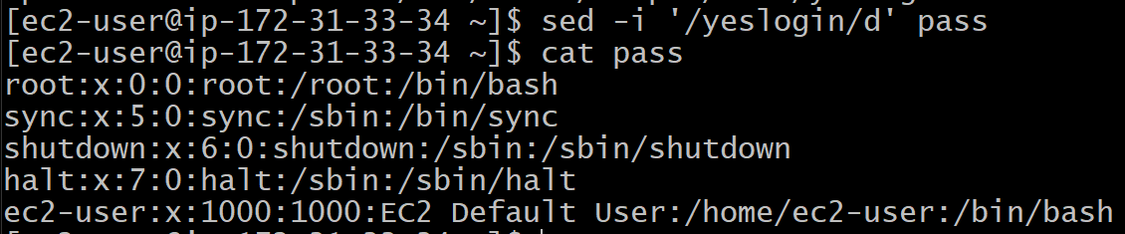

**39) Append or insert text before or after a specific pattern or line.**

**Append (add after a matching pattern)**

**sed -i '/pattern/a new text here' file.txt**

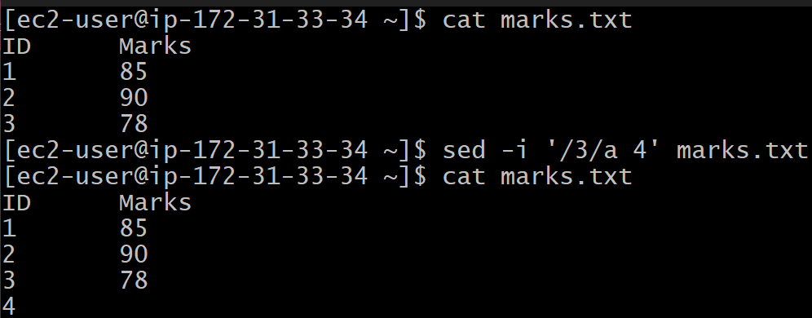

**Insert (add before a matching pattern)**

**sed -i '/pattern/i new text here' file.txt**

