1. **Configure and secure a MySQL Database.**

**Step1) Add the MySQL Community Repository**

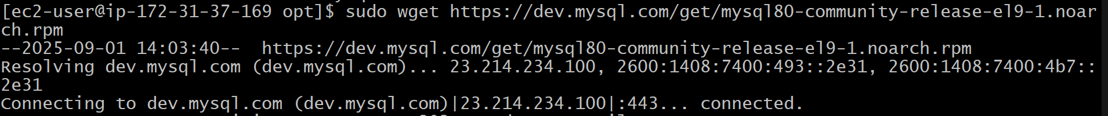

**Step2)** **Install the repository:**

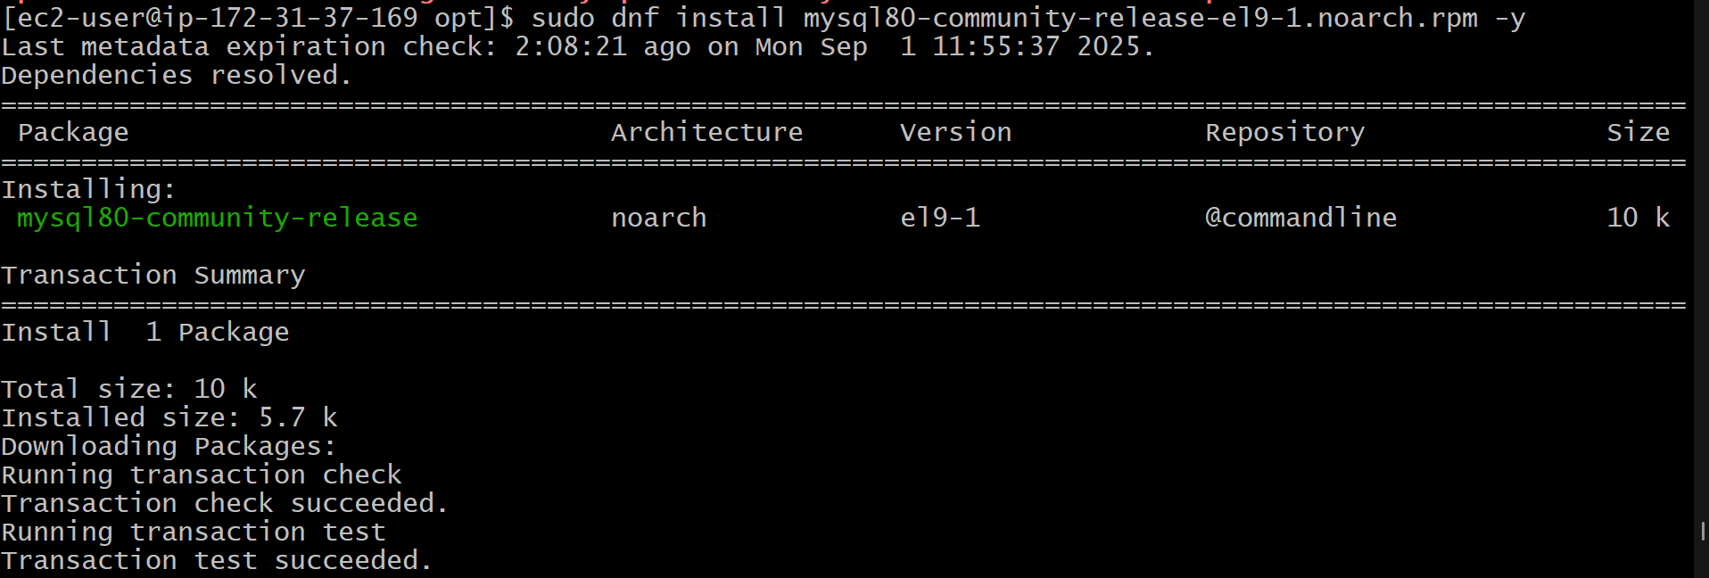

**Step3) Verify the repository is enabled**

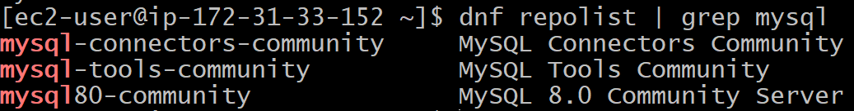

**You should see mysql80-community listed.**

**If you encounter GPG key errors later, you can temporarily disable GPG checking by editing /etc/dnf/dnf.conf or the repo file (/etc/yum.repos.d/mysql-community.repo) and setting gpgcheck=0. Re-enable it after installation for security.**

**STEP4) Install MySQL Server**

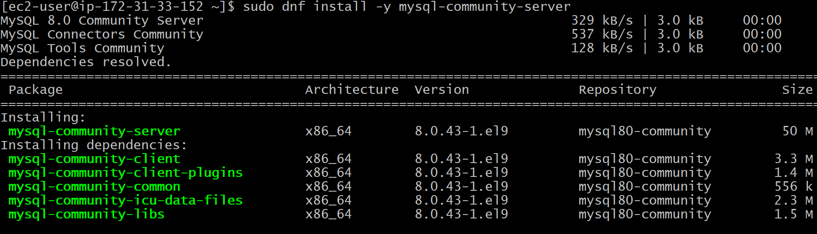

**STEP4) Then start , enable and check the status**

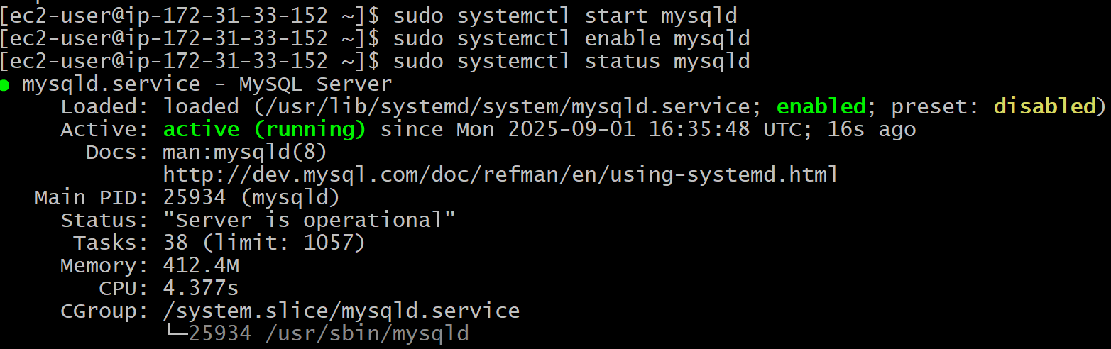

**Step5)** **Retrieve the Temporary Root Password**



**Step6)** **Secure the MySQL Installation**

**sudo mysql_secure_installation**

**Prompts:**

* **Enter the temporary password from Step 5.**
* **Set a new root password (choose a strong one, e.g., at least 8 characters with letters, numbers, and symbols).**
* **Validate password plugin? y (enable to enforce strong passwords; choose strength level, e.g., 1 for medium).**
* **Remove anonymous users? y**
* **Disallow root login remotely? y (recommended for security; change later if needed).**
* **Remove test database? y**
* **Reload privilege tables? y**

This removes insecure defaults and sets up a secure MySQL instance.

Step7) Log In to MySQL

Test the MySQL login with the new root password.

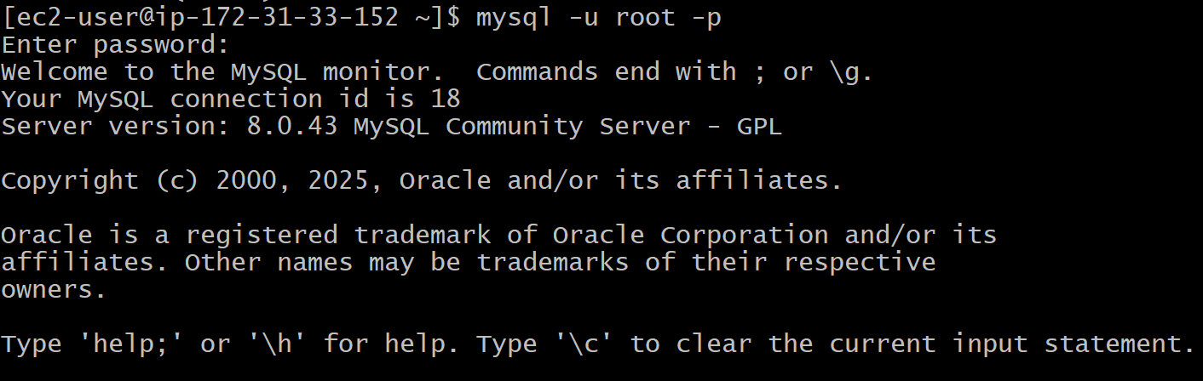

You should see the MySQL prompt (mysql>). Type EXIT; to quit.

Create a Database at the mysql prompt:

CREATE DATABASE mydatabase;

CREATE USER 'myuser'@'localhost' IDENTIFIED BY 'mypassword';

GRANT ALL PRIVILEGES ON mydatabase.* TO 'myuser'@'localhost';

FLUSH PRIVILEGES;

EXIT;

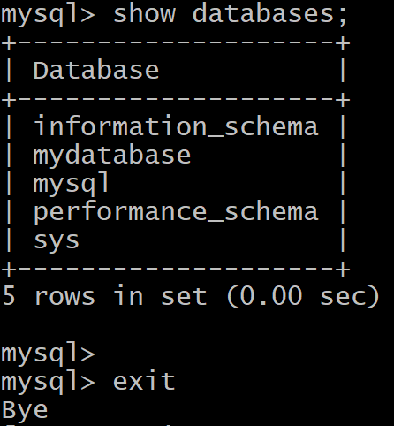

1. **Set up a Application Server (e.g.,Apache Tomcat)**

**Configured and installed Tomcat :**

1. **Download tomcat binary in /opt/:**

**wget** [**https://dlcdn.apache.org/tomcat/tomcat-9/v9.0.108/bin/apache-tomcat-9.0.108.tar.gz**](https://dlcdn.apache.org/tomcat/tomcat-9/v9.0.108/bin/apache-tomcat-9.0.108.tar.gz)

1. **Extract/untar using tar xvf apache-tomcat-9.0.108.tar.gz and rename it to tomcat9:**



**3)then goto bin directory of tomcat**

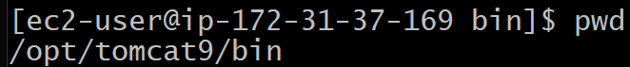

1. **And run/execute the start.sh file:**

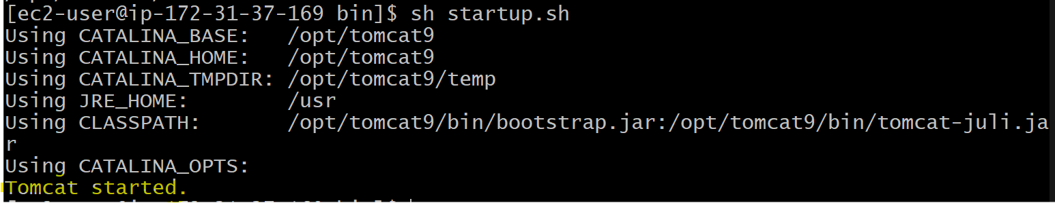

1. **Then open the inbound rule of security group with 8080 and 80:**

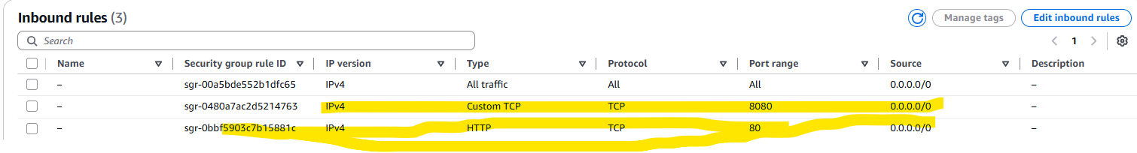

**Then open the ip with 8080 port in the url:**

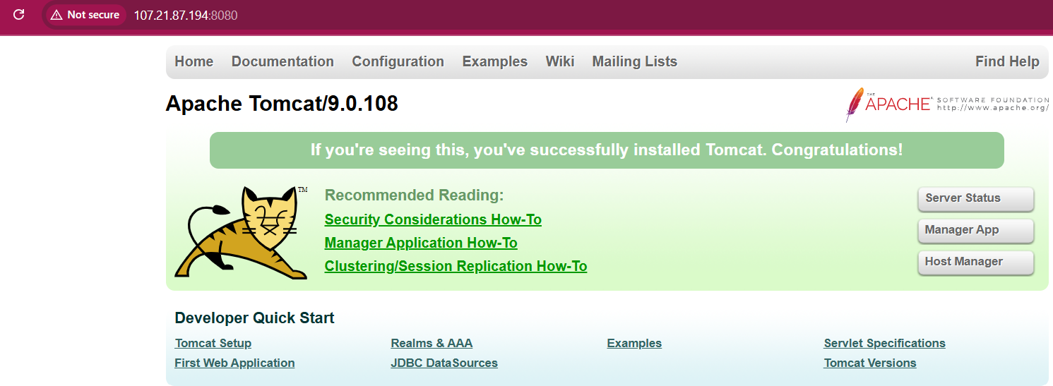

1. **create a service file for Apache Tomcat.(Should execute by using systemtctl command)**
2. **Download tomcat binary in /opt/:**

**wget** [**https://dlcdn.apache.org/tomcat/tomcat-9/v9.0.108/bin/apache-tomcat-9.0.108.tar.gz**](https://dlcdn.apache.org/tomcat/tomcat-9/v9.0.108/bin/apache-tomcat-9.0.108.tar.gz)

1. **Extract/untar using tar xvf apache-tomcat-9.0.108.tar.gz and rename it to tomcat9:**



1. **Change the owner to ec2-user and permission to chmod 777 tomcat9**

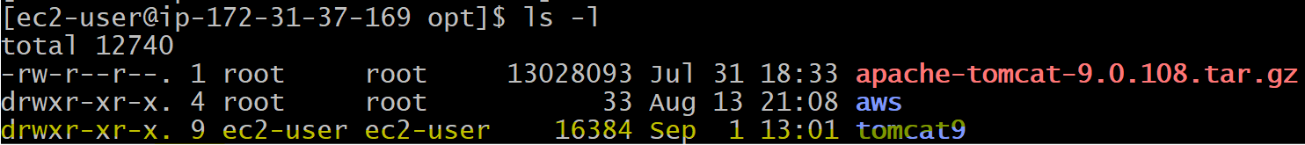

1. **Then create a service file /etc/system/system/tomcat.service**

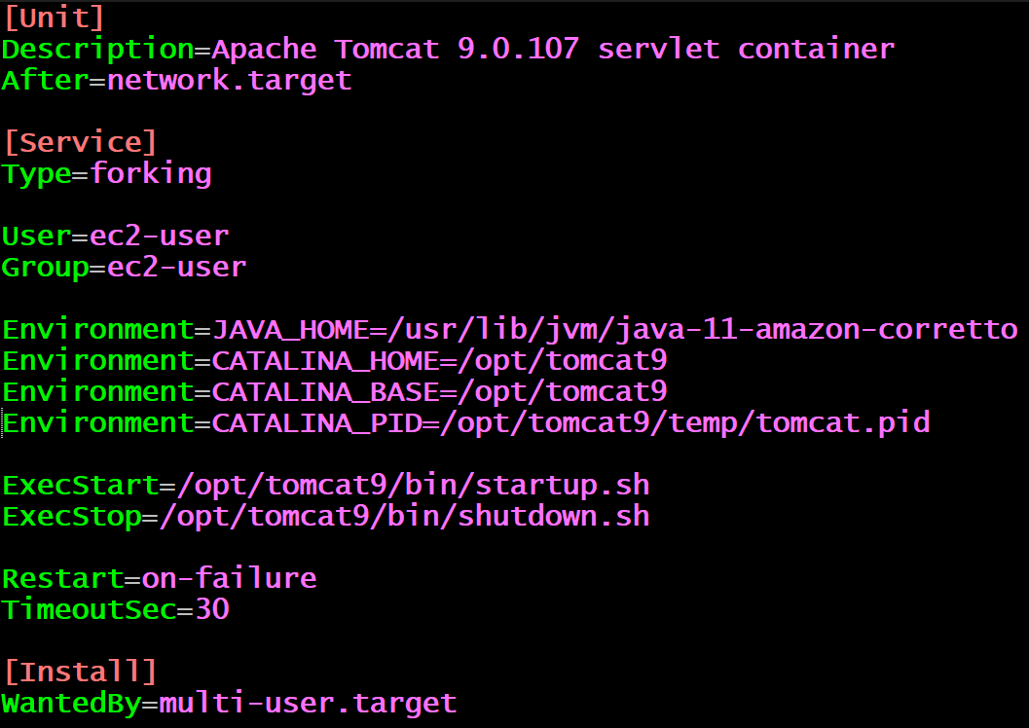

1. Next do the daemon-reload using systemctl:



1. Next start the tomcat : systemctl start tomcat.service
2. Next check the status : systemctl status tomcat.service

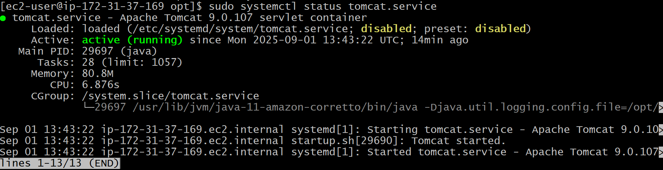

And open the security inbound port 8080 and 80 and access the tomcat on url:

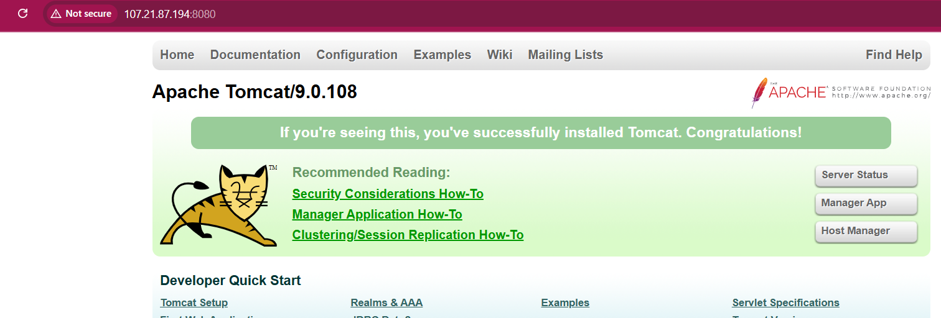

1. **Calculate and print the average, sum, or other statistics of a column.**

**Create a file data.txt with contents:**

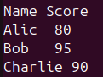

**Let’s calculate statistics for the second column (Score).**

1. **Using awk (Average, Sum, Min, Max, Count)**

**Using sum we calculate sum of all:**



**2. Next, calculating Average :**



1. **Next calculating Minimum:**



**NR>1: Skips the first row (header).**

**$2 != "": Ensures the field is not empty.**

**NR==2 || $2<min: Sets min to the first valid value on the second row, then updates if a smaller value is found.**

**Output: Min: 80 (for your example data: 80, 95, 90).**

1. **Next Calculating Maximum Value.**



**33) Perform string manipulation, such as extracting substrings or changing case.**

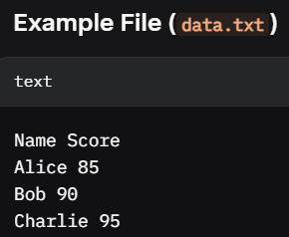

**Extract a substring from Name column( e.g., characters 2 to 4):**

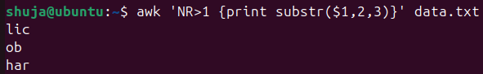

**NR>1: Skips the header.**

**substr($1, 2, 3): Extracts 3 characters starting from position 2 of the first column.**

**Output:**

**text**

**lic**

**ob**

**har**

**Using sed**

Extract a substring using a regular expression (e.g., first 3 characters):

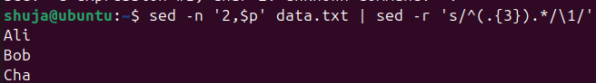

* sed -n '2,$p': Prints lines 2 onward (skips header).
* s/^(.{3}).*/\1/': Captures the first 3 characters and discards the rest.
* **Output**:

text

Ali

Bob

Cha

To extract a substring from a single string (e.g., HelloWorld):



**Using awk** Convert the Name column to uppercase or lowercase.

* **Uppercase**:

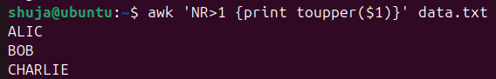

* + toupper($1): Converts the first column to uppercase.
  + **Output**:

ALICE

BOB

CHARLIE

Lowercase:

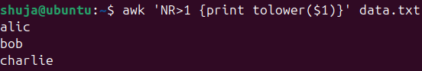

**35) Sort lines based on a specific field or column.**

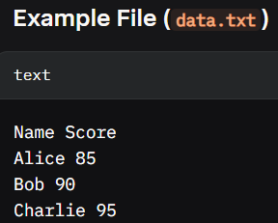

**Sort by Name (Column 1, Alphabetical)**

To sort alphabetically by the Name column in ascending order:

bash

sort -k1 data.txt

* -k1: Sorts based on the first field (alphabetical by default).

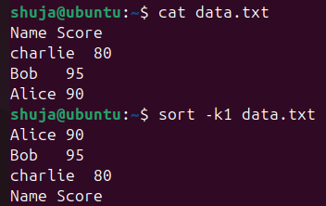

**36) Merge multiple files based on a common field or column.**

**=>Example1:create 2 files with contents**

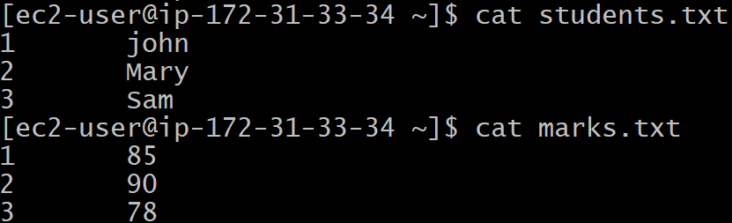

**Here the ID column is common in both the files.**

**Using join :**

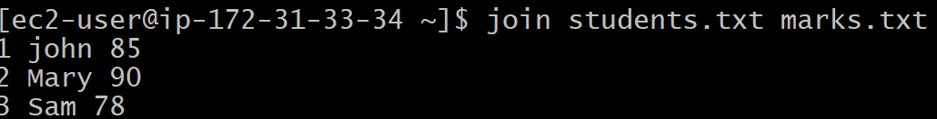

**Example2: file with Column Header:**

**Create 2 files with header:**

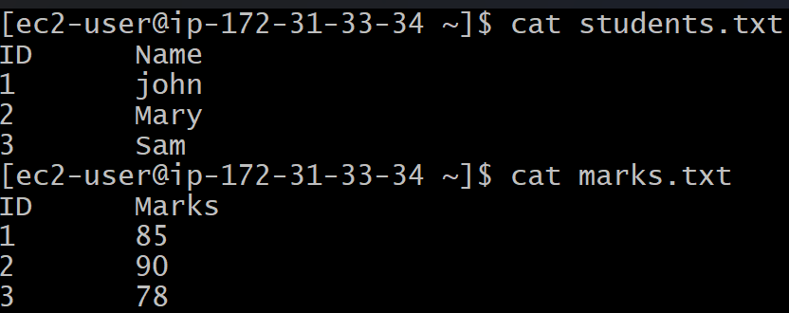

**Step 1: Remove headers and sort**

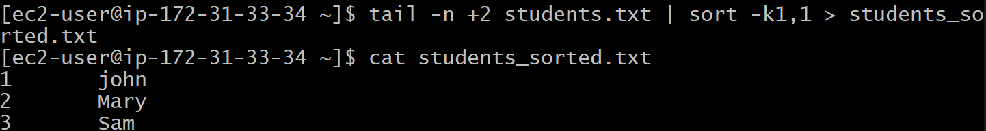

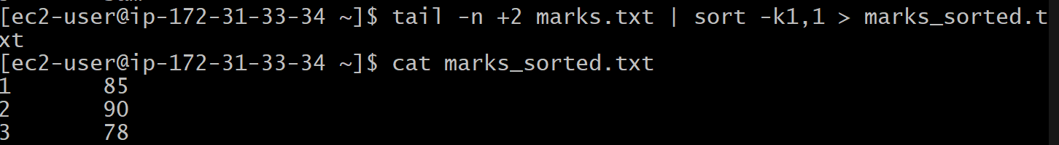

**Step 2: Use join**

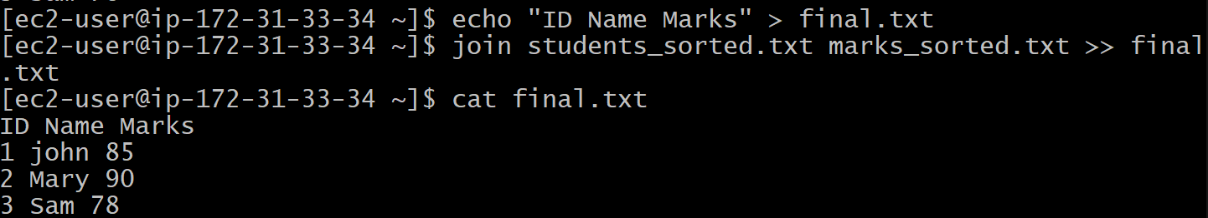

**37) Substitute text in a file using search and replace.**

**Syntax: sed -I ‘s/search/replace/g’ file**

**Taking example in the following file:**

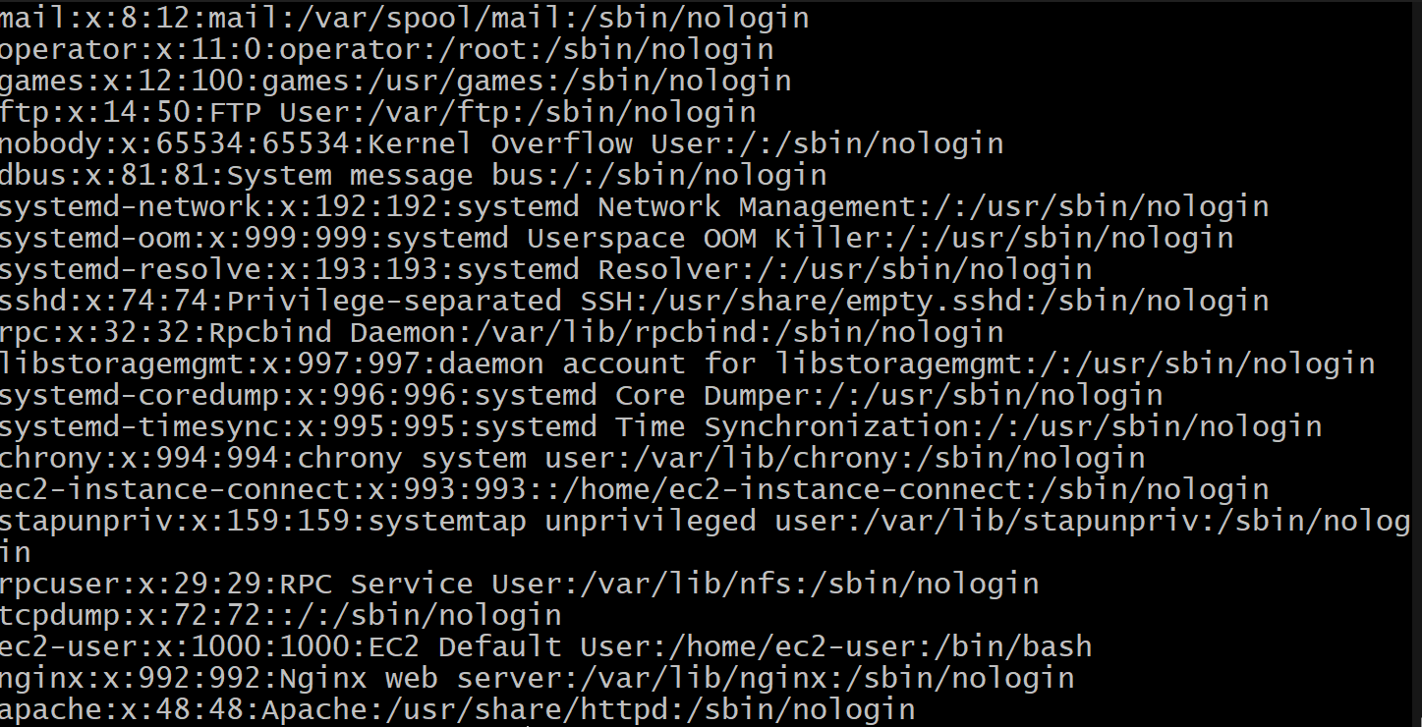

**Here I want to search for nologin and replace with yeslogin**



**Then output would be:**

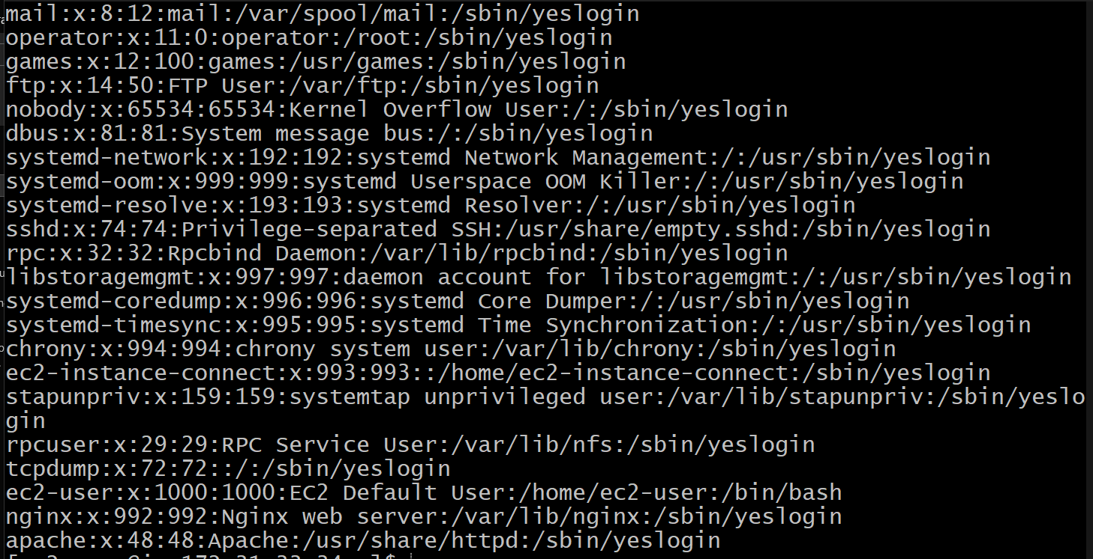

**38) Delete specific lines based on a pattern or line number.**

**39) Append or insert text before or after a specific pattern or line.**

**41)  Copy file from linux to windows machine**

If the Windows machine has an SSH server (e.g., OpenSSH Server or a third-party server like Cygwin), you can push the file from Linux:

1. Ensure both Linux and Windows as open 22 port.
2. Then goto power shell in windows and give the details:
3. scp -i C:\Users\dell\Downloads\amazon_linux_kkey.pem ec2-user@107.21.87.194:/home/ec2-user/linux_file C:\Users\dell

Note: In this example I have created a file in linux with name ‘linux_file’ with some contents and then try to copy/send this file to windows:



Then check in the windows this file:

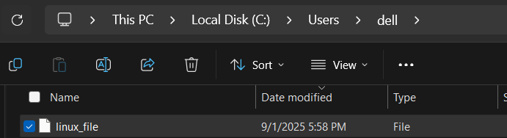

It will get copied here with the contents:

