1. Install nginx and run nginx on port number 81.

Step1) Install nginx using command :

yum install nginx -y

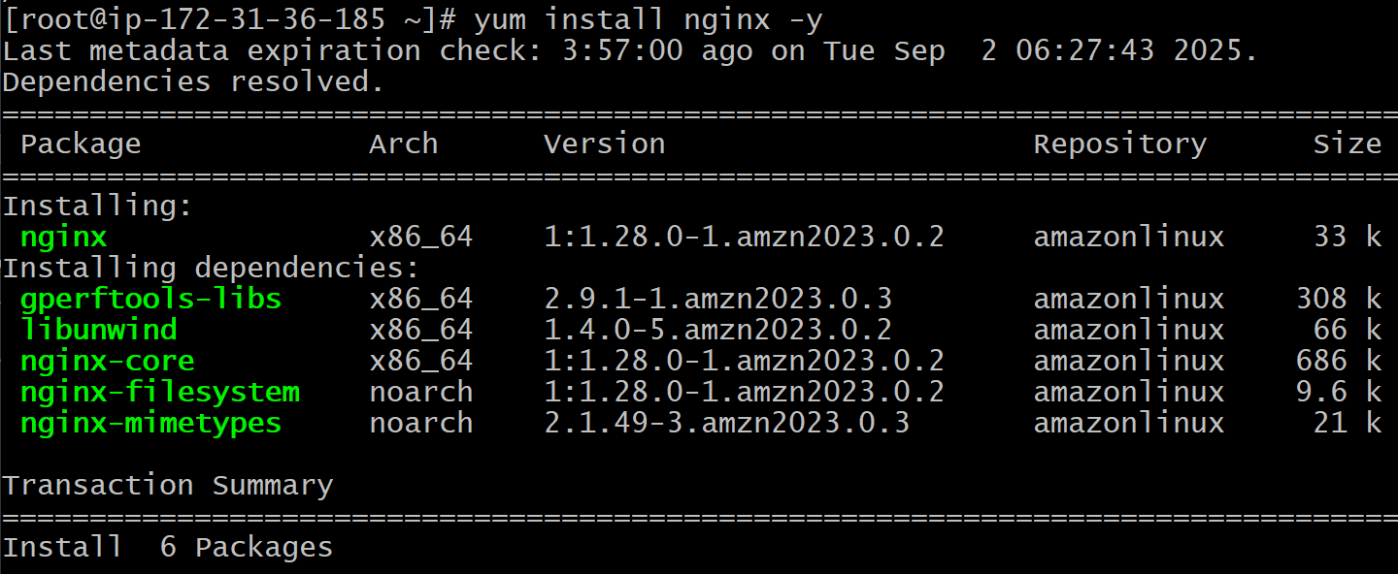

Step2) open the file /etc/nginx/nginx.conf



Change the port from 80 to 81

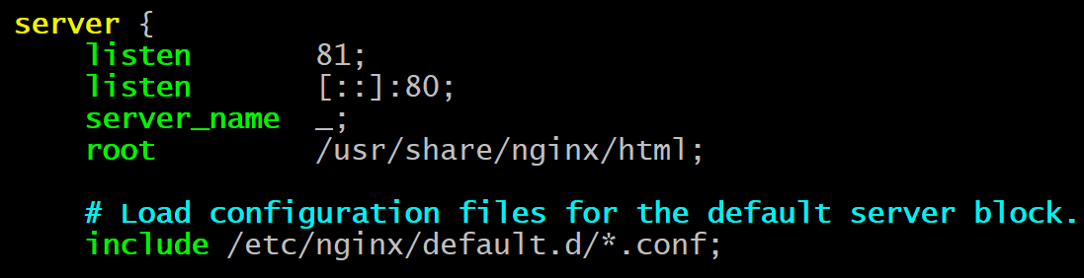

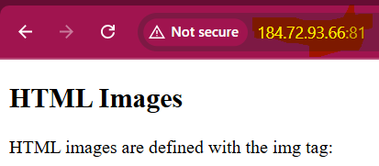

Note: I have changed the index.html in the /usr/share/nginx/html/index.html to sample html file.

1. Deploy a sample index.html file on nginx.

Deploy the sample index.html file on /usr/share/nginx/html/index.html

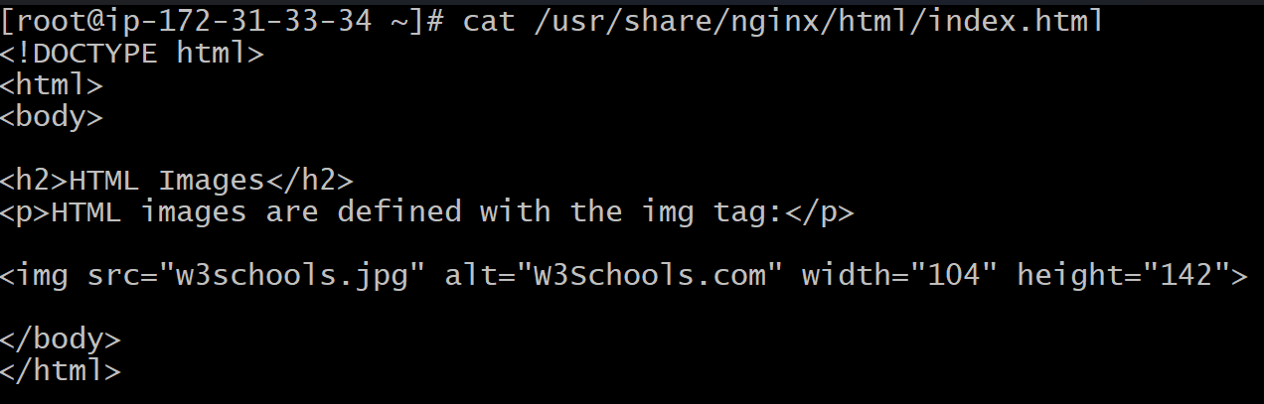

Then do the systemctl daemon-reload

And restart and access the nginx

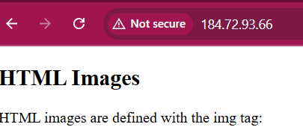

1. Install Apache and run Apache on port number 82

Install httpd:

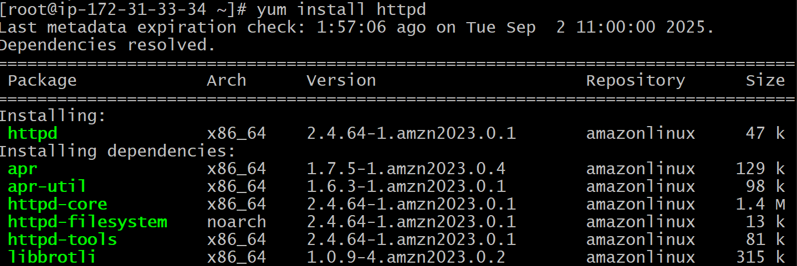

Change the port to 82 in the /etc/httpd/conf/httpd.conf:

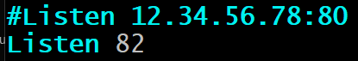

Access the httpd on url with ip:82



1. Deploy a sample index.html file on Apache.

Install httpd



Add the index.html in /var/www/html/





Do the systemctl daemon-reload

And systemctl restart httpd

And access the httpd using url



Note: in the httpd I have changed the port from 80 to 82 in /etc/httpd/conf/httpd.conf

1. Install Apache tomcat on port number 8082

install java



Do cd /opt/



Download tomcat 9:



And extract



Change the permission of /bin



Change the permission of conf



Change the port 8080 to 8082 in /opt/apache_tomcat9/conf/server.xml

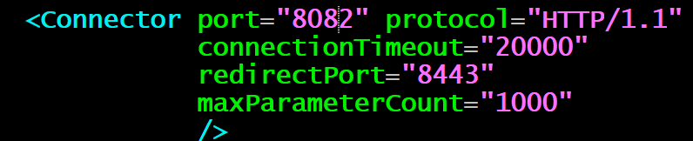

Then start the tomcat:



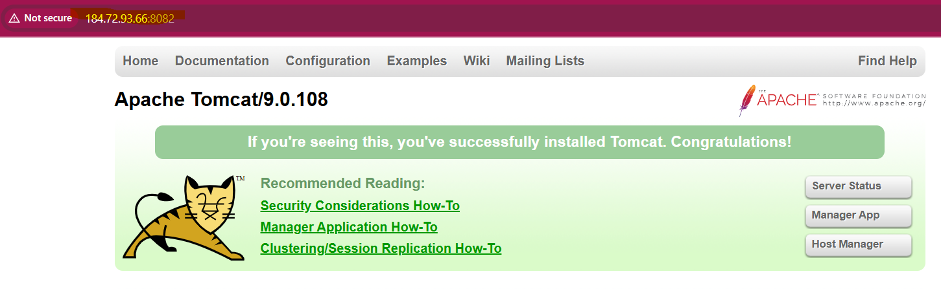

1. Deploy a sample app on webapps

Goto directory /opt/apache_tomat9/webapps and download the sample war :



And in the URL give the ip:8082/sample:

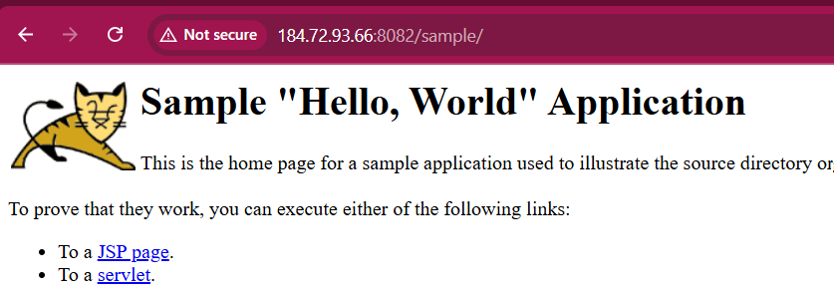

Note: I have changed the port from 8080 to 8082 in /opt/apache_tomcat9/conf/server.xml.

1. Create a tomcat. Service file for tomcat.

**Download tomcat binary in /opt/:**

**wget** [**https://dlcdn.apache.org/tomcat/tomcat-9/v9.0.108/bin/apache-tomcat-9.0.108.tar.gz**](https://dlcdn.apache.org/tomcat/tomcat-9/v9.0.108/bin/apache-tomcat-9.0.108.tar.gz)

**Extract/untar using tar xvf apache-tomcat-9.0.108.tar.gz and rename it to tomcat9:**



**Change the owner to ec2-user and permission to chmod 777 tomcat9**

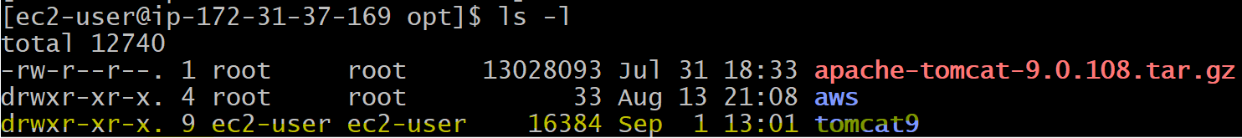

**Then create a service file /etc/system/system/tomcat.service**

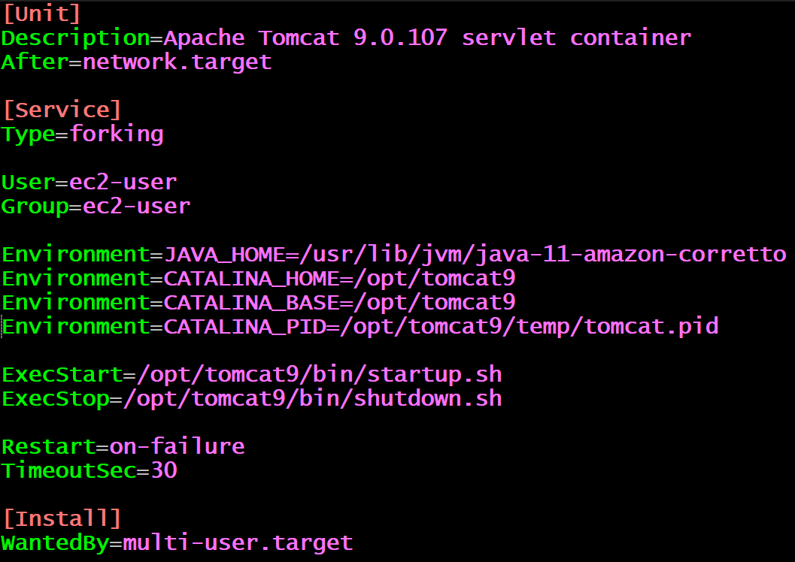

Next do the daemon-reload using systemctl:



Next start the tomcat : systemctl start tomcat.service

Next check the status : systemctl status tomcat.service

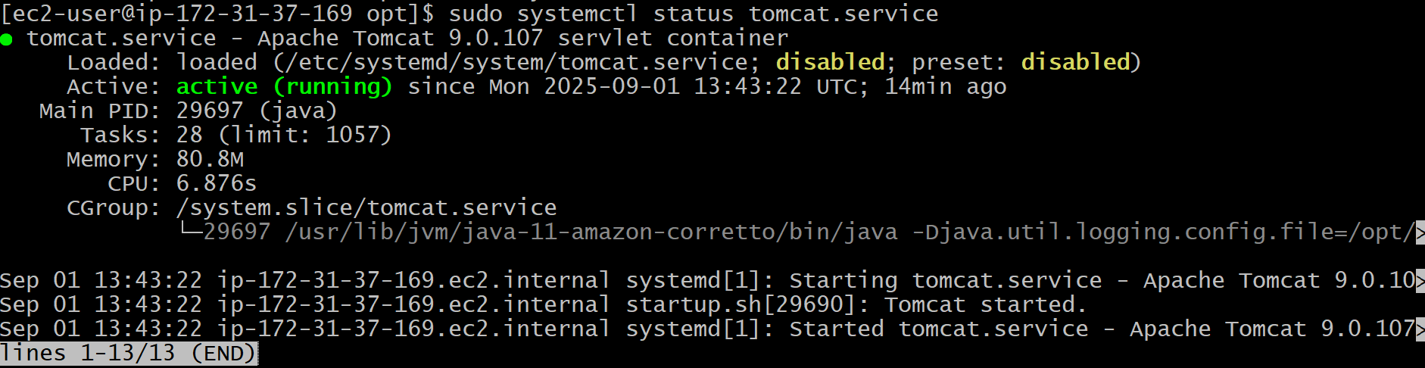

And open the security inbound port 8080 and 80 and access the tomcat on url:

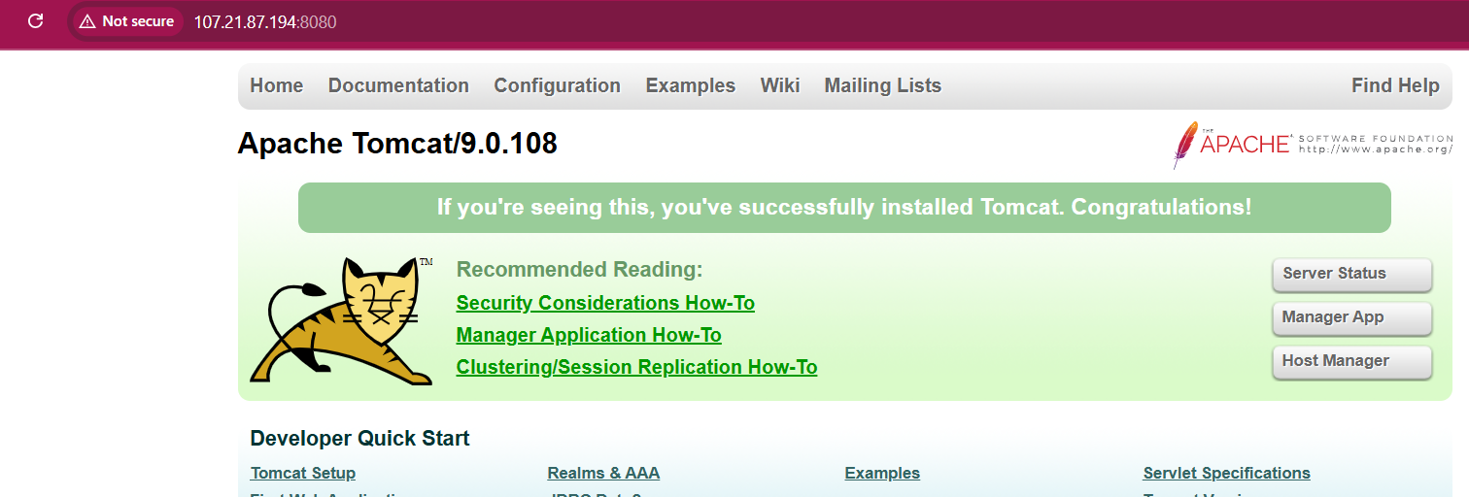

1. Configure HA Proxy server

**Configure HA Proxy Server:**

**Launch 3 ec2 instances name as Server-1, Server-2, HA-Proxy-Server:**

**Server-1 Steps:**

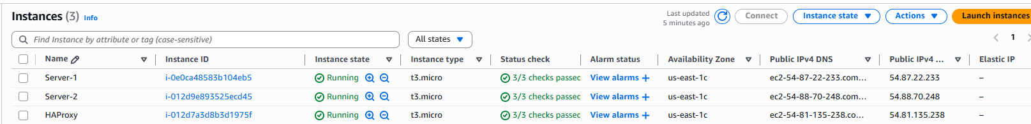

**Run the following command to Access the Server-1**

* **ssh -i key.pem ec2-user@public_ip of server-1 instance**

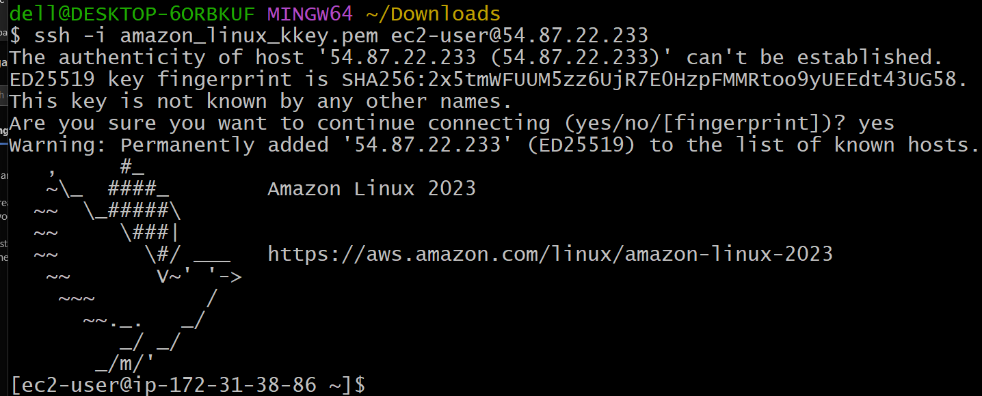

**Do the sudo -i means change to root user:**



**Install httpd**

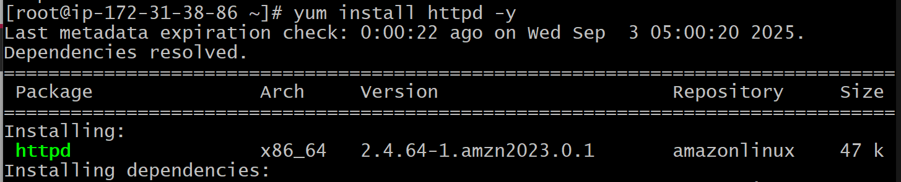

**vi /etc/hosts**

**Add HAProxy Server Public IP Address:**



**Run the ping command on Server-1**

**ping load_balancer -c 4**

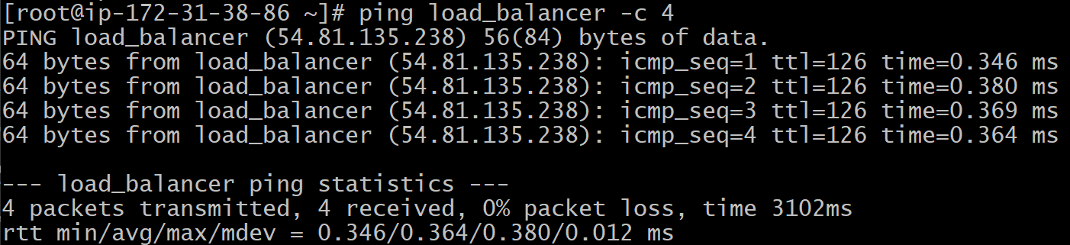

**Start the httpd and check the status of httpd using systemctl:**

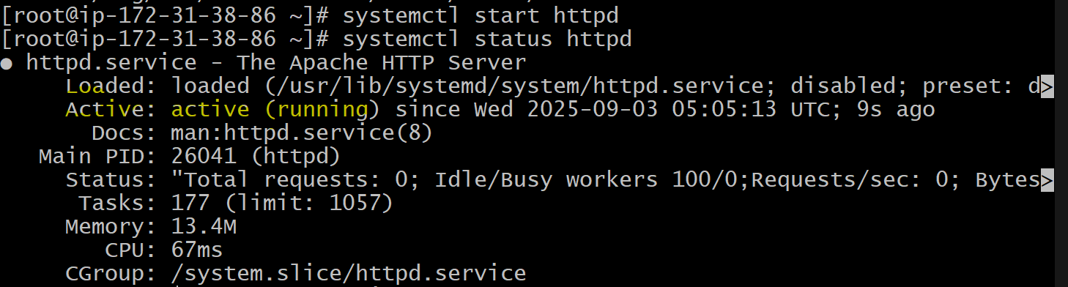

**Browse with Server-1 public ip address:80**



**Server-2 Steps:**

**Run the following command to Access Server-2**

**ssh -i key.pem ec2-user@public ip of server-2 instance**



**Change to Root user**



**Install nginx**

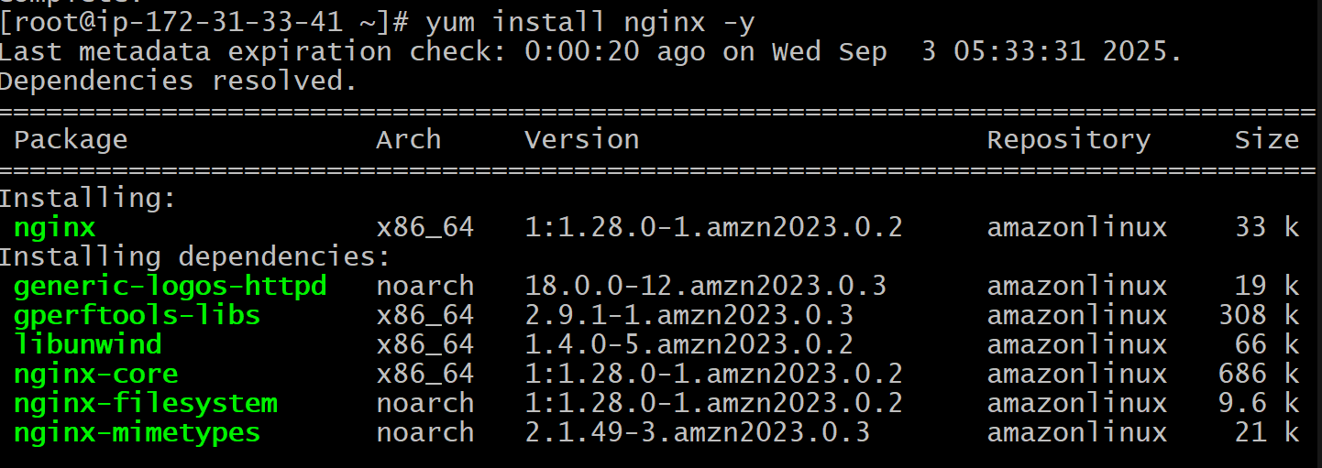

**vi /etc/hosts**

**Add HAProxy-Server public ip address**





**Run the ping command on Server-2**

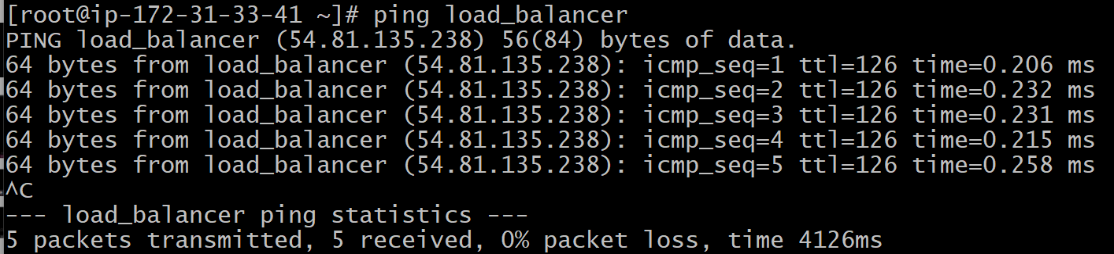

**Start nginx ad check the staus of nginx**

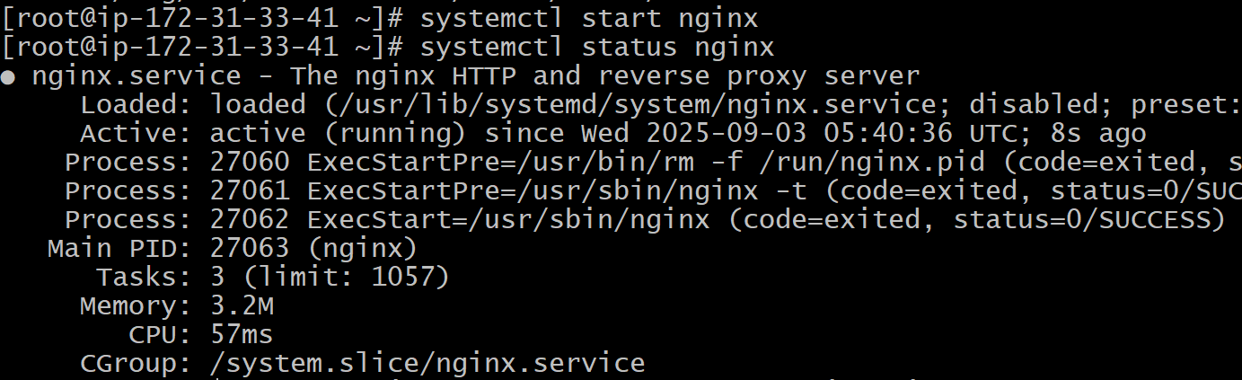

**Browse the Server-2 public ip:80**

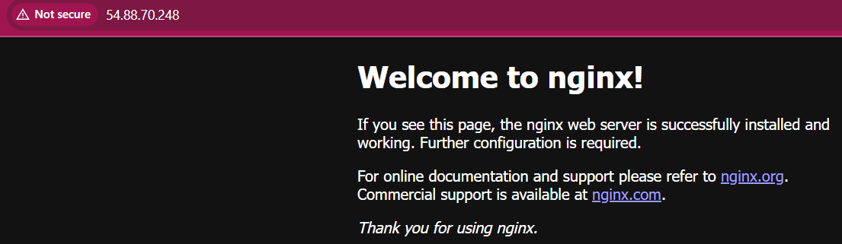

**HA Proxy-Server Setup:**

**Run the following command to Access HA-Proxy Server:**

**ssh -i key.pem ec2-user@public ip of HA Proxy-Server instance**

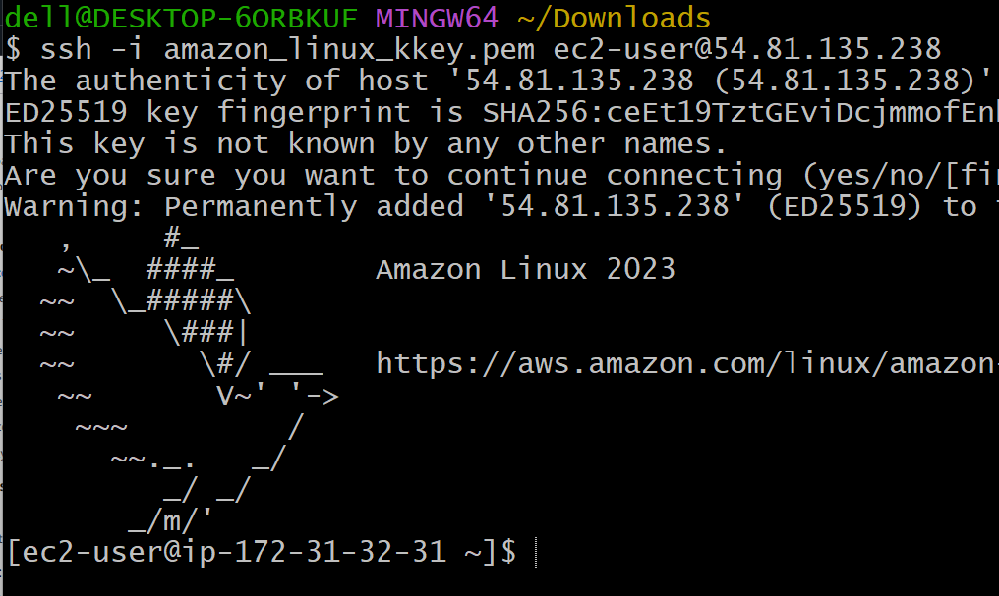

**Change to Root user and update the system**

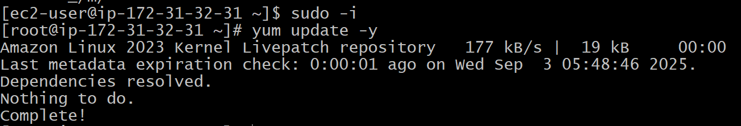

**Install haproxy**

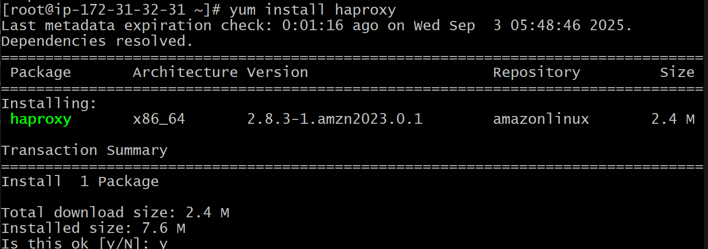

**Vi /etc/hosts**

**Add server-1 and server-2 public ips**

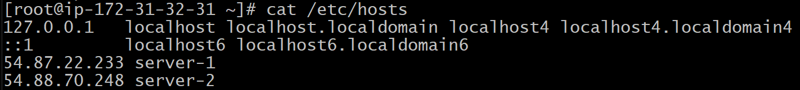

**vi /etc/haproxy/haproxy.cfg**

**Add the Server-1 and Server-2 public ip**

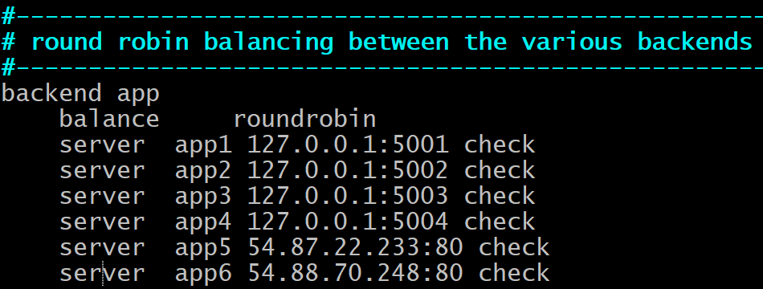

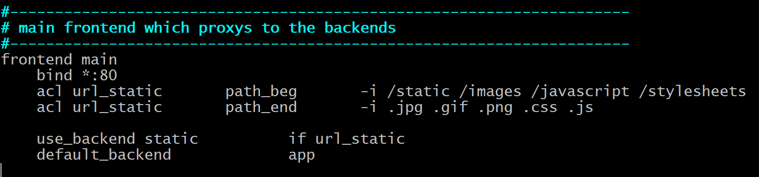

**Run the below command:**

**haproxy -c -f /etc/haproxy/haproxy.cfg**

**it should show the configuration is valid.**

**Then restart the haproxy**

**And access the HAProxy-Server public ip:**

**Alternatively HAProxy will send the request sometimes to httpd and sometimes to nginx:**



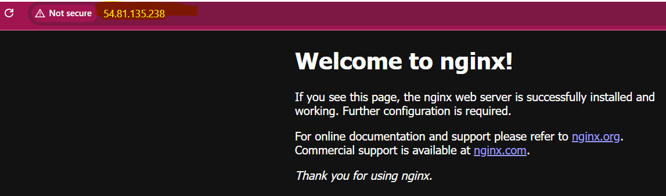

**Note: you can check the ip is not changing because it acts as a load balancer which is sending the request to httpd and nginx servers.**

**-----------------------------------------------Completed----------------------------------------------------**