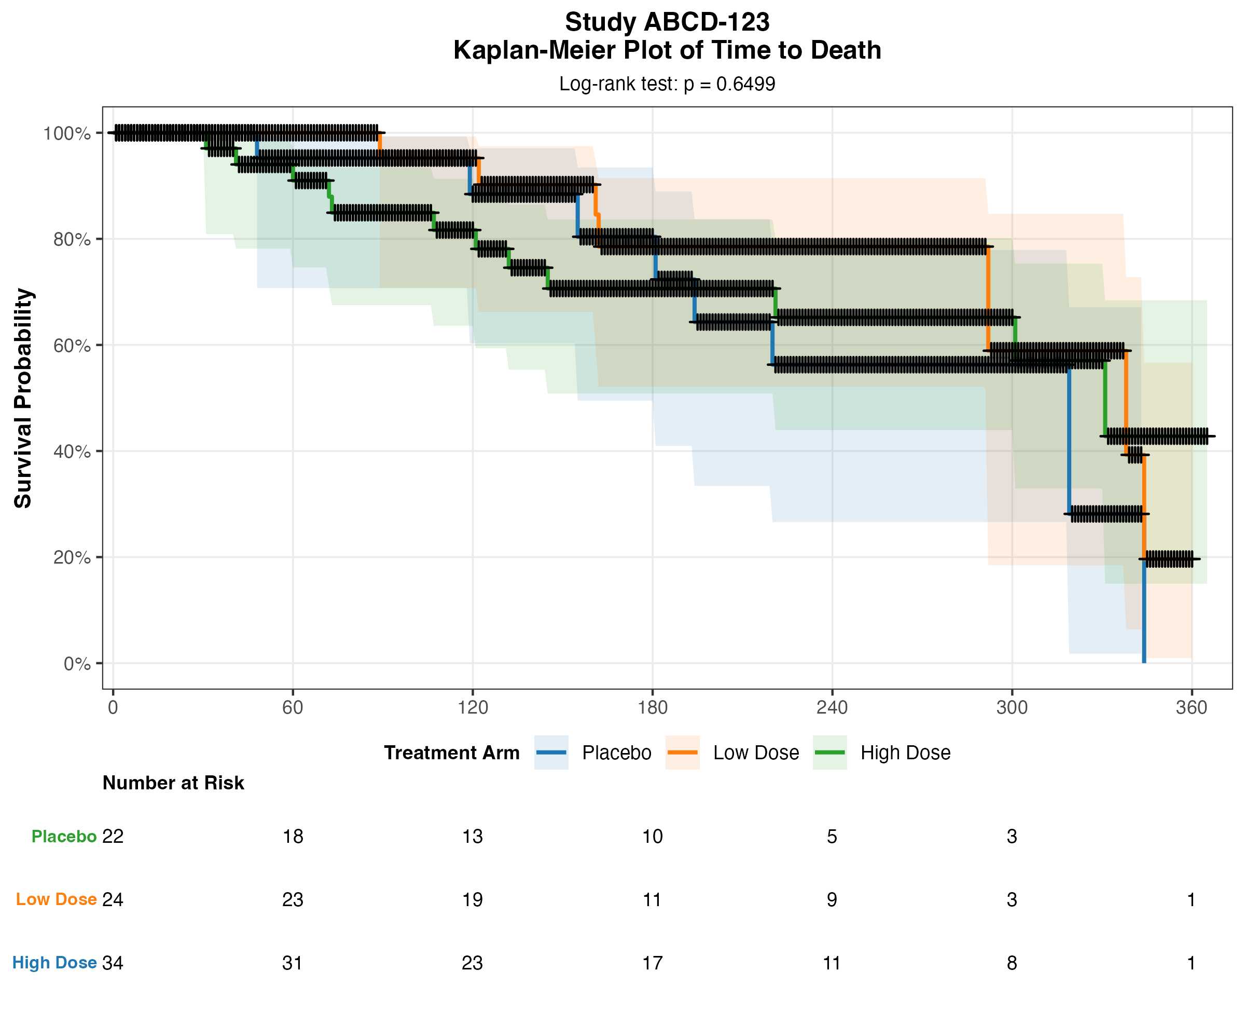

Study ABCD-123 | Parameter: Time to Death | Log-rank: p = 0.6499

