Study ABCD-123 - Kaplan-Meier Plot of Time to Death
Log-rank test: p = 0.6499
Note: + denotes censored observations.
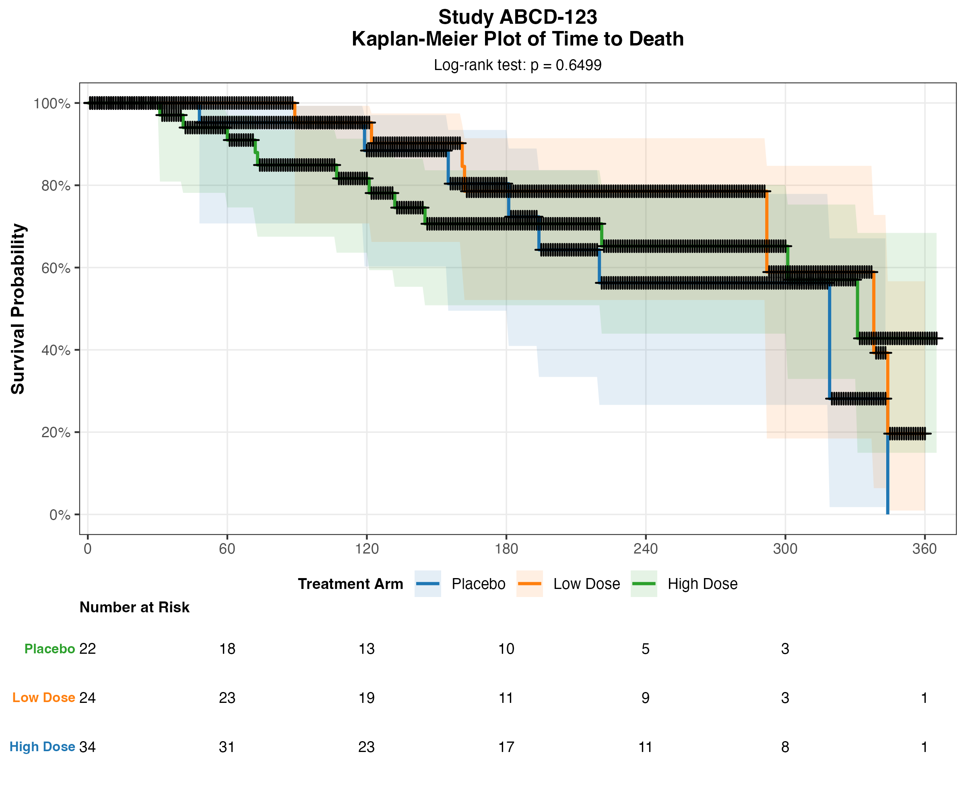
Summary of Median Survival:
Arm Records Median
TRT01P=Placebo 22 319
TRT01P=Low Dose 24 338
TRT01P=High Dose 34 331
Study: ABCD-123 | Parameter: Time to Death | Generated: 2026-05-15

