**Supply shock events in commodity markets: How midwestern weather affects prices for corn**

**Carrick Coakley**

**Noah Gonzales**

**Luca Toressani**

**Shujie Wu**

**Husain Kurawadwala**

**Introduction**

For this project, we wanted to explore a general interest among the group about futures prices for commodities as well as utilize skills from homework two. We chose to analyze nearby and third deferred futures prices because we thought it would offer more insight about how weather variability would change future supply. After considering different countries for our research focus, we settled on sticking to the US because it had much more available and comprehensive data, both in terms of the actual raster data and the reality that US weather would likely have a major impact on the world’s largest commodities market in Chicago (CME). We considered what satellite level effects we could analyze that would be apparent in raster data and might affect futures prices and went with temperature and precipitation, as we were familiar with sourcing from PRISM which provided these values. In our analysis, we will see how or if variability in these measures has any effect on futures prices or backwardation.

**Literature Review:**

Agriculture in the Midwest United States represents one of the most intense areas of agriculture in the world. This area is not only critically important for the United States economy but also for world exports of grain and meat. In the 2007 Census of Agriculture these states had a market value of crop and livestock products sold of $76 billion (USDA Census of Agriculture, 2007,Hatfield, J., 2012).

Corn (along with soybean), is the most important commodity for the US in terms of acres grown and a vital component of global commodity markets. According to a 2019 USDA Agricultural projections report, U.S. corn production is projected to continue to grow over the next decade as trade tensions with China constrain soybean plantings while expanding meat production increases feed usage. Planted area is expected to increase in the near-term. The USA is the largest exporter of corn in the world. In 2018/19, U.S. corn exports were expected to be more than double those of Brazil, the next largest exporter.

*Sensitivity of corn yields to extreme precipitation and temperature:*

Increasing drought and extreme rainfall are major threats to corn production in the United States. Using crop yield, weather and insurance data from 1981 to 2016, researchers showed that excessive rainfall can reduce corn yield up to 34% (17 ± 3% on average) in the United States relative to the expected yield from the long‐term trend, and up to 37% loss by extreme drought (32 ± 2% on average) (Li et.al, 2019).

Extreme dry and extreme wet conditions, despite accounting for ~1% of county-year samples each, caused substantial damage, reducing corn yield on average by 32.2 ± 2% and 16.6 ± 2.7% respectively, relative to their average yield trend from 1981 to 2016 across USA (Li et.al, 2019). In extreme wet conditions the growing season precipitation was dominated by the most intensive heavy rain which accounted for more than 30% of the precipitation (more than any other intensity of rainfall). These heavy rain events and associated adverse weather (e.g., hail and wind) could cause direct physical damage to crops.(Li et.al,2019)

The effect of extreme temperature is particularly important for loss of yield through drought. Extreme drought coupled with extreme heat resulted in an average yield reduction of 37.2 ± 2.9%, which was much greater than drought conditions without extreme heat- 25.8 ± 2.6% on an average across the USA. This is because temperature not only exacerbates water deficiency through increasing atmospheric water demands but also adds additional heat stress that can greatly suppress yield (Lobell et al., 2013; Schlenker & Roberts, 200; Li et.al, 2019). Unlike drought, the damage of extreme rainfall seemed to primarily arise from excessive water instead of temperature interaction, since there was no clear evidence for a greater yield reduction of extreme rainfall coupled with extreme cold.

July is the month where impacts of extreme drought can be most severe, because it coincides with the critical stage of grain filling and is usually the hottest month of the growing season. Drought during the reproductive stage of corn, co-occurring with heat, can cause the most damage to yields. For the excessive rainfall impact, June and July are months where impacts can be most severe. June corresponds to the early vegetative stage when most of corn was either planted or emerged and is also generally the wettest month on average. July corresponds to the reproductive stage. Field evidence suggests that both stages are susceptible to excessive moisture, especially the vegetative state (Carter et.al, 1990; Kanwar, 1988; Li et. al, 2019)

The 12 major corn producing states in the United States (mostly Midwestern states) that produced 88% of corn over the last decade were severely affected by extreme drought, with yield reduction from -45.7% ±3.2 in Illinois to -12.2 ± 5.9% in Nebraska. For extreme rainfall, yield effects were more spatially distributed,with states such as Iowa (-32.2± 4.1%) , Minnesota (-35.7± 9.7%) and Missouri (-31.3± 3.7%) the most negatively affected areas. Corn yield decrease in these areas could even exceed that caused by extreme drought.

Extreme changes in weather can cause significant fluctuations in crop yields which can cause supply shocks and futures prices to rise rapidly. One of the notable events this decade which caused a spike in corn futures prices include the 2012 Midwest drought (Chung et.al, 2014). More recently, corn futures prices rose to the highest level since 2012 in April of 2021 as drought conditions persisted in the Upper Midwest potentially reducing yields (CNBC, 2021)

***Figure 1.- Effect of extreme precipitation in Midwestern states on corn yields.***

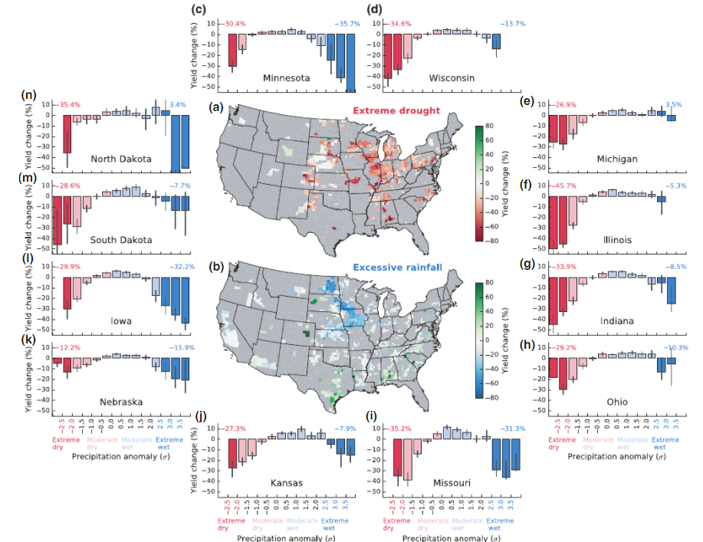

*Source:Li et.al,2019*

**Methods and Data:**

For the weather data, we downloaded the precipitation and temperature data for all states and then selected specifically for the top ten corn yielding states that we wanted to analyze. From there, we created dataframes for each month in the dataset, merged each of those months into individual years and finally merged all years together. This meant that our final weather data frame consisted of precipitation and temperature data for individual state-months and therefore had 1250 data points from 125 months and ten states. From this, we were able to find what the average value of precipitation and temperature were in each month in each state over the entirety of the dataset. We subtracted the individual state-month’s value from the full dataset average for that state and month in order to characterize how much that specific month deviated from ‘normal’ in this time period. We planned to use this information to draw a relationship between weather variability and futures prices, as environmental stressors may serve as a signal for investors about future commodity supply and in turn affect futures prices.

In order to evaluate the impact of weather on corn futures prices we used price data from the Chicago Mercantile Exchange (CME). For any commodity, there is a cost of carrying or holding the physical product which include storage and transportation costs. The futures price is the cost of purchasing that commodity today plus the cost of carrying that commodity. In a normal market , prices for more distant futures are higher than those for nearby (the market is in contango). If the distant futures prices are lower than those of contracts nearer to expiration (the market is in backwardation). When the market is in backwardation this implies that the cost of carry is negative, people are so demanding on the commodity now than in the future that it is a return but not a cost to carry the commodity. This is usually caused by low levels of inventory for that commodity. Thus, the effect of rain and temperature on futures prices can be determined by observing the cost of carry for the commodity, as weather affects production at the supply side. In the CME corn futures market, settlement prices are observed on the 15th trading day of each month which is the expiration of the previous future contract. Therefore, the cost of carry for each month can be determined by taking the difference between the 3rd deferred futures contract and second deferred futures contract.

Along with the cost of carry, we measured inventory provided by the USDA World Agricultural Supply and Demand Estimates (WASDE) report. This report is released monthly, and provides annual forecasts of supply and use of U.S. and world commodities. Thus, the ending stock monthly projection can be used as a benchmark for the cost of carry measure. The WASDE report supply projections capture expectations on the future market functions so it should be positively related to the cost of carry.

𝐸𝑛𝑑𝑖𝑛𝑔𝑆𝑡𝑜𝑐𝑘𝑠=(𝐵𝑒𝑔𝑖𝑛𝑛𝑖𝑛𝑔𝑆𝑡𝑜𝑐𝑘𝑠+𝑆𝑢𝑝𝑝𝑙𝑦𝑇𝑜𝑡𝑎𝑙)−(𝐸𝑥𝑝𝑜𝑟𝑡𝑠+𝐷𝑜𝑚𝑒𝑠𝑡𝑖𝑐𝐶𝑜𝑛𝑠𝑢𝑚𝑝𝑡𝑖𝑜𝑛)

**Findings:**

In Figure 1 the Cost of Carry measure computed from 2008 to 2017 CME Corn Futures Database is compared with the Ending Stocks Yearly Projections derived from the monthly USDA reports (*“U.S. Feed Grain and Corn Supply and Use”*). From the Cost of Carry chart, three relevant reversed spikes are recognizable. The future corn market was strongly inverted from the end of 2010 to the Summer of 2011, for a great part of 2012 and in 2013 until the end of August. This means that for those months the prices of the third deferred corn future contracts were lower compared to the first deferred one. As explained before, backwardation is a market condition, caused by a scarcity of commodities in the present compared to the future. To track this change in the second subplot of Figure 1, also the Projected yearly Ending Inventories are depicted. Here low projected ending-stocks of corn are found in similar times when also the future market for corn is backwarted. To have a better understanding of this graph it is important to know that the harvest of Corn in early fall of previous year influences, together with the demand, the level of inventories projected.

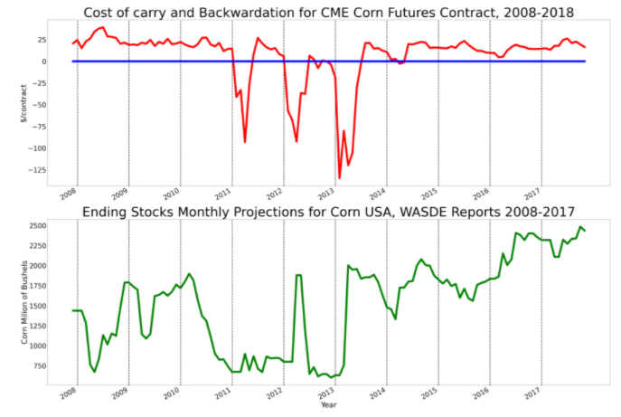

***Figure 2 Cost of Carry and Ending Stocks US Corn Projections from 2008 to 2017***

The inventories chart is being disentangled in Figure 2 where the projected corn demand and supply are plotted (data come also from the WASDE monthly announcements). Since the demand and supply are divided , the graph gives an understanding of the hypothetical cause of backwardation in 2011,2012 and 2013. Two major events need to be remembered, 2009 was a Record Year for Corn Production in the USA and during the summer of 2012 a drought led to a huge decrease in the MidWest Corn yield.

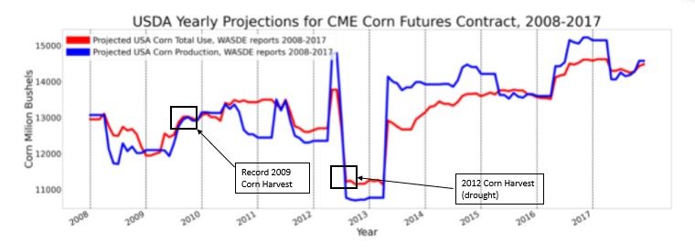

***Figure 3 US Corn Supply and Demand USDA Projection from 2008 to 2017***

Figure 2 shows that the corn futures market was inverted in 2011 and part of 2012 due to a *Demand Shock* and for late 2012 and much of 2013 due to a *Supply shock.* Before the 2009 Harvest, USDA already predicted the rise in production, which can be seen from the mid 2019 increase in Demand and Supply. However, the US corn production in 2010 and 2011 were much less. Is plausible that backwardation in 2011 and beginning of 2012 happened because demand in those years was still triggered by the 2009 harvest. Due to this delta, in 2011 from March to June and in 2012 from March to July Corn Future Market was inverted (Table 1). As regards the market inversion in 2013, it happened probably due to the drought of 2012, which is a *Supply Shock*. At the beginning of this year the projections for corn production were positive but an unpredicted drought, that happened in July, caused major problems for the crop. The year later (2013) inventories were almost not sufficient to satisfy the demand, causing a prolonged backwardation from January to August 2013 (Table 1).

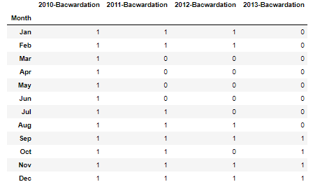

***Table 1 Corn Futures Market Backward Period from 2010 to 2013 (0=backwardation, 1=countago)***

To test the statistical significance of these shocks, and disentangle the demand and supply shocks effect on Corn Future Prices we model these effects and variables in different models. We conducted two series of regression analysis to examine the reasons behind backwardation and the relationship between it and weather. Instead of using cost of carry in the regression, we derived a new binary variable called slope which would be 1 if cost of carry is positive, 0 if it is negative and in backwardation.

Phase 1 regressions are used to prove that cost of carry relates to WASDE projections. The slope~production regression gives a zero coefficient and an intercept of 0.08, suggesting that when there is no production, the slope is very close to zero, and it can be interpreted as extreme low supply is correlated with an almost constant backwardation. The slope~total use regression shows a zero coefficient and an intercept of -0.741, so when there is no demand in the market, the market is neither in contango or backwardation as the cost of carry is neither positive or negative. When the slope is regressed on ending stock, the coefficient is 0 and the intercept is 0.568, showing that when there is no ending stock, the market can possibly be contango and backwardation. Since ending stock and productions are both supply measures, and with no production the slope is much closer to zero. As a result, backwardation caused by supply is more likely due to the negative production shock.

Phase 2 regression test how changes in precipitation and temperature affect backwardation. Since there could be situations where rapid precipitation and temperature change occur together, we introduced an interactive variable “precipitation*temperature” to measure the effect when both happen. Rapid weather changes are more frequent in the summertime, therefore, we created a dummy variable and set it to be 1 when the month is June, July, and August, and 0 in other months. The regression slope~weather change~interactive variable~dummy is conducted and the result is as follow:

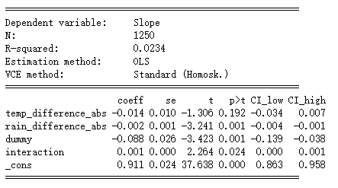

***Figure 4- Regression results***

The coefficients show that change in temperature and precipitation will lead to backwardation. The temperature change has a greater impact than the precipitation change, though the coefficient of temperature change is insignificant. Backwardation is highly related with summer, as the coefficient of the dummy is negative. The interactive variable does not have much effect, probably due to the mixed effects of the four situations the variable represents.

As we mentioned before, drought is one significant reason for supply shock, and there was a huge backwardation following the 2021 drought. To examine the effect of drought, we created a drought measurement to be mean temperature divided by mean precipitation. Then we regressed slope on weather change, drought, and dummy. The following table shows the result:

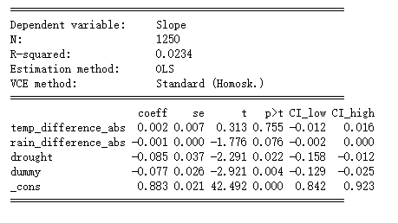

***Figure 5- Regression results***

Based on the coefficients, we can conclude that the appearance of backwardation is strongly affected by the drought that happens in summertime.

As a conclusion of overall finding from regressions, the backwardation is very likely caused by anticipated negative production shock in the market, and such production shock is possibly due to the droughts in the summer, while general weather changes also stay effective.

**Conclusion:**

In this research, we were able to find that weather does in fact have an effect on supply and this effect shifts expectations which can be reflected in both cost of carry as well as backwardation. More specifically, increased weather variability in the midwest can lower cost of carry and increase incidence of backwardation. Unsurprisingly, there can be delay in price effects relating to weather variability, as a good or bad harvest from a previous year due to weather may have an effect on the following year.

To further this research, anyone using the repository could incorporate demand shifts to better understand how weather alone shifts prices. Additionally, PRISM data goes back quite far so as long as a researcher has access to corresponding futures price data, they can expand our analysis to a broader time scale. Additionally, more insight may be available by categorizing weather conditions into ‘drought’ or ‘excess rain’ rather than just using the variable difference of a month's weather with respect to the mean. This may be able to indicate whether prices move with any weather variability or only if variability is extreme enough or over a long enough period to have an effect on yield.

**References**

1. Li, Y., Guan, K., Schnitkey, G. D., DeLucia, E., & Peng, B. (2019). Excessive rainfall leads to maize yield

loss of a comparable magnitude to extreme drought in the United States. *Global change biology*, *25*(7), 2325-2337.

1. Projections, U. L. T. (2011). USDA Agricultural Projections to 2020.
2. Hatfield, J. (2012). Agriculture in the Midwest. US National Climate Assessment Midwest Technical Input

Report, 1-8.

1. Kanwar, R. S., Baker, J. L., & Mukhtar, S. (1988). Excessive soil water effects at various stages of

development on the growth and yield of corn. Transactions of the ASAE, 31(1), 133-0141.

1. Carter, C. E., Halverson, B., Rogers, J. S., & Musgrave, M. (1990). Effects of excess soil water on sweet

corn yield. Transactions of the ASAE, 33(4), 1203-1207.

1. Lobell, D. B., Hammer, G. L., McLean, G., Messina, C., Roberts, M. J., & Schlenker, W. (2013). The

critical role of extreme heat for maize production in the United States. *Nature climate change*, *3*(5), 497-501.

1. Lobell, D. B., Roberts, M. J., Schlenker, W., Braun, N., Little, B. B., Rejesus, R. M., & Hammer, G. L.

(2014). Greater sensitivity to drought accompanies maize yield increase in the US Midwest. Science, 344(6183), 516-519.

1. Schlenker, W., & Roberts, M. J. (2009). Nonlinear temperature effects indicate severe damages to US crop

yields under climate change. Proceedings of the National Academy of sciences, 106(37), 15594-15598.

1. Chung, U., Gbegbelegbe, S., Shiferaw, B., Robertson, R., Yun, J. I., Tesfaye, K., ... & Sonder, K. (2014).

Modeling the effect of a heat wave on maize production in the USA and its implications on food security in the developing world. Weather and Climate Extremes, 5, 67-77.

1. Corn futures jump to a 7-year high on supply concerns.

https://www.cnbc.com/2021/04/26/corn-futures-jump-to-a-7-year-high-on-supply-concerns.html