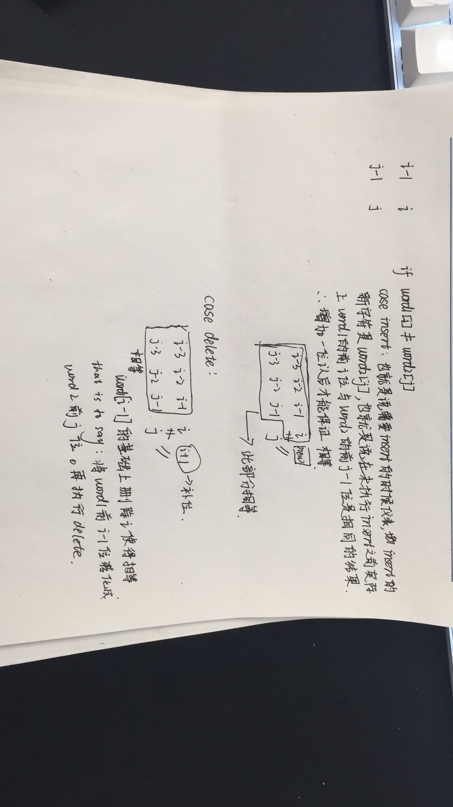

https://www.jianshu.com/p/5eba04971d60