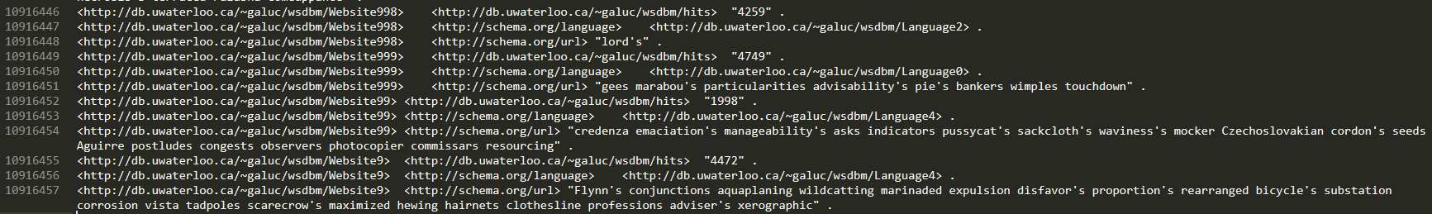

WaiDiv10M共有三元组一千零九十一万六千四百五十七个。

|  |  |
| --- | --- |
| S P ?O time 微秒 | S ?P O time 微秒 |
| 737 | 3864 |
| 1104 | 1216 |
| 1079 | 1338 |
| 821 | 1732 |
| 1159 | 1439 |

五条Sparql语句分别为：

<http://db.uwaterloo.ca/~galuc/wsdbm/City0> <http://www.geonames.org/ontology#parentCountry>

<http://db.uwaterloo.ca/~galuc/wsdbm/City0> <http://db.uwaterloo.ca/~galuc/wsdbm/Country6>

<http://db.uwaterloo.ca/~galuc/wsdbm/City100> <http://www.geonames.org/ontology#parentCountry>

<http://db.uwaterloo.ca/~galuc/wsdbm/City100> <http://db.uwaterloo.ca/~galuc/wsdbm/Country2>

<http://db.uwaterloo.ca/~galuc/wsdbm/City101> <http://www.geonames.org/ontology#parentCountry>

<http://db.uwaterloo.ca/~galuc/wsdbm/City101> <http://db.uwaterloo.ca/~galuc/wsdbm/Country2>

<http://db.uwaterloo.ca/~galuc/wsdbm/City102> <http://www.geonames.org/ontology#parentCountry>

<http://db.uwaterloo.ca/~galuc/wsdbm/City102> <http://db.uwaterloo.ca/~galuc/wsdbm/Country17>

<http://db.uwaterloo.ca/~galuc/wsdbm/City103> <http://www.geonames.org/ontology#parentCountry>

<http://db.uwaterloo.ca/~galuc/wsdbm/City103> <http://db.uwaterloo.ca/~galuc/wsdbm/Country3>

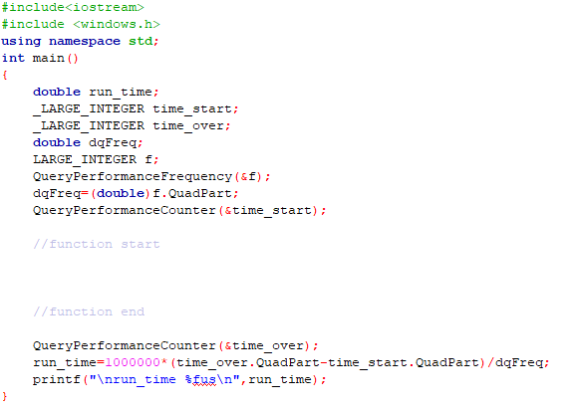

结果是：

