Robot Autonomy HW4

1.

There are three states in the control space,, and duration.

We use the following setting to design our control set:

Duration = 0 to 3 seconds with 0.1 seconds interval

If the control set is too simple, it limits the maneuverability of the robot. However, if the control set is too complicate, it is hard to design evaluation metrics to select the optimal trajectory.

The reason why we choose this setting is that you try to select a moderate size of the control set.

The figures below show the trajectories of our control set in different orientation.

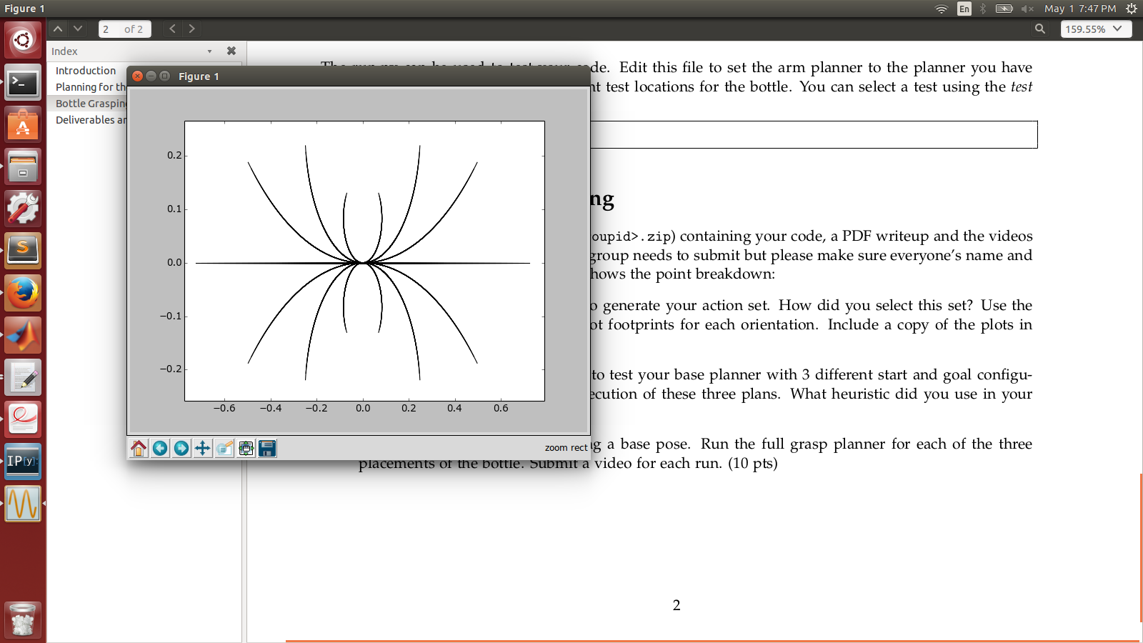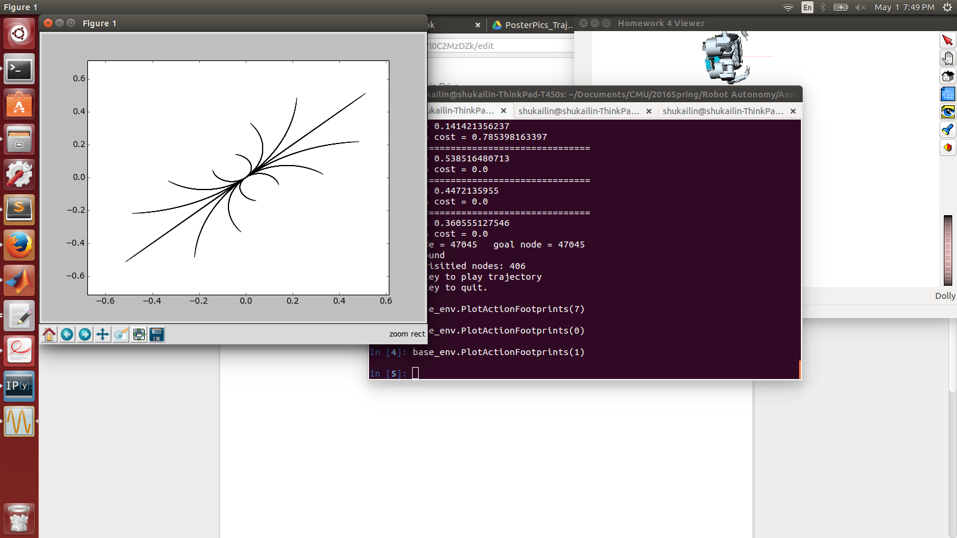

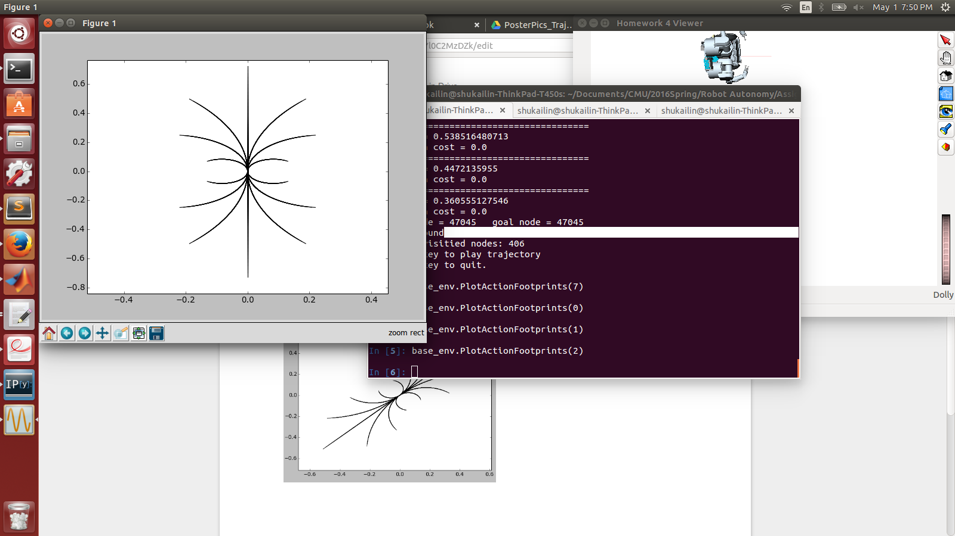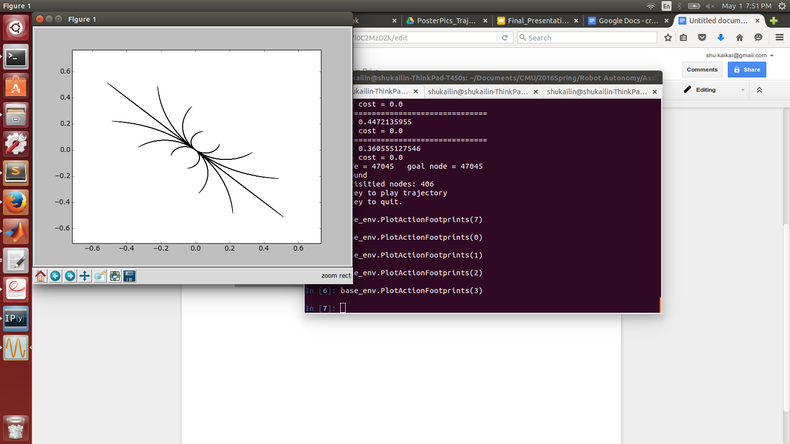

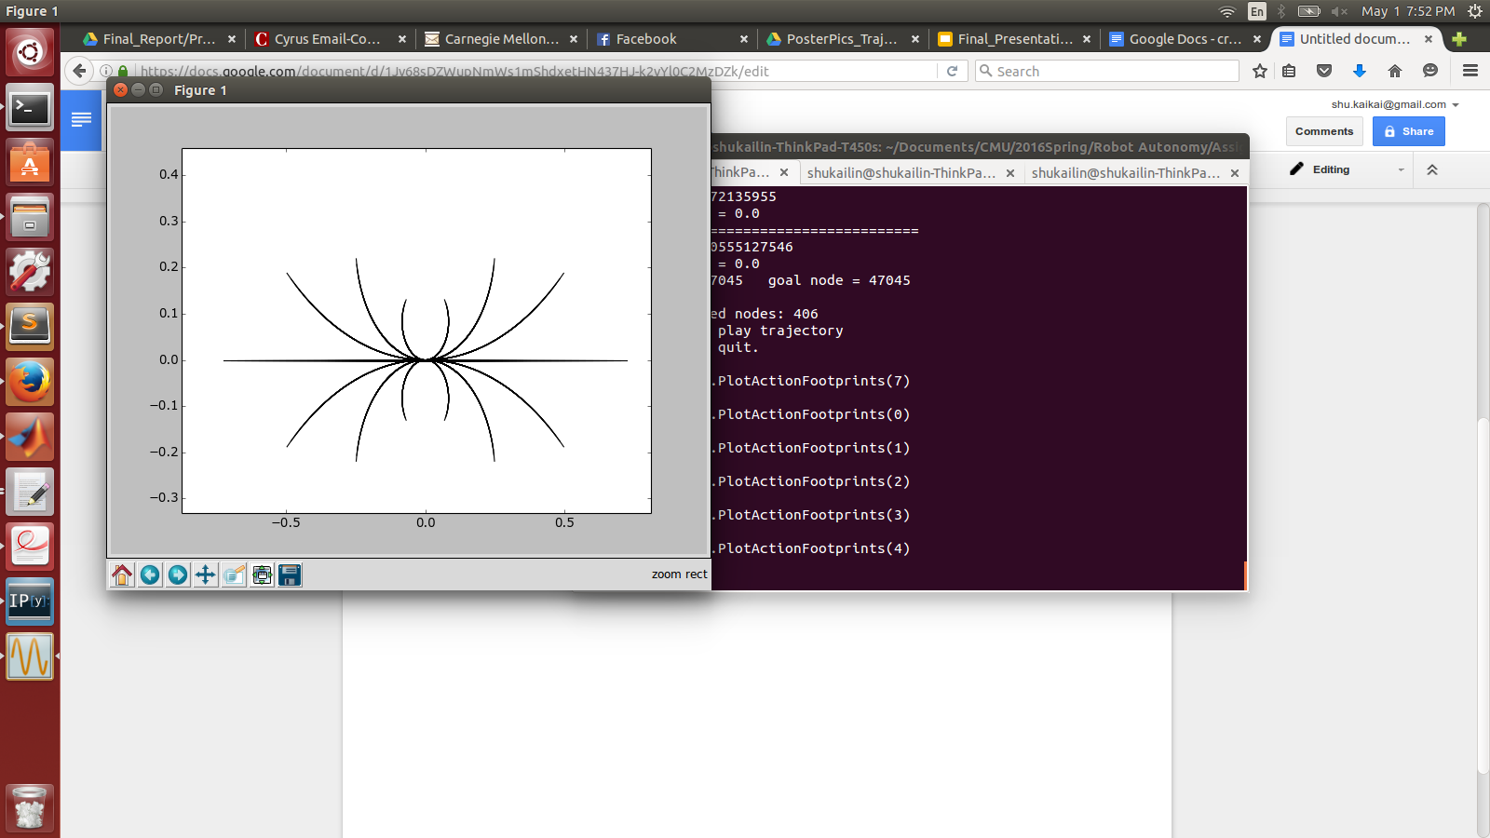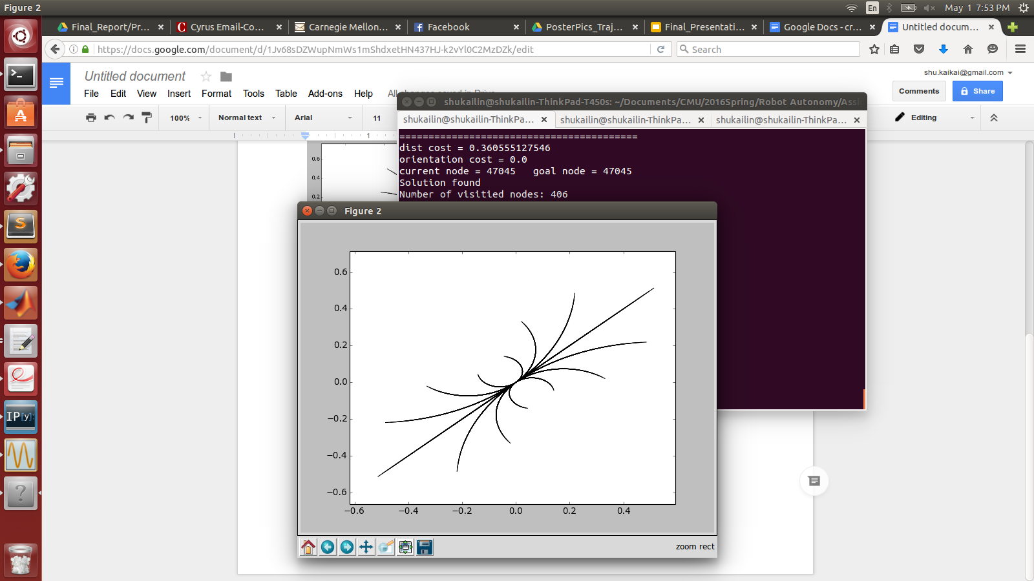

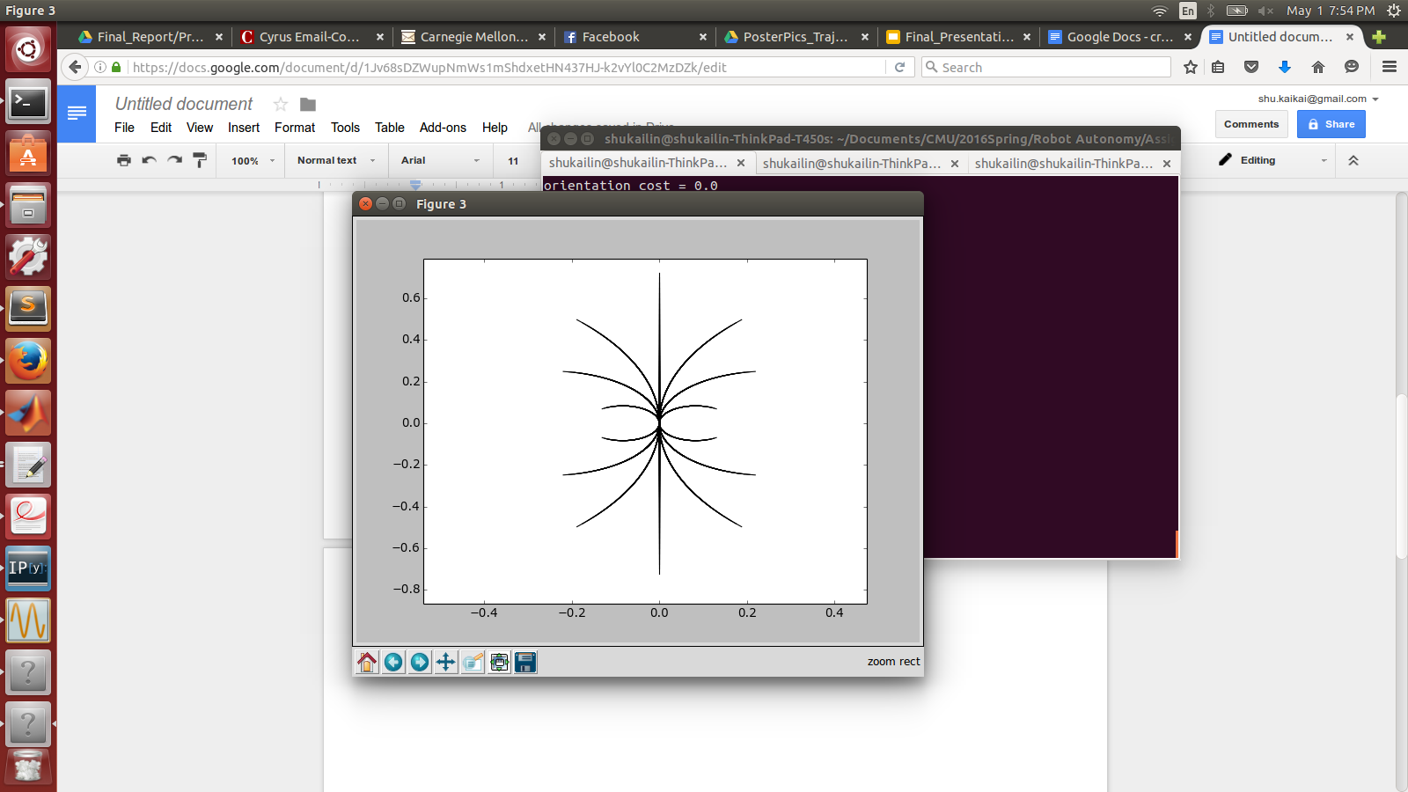

2.

Configuration 1

start_config = [-0.5 ,0 ,numpy.pi/2]

goal_config = [-0.5 ,2 ,0]

Configuration 2

start_config = [-0.5 ,0 ,numpy.pi/2]

goal_config = [2 ,2 ,0]

Configuration 3

start_config = [-0.5 ,0 ,-numpy.pi/2]

goal_config = [-0.5 ,-2 ,0]

For this part, we modify the “ComputeDistance“ function and “ComputeHeuristicCost” funciton.

In “ComputeDistance“, instead of using Euclidean distance metric, we add a weighting number on orientation trying to let it find the correct orientation as soon as possible.

In “ComputeHeuristicCost”, we add a weighting number on distance of x and y coordinates trying to let it go close to the goal position.

The current result is acceptable.